DENG ALEER -BIT/2025/32166
COURSE-MOBILE APPLICATIOS DEVELOPMENT
WEEK 1TASK:DEVELOPING TOOLS
I choose to go with android studio .I downloaded it successfully and also downloaded other requirements for the app .After making sure the app is running well I now went on and downloaded an emulator .The emulator was able to run and was functional but I encountered some lag on the end of the emulator but the emulator was running successfully. Below is the screenshot of the emulator

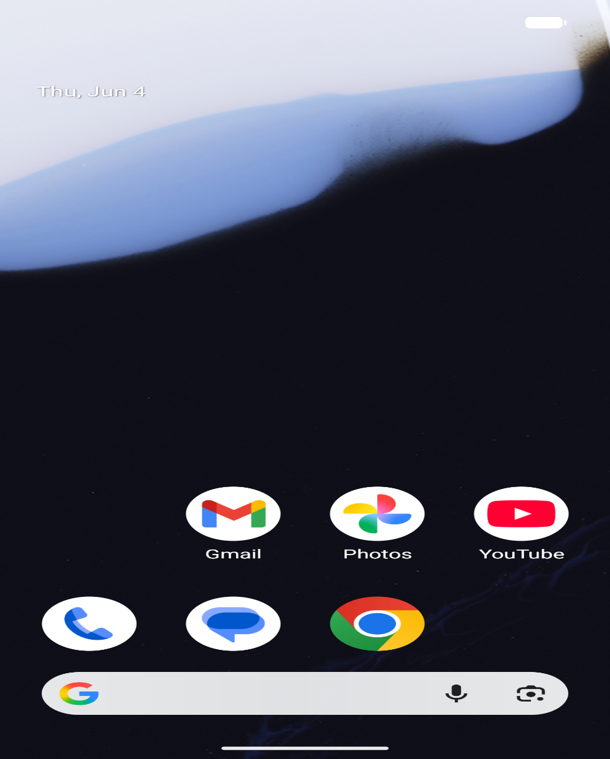

I proceeded to build a simple flutter app and was successful in doing so .At first it had problems running but it finally ran successfully on the emulator. The screenshot below shows the output on the emulator

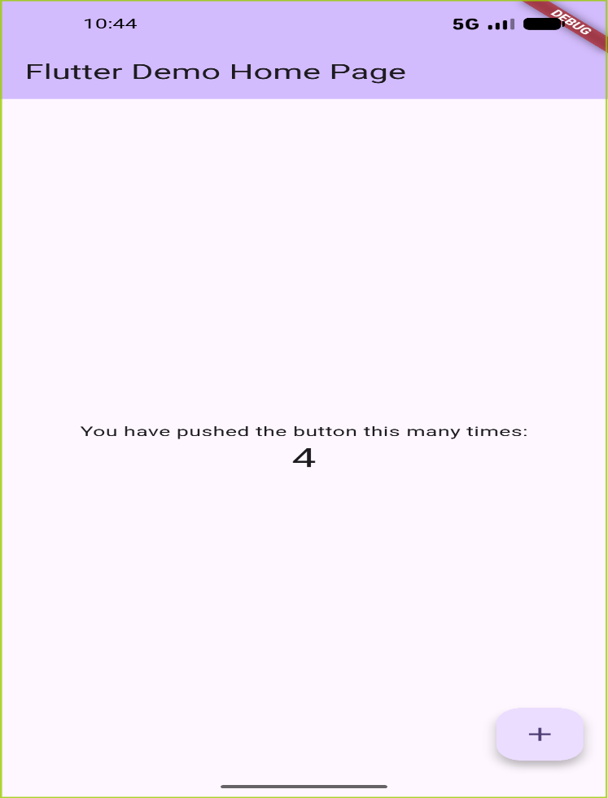
I was also able to change the app tittle ,the background colour and also the font size.

WEEK 2 TASK:MINI STUDENT

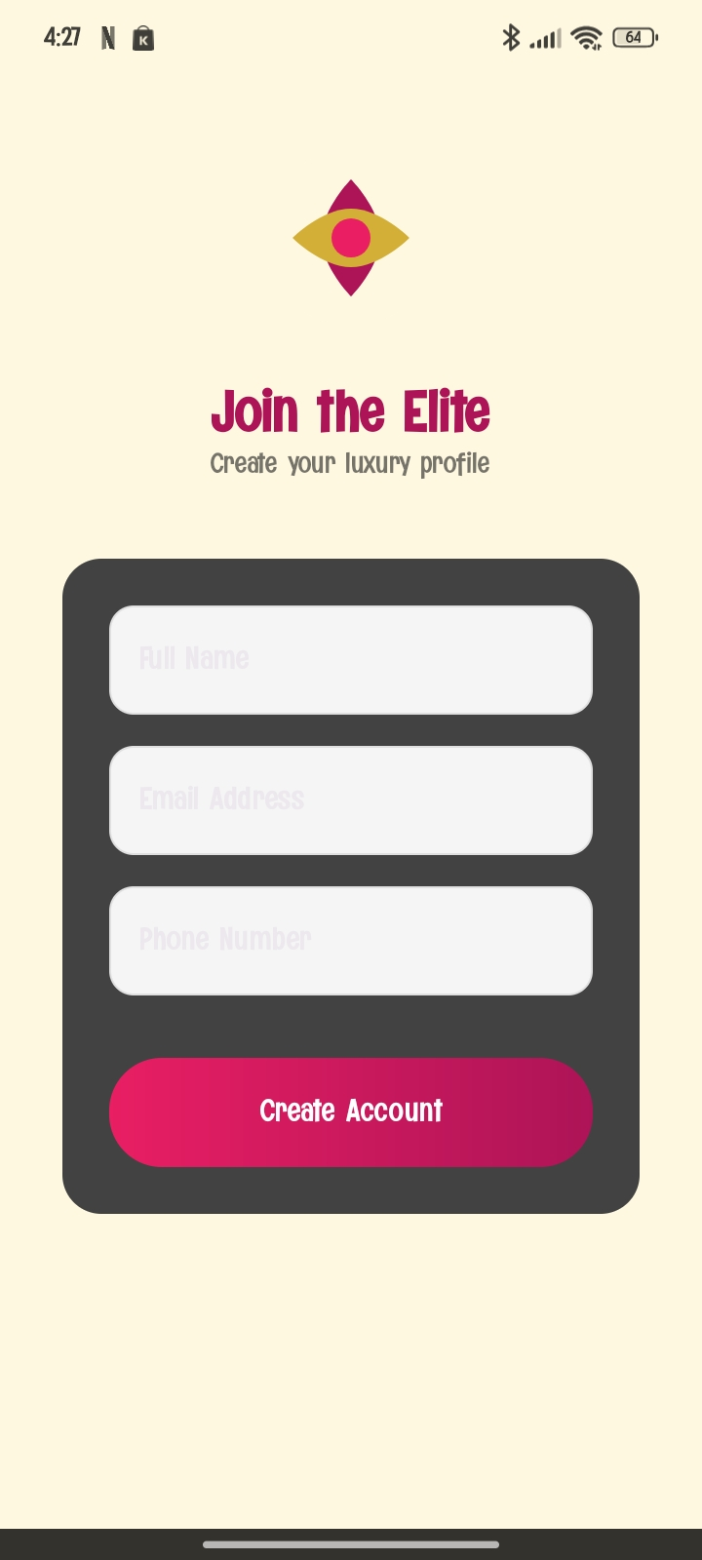
WEEK 3:INTERFACE AND UI DEVELOPMENT
Built an app with a modern ui and simple navigation

