The version numbers listed below are current as of 11/10/2014. Be sure to keep track of where everything is installed for setup in Eclipse.

Install (in order):

1. Firefox 33.0.2

Found at <https://www.mozilla.org/en-US/firefox/new/>

1. Java SE 8u25

Found at <http://www.oracle.com/technetwork/articles/javase/index-jsp-138363.html>

1. JUnit 4.11

Found at <https://github.com/junit-team/junit/wiki/Download-and-Install>

1. TestNG 6.8.21

Found at <http://testng.org/doc/download.html>

1. Hamcrest 1.3

Found at <https://code.google.com/p/hamcrest/downloads/list>

1. Selenium 2.44.0 (update)

Found at <http://www.seleniumhq.org/download/>

1. SQLite 3.8.7.1

Found at <https://bitbucket.org/xerial/sqlite-jdbc/downloads>

1. Eclipse Version: Kepler Service Release 2, Build id: 20140224-0627

Found at <https://www.eclipse.org/downloads/>

1. Eclipse Add-Ins In Eclipse menu under: Help | Eclipse Marketplace...

Eclipse Java 8 Support (for Kepler SR2) JDT, PDE, 1.0.0

Java 8 support for Eclipse Kepler SR2

1. WikiTestSelenium project

Found at <http://github.com/doncarver/WikiTestSelenium>

After everything is installed, follow these directions to prepare the tests to run

1. Create a java project (File | New | Java Project)

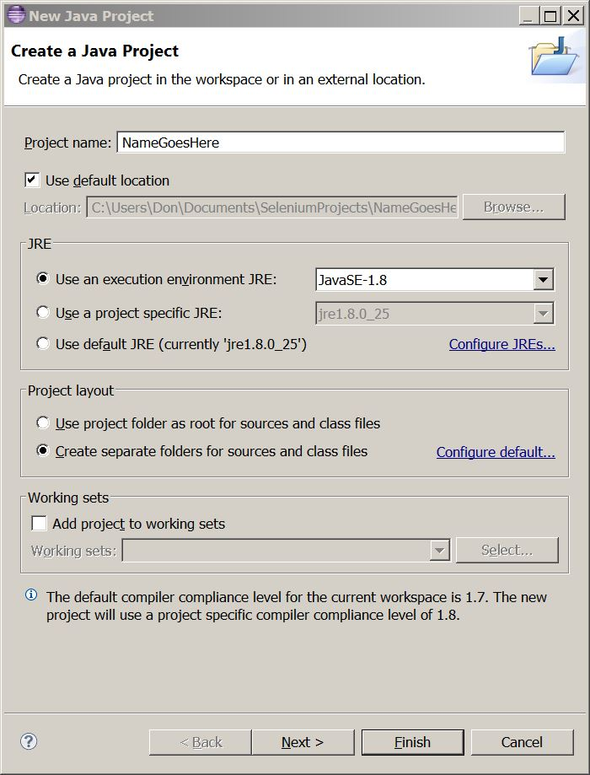

1. Add a source directory (File | New | Source Folder)

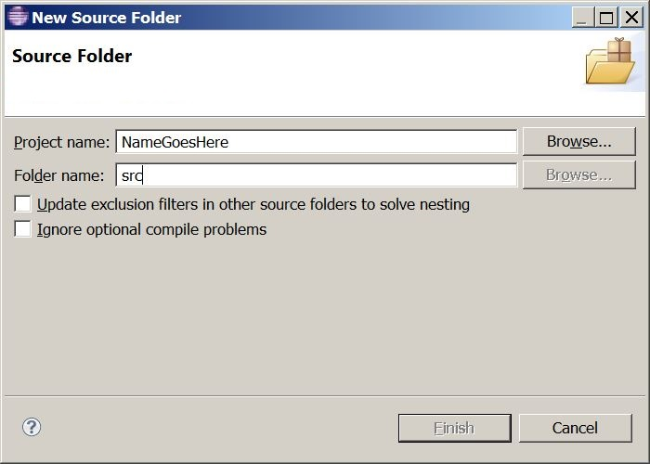

1. Add the following packages (File | New | Package)

com.selenium.wikitest.bugs

com.selenium.wikitest.shared

com.selenium.wikitest.webpage

com.selenium.wikitest.webpage.homepage

com.selenium.wikitest.webpage.homepage.automatedtests

com.selenium.wikitest.webpage.homepage.data

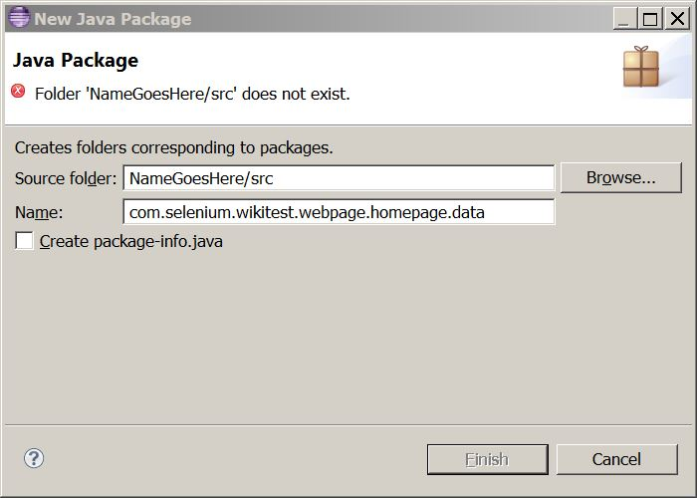

1. Right-click on project click Properties
2. Click on Java Build Path
3. Click on Libraries tab

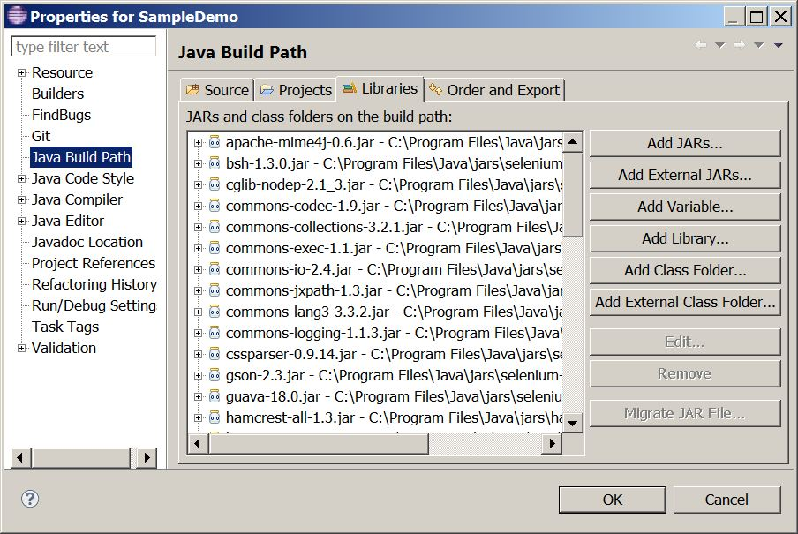

1. Click on the Add External JARs... button
2. Add all jars downloaded above (JUnit, Hamcrest, Selenium, and SQLite)
3. Drag and drop .java files into appropriate packages in Eclipse

In the Project Explorer, open the file AllHomePageTests.java from the package com.selenium.wikitest.webpage.homepage.automatedtests

Run all the tests from the menu (Run | Run As | JUnit Test)