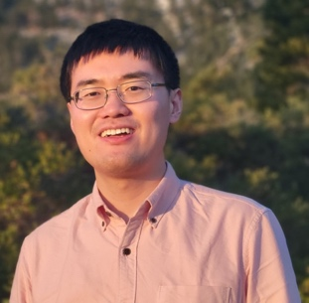**Tong Wang, PhD**

Postdoctoral Research Fellow of Yang-Yu Liu’s lab,

Channing Division of Network Medicine,

Department of Medicine, Brigham and Women’s Hospital,

Harvard Medical School, Boston, MA 02115, USA

**Talk Title: Machine learning for precision nutrition**

Talk Abstract: Due to highly personalized biological and lifestyle characteristics, different individuals may have different metabolic responses to specific foods and nutrients. In particular, the gut microbiota, a collection of trillions of microorganisms living in our gastrointestinal tract, is highly personalized and plays a key role in our metabolic responses to foods and nutrients. Characterizing the metabolic profile of a microbial community and accurately predicting metabolic responses to dietary interventions based on individuals’ gut microbial compositions are crucial for understanding its impact on the host and hold great promise for precision nutrition. I will present two computational methods: (1) mNODE (metabolomic profile predictor using neural ordinary differential equations) to predict the metabolomic profile based on the microbial composition of the community and (2) McMLP (Metabolic response predictor using coupled Multilayer Perceptrons) to predict the metabolic response to food intervention. Both methods clearly outperform existing methods on synthetic data and various real data. Additionally, by employing sensitivity analysis, mNODE infers microbe-metabolite interactions, while McMLP facilitates the inference of tripartite food-microbe-metabolite interactions. The presented tools have immense potential to guide the design of microbiota-based personalized dietary strategies to achieve precision nutrition.

Brief bio: Dr. Tong Wang is a postdoctoral research fellow from Yang-Yu Liu’s lab at Brigham and Women’s Hospital and Harvard Medical School. He received his Ph.D. in Physics from the University of Illinois at Urbana-Champaign in 2021, with his thesis focusing on modeling microbial communities with cross-feeding and predator-prey interactions. The primary goal of his current research is to combine ecological models and omics data to reveal the assembly rules of microbial communities, especially the human gut microbiomes. Besides mathematical modeling, he has also worked on predicting metabolomic profiles from microbial compositions and dietary information using ecology-based models and machine-learning models.