

**Basic Linux Commands Assignments**

Assignment-1

Connect and disconnect with login Access

* What happens when you login a non-existent users or username?
  + Provide Screenshot and What you understand, explain in short brief?

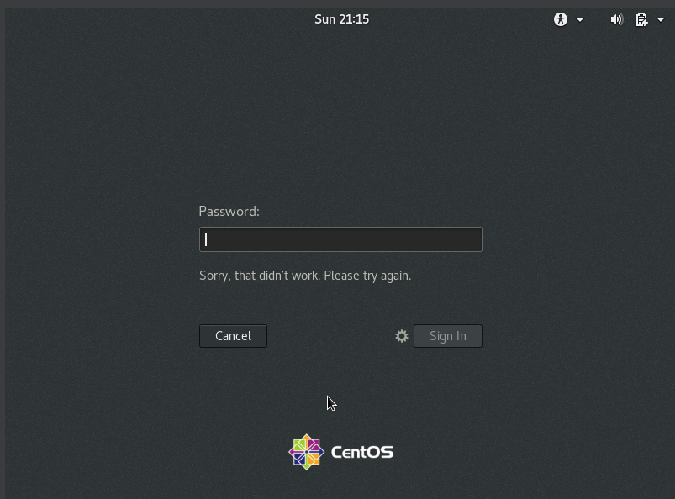

* tried logging in using a username “someone” which doesn’t exist thus it doesn’t show here and throws some kind of error.

Assignment-2

Password changing

* Login into your account and then change password?
  + Change your password into ***IneuR0n#42*** and hit the **Enter** key
    - Explain what happen and give screenshot?

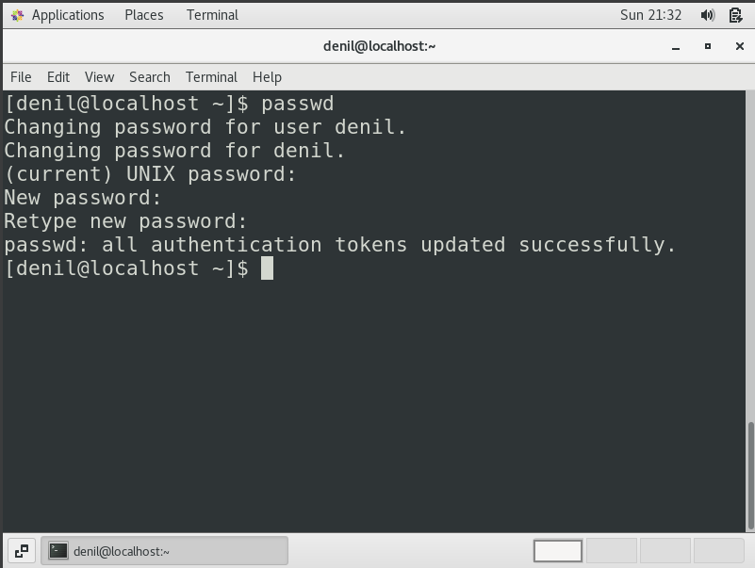

* it asked for my current password upon entering which I was able to create my new password, (thing to notice here: you won’t be able see the password you type as it is masked). Thereafter I was asked to verify my newly entered password.
  + Try again to change password but use like password ***1234*** or ***abcd***
    - Explain what happen and give screenshot?

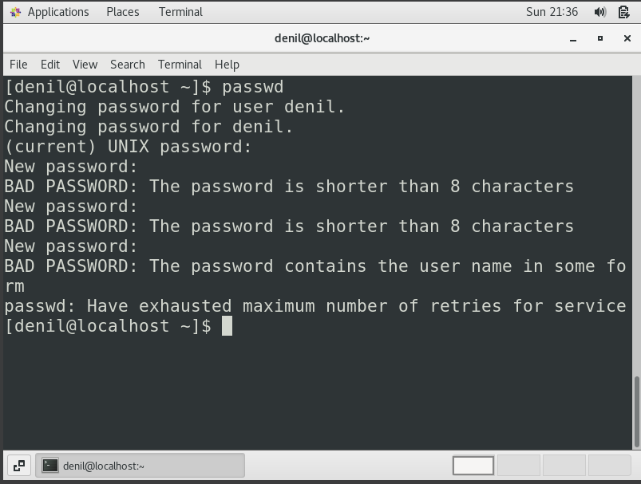

* Upon setting passwords like **abcd** or **1234** a warning is thrown, asking us to make a stronger password. I also tried to set a password that contained my name and it didn’t allow me saying it contained my username.
* this tells us that the OS enforces better security practices.
  + Try again to change password but now don’t use any password just hit **Enter** key
    - Explain what happen and give screenshot?

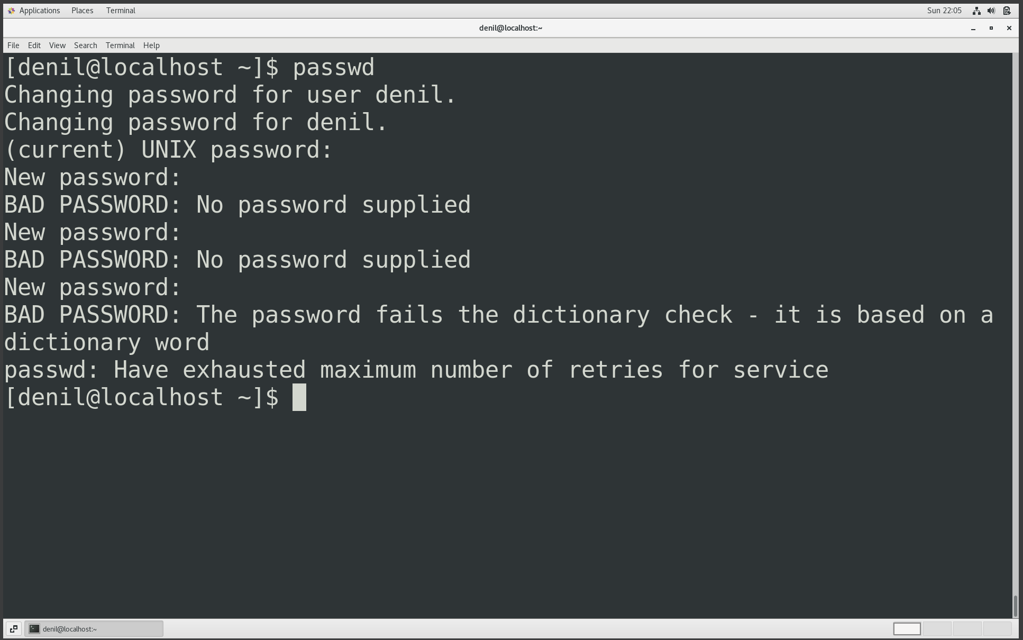

* the OS doesn’t allow to setup empty password and throws warnings

Assignment-3

Working with Directories

* Enter the command **cd /** and then **ls** and then hit **Enter** key
  + Take screenshot and explain what output we got?

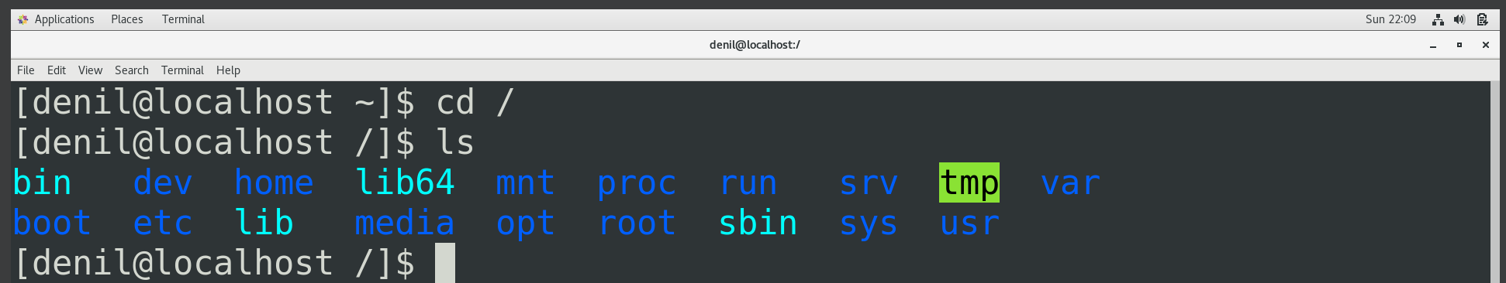

* Enter the command now **cd /home** and then hit **Enter** key
  + Do **ls,** provide screenshot and explain what is **/home** directory used for?

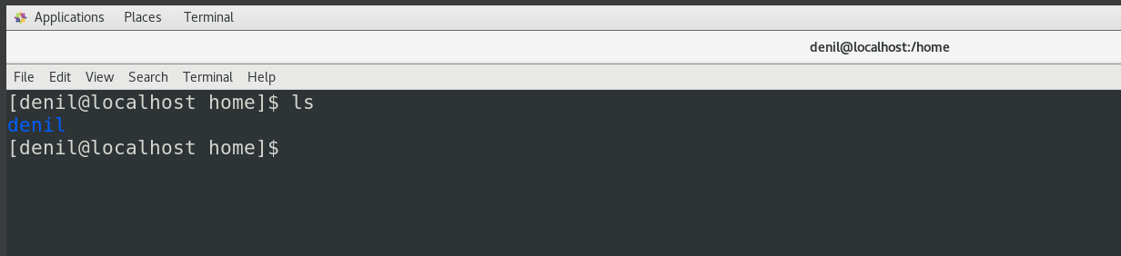

* /home : is the directory contains home directories of all users other than root
* Enter **cd ..** and hit **Enter** key [ *Note: here we have space after cd then use double dot*]
  + Check what happen and give screenshot?

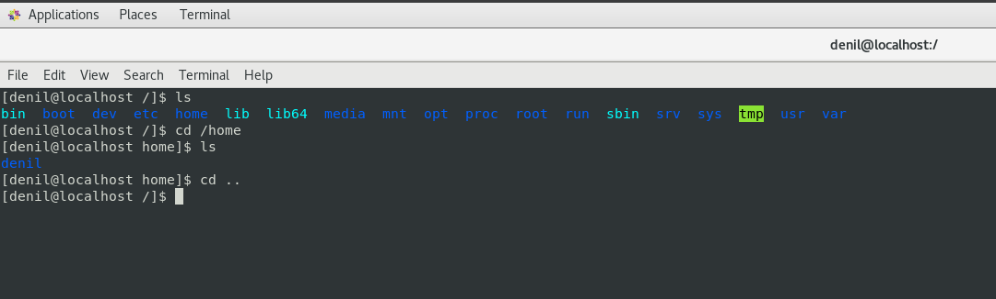

* by using **cd ..** I am redirected to previous folder (a step back in the directory structure)
* Now enter **cd /var/www/html** and then type **cd** and hit **Enter** key
  + Explain what happen and give screenshot?

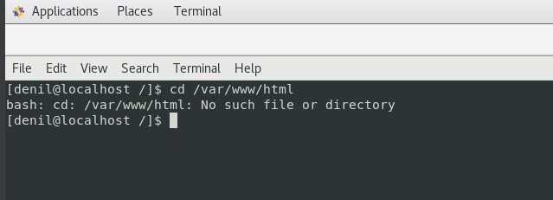

* weirdly it showed the file doesn’t exist but according to my knowledge it opens the directory where all html files which are to be served by a server (I have used apache server previously)

are stored.

* Now type **cd /root** and then hit **Enter** key
  + Do **ls,** check any output we have on screen if yes then take screenshot?

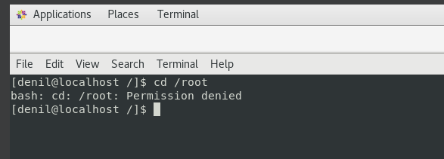

* It throws permission denied error, I suppose we need higher permissions to access the folder of root user.

Assignment-4

Working with File Listing

* Go to **cd /etc** and type **ls**
  + Take screenshot and explain what files you have seeing?

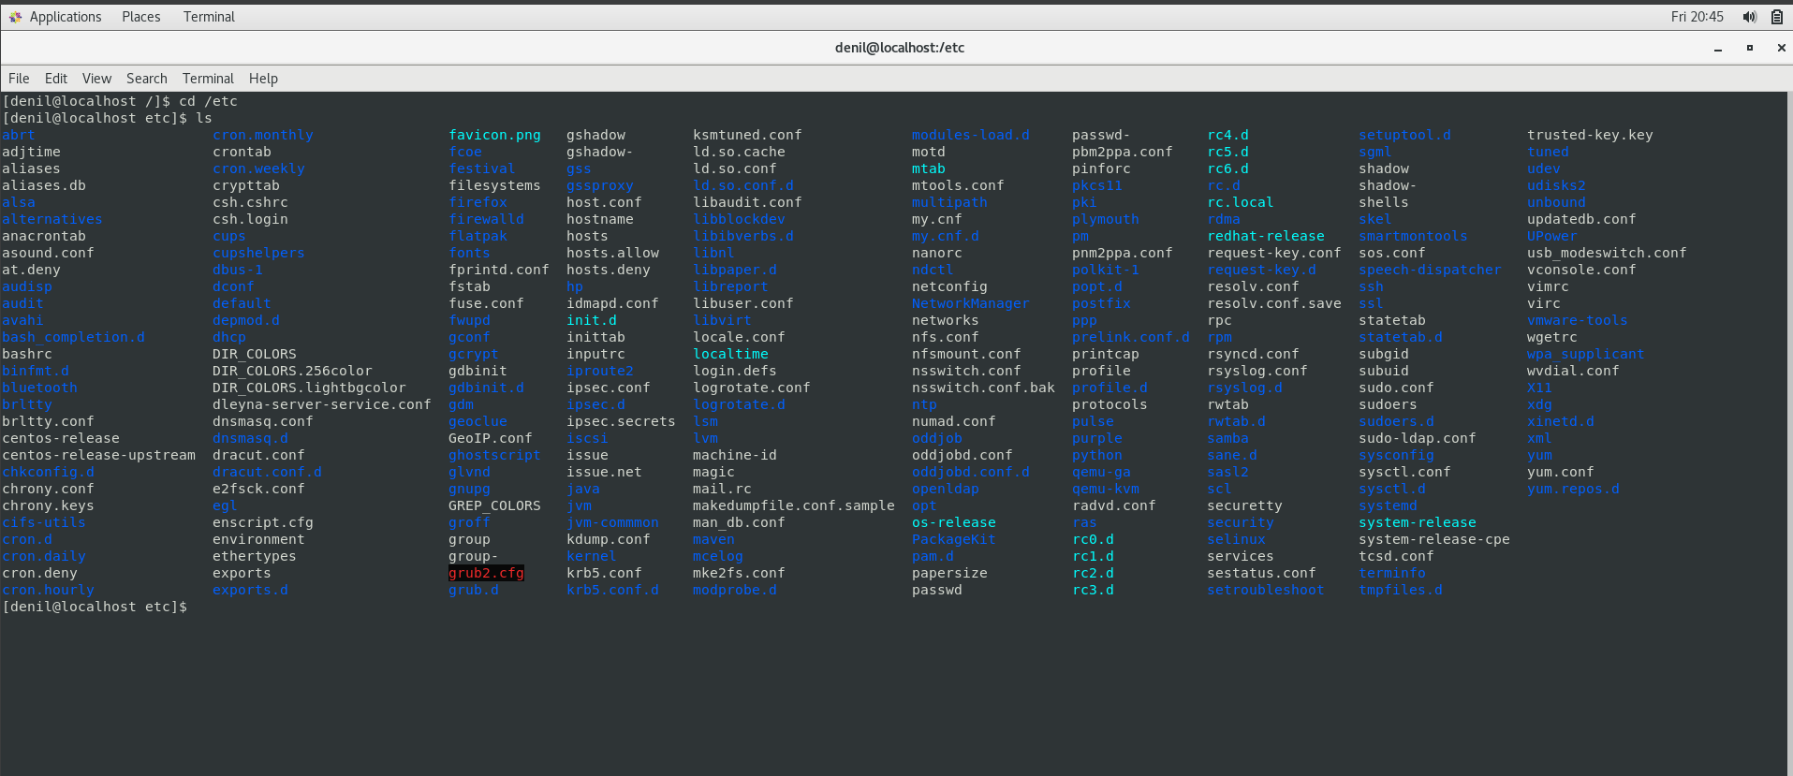

* /etc: this folder seems to contain configuration files of system as well as other applications
  + Take screenshot and explain what different output you found compare to previous command you used?
* didn’t understand the question I guess the command is missing here
* Then type **ls -al** and hit **Enter** key
  + Take screenshot and explain what new file or directory you found?

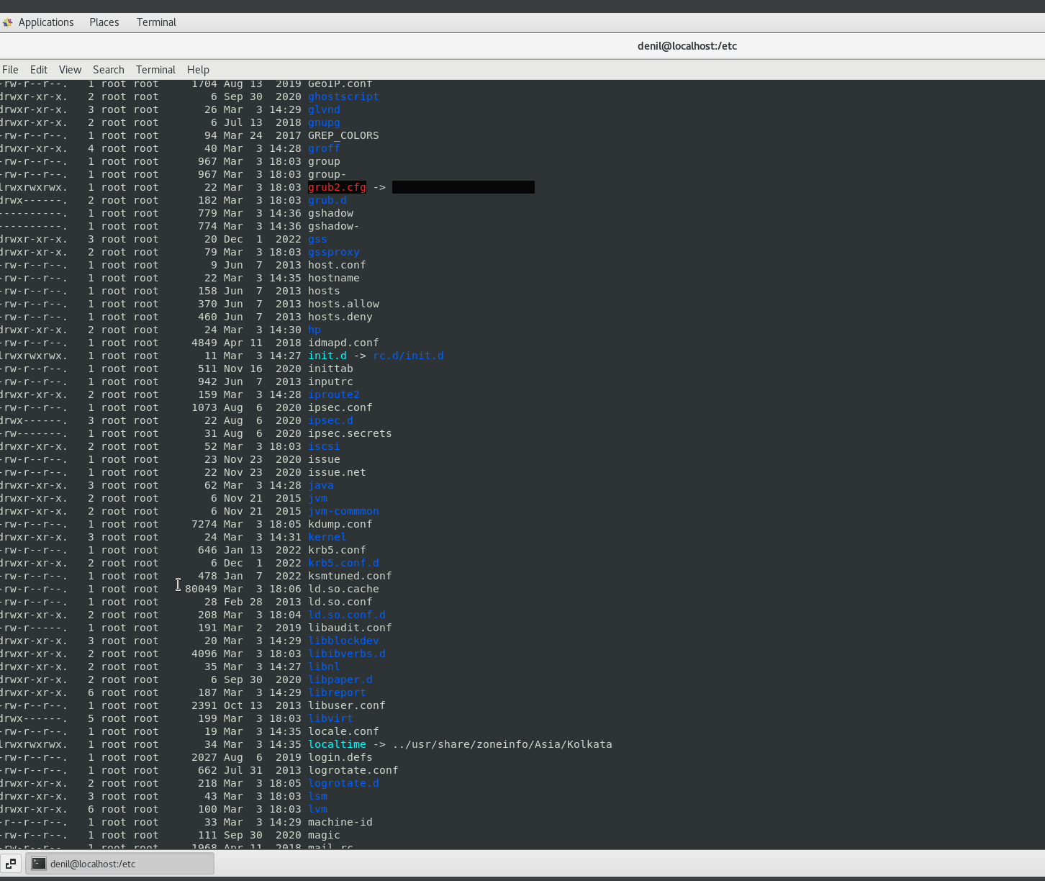

* the -al command provides details information of each file present in the directory, in my understanding here ‘a’ is for all files and ‘l’ is for long format
* Then use **ls -i** and hit **Enter** key
  + Now see what different output its shows and take screenshot?

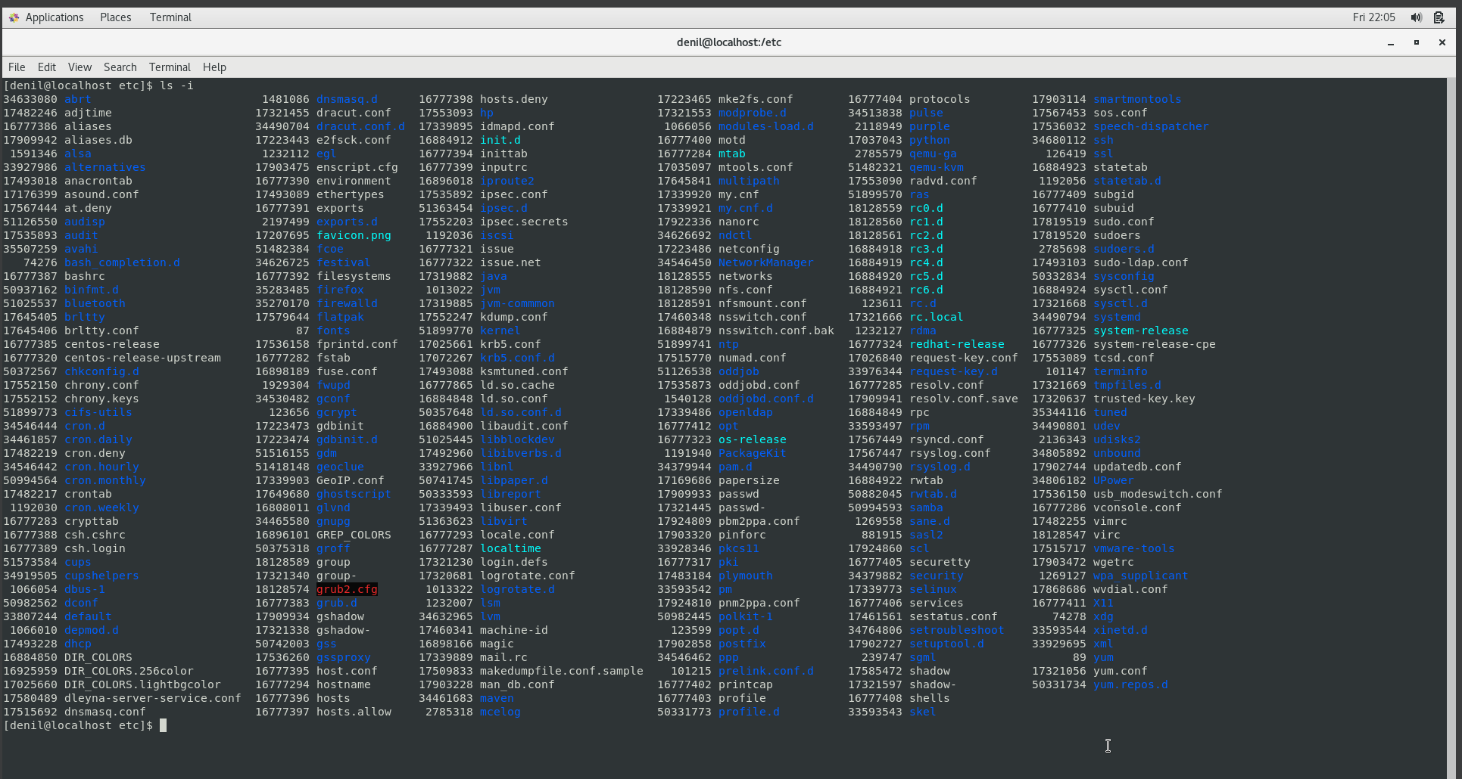

* the -i command seems to list the files along with their inode numbers ( something related to linux file system - used to uniquely identify each file and directory )
* Then use **ls –help** and see other options about **ls** command
  + Explore it and try with other attribute we can use with **ls** command
* **ls -m** for listing all the files as comma separated values

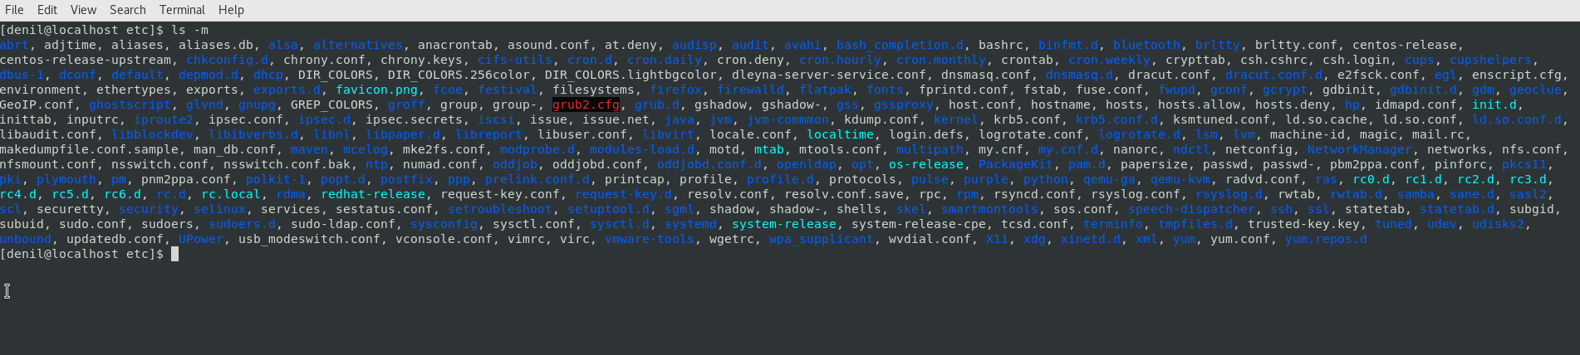

Assignment-5

Know where you are and where you working

*Here we use* ***pwd, cd and ls*** *as combine task to understand where you working on terminal and how you can switch from one directory to another one.*

* Open terminal after restart the linux
  + Check which location you working, type **pwd** and take screenshot

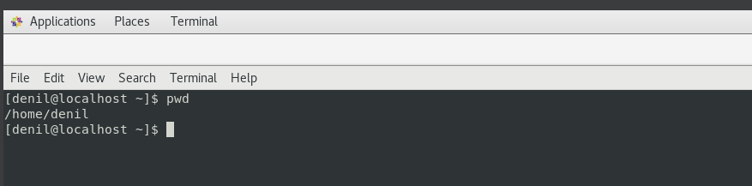

* on terminal restart, I seem to have landed on home directory of current user
* Now use **cd /var** and hit **Enter** key
  + Do **ls,** and see what output comes, give screenshot?

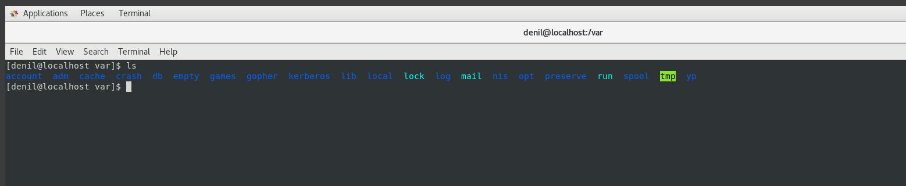

* the /var directory seems to store files of kind whose size might be changing continuously, eg. log files, It also stores queues for some system programs. /var directory also contains temporary files which are need to be accessed across system restart sessions. It can also store the mail inbox of the local user.
* Do explore other help options of each command to learn more other things we can do with these commands