

**Linux Basic Commands Assignment**

***Assignment Part-3***

Playing with files

1. Create a file like **nano file1.txt**

o Edit some data and then save the file

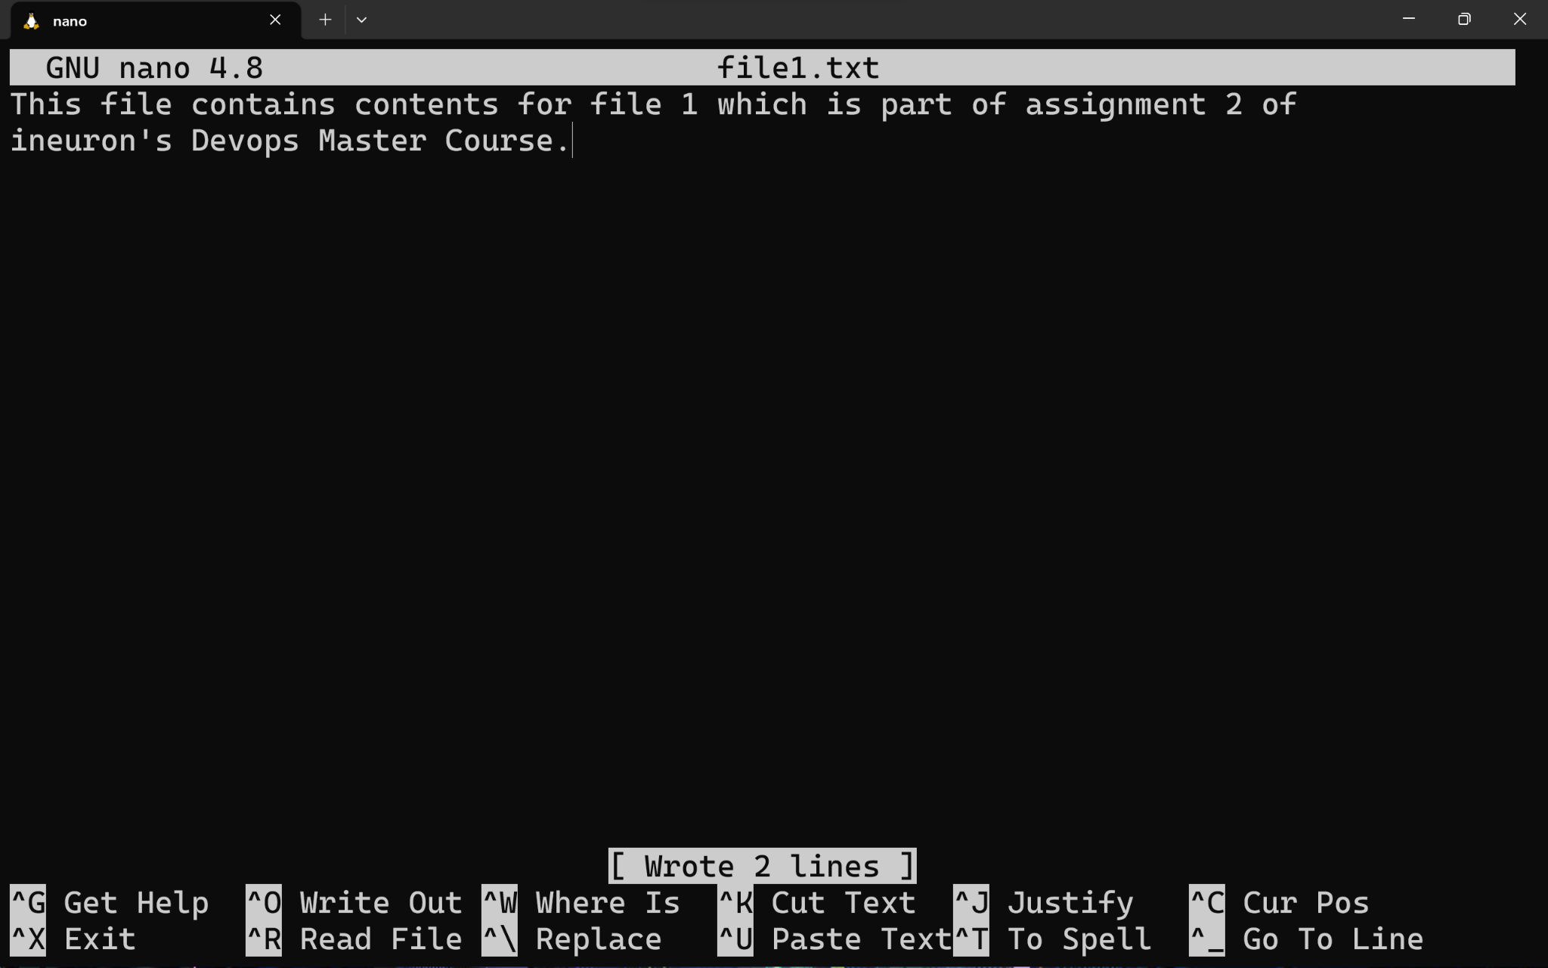

2. Now we will copy date from file1 to new file2

**o cp file1.txt file2.txt**

o Then see the output of file2.txt, **cat file2.txt**

o Give screenshot

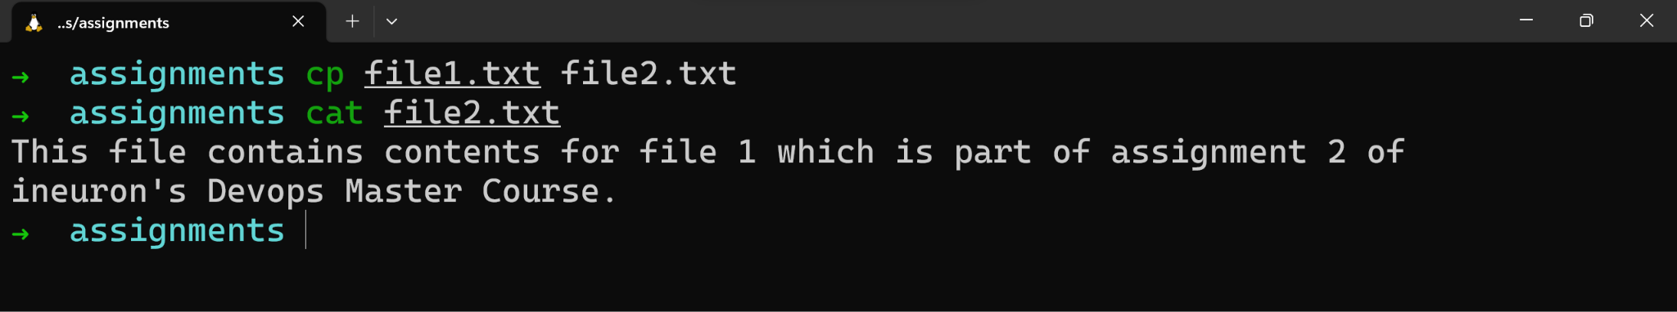

3. Now we will move the file2.txt to new folder **/home**

o **mv file2.txt /home**

o Then go to **home** directory and check **ls,** file exits or not?

* The file wasn’t moved to /home directory since we didn’t have root access while command execution.

o Given screenshot

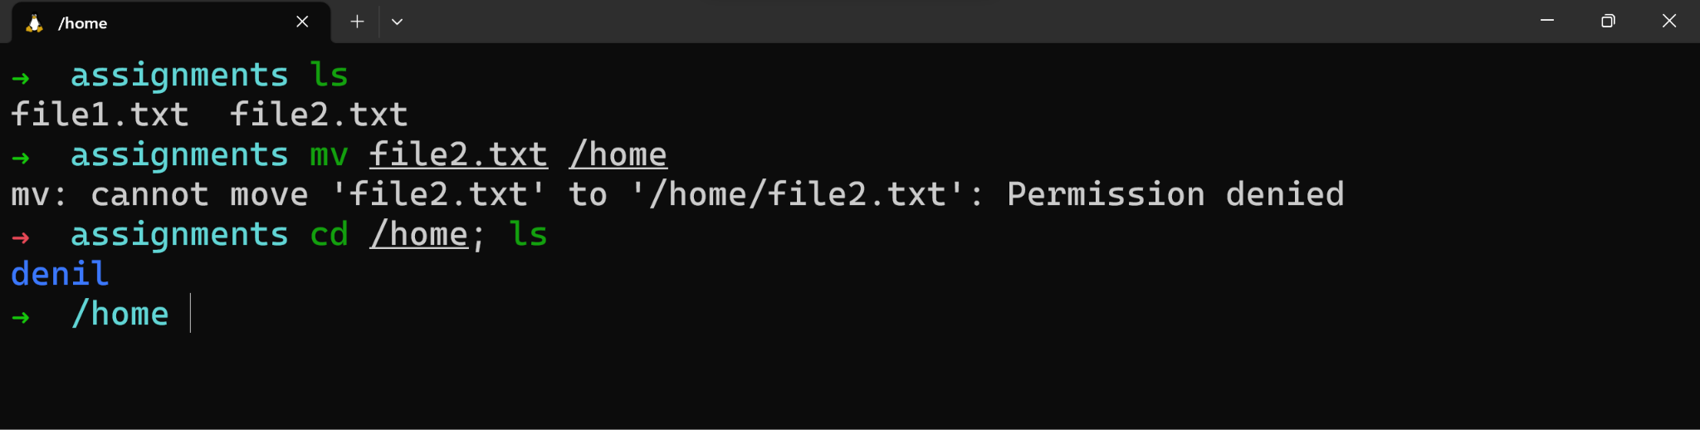

4. Then we create a new **file3.txt and file4.txt** in **home directory** and add content in it.

o Now do **echo “Hello I am newline” > file3.txt** and provide the output of file3.txt

o Now do **echo “Hello I am newline” >> file4.txt** and provide the output of file4.txt

o Tell the different between both step you follow and the reason behind it

* I was still facing permission denied error even while staying in /home directory. I assume this can work only with root (sudo) access.

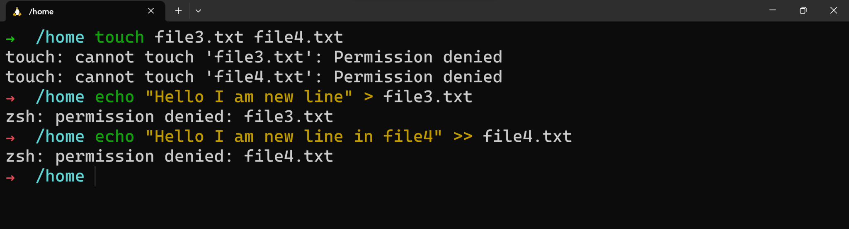

5. For remove a file or directory you can use the below two commands **o** To delete a file – **rm <any_filename>**

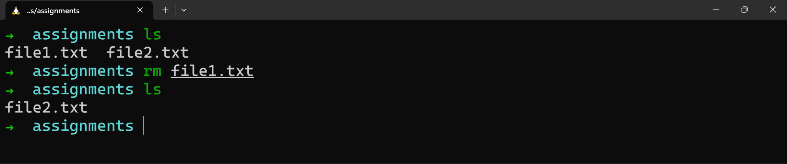

**o**Todeleteadirectory -**rmdir<any_directoryname>**

* Facing some issue to delete using rmdir, I generally use

**rm -rf <dir_name>**



