**TUGAS KELOMPOK BASIS DATA**

**STUDI KASUS SIRIMA**



**KELOMPOK A1**

**FAKULTAS ILMU KOMPUTER**

**DEPOK 29 APRIL 2017**

1. **TAHAP PERTAMA IMPLEMENTASI BASIS DATA SIRIMA (CREATE SCHEMA, TABLE, TRIGGER/STORED PROCEDURE, DAN MENGISI DATA TIAP TABLE)**

* **tabel akun**

CREATE TABLE akun(  
username VARCHAR(50),  
role BOOLEAN NOT NULL,  
password VARCHAR(20) NOT NULL,  
PRIMARY KEY (username)   
);

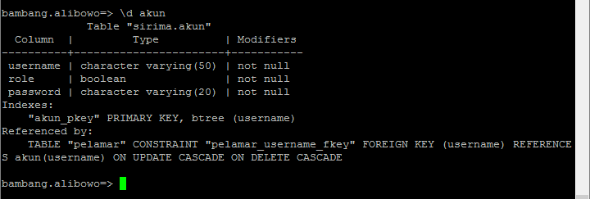

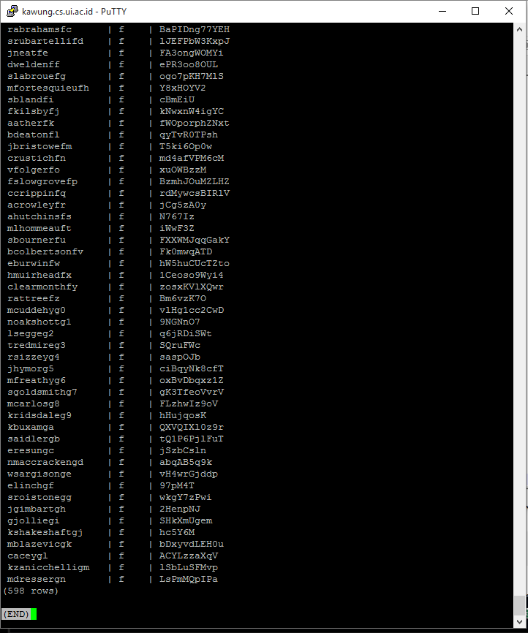

* **tabel periode_penerimaan**

**CREATE TABLE periode_penerimaan(  
nomor SMALLINT UNIQUE,  
tahun CHAR(4)UNIQUE,  
PRIMARY KEY (nomor,tahun)  
);**

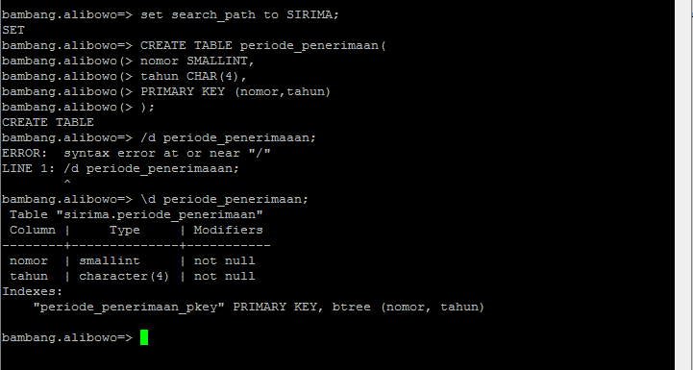

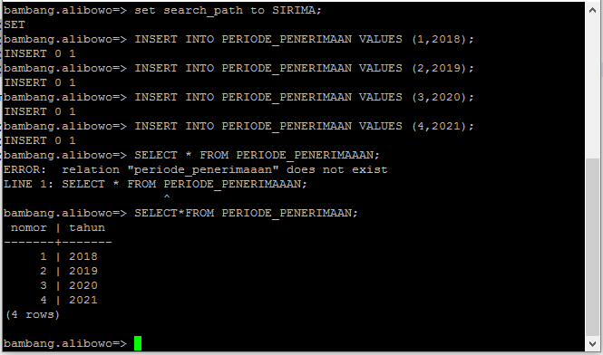

* **tabel jadwal_penting**

**nomor SMALLINT,  
tahun CHAR(4),  
jenjang CHAR(2),  
waktu_mulai TIMESTAMP,  
waktu_selesai TIMESTAMP NOT NULL,  
deskripsi VARCHAR(150) NOT NULL,  
PRIMARY KEY (nomor,tahun,jenjang,waktu_mulai),  
FOREIGN KEY (nomor) REFERENCES periode_penerimaan(nomor) ON UPDATE CASCADE ON DELETE CASCADE,  
FOREIGN KEY (tahun) REFERENCES periode_penerimaan(tahun) ON UPDATE CASCADE ON DELETE CASCADE,  
FOREIGN KEY (jenjang) REFERENCES jenjang(nama) ON UPDATE CASCADE ON DELETE CASCADE  
);**

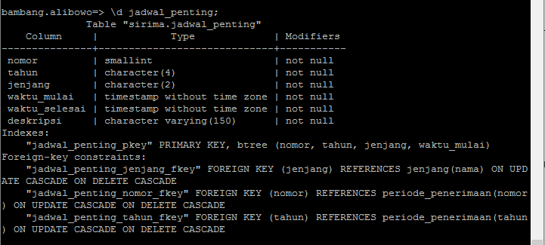

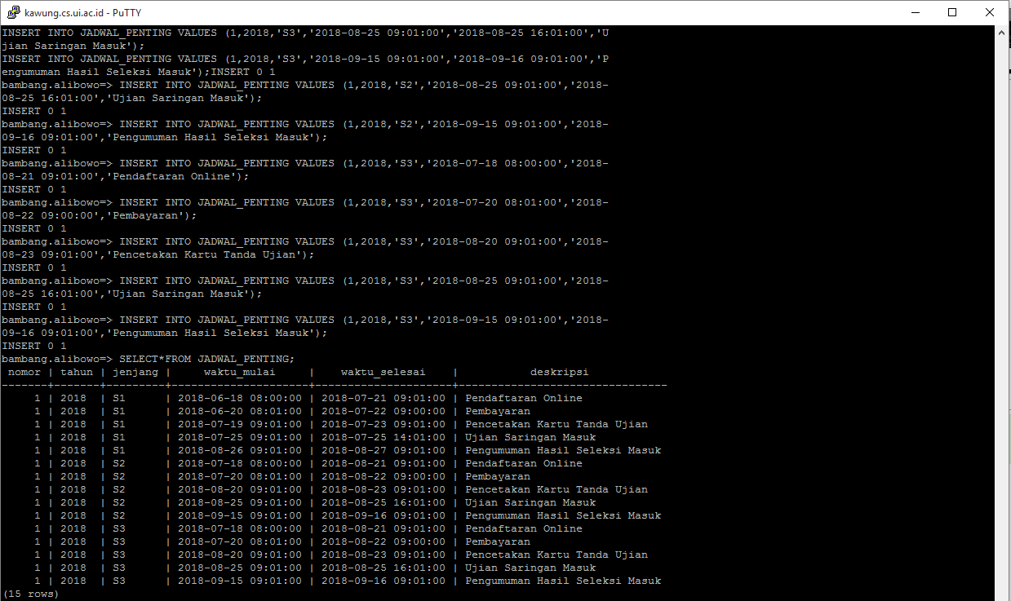

* **tabel jenjang**

**CREATE TABLE jenjang(  
nama CHAR(2),  
PRIMARY KEY (nama)  
);**

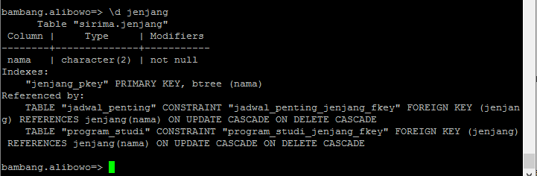

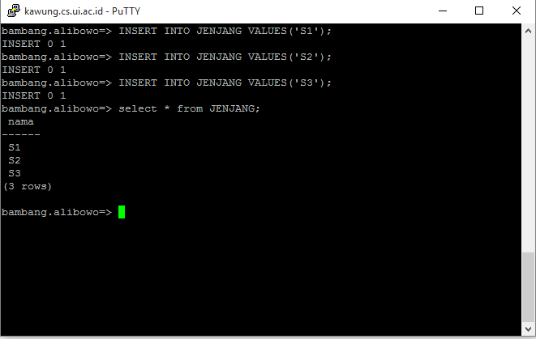

* **tabel program_studi**

**CREATE TABLE program_studi(  
kode SERIAL,  
nama VARCHAR(100) NOT NULL,  
jenis_kelas VARCHAR(50) NOT NULL,  
nama_fakultas VARCHAR(50) NOT NULL,  
jenjang CHAR(2) NOT NULL,  
PRIMARY KEY (kode),  
FOREIGN KEY (jenjang) REFERENCES jenjang(nama) ON UPDATE CASCADE ON DELETE CASCADE  
);**

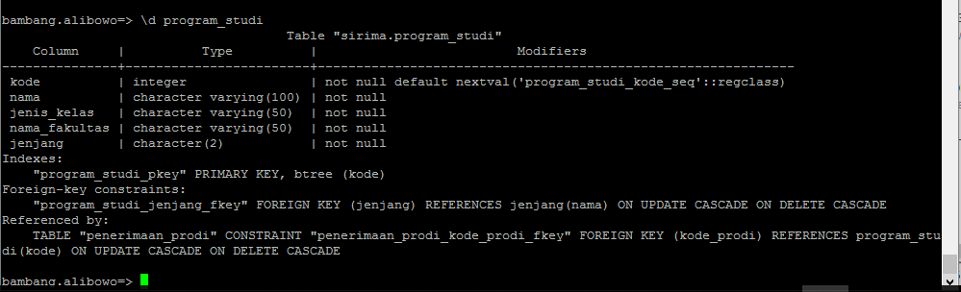

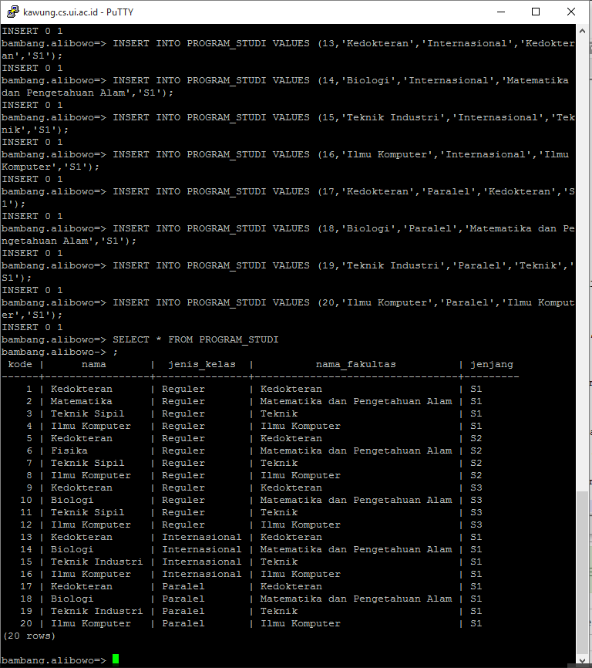

* **tabel penerimaan_prodi**

**CREATE TABLE penerimaan_prodi(  
nomor_periode INT,  
tahun_periode CHAR(4),  
kode_prodi INT,  
kuota INT NOT NULL,  
jumlah_pelamar INT,  
jumlah_penerima INT,  
PRIMARY KEY (nomor_periode,tahun_periode,kode_prodi),  
FOREIGN KEY (nomor_periode) REFERENCES periode_penerimaan(nomor) ON UPDATE CASCADE ON DELETE CASCADE,  
FOREIGN KEY (tahun_periode) REFERENCES periode_penerimaan(tahun) ON UPDATE CASCADE ON DELETE CASCADE,  
FOREIGN KEY (kode_prodi) REFERENCES program_studi(kode) ON UPDATE CASCADE ON DELETE CASCADE  
);**

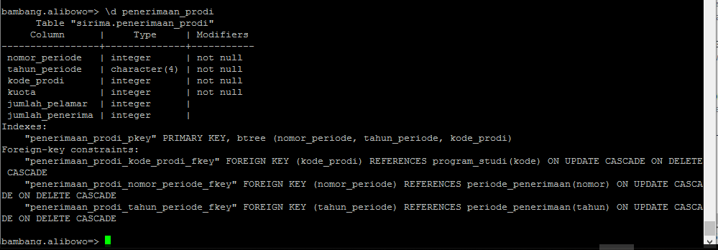

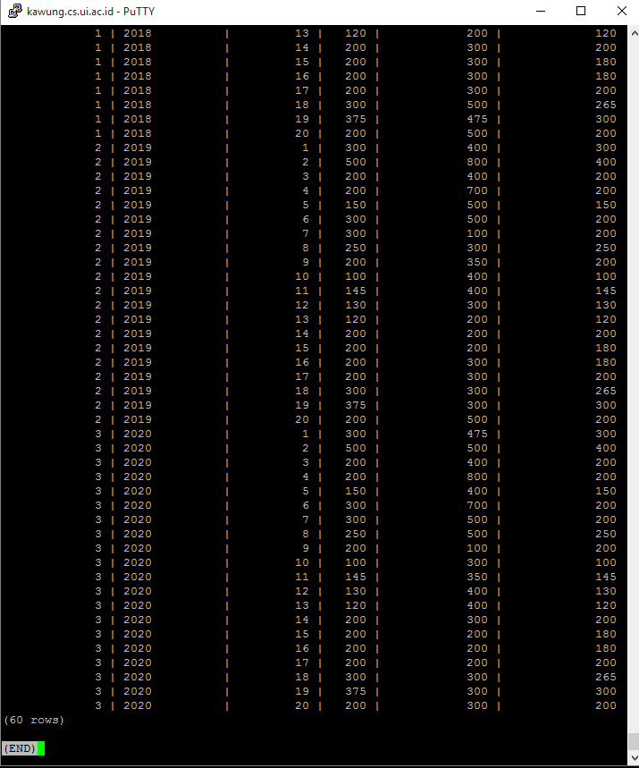

* **tabel pelamar**

**CREATE TABLE pelamar(  
username VARCHAR(50),  
nama_lengkap VARCHAR(100) NOT NULL,  
alamat TEXT NOT NULL,  
jenis_kelamin CHAR(1) NOT NULL,  
tanggal_lahir DATE NOT NULL,  
no_ktp CHAR(16) NOT NULL,  
email VARCHAR(100) UNIQUE NOT NULL,  
PRIMARY KEY (username),  
FOREIGN KEY (username) REFERENCES akun(username) ON UPDATE CASCADE ON DELETE CASCADE  
);**

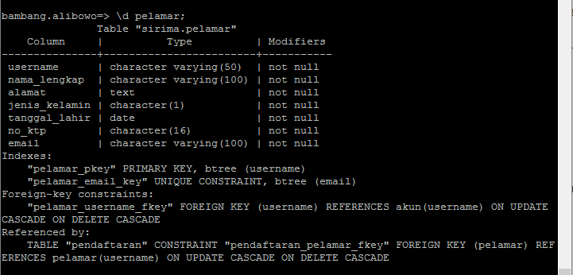

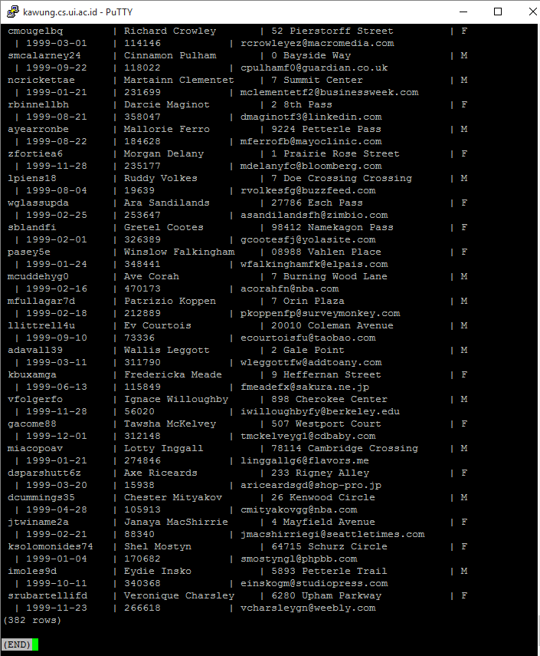

* **tabel pendaftaran**

**CREATE TABLE pendaftaran(  
id SERIAL,  
status_lulus BOOLEAN DEFAULT FALSE NOT NULL,  
status_verifikasi BOOLEAN DEFAULT FALSE NOT NULL,  
npm CHAR(10),  
pelamar VARCHAR(50) NOT NULL,  
nomor_periode SMALLINT NOT NULL,  
tahun_periode CHAR(4) NOT NULL,  
PRIMARY KEY (id),  
FOREIGN KEY (pelamar) REFERENCES pelamar(username) ON UPDATE CASCADE ON DELETE CASCADE,  
FOREIGN KEY (nomor_periode) REFERENCES periode_penerimaan(nomor) ON UPDATE CASCADE ON DELETE CASCADE,  
FOREIGN KEY (tahun_periode) REFERENCES periode_penerimaan(tahun) ON UPDATE CASCADE ON DELETE CASCADE  
);**

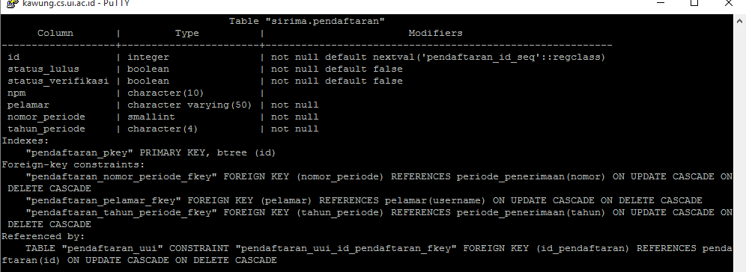

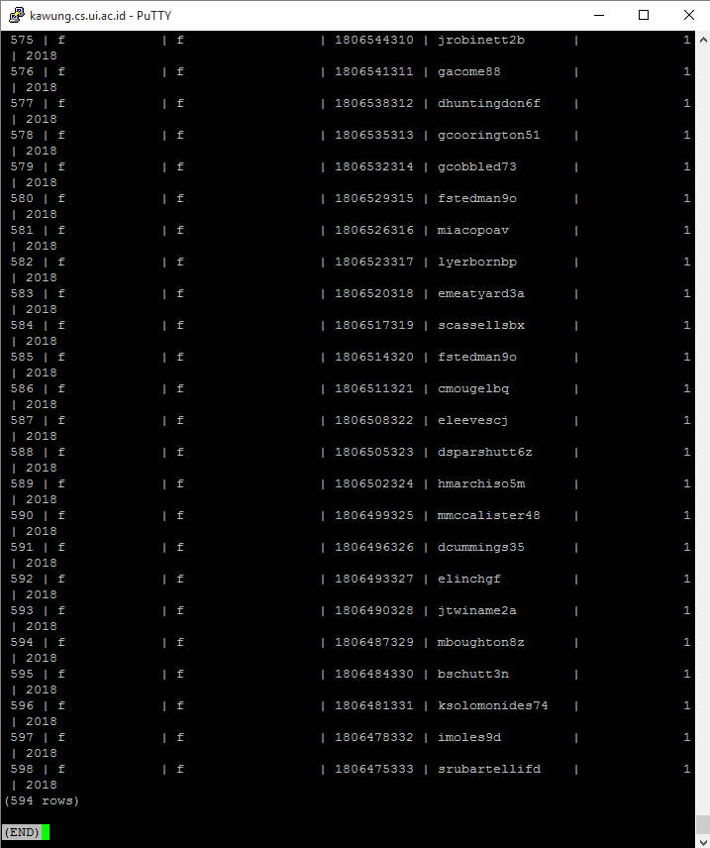

* **tabel pendaftaran_UUI**

**CREATE TABLE pendaftaran_uui(  
id_pendaftaran INT,  
rapot VARCHAR(100) NOT NULL,  
surat_rekomendasi VARCHAR(100) NOT NULL,  
asal_sekolah VARCHAR(100) NOT NULL,  
jenis_sma VARCHAR(50) NOT NULL,  
alamat_sekolah TEXT NOT NULL,  
nisn VARCHAR(10) NOT NULL,  
tgl_lulus DATE NOT NULL,  
nilai_uan NUMERIC(10,2) NOT NULL,  
PRIMARY KEY (id_pendaftaran),  
FOREIGN KEY (id_pendaftaran) REFERENCES pendaftaran(id) ON UPDATE CASCADE ON DELETE CASCADE  
);**

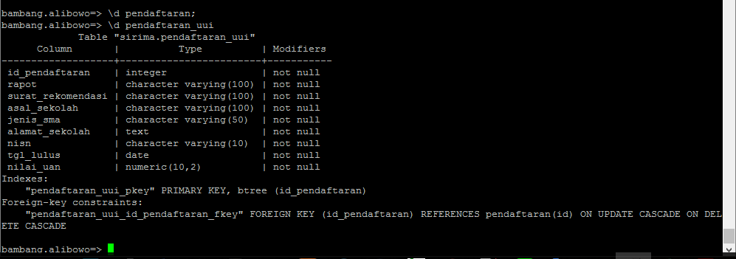

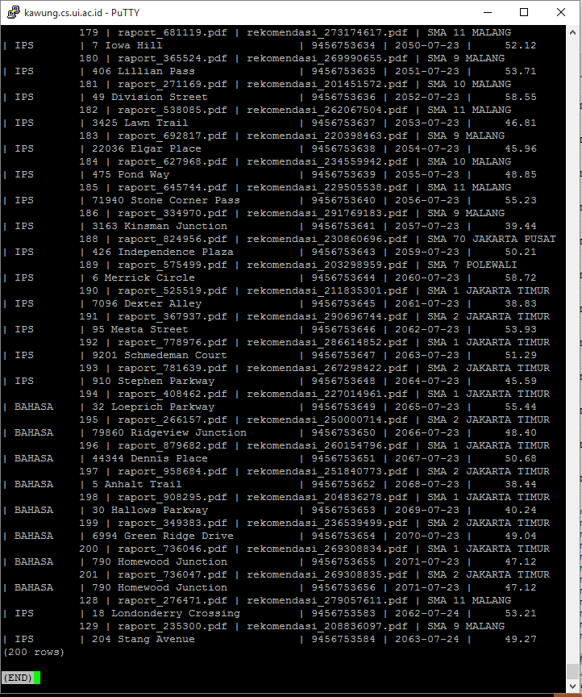

* **tabel rekomendasi**

**CREATE TABLE rekomendasi(  
 tgl_review DATE,  
 id_pendaftaran INT,  
 status BOOLEAN NOT NULL,  
 nilai INT NOT NULL,  
 komentar TEXT NOT NULL,  
 PRIMARY KEY (tgl_review,id_pendaftaran),  
 FOREIGN KEY (id_pendaftaran) REFERENCES pendaftaran_uui(id_pendaftaran) ON UPDATE CASCADE ON DELETE CASCADE  
);**



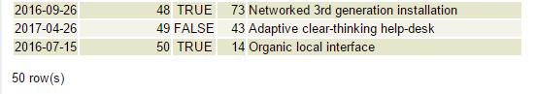

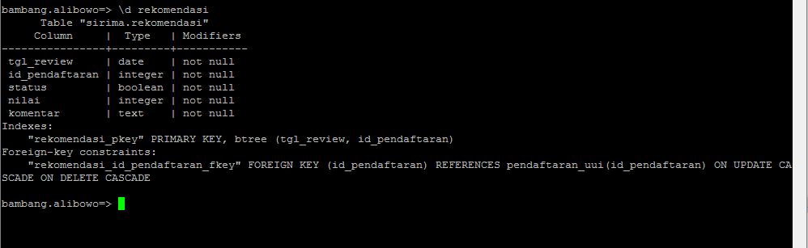

**- tabel pendaftaran_semas**

**CREATE TABLE pendaftaran_semas(  
 id_pendaftaran INT,  
 status_hadir BOOLEAN NOT NULL,  
 nilai_ujian INT NOT NULL,  
 no_kartu_ujian CHAR(10) NOT NULL,  
 lokasi_kota VARCHAR(100) NOT NULL,  
 lokasi_tempat VARCHAR(150) NOT NULL,  
 PRIMARY KEY (id_pendaftaran),  
 FOREIGN KEY (id_pendaftaran) REFERENCES pendaftaran(id) ON UPDATE CASCADE ON DELETE CASCADE,  
 FOREIGN KEY (lokasi_kota) REFERENCES lokasi_ujian(kota) ON UPDATE CASCADE ON DELETE CASCADE,  
 FOREIGN KEY (lokasi_tempat) REFERENCES lokasi_ujian (tempat) ON UPDATE CASCADE ON DELETE CASCADE  
);**



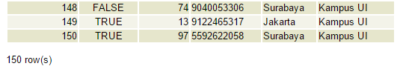

**- tabel pendaftaran_semas_sarjana**

**CREATE TABLE pendaftaran_semas_sarjana(  
 id_pendaftaran INT,  
 asal_sekolah VARCHAR(100) NOT NULL,  
 jenis_sma VARCHAR(50) NOT NULL,  
 alamat_sekolah TEXT NOT NULL,  
 nisn VARCHAR(10) NOT NULL,  
 tgl_lulus DATE NOT NULL,  
 nilai_uan NUMERIC(10,2) NOT NULL,  
 PRIMARY KEY (id_pendaftaran),  
 FOREIGN KEY (id_pendaftaran) REFERENCES pendaftaran_semas(id_pendaftaran) ON UPDATE CASCADE ON DELETE CASCADE  
);**



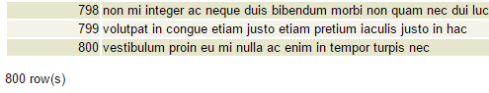

**- tabel pendaftaran_semas_pascasarjana**

**CREATE TABLE pendaftaran_semas_pascasarjana(  
 id_pendaftaran INT,  
 nilai_tpa INT NOT NULL,  
 nilai_toefl INT NOT NULL,  
 jenjang_terakhir CHAR(2) NOT NULL,  
 asal_univ VARCHAR(100) NOT NULL,  
 alamat_univ TEXT NOT NULL,  
 prodi_terakhir VARCHAR(100) NOT NULL,  
 nilai_ipk NUMERIC(10,2) NOT NULL,  
 no_ijazah VARCHAR(50) NOT NULL,  
 tgl_lulus DATE NOT NULL,  
 jenjang CHAR(2) NOT NULL,  
 nama_rekomender VARCHAR(100),  
 prop_penelitian VARCHAR(100),  
 PRIMARY KEY (id_pendaftaran),  
 FOREIGN KEY (id_pendaftaran) REFERENCES pendaftaran_semas(id_pendaftaran) ON UPDATE CASCADE ON DELETE CASCADE,  
 FOREIGN KEY (jenjang_terakhir) REFERENCES jenjang(nama) ON UPDATE CASCADE ON DELETE CASCADE,  
 FOREIGN KEY (jenjang) REFERENCES jenjang(nama) ON UPDATE CASCADE ON DELETE CASCADE  
);**



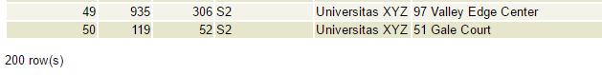

*150 untuk S2, 50 untuk S3

**- tabel pembayaran**

**CREATE TABLE pembayaran(  
 id SERIAL,  
 waktu_bayar TIMESTAMP NOT NULL,  
 jumlah_bayar NUMERIC(10,2) NOT NULL,  
 id_pendaftaran INT NOT NULL,  
 PRIMARY KEY (id),  
 FOREIGN KEY (id_pendaftaran) REFERENCES pendaftaran_semas(id_pendaftaran) ON UPDATE CASCADE ON DELETE CASCADE  
);**



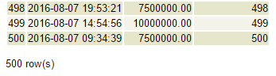

**- tabel lokasi_ujian**

**CREATE TABLE lokasi_ujian(  
 kota VARCHAR(100),  
 tempat VARCHAR(150),  
 nomor_periode SMALLINT NOT NULL,  
 tahun_periode CHAR(4) NOT NULL,  
 jenjang CHAR(2) NOT NULL,  
 waktu_awal TIMESTAMP NOT NULL,  
 PRIMARY KEY (kota,tempat),  
 FOREIGN KEY (nomor_periode) REFERENCES jadwal_penting(nomor) ON UPDATE CASCADE ON DELETE CASCADE,  
 FOREIGN KEY (tahun_periode) REFERENCES jadwal_penting(tahun) ON UPDATE CASCADE ON DELETE CASCADE,  
 FOREIGN KEY (jenjang) REFERENCES jadwal_penting(jenjang) ON UPDATE CASCADE ON DELETE CASCADE,  
 FOREIGN KEY (waktu_awal) REFERENCES jadwal_penting(waktu_mulai) ON UPDATE CASCADE ON DELETE CASCADE  
);**



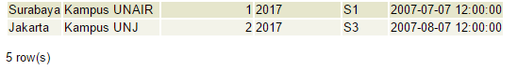

**- tabel ruang_ujian**

**CREATE TABLE ruang_ujian(  
 kota VARCHAR(100),  
 tempat VARCHAR(150),  
 id SMALLINT,  
 PRIMARY KEY (kota,tempat,id),  
 FOREIGN KEY (kota) REFERENCES lokasi_ujian(kota) ON UPDATE CASCADE ON DELETE CASCADE,  
 FOREIGN KEY (tempat) REFERENCES lokasi_ujian(tempat) ON UPDATE CASCADE ON DELETE CASCADE  
);**



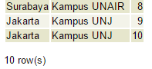

**- tabel pengawas**

**CREATE TABLE pengawas(  
 nomor_induk VARCHAR(16),  
 nama VARCHAR(100) NOT NULL,  
 no_telp TEXT NOT NULL,  
 lokasi_kota VARCHAR(100) NOT NULL,  
 lokasi_tempat VARCHAR(150) NOT NULL,  
 lokasi_id SMALLINT NOT NULL,  
 PRIMARY KEY (nomor_induk),  
 FOREIGN KEY (lokasi_kota) REFERENCES ruang_ujian(kota) ON UPDATE CASCADE ON DELETE CASCADE,  
 FOREIGN KEY (lokasi_tempat) REFERENCES ruang_ujian(tempat) ON UPDATE CASCADE ON DELETE CASCADE,  
 FOREIGN KEY (lokasi_id) REFERENCES ruang_ujian(id) ON UPDATE CASCADE ON DELETE CASCADE  
);**



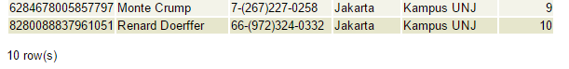

**- tabel pendaftaran_prodi**

**CREATE TABLE pendaftaran_prodi(  
 id_pendaftaran INT,  
 kode_prodi INT,  
 status_lulus BOOLEAN NOT NULL,  
 PRIMARY KEY (id_pendaftaran, kode_prodi),  
 FOREIGN KEY (id_pendaftaran) REFERENCES pendaftaran(id) ON UPDATE CASCADE ON DELETE CASCADE,  
 FOREIGN KEY (kode_prodi) REFERENCES program_studi(kode) ON UPDATE CASCADE ON DELETE CASCADE  
);**



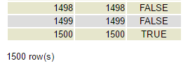

|  |  |  |  |
| --- | --- | --- | --- |
| **NPM** | **Nama** | **Deskripsi Tugas** | **Kontribusi** |
| 1106023133 | Riandy Aditya Putra | DDL create table (9 tabel) | 25% |
| 1206228544 | Bambang Alibowo | Generate data (9 tabel) | 25% |
| 1406557491 | Eros Adisyaputra | Generate data (9 tabel, Rekomendasi-Pendaftaran Prodi), Membuat laporan | 25% |
| 1406571836 | Deni Pramulia | DDL create table (9 tabel) | 25% |