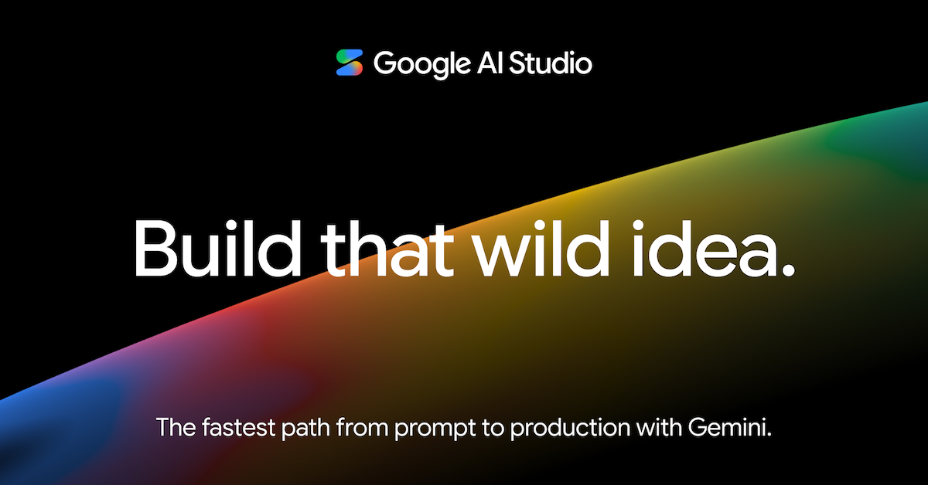

Run and deploy your AI Studio app
This contains everything you need to run your app locally.

View your app in AI Studio: https://ai.studio/apps/a7712d8f-180d-4c60-bf20-991e86d4712c

Run Locally
Prerequisites: Node.js

- Install dependencies: npm install
- Set the GEMINI_API_KEY in .env.local to your Gemini API key
- Run the app: npm run dev

