Denis Draca 11710326

denis.draca@student.uts.edu.au

Robotics 41013

Assignment 1- Sawyer Assembly Task

Contents

Workspace Design (Point A) 2

Task Requirements 2

Risk Assessment (Point B) 5

Use of the Sawyer arm in Manufacturing (Point C) 6

Appropriateness 6

Limitations 6

MATLAB and the Robotics Toolbox (Point D) 6

Precision Required and Robot Control (Point E) 6

Sensing and Grasping Challenges (Point F) 7

Robot Safety (Point G) 8

Reference List 9

Bonus Question (point 2, Gripping the parts) 10

Gripping the Housing Top 10

Gripping the Housing Bottom 10

Gripping the PCB 11

Bonus Question (Point 3) 12

Bonus Question (Point 4) 12

Appendix A – SafeCo SWMS 14

# Workspace Design (Point A)

## Task Requirements

The overall task requirement is to assemble a PCB into its housing. That is, place a PCB into an enclosure and close it off.

The specific task details are as follows:

* Locate box containing the housing tops.
* Derive and move to a joint position that would allow successful grasping of the part.
* Move the arm back to a position that will allow the other arm to place a PCB into the housing without it falling out.
* The second arm should locate the box containing the PCB’s.
* Derive and move to a joint position that would allow successful grasping of the part.
* Move the PCB into the housing top
* Locate the box containing housing bottoms
* Derive and move to a joint position that would allow successful grasping of the part.
* Bring the housing bottom to the join position to close in the PCB and finish the assembly.
* The first arm should place the completed part into a drop off bin.
* PERFORM THE TASKS SAFELY

To accomplish these tasks safely, we here at SafeCo have designed a workspace for the Sawyers to work in:

Firstly, the base. The Sawyer is to sit on the following base during movement and operation. The base will provide stability during operation and ease of manoeuvrability. This is to protect the users back when moving the sawyer from place to place. The Base also features an Estop (pictured) that can be used in emergencies.

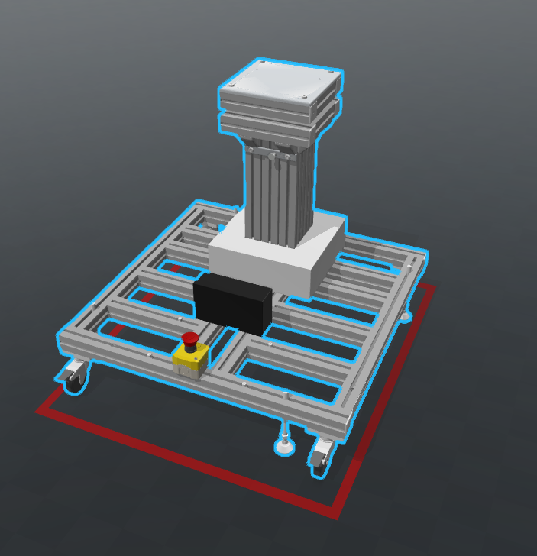

Figure : Sawyer Stand

The sawyers themselves are to be placed in the designated work zone. This work zone consists of a fenced of area that that can only be accessed through a single door. This door is to be integrated with an estop that will be triggered when the door is opened, causing the Sawyers to stop moving. There must also be another safety stop next to the door to add redundancy and allow the users to stop the sawyers while next to the door without opening the door.

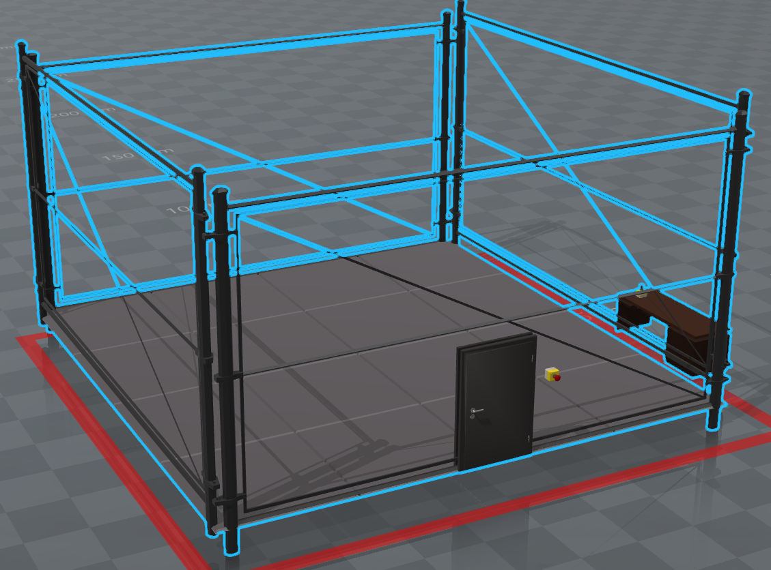

Figure : Sawyer Fenced off area

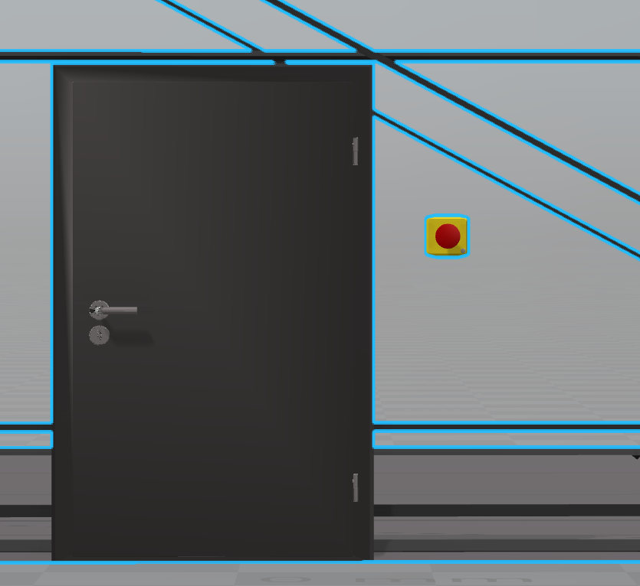

Figure : Safety access door with side by E-Stop

The sawyer control desk is to be placed outside the Sawyer work zone but somewhere with clear sightlines of the robots in action. This will allow the supervisor to make quick decisions.

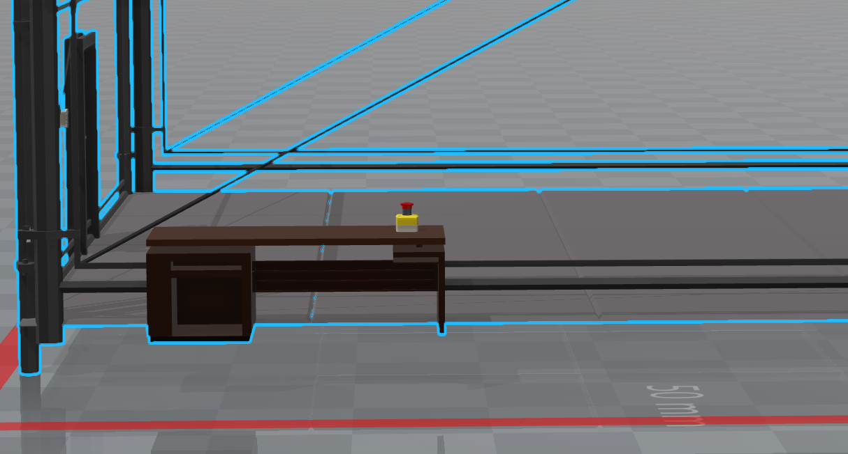

Figure : Sawyer Control Desk with at hand E-stop

The boxes containing the loose parts will be placed on to their own tables, allowing the parts to be at a level the Sawyer can easily reach but allow the parts to be placed anywhere.

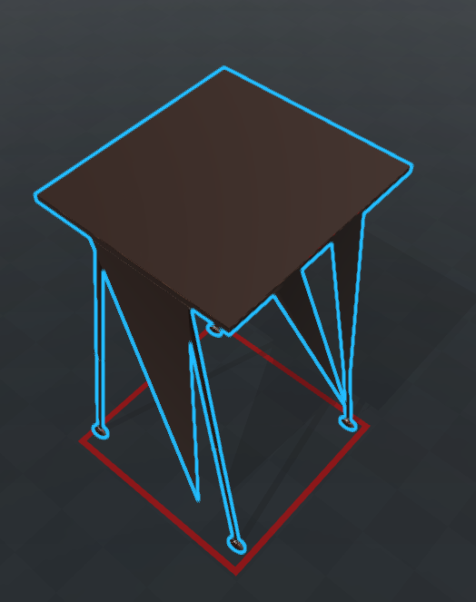

Figure : Table to hold box of parts

The Sawyer and Assembly pieces will be aligned as seen in the pictured below. This aligned allows for the least chance of robot to robot collision as the only time the robots need to be close to each other is when they bring the two parts together. When they go to pick up parts they have to move away from each other to locate and pick up the part allowing for increased robot safety.

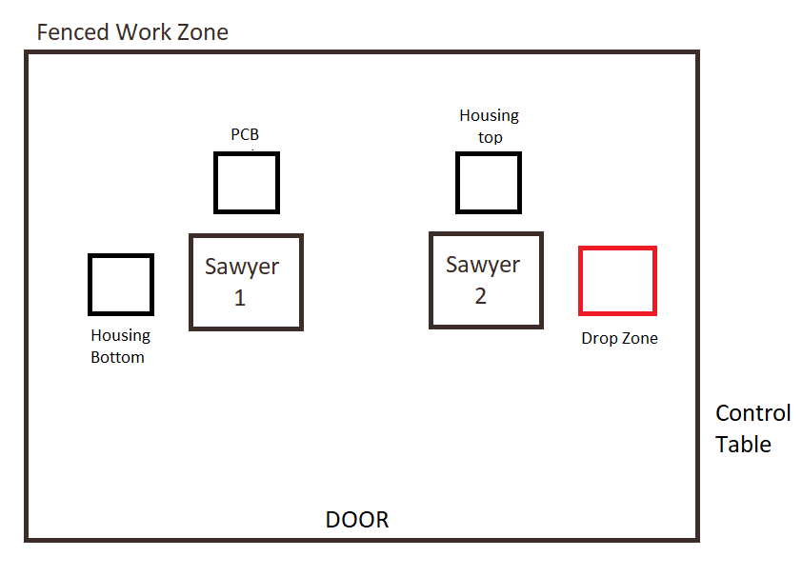

Figure : Work Zone Layout

# Risk Assessment (Point B)

|  |  |  |  |  |  |
| --- | --- | --- | --- | --- | --- |
| Hazard | Consequence | Probability | Severity | Overall Risk | Control |
| Human Robot Collision | Possible injury to person, Possible damage to robot | Med | Med – High | Med | Enable all Sawyer Safety Features. No Person allowed in Sawyer work zone. E-Stops, sawyer must be off when approached |
| Robot-Robot Collision | Possible Damage to Robot | Low | High | Med | Software Checks and bounds on control system. Safe work Zones. Operator with access to quick and eStops. |
| Robot-Environment Collision | Damage to Robot, Environment and assembly parts | Low | High | Med | Software Checks and bounds on control system. Safe work Zones. Operator with access to quick and eStops |
| Part Misalignment | Inadequate part quality | Low | Low | Low | Quality assurance checks at the end to make sure parts were made properly. |

Refer to Appendix A for the safe work statement.

# Use of the Sawyer arm in Manufacturing (Point C)

## Appropriateness

The sawyer arm features a 7DOF arm. This arm allows the Sawyer robot to reach any point within its workspace and at an orientation. This capability allows the Sawyer to be less restrictive in where each of the parts is to be placed and its orientation to those parts. This will also allow the Sawyers to be applied to many other manufacturing operations. For this task, specifically, the parts will be placed loosely in a box. That is, the parts can be at any orientation and transform. The grabbing mechanism will need to be able to compensate to perform this task. That is where the Sawyer arm is the most appropriate.

Another aspect is the Sawyers attention to Safety. The safety of the Sawyer is inherent in its design. The motors have been selected and tuned so that the torques are kept very low. The gear boxes used are very efficient allowing the user to easily push away and overcome the robots power. Finally, the series elastic actuator joint design provides a spring at every joint that can absorb some kinetic impact. (Rethink Robotics 2015, para. 6).

## Limitations

The Sawyer’s joints can be quite elastic meaning that there would a lot of wobble during movements. This results in higher deviation between movements and can lead to high error between expected end effector position and actual position. This can make the Sawyer inappropriate if precision is required. This will also mean that better control of the Sawyers joint states will be needed when joining the PCB with the housing top and bottom parts to allow for this error.

Also, due to the safety aspect of the motors, if the needs of the company change and new production is required. The Sawyer will have a very low payload capability meaning that it won’t be able to be used to do any heavy lifting. That means that the Sawyer will also not be able to lift away the box of completed parts. Another solution will be required for that.

# MATLAB and the Robotics Toolbox (Point D)

Due to the low processing power requirement of the MATLAB is very appropriate for our uses. The mathematical capabilities of MATLAB coupled with the available capabilities of the Robotics toolbox will allow for quick development of a demonstrable working solution. However, the Robotics toolbox has no communication capabilities of talking with the Sawyer itself. A communication protocol that can send messages over ROS will be required to be able to actuate the physical robot. This protocol will need to be able to take in the outputs of the robotics toolbox and covert it to a ROS message.

# Precision Required and Robot Control (Point E)

Given the nature of the parts that we will be assembling. The precision required to pick up the parts will not need to be highly precise. Just generally moving the end effector to have the same pose as the part that is being picked up then closing the gripper to securely pick up the part will be enough. What will be important is the gripper not damaging the part as it closes to pick up the part and the two parts joining together. The PCB fits snuggly into the housing, meaning there isn’t much wiggle room. This coupled with the springiness of the motors means that joining the parts together might be more difficult. As such, the control of the system will be to slow the process down as the end point is approached. That way the springiness of the motor joints can be decreases allowing for more accurate movement.

# Sensing and Grasping Challenges (Point F)

* **Localising the parts –** We have a box of loose parts, that is, we do not know the transform of any part at all. We have the location of the box and the dimensions of the box, this location can be hard coded into control software but it would mean that the box must be in the right spot. It won’t be able to find the box on its own. Even though we know the position of the box the parts inside are still a mystery, we need to be able to look inside the box, possible using an eye in hand type system or a camera facing down above each of the boxes. This way we may be able to find the location of the part without just randomly placing the gripper into the box and hoping we caught something.
* **Gripping the part –** Due to the capabilities of the gripper and the parts themselves, you cannot grab the part from any position. For example, grabbing the part in a way that blocks the slot that the PCB would sit in would make the assembly impossible. Or gripping the PCB in a position that might cause damages would also be unacceptable. This is where accurate localisation of the part would be vital. Knowing the exact location and orientation of the part along with allowable gripping positions would allow better path planning to avoid the box, the other parts and manoeuvre into a position that allows the gripper to pick up the part. There may even need to be decision making processes involved, if there is no way to pick up the part in a way that would make assembly possible it would need to flip the part and then grab it.
* **Safe Gripping –** Once it has gripped the part it needs to know if it has safely gripped the part. Is it applying enough force to hold the part but not so much that it breaks the part. It also needs to know if the part has slipped from its grip so that it doesn’t ruin the assembly process. Finally, when it places the part down, how has it placed it? Did it just drop the part into a box, will that break the part, is that the optimal way to place it? More likely it will need to neatly stack the part. That means working out the best way to place the part down.

# Robot Safety (Point G)

Firstly, self-collision. This involves collision with itself and the other robot in its workspace. The Sawyer arms need to have a good grasp of where each other’s arms and their own will be in the environment that they share. They decision making process for the required joint trajectories will need to take these into consideration and plan accordingly. Another method would be to set working zones, that is, hard coded safe boxes around the robot where the robot can move freely within that environment but move outside of it. However, there will be significant challenges mating the compounds as this is where possible collision is most likely. Safe and slow movements will need to be considered to mate the two parts without collision. If this isn’t considered, then the safety of the robots themselves is compromised and the robots may be damaged during operation.

Another aspect is the collision with the environment, once again, as the arm is moving around it may collide with a physical object in the environment. This could cause damage to both the robot and the environment itself. Once again this could be solved by outlining safe working zones that the robot can move freely in and only should move carefully and slowly when grasping a part. As this is the situation that is most likely to cause a collision with the environment. At the same time, this will make the environment very static others its dangerous. Using an array of sensors to calculate the location of objects will allow for a more dynamic environment but more difficult engineering and slower production.

Finally, human safety. The robots may collide with humans if they can walk amongst the robot as they work. Due to the fast and hard to predict movements of humans it will be safer for now to not allow the robots to operate while a person is within their environment. That is why the robot must be safely stopped prior to a person entering. This can be done through a software stop prior but there will be an E-Stop wired into the door that would cause the robots to stop moving if the door is opened. There will also be other E-stops in easy to reach locations as redundancy.

# Reference List

SafeWork NSW n.d, *Safe work method Statements,* viewed 23 August 2017,   
< http://www.safework.nsw.gov.au/health-and-safety/safety-topics-a-z/formwork/accordians/safe-work-method-statements >

Justdoit 2013, *Fence-3d Model,* viewed 10 August 2017, <https://free3d.com/3d-model/fence-43609.html>

Drop23 2016, *Simple Door 3d Model,* viewed 12 August 2017, < https://free3d.com/3d-model/simple-door-20277.html>

Mmnkl9 2013, *Modern Desk 3d Model,* viewed 12 August 2017, < https://free3d.com/3d-model/modern-desk-34387.html>

Duality 2017, *Ikea Desk THYGE 3d Model,* viewed 12 August 2017, < https://free3d.com/3d-model/ikea-desk-thyge-85093.html>

Gatineau 2017, *Marble floor 3d Model,* viewed 13 August 2017, < https://free3d.com/3d-model/marble-floor--32415.html>

Hafiz 2012, *Emergency Button,* viewed 13 August 2017, < https://grabcad.com/library/emergency-button>

Rethink Robotics 2015, *Safety,* viewed 23 August 2017,   
< http://mfg.rethinkrobotics.com/wiki/Safety>

# Bonus Question (point 2, Gripping the parts)

## Gripping the Housing Top

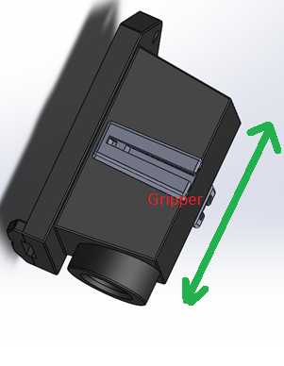

Sawyer Arm

For the housing top, the only appropriate location to grip from is the bottom of the part (As seen in the above image). This is to keep the gripper from interfering with the opening of the part (where the PCB sits in). If we grip from the other side, then the gripper will block the PCB from fitting into the slot. If we grip the part long ways, then we go beyond the grippers make size limitation. However, you can slide along the long ways axis (Green arrow). Gripping anywhere along the green arrow will allow for a successful grip.

## Gripping the Housing Bottom

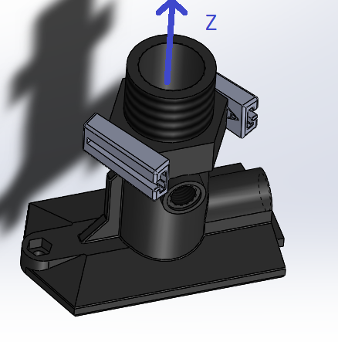

Sawyer Arm

Sawyer Arm

This part is more complex than the Top part. These means that it will be more difficult for the gripper itself to pick up. However, in the above picture we see a likely location to grip. The Hexagonal nut section gives a nice gripping location that can be accessed from either end by the Sawyer arm. This will stop the end effector or the sawyer itself affecting the ability of the parts to be mated together as they won’t be covering the mating faces. The part can also be rotated one step positively along its ‘z’ axis and still constitute a safe grip. Going more than that or a negative rotation will get the gripper to sit on a more complex part, leading to an unsafe grip.

## Gripping the PCB

The PCB will be considerably more difficult to pick up. This is due to the PCB needing to go inside the housing top but the gripper cannot fit inside the housing top while holding the PCB. We also do not know what electronics are on the PCB so we cannot assume if it is safe to grip anywhere on the front or back face of the PCB. As such we will need to employ a grip like in the following:

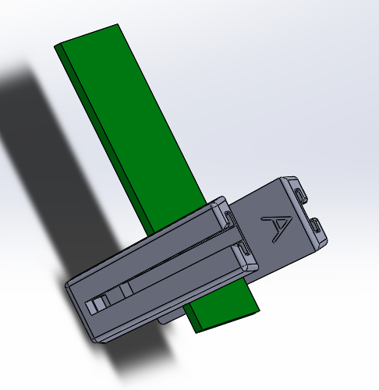

Sawyer Arm

Sawyer Arm

Since we do not know which face is ‘up’ we can assume that the gripper can come in from either side. The reason the gripper needs to grip on one end of the PCB is so that it can employ the following manoeuvre.

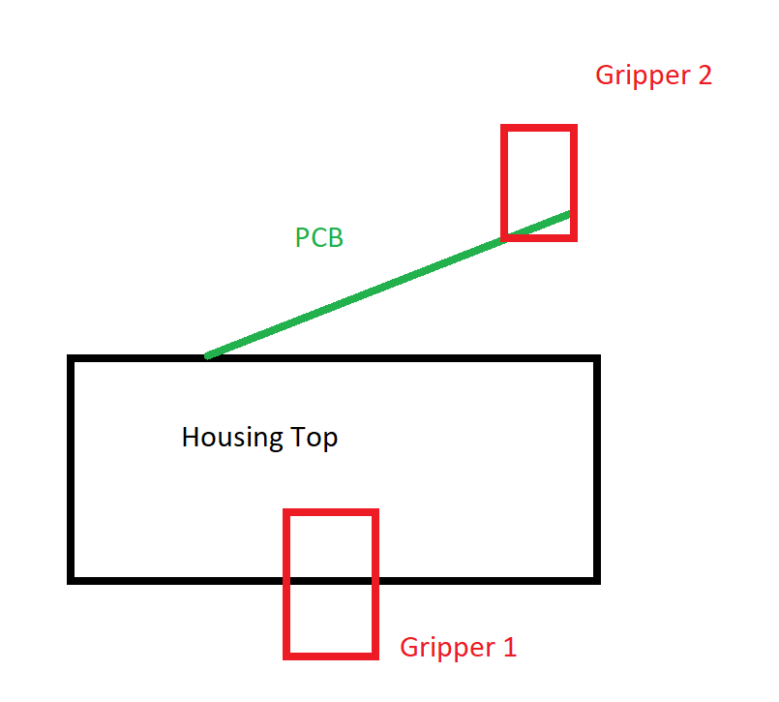

This manoeuvre will allow the PCB be to slid into the housing top without the gripper needing to go into the housing either. It also stops us from needing to drop the PCB into there reducing the chances of shock damage to the PCB.

# Bonus Question (Point 3)



The optimal base location is as seen at the top. It employs safe working practices as the Sawyers move away from each other when gripping. They can move simultaneously without worry of hitting each other when going to pick up parts which will increase the rate of production.

The optimal way to code for these pick-up parts will be the ‘teach’ method that the Sawyers already have. This would be essentially to hard code a path that will pick up the objects. This will give optimal production rate in the long term as the arms will not need to calculate a trajectory each time (processing intensive). This is the fastest and safest way of going about this task.

# Bonus Question (Point 4)

After going through the profile tools to determine the worst offenders for making the execution of the software perform very slowly I found the following to be the worst offenders. I will least likely solutions along with the offender:

1. **Ply Read –** This was by far the slowest process running on my system. Where it could vary from 30 seconds to over a minute depending on which part I was loading or which computer it was being done. However, this would slowly down operation (to a point), it mainly affected the start-up time. There are several solutions for this:
   1. Currently the Sawyer class is self-contained. It deals with the part loading and control of the robot. However, this means that the same part file needs to be loaded with each generated Sawyer. There are many solutions to this, Load the ply file once and pass it into the Sawyer class. This would get the Sawyer class to give up this control but cause the start up to be much quicker as it would only need to load once. Design the class so that it is a static member that is shared across multiple generated sawyer objects. Only the first Sawyer would need to load the model, the rest would just use the same one.
   2. Another solution is to use compressed models. Compressing the models would leave less vertices leading to faster load times.
2. **Part Animation –** Having to redraw each mesh is intensive and we only use the CPU to perform this task. Along with that, we use just a single thread. Some hard acceleration would be needed to speed this up. By Spawning more threads to deal with the tasks, or even employing the graphics card to do something, we could considerably speed up the animations.
3. **Joint state planning –** Currently the joint state path planning function is calculated with each movement of the arm. However, during production the arms would essentially repeat the same movements multiple times. The joint states should be calculated only at the very beginning then just repeated with each part that gets made. That or just hard code the path, either way the process would be much faster.
4. **Logging –** This one is noticeable visually as well, when writing to a file is off, the animations are smooth, when logging is on, the animations stutter and lag and the entire execution of the code slows down. As it currently logs each transform, it has a lot to do. By limiting how often it logs, or to log only during errors, it would still give valuable feedback without overloading the process.

# Appendix A – SafeCo SWMS

|  |  |  |  |  |  |  |  |  |
| --- | --- | --- | --- | --- | --- | --- | --- | --- |
| **NOTE:** Work must be performed in accordance with this SWMS.  This SWMS must be kept and be available for inspection until the high risk construction work to which this SWMS relates is completed.  If the SWMS is revised, all versions should be kept.  If a notifiable incident occurs in relation to the high risk construction work in this SWMS, the SWMS must be kept for at least 2 years from the date of the notifiable incident. | | | | | | | | |
| **SafeCo** | | | | **Principal Contractor (PC)** | | SafeCo | | |
| **Works Manager:**  **Contact phone:** | 5555555 | | | **Date SWMS provided to PC:** | | 23/08/17 | | |
| **Work activity:** | Interaction With Sawyer Robotic Arm | | | **Workplace location:** | | SafeCo Workplace | | |
| **High risk construction work:** | Possible Injury to person due to moving Robotic Arms | | Possible injury due to improper handling of the sawyer arm | | | |  | |
|  | |  | | | |  | |
|  | |  | | | |  | |
|  | |  | | | |  | |
|  | |  | | | |  | |
|  | |  | | | |  | |
| **Person responsible for ensuring compliance with SWMS:** | | SafeCo Manager | | | **Date SWMS received:** | | | 23/08/2017 |
| **What measures are in place to ensure compliance with the SWMS?** | | **Easily Seen Compliance Signs. Warning Symbols. Training.** | | | | | | |
| **Person responsible for reviewing SWMS control measures:** | | SafeCo Manager 2 | | | **Date SWMS received by reviewer:** | | | 23/08/2017 |
| **How will the SWMS control measures be reviewed?** | | Montly review with safety manger | | | | | | |
| **Review date:** | | 23/08/17 | | | **Reviewer’s signature:** | | |  |

|  |  |  |
| --- | --- | --- |
| **What are the tasks involved?** | **What are the hazards and risks?** | **What are the control measures?** |
| List the work tasks in a logical order. | Identify the hazards and risks that may cause harm to workers or the public. | Describe what will be done to control the risk. What will you do to make the activity as safe as possible? |
| **Approaching the Sawyer during operation.** | Impact with user with the moving sawyer robotic Arm. | Clearly outlined and guarded area. Wired E-stop to force stop the movement of the sawyer arm.  The user is exercise caution and only approach the sawyer after making sure that the sawyer has indeed stopped moving. |
| **Moving the sawyer arm around manually** | Injury to person as the sawyer is quite heavy. Repetitive task injury possibility. | The sawyer is to sit on its provided moving base. Allowing user to simply push the base. If the sawyer must be lifted for any reason. The job is to be done by 2 people. |

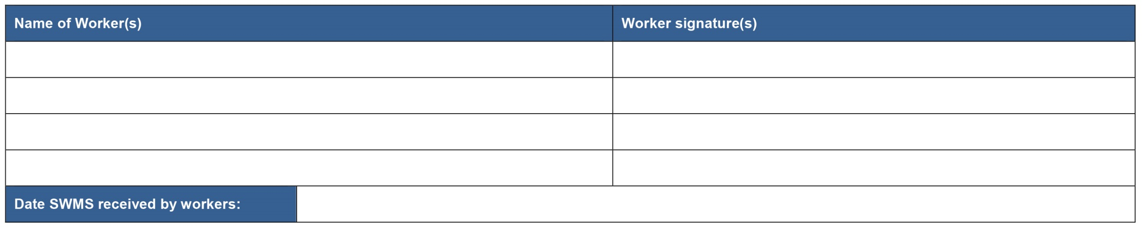PLEASE NOTE: THE TRIAL PERIOD FOR THIS DOCUMENT HAS CONCLUDED AND IS NOW BEING REVIEWED. THE CONTROLS ARE INDICATIVE ONLY AND WILL CHANGE IN ACCORDANCE WITH SITE CONDITIONS.