WiFi Mesh Simulator
User Manual

Contents
Contents 2
Graphical User interface 3
Command line interface 10
Command line format: 10
Parameters explanation: 10
Example: 10
File formats 11
Configuration file format 11
Explanations: 11
Example of a legal configuration file: 12
Path Loss File Format 12
Explanations: 12
Example of a legal path loss file: 13
Appendix 14
Figures table 14

Graphical User interface
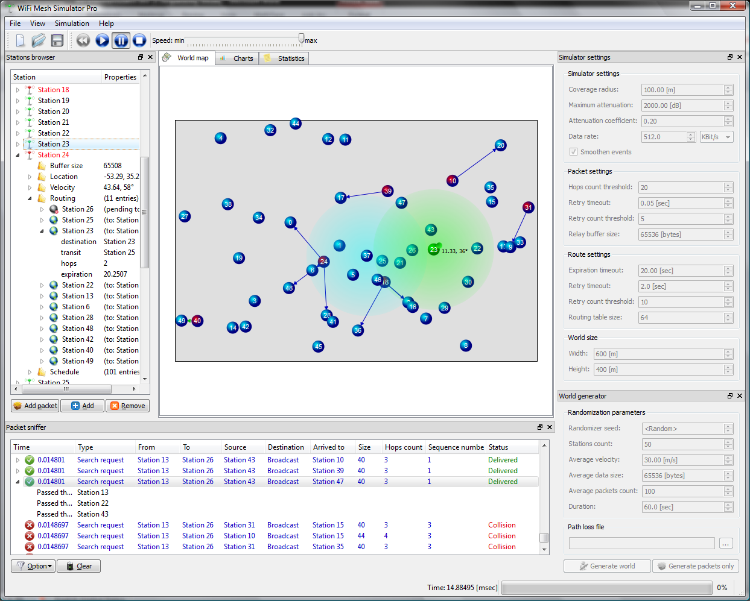
Figure 1: Entire view
The graphical user interface consists of the following major elements:
- Tool bar – provides a quick access to such functions as new document creation, file opening, file saving and simulation running controls
- Stations browser – provides textual way for stations tracking, showing detailed properties (free buffer size, location vector, velocity vector, routing table and scheduler):
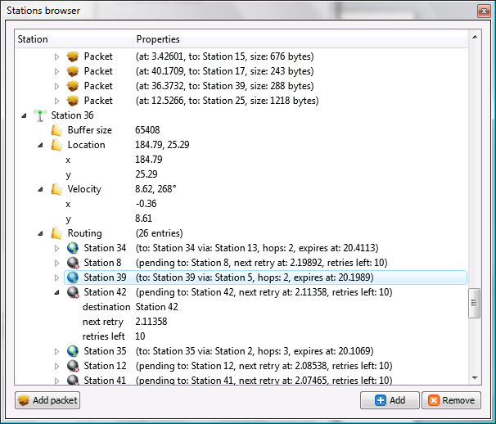
Figure 2: Stations browser
- World map – provides visual “world” view, where each station is represented by a numbered sphere. Focused or hovered sphere is being highlighted with coverage range, allowing seeing all stations which have direct connection with the selected one. During simulation the user may see currently transmitting stations, which are marked by red gradient. Arrows show transmitting and receiving stations, while arrow color corresponds to packet type. Focused station has a “green satellite”, which is connected to a station with an arrow – it represents a velocity vector:
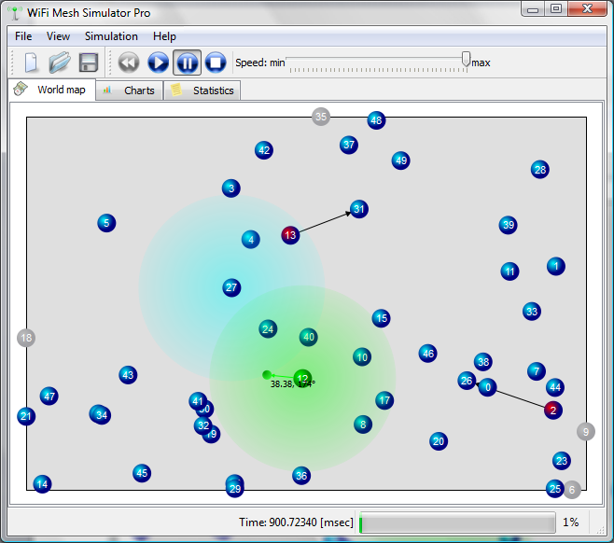
Figure 3: World map view
- Charts view – provides charts, based on collected statistics:
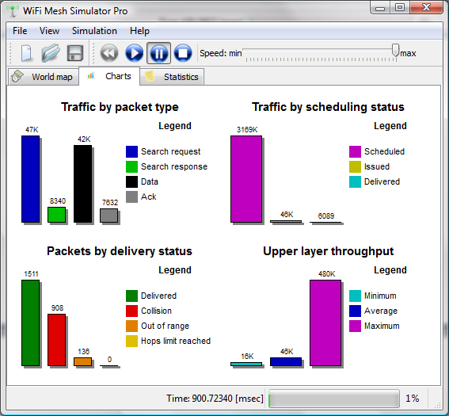
Figure 4: Charts view
- Statistics view:
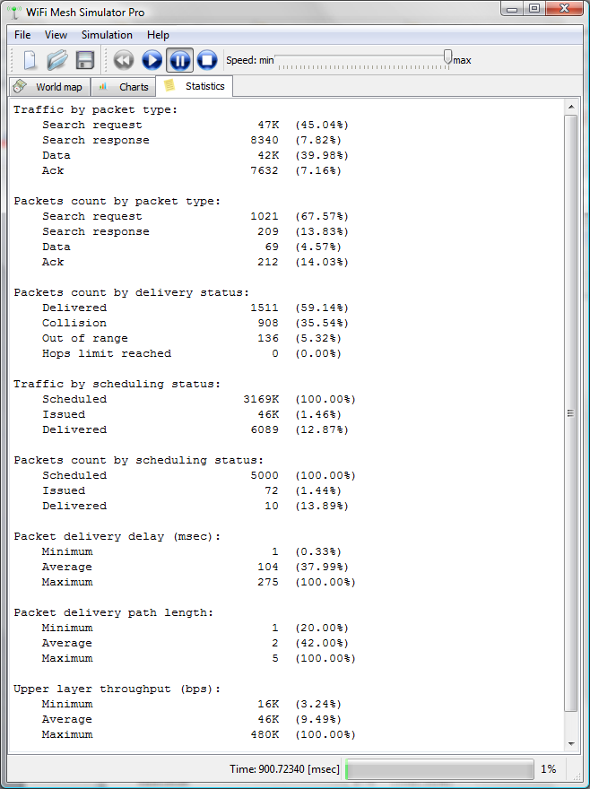
Figure 5: Statistics view
- Simulator settings
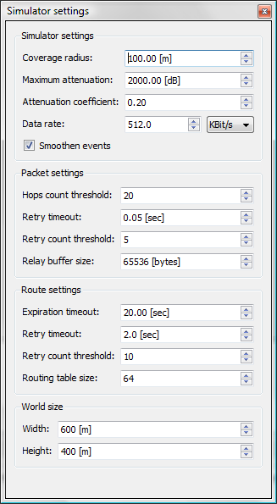
Figure 6: Simulator settings
- World generator
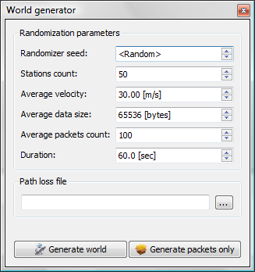
Figure 7: World generator
- Packet sniffer
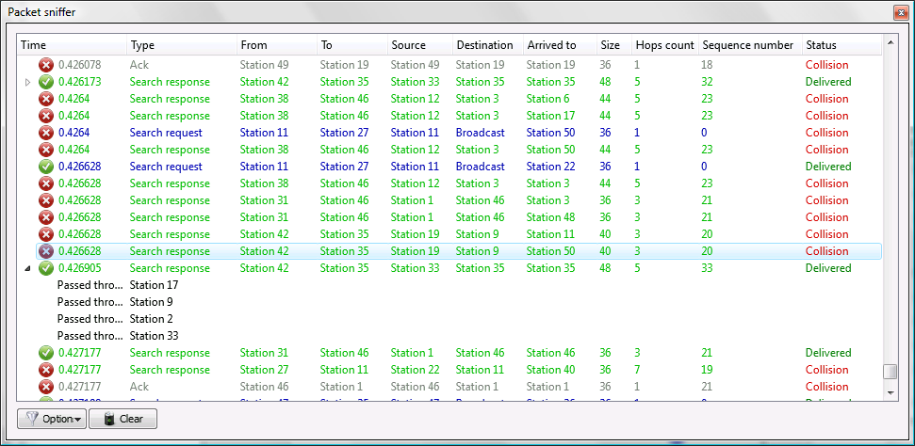
Figure 8: Packet sniffer

Command line interface

Command line format:
meshcore.exe -i <input_file> [-p <path_loss_file>] [-l <log_file>]

Parameters explanation:
Parameter | Description | Comment
<input_file> | Simulation configuration file | Input, mandatory
<path_loss_file> | Path loss file | Input, optional
<log_file> | Log file (in .csv format) | Output, optional

Example:
meshcore.exe -i simulation.txt -p pathloss.txt –l log.csv

File formats

Configuration file format
A configuration file for the simulator should be in the following format:
<World Max X> <World Max Y> <#stations>
<Max Attenuation> <Attenuation Const> <Bandwidth> <Buffer Size>
<RT size> <Max entry age> <Search retries threshold> <Time until retry> <Hops threshold> <Transmit retries threshold> <Transmit retry timeout> <Simulation timeout>

<id1><x1><y1><angle1><velocity1>
<id2><x2> <y2> <angle2> <velocity2>
…
<id_{n}><xn> <yn> <anglen> <velocityn>

<Id1> <source1> <dest1> <startTime1> <size1>
<Id2> <source2> <dest2> <startTime2> <size2>
…
<Idn> <sourcen> <destn> <startTimen> <sizen>
Figure 9: Configuration file format

Explanations:
1st line contains parameters of the simulation world: its width and height dimensions (meters), number of participating stations.
2nd line contains maximal attenuation (dB) and value of a constant used for calculation of attenuation (dB/m²), bandwidth (Kbit/s) and buffer size (bytes).
3rd line contains parameters for routing protocol: routing table size, maximal age of routing entry (sec), retry timeout (sec), number of search attempts before considering a search as failed.
4th line contains packet transmitting settings: maximum hops count, retries count threshold, time between retries (sec), simulation timeout (sec).
The following <#stations> lines contain information about each station: station id, its initial location (x and y respectively, meters), angle of movement (in degrees) and velocity of movement (m/s).
Starting from next line and until the end of the file, each line describes a single message that is to be sent - its message id, source station id, destination station id, time when first ttempt to send it should be performed by source station (in seconds), size (in bytes).

Example of a legal configuration file:
600.000000 400.000000 7
2000.000000 0.200000 64 65536
64 20.000000 10 2.000000
20 5 0.050000 60.000000

0 178 221 187.261811 42.662776
1 228 181 225.187539 36.926380
2 278 222 13.320453 7.412697
3 318 275 249.286690 35.919798
4 361 222 322.624432 34.471515
5 405 172 227.760299 41.137947
6 126 271 356.320946 17.898522

0 6 5 0.000000 1 20
Figure 10: Configuration file example

Path Loss File Format
Path Loss file may be sent as a parameter to the simulator in order to explicitly specify the connectivity (in terms of actual attenuation, specified in dB units) between participating stations as a function of current time. It should follow the following format:

<time1> <station1> <path_loss_to_station1> … < path_loss_to_stationn>
<time1> <station2> <path_loss_to_station1> … < path_loss_to_stationn>
…
<time1> <stationn> <path_loss_to_station1> … < path_loss_to_stationn>

<time2> <station1> <path_loss_to_station1> … < path_loss_to_stationn>
<time2> <station2> <path_loss_to_station1> … < path_loss_to_stationn>
…
<time2> <stationn> <path_loss_to_station1> … < path_loss_to_stationn>

…

<timek> <station1> <path_loss_to_station1> … < path_loss_to_stationn>
<timek> <station2> <path_loss_to_station1> … < path_loss_to_stationn>
…
<timek> <stationn> <path_loss_to_station1> … < path_loss_to_stationn>
Figure 11: Path loss file format

Explanations:
Each line of the file contains the following: specific time, station index and list of path losses between this station and all other stations. When an application needs to check path loss between station i and station j, it find the line with the most recent (comparing to current simulation time) time corresponding to i and fetches the j_{th} path loss from that line. In this way simulator retrieves A_{i,j} – attenuation between stations i & j.

Example of a legal path loss file:
0 0 0 30 30 30
0 1 30 0 30 30
0 2 30 30 0 30
0 3 30 30 30 0
1 0 0 150 150 150
1 1 150 0 150 150
1 2 150 150 0 150
1 3 150 150 150 0
Figure 12: Path loss file example

Note:
If no path loss file is given to the simulator, appropriate calculations will be made based on distances between stations in each time point. For details, see appropriate section.

Appendix

Figures table
Figure 1: Entire view 3
Figure 2: Stations browser 4
Figure 3: World map view 5
Figure 4: Charts view 6
Figure 5: Statistics view 7
Figure 6: Simulator settings 8
Figure 7: World generator 9
Figure 8: Packet sniffer 9
Figure 9: Configuration file format 11
Figure 10: Configuration file example 12
Figure 11: Path loss file format 12
Figure 12: Path loss file example 13

