WiFi Mesh Simulator
© 2009 Denis Itskovich
Table of Contents
1. Overview 3
2. Protocol Stack Description 7
3. RRP - Reactive Routing Protocol 8
Control messages format 8
Data structures required on each host 10
Actions on sending message 12
Actions on receiving message 12
Actions performed on background: 12
1. LLC - Logical Link Control Protocol 13
2. CSMA Protocol 14
3. Design Assumptions 15
4. Design Decisions & Improvements 16
5. User Manual 18
6. Configuration File Format 25
7. Pass Loss File Format 28

Overview
This document describes the structure, design and implementation details of the simulator, an application for simulating routing and data transmission in wireless ad-hoc networks.
In the simulation world, there are hosts (stations), which are capable of the following actions:
- Moving - each station can either remain at the same location all the time, or move in 2-D space in a given direction. In each simulation step, the simulator updates current location of each station by applying its movement function on its current location. Currently, only the simplest type of movement is simulated, which is movement with a constant speed and to a constant direction. The world is bounded by its size in X and Y coordinates, and when a moving station breaks these bounds (which are final and constant during the simulation), it is considered dead and never takes part in later simulation steps. Each station’s movement velocity and direction, as well as its initial coordinates are provided as part of initial configuration.
- Locating set of peer stations - each station can find its peers in order to communicate with them. Peers of a given station are defined as all stations which are currently within its “visibility range”, i.e. attenuation to which doesn’t exceed the maximal attenuation possible. (Of course, since all hosts are mobile, set of peers of each station may change as time advances). An attenuation between two stations can be specified by two ways:
  - By specifying an explicit pass loss file, from which attenuation between any pair of stations in any time can be found (see appropriate section).
  - In absence of an aforementioned file, attenuation will be calculated by the following formula: (attenuation constant) x (distance)². The distance between each pair of stations is known since the simulator knows the exact location of each station at any time (and evaluates it at each step, as mentioned above).
Maximal attenuation and attenuation constant are specified as part of initial configuration.
- Transmitting and receiving messages - each station can directly communicate with its peers (as described above). In order to allow communication between all stations in the simulation world (and not only with those who “see” each other), a protocol stack is defined and completely documented at the following sections. Here we only mention several aspects related to all implemented protocols:
  - The simulated network has a finite and constant bandwidth, which serves as a limitation to amount of information that may be delivered between stations at a single time unit. It is specified as part of initial configuration and taken into account while simulating send/receive events.
  - Since not all stations see each other, they have no other choice but to use other stations as “relays”, and consequently to serve as relays to other stations by forwarding their messages to needed destinations. As a message for forwarding is received, it is buffered at a relay host and later sent (the exact details are protocol-dependent and will be described later). The buffer for forwarded messages is of finite and constant size and is the same in all stations. It is given as part of initial configuration.
  - Regardless of the protocol used, two different strategies for messages’ sending are possible: either all messages have the same priority, or control messages (those that do not carry data but used for connection establishment, route discovery etc. ) get higher priority and are sent earlier. The choice of a strategy is remained to user and can be specified as part of initial configuration (see description of configuration file for details).
List of all data messages which are to be sent during the simulation are provided in a configuration file. Each message has:
    - “From” station id – message origin id
    - “To” station id – message final destination id
    - Sender station id – immediate source id
    - Receiver station id – immediate destination id (may be special – broadcast id)
    - Sequence number – message sequence number, marked by sender station. Is used for sending ACK messages back.
    - an ID (it is up to creator of an input configuration file as specified in Configuration File Format section to make sure all IDs of data messages are unique);
    - a size of a message’s payload in bytes;
    - a TTL (which is the maximal allowed number of stations which the message may be transmitted through).
    - Path (up to 64 stations) – ids of all stations the message has passed through
The simulation is performed in discrete steps. In each step the simulator takes a “snapshot” of the world, evaluates current locations of all stations and calculates current status of every single packet which is transmitted by any participating station - whether it is successfully received, or is still in process of delivery, or failed due to an error (for instance, an increased distance between a sender and a receiver as a result of their movement, during which they’ve stopped seeing each other, or a collision between several packets). Exact details of these operations are specified in upcoming sections. Number of steps per second (“simulator granularity”) is a part of a configuration file.

Simulation input
For a complete description of all input parameters, see Configuration File Format description.

Simulation output
The simulation terminates when either there are no more data to deliver (all of the specified data messages have either reached their destinations or died) or no more stations are alive (as mentioned earlier, a station dies when it crosses the border of the simulation world), or simulation lasts more than a predefined maximal allowed time period. After that, the following information is presented to a user:
- Overall number of packets carrying real data transmitted over the network during the simulation (not including retransmissions);
- Overall number of control packets transmitted over the network during the simulation;
- Data traffic used (i.e. sum of sizes of all data messages transmitted during the simulation, including retransmissions);
- Control traffic used (i.e. sum of sizes of all control messages which were transmitted during the simulation);
- Amount of successfully delivered data messages out of all that were sent;
- Minimal/maximal/average end-to-end message delay (among all successfully delivered messages);
- Minimal/maximal/average end-to-end hop count (among all successfully delivered messages);
- In case of using reactive routing protocol (see below), number of messages which have failed due to unsuccessful search operation (source station has not received any reply for search queries);
- In case of using proactive routing protocol (see below), number of messages which have failed due to local routing failures (destination station was not found in a local network graph);
- Number of messages which have failed due to insufficient TTL value;
- Number of messages which have failed due to lack of space in a relay buffer of some intermediate station;
- Number of messages which have failed due to link layer error

Protocol Stack Description
The protocol stack used in the simulation in of the following form

Application
RRP
LLC (S&W ARQ)
CSMA
Physical

where:
RRP - Reactive Routing Protocol (Network/Routing Layer)
LLC - Logical Link Control Protocol
CSMA - Carrier Sense Multiple Access Protocol (Data Link Layer)
See descriptions of all of the aforementioned protocols (as defined and used in this simulation) below.
Before the simulation starts, a user specifies (either via configuration file or by using graphical interface - see User Manual) which of the two available routing protocols will be used in the current run, and which of the two link layer protocols will be used - overall four different combinations exist.
In general, each layer makes no special assumptions about the underlying one. Network layer assumes a reliable link layer, which either successfully transmits a given packet or detects an error and notifies about it, and link layer itself assumes nothing about physical one. Hence, in future the given protocol stack may be relatively easily extended to simulate behavior of more link or routing protocols.

RRP - Reactive Routing Protocol
In reactive routing protocol, each station performs route discovery “on demand” instead of constant maintaining of local topology view. Only when an upper layer passes it a message to be sent and the route to this destination is unknown, a discovery procedure is performed. A station does its best to use its incoming traffic in order to learn about valid routes to its peers (see below) and thus to minimize amount of control messages.
We divide the exact specification of the protocol into several parts: describing format of messages, data structures needed at each host, actions performed on sending or receiving a message and actions being performed periodically during the run regardless of incoming/outgoing traffic.

Control messages format
The protocol defines the following types of messages:
Data message - this message contains a payload received from upper level which needs to be delivered to an application on a remote host. The format of Data message is:

Opcode (1 byte) | “From” MAC  (6 bytes) |  | “To” MAC  (6 bytes) | Sender MAC  (6 bytes) | Receiver MAC  (6 bytes)
Packet ID (4 bytes) |  | Payload Size (2 bytes) |  | Payload | CRC (4 bytes)
Path Length (1 byte) |  | Path (up to 64 MAC addresses)
where:
- Opcode - message’s type.
- From MAC – original
- To MAC – final destination
- Source MAC - the immediate source MAC address of the sender of this message.
- Destination MAC - the immediate destination MAC address of the host to which the message is destined.
- Packet ID - a unique ID of this data message that will distinguish it from any other data message on the network (received as a part of input).
- Payload Size - size in bytes of the payload.
- CRC - a field used for CRC check of an incoming message by a receiver.
- Payload - the data to be sent, which arrived from application layer.
- Path length – MAC addresses count of the Path field
- Path – up to 64 MAC addresses

Path Query message - a message broadcasted by any station which performs search for another station, and forwarded by any station which is not the desired destination. The format of Path Query message is:
Opcode (1 byte) | “From” MAC  (6 bytes) |  | “To” MAC  (6 bytes) | Sender MAC  (6 bytes) | Receiver MAC  (6 bytes)
Packet ID (4 bytes) |  | CRC (4 bytes)
Path Length (1 byte) |  | Path (up to 64 MAC addresses)
where:
- Opcode - message’s type.
- From MAC – original source station
- To MAC – final destination (station being searched)
- Source MAC - the immediate source MAC address of the sender of this message.
- Destination MAC - the immediate destination MAC address of the host to which the message is destined. (broadcast)
- CRC - a field used for CRC check of an incoming message by a receiver.
- Path length – MAC addresses count of the Path field
- Path – up to 64 MAC addresses

Path Update message - this message is sent as a reply to a received query. It is sent by shortest known path to the destination (the shortest path by which search query was received) and also contains this path, thus enabling all stations on it to update their routing tables with this information. The format of Path Update message is:
Opcode (1 byte) | “From” MAC  (6 bytes) |  | “To” MAC  (6 bytes) | Sender MAC  (6 bytes) | Receiver MAC  (6 bytes)
Packet ID (4 bytes) |  | CRC (4 bytes)
Path Length (1 byte) |  | Path (up to 64 MAC addresses)
where:
- Opcode - message’s type.
- From MAC – original
- To MAC – final destination
- Source MAC - the immediate source MAC address of the sender of this message.
- Destination MAC - the immediate destination MAC address of the host to which the message is destined.
- Packet ID - a unique ID of this data message that will distinguish it from any other data message on the network (received as a part of input).
- CRC - a field used for CRC check of an incoming message by a receiver.
- Path length – MAC addresses count of the Path field
- Path – up to 64 MAC addresses

Data structures required on each host
- Routing Table:
  - Contains entries of 2 types:
    - Routing entry – describes the beginning of the discovered path. Contains following fields:
      - Destination id
      - Next station id
      - Expiration time
      - Path length
    - Pending entry – describes the path being discovered. Contains the following fields:
      - Destination id
      - Next retry time
      - Retries left
  - Can contain zero or 1 entries per destination
  - When a user tries to insert an entry which is already located in the table, new entry will not be created, but last update time of an existing one will be set to current time.
  - Has a finite size (a configurable parameter).
  - Any entry whose age exceeds maximal allowed age (a configurable parameter) will be removed from routing table.
  - If a user tries to insert a routing entry into a full table, LRU replacement policy will be applied.
- Scheduler
  - Responsible of scheduling outgoing messages (actually – represents an upper layer)
  - Contains entries, of the following form:
    - Time – the time a message should be issued
    - Message itself

Actions on sending message
When request to send a message is accepted from an upper layer, the following actions are performed by the sending host:
  - Search the routing table for entry corresponding to the destination host. If a corresponding entry was found, send data packet to the next hop in the route and finish.
  - If no entry was found, broadcast a query message and put into routing table pending entry.
  - If no reply received within a “route retry timeout” retry a query.
  - If maximal allowed number of queries was sent with no reply (maximal number of queries is a system constant), return error message to upper layer and finish.
  - When Path Update for a query received, behave as specified below.

Actions on receiving message
      - Routing table is being updated upon receiving every incoming message.
      - If the host is not a final destination, the message is pushed into outbox (if there is enough space in relay buffer, otherwise the message is discarded)
      - If the host is a final destination, the message is being processed according to it’s type:
Data packet received: a payload is transferred to upper layer
Ack packet received: a corresponding packet is being removed from outbox queue
Query packet received: update packet is being sent back
Update packet received: none (the routing information was already extracted at step 1)

Actions performed on background:
- Periodically check whether any of routing entries are too old (their age exceeds maximal allowed age) and discard them.
- Periodically check whether it’s time to send updates for any of previously received queries.
- If waiting for a reply to a sent query, check for search timeout.

LLC - Logical Link Control Protocol

LLC protocol is simulated by means of ACK packets, sent as a response to any non-broadcast packet. This allows retransmitting messages which were broken due to collision for example.

CSMA Protocol
This is a basic and very simple protocol for link-level packets transmission. A station that wishes to transmit a message received from an upper (LLC) layer listens to its channel, waits until it is silent (no other transmission by another host is observed) and starts its own transmission. When the transmission ends, the station is aware of delivery status, which may be

- successful - in such case no other actions take place and success is reported to upper level
- failed due to collision between this and another transmission, may happen in case two or more stations started to transmit simultaneously, or because of a new station entering this transmission range while being not silent itself, or because of wrong configuration of one of the stations, or any other error - in this case the station performs Binary Exponential Backoff algorithm either until it succeeds or until maximum amount of attempts was performed, in the last case error is reported to an upper layer
- failed due to destination being unreachable (outside of visibility range of the source) - in this case it is assumed that a topology change has taken place and an error is reported to an upper layer
In case the destination address of a packet is broadcast, no retransmissions are performed, no error messages are generated and such packet delivery is always considered successful.
CSMA does not involve any special control messages of its own; neither needs any special data structures to save information on a host (with an exception of status of a current message and number of send attempts).

Design Assumptions
During the design and implementation stages, the following assumptions were made regarding the parameters and the behavior of the network:
- Reliable 2-layer connection between stations (i.e. if station S sends message to station D which is within its visibility range, this message will always be successfully delivered if no collisions occur). In other words, we assume an implicit LLC layer, as stated in an appropriate section. This assumption is strong and will be relaxed in future versions (see Future Development).
- Maximal number of hosts on a legal path from source to destination is 255 (this assumption is implied by allocating a single byte for TTL field in Reactive Routing Protocol control messages - see appropriate section).
- Maximal size of payload carried by data messages is 64KB (this assumption is implied by allocation two bytes for Payload Size field in Reactive Routing Protocol control messages - see appropriate section)
- Maximal number of neighbors on a station (i.e. hosts with which this station has layer-2 communication) is 255 (this assumption is implied by allocating a single byte for neighbors count field in Proactive Routing Protocol neighbors list control message – see appropriate section)
- The shortest possible sending time for a message is not less than a single simulation step time - in other words, simulation granularity (see Configuration Path Format) must be tuned such that a single message transmission by a single station will take at least a single step and no station will be able to perform more than one single action at a single step

Design Decisions & Improvements
The following decisions were made during system design and implementation, which
had a considerable impact on the outcome. Some of them (namely, 3-way handshake
and random number addition to timeout value) are clear improvements over original
requirements, making the resulting protocols more robust and feasible.
- Usage of routing table as defined above. It was decided that a table will contain routes using combination of destination and next hop as a unique key, however, containing more than one entry for each destination is possible (shortest available path will be selected). No protocol of inserting new entries to full table was defined and such operation will fail, but this is going to change in future version (see future development section).
- Extension of Reactive Routing Protocol to handle error conditions - a timeout value was defined which limits the amount of time a querying host will wait for reply (thus preventing a host from waiting forever). This value is 4 * (maximal path length) * (query send time), as described in a corresponding section, and it was given since it is twice the value of maximal round trip time in the network in absence of error conditions.
- Also, a small random number is added to the aforementioned timeout at each station, in order to prevent situations where multiple hosts simultaneously fail to send their messages and then synchronously wait for the same timeout to expire, generating new wave of collisions over and over again (similarly to the base concept of binary exponential back-off method).
- As an additional extension to the same protocol, a limit was defined on number of unsuccessful queries for same host. Without defining it, a station would query some other misbehaving station infinitely.
- Usage of a structure for saving global network topology. We have chosen to define it as an undirected graph, implemented as a matrix of size (#stations)². This implementation is the most suitable for networks with static set of stations and very dynamic set of edges (which is exactly our case), making it easy to maintain and modify local information. Search operation in a graph is implemented using BFS algorithm. In future version, we expect the set of nodes to become dynamic (so that addition of stations on-the-fly will become possible) and edges to become weighted, hence changes will be made here (see future development section).
- On startup of a network configured to use Proactive Routing Protocol, all stations immediately try to broadcast a beacon message, which collide among themselves, thus preventing the exchange of routing information (as well as any other information, since no host is aware of its peers) and it takes a long period of time until the system becomes stable. To solve the problem, the protocol was extended, specifying that a station must wait for a small random period before sending the first beacon. Assuming the range of times to wait is large enough, no more collisions are supposed to occur on startup.
- It was decided that no negotiation process will be performed if a station is willing to broadcast a message (otherwise it would result in very large number of simultaneously sent/received control messages which would make an algorithm almost impossible to use) or to send a data message whose size is smaller than the size of a single map slot (this gives us a gain in performance as all the unneeded overhead is prevented)
- Upper and lower bounds were defined on number of slots a single sender may occupy on receiver’s map. This decision was made for two reasons: on one hand, allocating too few slots would result in unnecessarily slow data transmissions, and on the other hand, a station needs to have enough “free” slots when it would remain silent to allow its peers to communicate with others.

User Manual
The graphical user interface consists of the following major elements:
- Tool bar – provides a quick access to such functions as new document creation, file opening, file saving and simulation running controls
- Stations browser – provides textual way for stations tracking, showing detailed properties (free buffer size, location vector, velocity vector, routing table and scheduler):
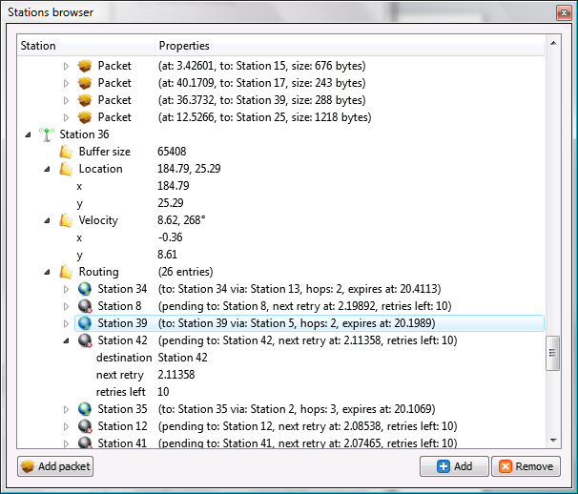
- World map – provides visual “world” view, where each station is represented by a numbered sphere. Focused or hovered sphere is being highlighted with coverage range, allowing seeing all stations which have direct connection with the selected one. During simulation the user may see currently transmitting stations, which are marked by red gradient. Arrows show transmitting and receiving stations, while arrow color corresponds to packet type. Focused station has a “green satellite”, which is connected to a station with an arrow – it represents a velocity vector:
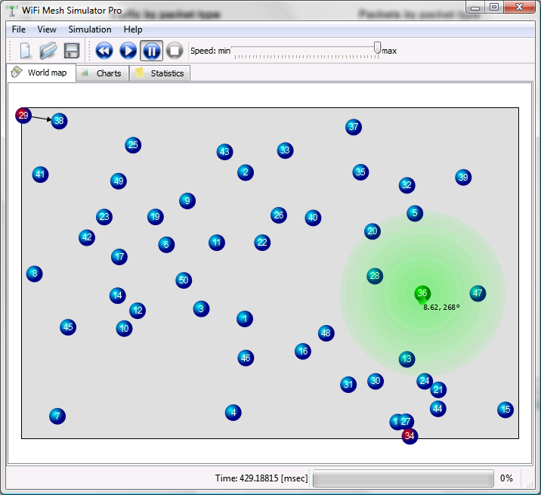
- Charts view – provides charts, based on collected statistics:
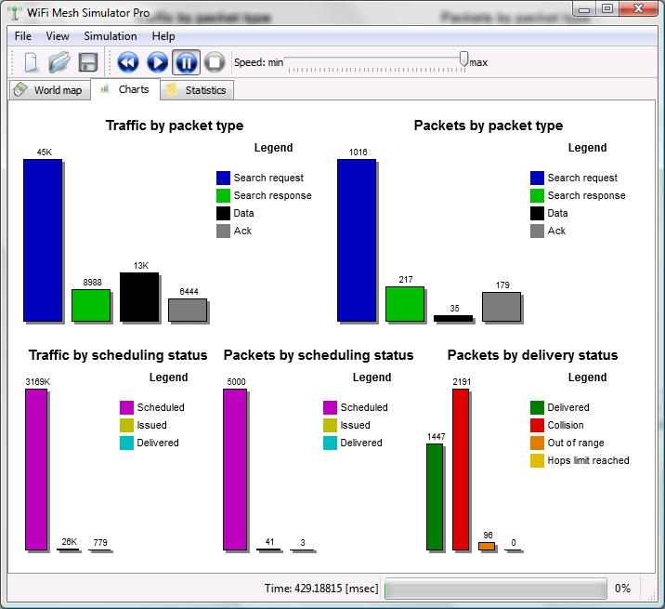
- Statistics view:
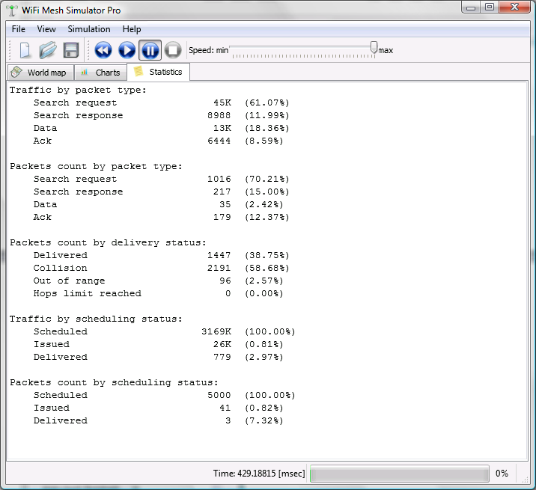
- Simulator settings
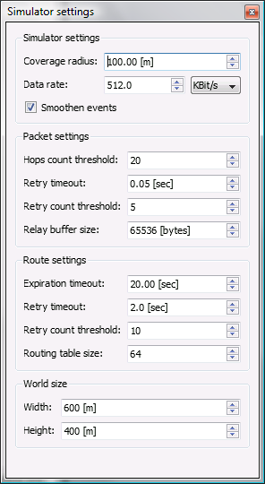
- World generator
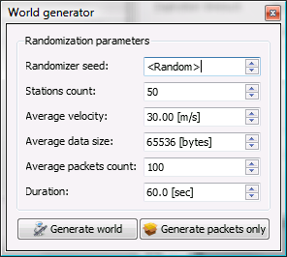
- Packet sniffer
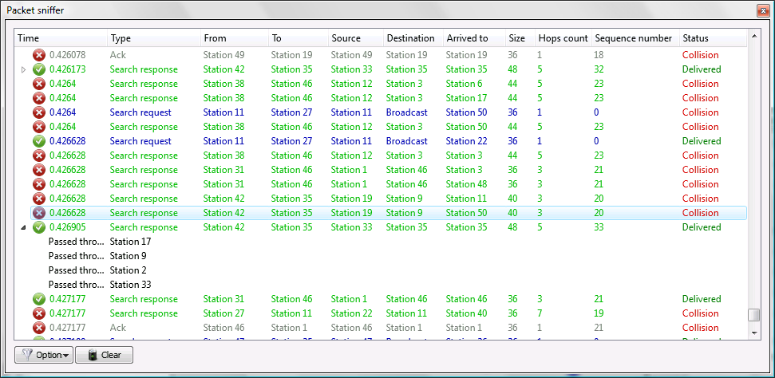
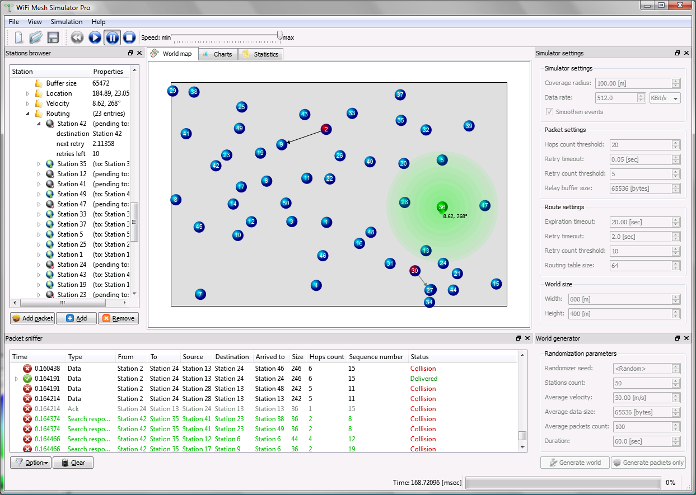
Figure 1

Configuration File Format
A configuration file for the simulator should be in the following format:

<Routing Protocol index> <Data Link Protocol index> <Buffer Routing Used>
<World Max X> <World Max Y> <#stations> <Max Attenuation> <Attenuation Const>
<Bandwidth> <Buffer Size> <Ctrl Messages Priority> <CRC success probability>
<Time until reply> <RT size> <Max entry age> <#Search Tries> <RT Policy>
<Max entries to same host>

<Beacon send interval> <Neighbors list send time>
<TDMA Slot size> <TDMA Slots number> <#Connection Attempts>
<Simulation sampling rate> <Simulation timeout>

<x1><y1><angle1><velocity1>
<x2> <y2> <angle2> <velocity2>
…
<xn> <yn> <anglen> <velocityn>

<Id1> <source1> <dest1> <startTime1> <size1> <ttl1> <Id2> <source2> <dest2> <startTime2> <size2> <ttl2>
…
<Idn> <sourcen> <destn> <startTimen> <sizen> <ttln>
Explanations:
- First line contains simulation modes. Legal values for <Routing Protocol index> are 1 for Proactive routing protocol and 0 for Reactive. Legal values for <Data Link Protocol index> are 1 for TDMA protocol and 0 for CSMA protocol. Legal values for <Buffer Routing Used> are 1 to use buffer routing and 0 otherwise.
- Second line contains parameters of the simulation world - its X and Y dimensions, number of participating stations, maximal attenuation and value of a constant used for calculation of attenuation.
- Third line contains general network parameters - bandwidth, size of each station’s buffer (in bytes), a parameter <Control Messages Priority> (whose legal values are 1 if control messages should have higher priority than ordinary (data) messages and 0 if all messages should be delivered with equal priority ) and a probability of CRC check success.
- Fourth line contains parameters for Reactive routing protocol - time interval between receiving of a search query and sending the result, number of available routing entries, maximal age of routing entry (here and below all time values are in seconds), number of search attempts before considering a search as failed, a parameter specifying the replacement policy used in routing table - 0 for None, 1 for FIFO, 2 for Random and 3 for LRU, and maximal allowed number of routing table entries to same destination.
- Fifth line contains parameters for Proactive routing protocol - time interval between successive sends of beacon messages and time interval between successive sends of neighbors’ lists.
- Sixth line contains parameters for TDMA protocol - a size of a single TDMA slot (in seconds), number of TDMA slots per one cycle and number of attempts for connection initialization (number of RTS1 send tries before considering negotiation as failed).
- Seventh line contains a value of simulation sampling rate and a value for simulation timeout.
- The following <#stations> lines contain information about each station - its initial location (x and y respectively), angle of movement (in degrees) and velocity of movement.
- Starting from next line and until the end of the file, each line describes a single message that is to be sent - its id, source station, destination station (indices of source and destination stations according to the order in which they appear in the previous section of configuration file), time when first attempt to send it should be performed by source station, size (in bytes) and the desired ttl.
Example of a legal configuration file:
1 0 0
50 50 2 100 2
1000 10000 0 1
5 20 50 1 3 2
10 80
2 10 4
4 5000

20 20 90 0.2
40 40 270 0.1

111 0 1 10 2000 2
222 1 0 40 3000 5

Pass Loss File Format
Pass Loss file may be sent as a parameter to the simulator in order to explicitly specify the connectivity between participating stations as a function of current time. It should follow the following format:

<time1> <station1> <path_loss_to_station1> … < path_loss_to_stationn>
<time1> <station2> <path_loss_to_station1> … < path_loss_to_stationn>
…
<time1> <stationn> <path_loss_to_station1> … < path_loss_to_stationn>

<time2> <station1> <path_loss_to_station1> … < path_loss_to_stationn>
<time2> <station2> <path_loss_to_station1> … < path_loss_to_stationn>
…
<time2> <stationn> <path_loss_to_station1> … < path_loss_to_stationn>

…

<timek> <station1> <path_loss_to_station1> … < path_loss_to_stationn>
<timek> <station2> <path_loss_to_station1> … < path_loss_to_stationn>
…
<timek> <stationn> <path_loss_to_station1> … < path_loss_to_stationn>

Explanations: each line of the file contains the following: specific time, station index and list of paths losses between this station and all other stations. When an application needs to check path loss between station i and station j, it find the line with the most recent (comparing to current simulation time) time corresponding to i and fetches the jth path loss from that line.
Example of a legal path loss file:

0 1 0 30 30 30
0 2 30 0 30 30
0 3 30 30 0 30
0 4 30 30 30 0
0 1 0 150 150 150
0 2 150 0 150 150
0 3 150 150 0 150
0 4 150 150 150 0

Note: if no path loss file is given to the simulator, appropriate calculations will be made based on distances between stations in each time point. For details, see appropriate section.

