WiFi Mesh Simulator

User Manual

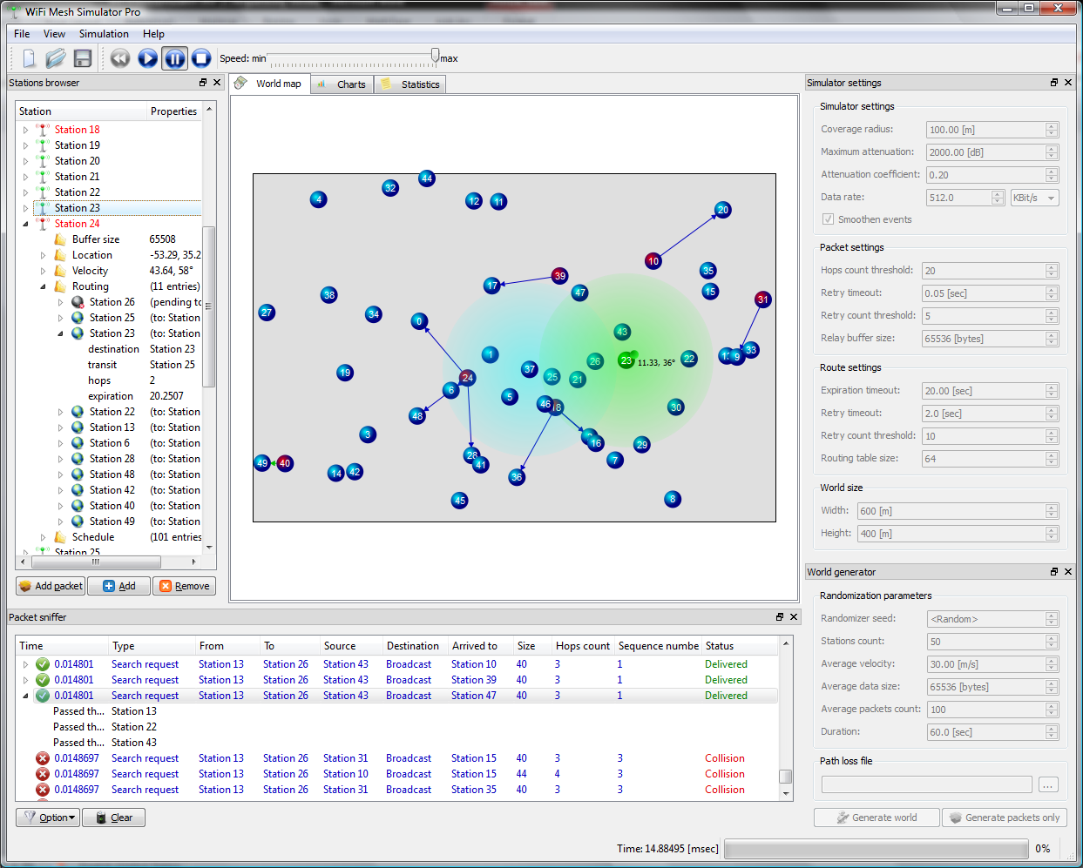
Figure 1
The graphical user interface consists of the following major elements:
- Tool bar – provides a quick access to such functions as new document creation, file opening, file saving and simulation running controls
- Stations browser – provides textual way for stations tracking, showing detailed properties (free buffer size, location vector, velocity vector, routing table and scheduler):
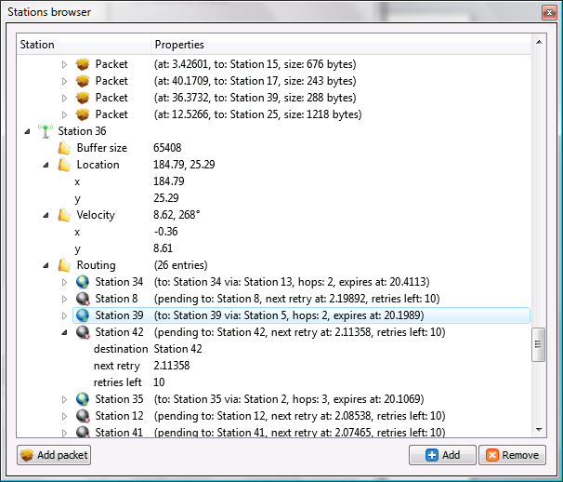
- World map – provides visual “world” view, where each station is represented by a numbered sphere. Focused or hovered sphere is being highlighted with coverage range, allowing seeing all stations which have direct connection with the selected one. During simulation the user may see currently transmitting stations, which are marked by red gradient. Arrows show transmitting and receiving stations, while arrow color corresponds to packet type. Focused station has a “green satellite”, which is connected to a station with an arrow – it represents a velocity vector:
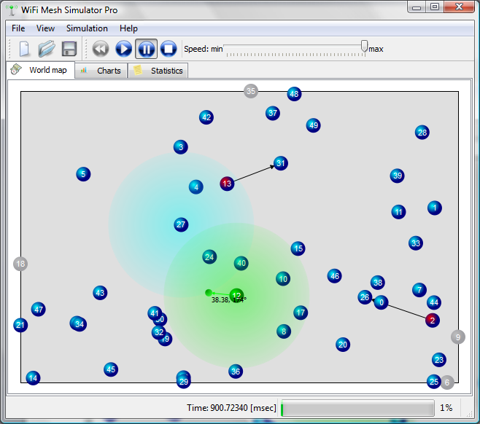
- Charts view – provides charts, based on collected statistics:
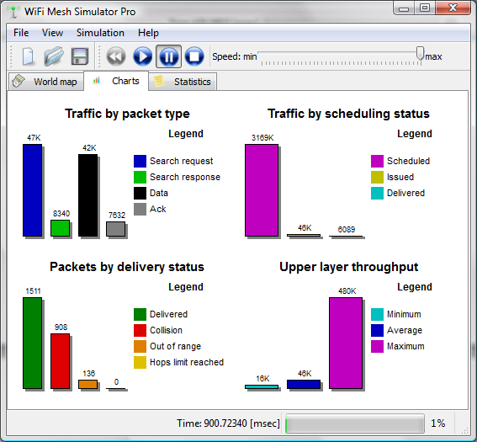
- Statistics view:
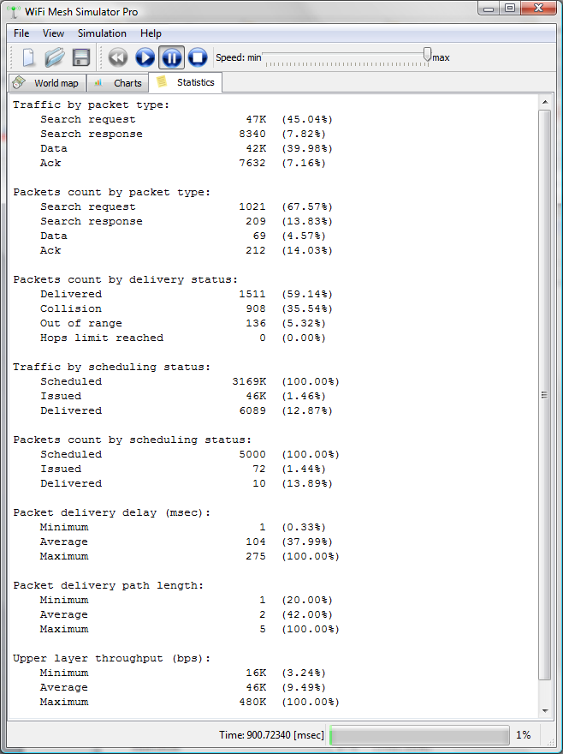
- Simulator settings
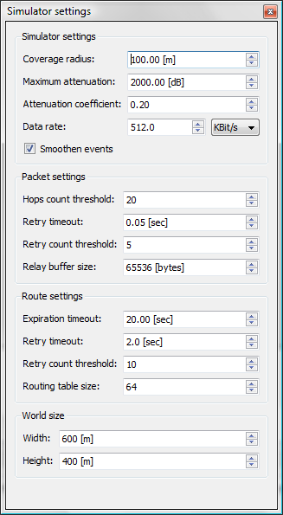
- World generator
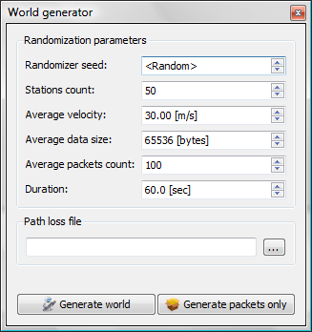
- Packet sniffer
