# vxchnge VPN Access

This document guides you through connecting to the VPN service at the vXchnge data center, this allows you to access any servers located there, but will not help you access anything located at HQ or hosted on AWS.

You need to have your VPN Username and password credentials to access the VPN, make sure you have these first.

## OpenVPN Client Setup – Windows

1. 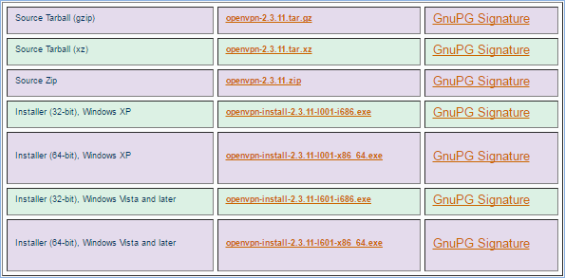Download and install the appropriate version of the OpenVPN Client [here](https://openvpn.net/index.php/open-source/downloads.html). If you have any issues installing the client see OpenVPN’s guide [here](https://openvpn.net/index.php/access-server/docs/admin-guides-sp-859543150/howto-connect-client-configuration/395-how-to-install-the-openvpn-client-on-windows.html).
2. 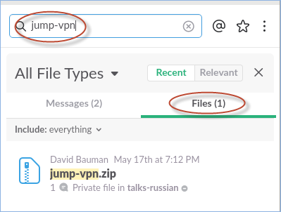Download the Agiloft vXchnge config file. This currently can be found in our Slack file directory. Open slack and enter ‘jump-vpn’ into the search bar, under the ‘Files’ tab, locate the file called jump-vpn.zip.
3. 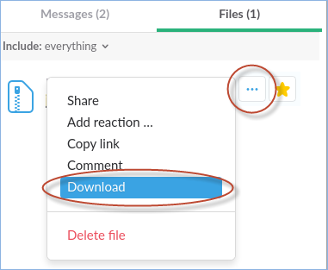Mouse over the jump-vpn.zip file, click ‘More actions’ represented by three dots. Under this context menu click ‘Download’.
4. 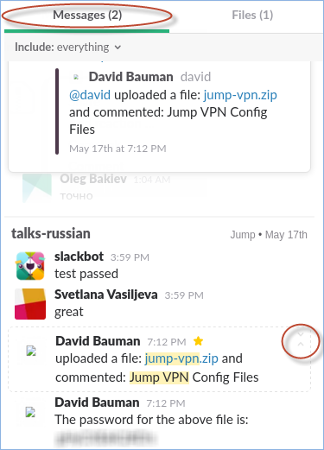Switch to the ‘Messages’ Tab, expand the message shown below to get the context, the message directly beneath contains the password to the zip file you just downloaded.
5. 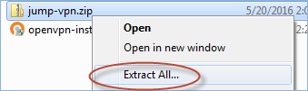Go to your downloads folder and locate the jump-vpn.zip file, right click it and in the context menu select ‘Extract All…’ You need [7Zip](http://www.7-zip.org/download.html) or similar for this option to be available. When prompted, click ‘Extract’.
6. 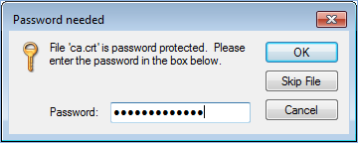A prompt for the password appears, enter it and click ‘OK’
7. 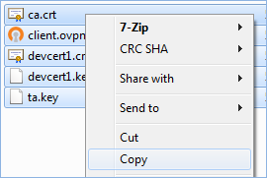The extracted archive folder appears, select and copy all the files inside.
8. Nagivate to the OpenVPN folder on your machine, the default path is **C: > Program Files > OpenVPN > config** Paste the files from the archive folder here.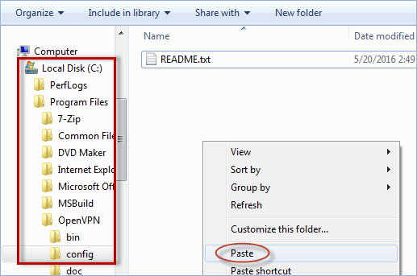
9. Start the ‘OpenVPN GUI’ program
10. 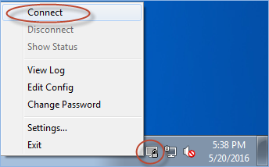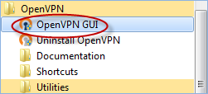No window should appear, instead right click the new icon in the system tray and select ‘Connect’ from the context menu.
11. 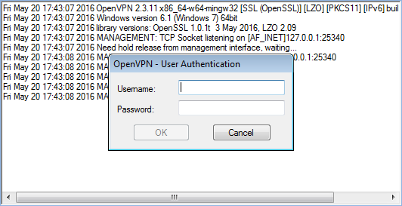OpenVPN prompts for your username and password, you should have been given these credentials, if not you need to request them. Enter your username and password in the appropriate fields and click ‘OK’.
12. 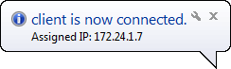Once the connection has established a pop up message in the bottom right of your screen appears. You are now connected to the VPN. Anything trying to access vXchange destinations will route through the VPN automatically.