Momentum-Based Equity Trading Strategy
Denis Laurichesse (April 2025), denis.laurichesse@gmail.com

Introduction
The trading strategy presented is a momentum-based investment approach specifically applied to equities. It focuses on a universe of individual stocks, such as those listed on major stock exchanges, and relies on momentum indicators derived from asset closing prices relative to their respective moving averages.

Methodology
Specifically, the momentum indicator is defined as a normalized difference between an asset’s closing price P and its moving average MA, calculated as:
$$μ=\frac{P-MA}{MA}$$
This normalization facilitates direct comparisons across various assets, allowing their ranking based on momentum strength.
Two distinct momentum indicators are calculated:
- A long-term momentum indicator ($μ_{\text{LT}}$), computed using a 240-day period, used primarily for generating entry signals.
- A short-term momentum indicator ($μ_{\text{ST}}$), computed using a 90-day period, designed for determining exit signals.
Asset weighting $w_{i}\left(t\right)$ at time $t$ is computed following these rules:
- Assets are sorted based on their $μ_{\text{LT}}$ indicator in descending order.
- Asset selection (entry signal) and weighting occur if and only if the following conditions are simultaneously satisfied:
  - Both $μ_{\text{LT}}$ and $μ_{\text{ST}}$ indicators for an asset are positive.
  - The market condition $Φ$ (defined below) exceeds a threshold of 0.1.
- Existing asset weights are retained from the previous period if the $μ_{\text{ST}}$ indicator remains positive.
- Up to a maximum of $N$ assets are allocated equal weights of $\frac{1}{N}$ to ensure diversification and mitigate concentration risk.
The market condition $Φ$ is defined as:
$$Φ=\frac{N_{+}-N_{-}}{N_{+}+N_{-}}$$
where:
- $N_{+}$ represents the number of assets exhibiting positive long-term momentum.
- $N_{-}$ represents the number of assets exhibiting negative long-term momentum.
$Φ$ is a bounded oscillator that ranges between -1 and +1, providing a normalized measure of market momentum breadth.
This market condition $Φ$ acts as a robust indicator for identifying adverse market conditions, thereby improving the strategy’s performance during bearish phases. Empirical evidence suggests that $Φ$ outperforms traditional index-based indicators in detecting market downturns. Additionally, the strategy is rebalanced on a monthly basis, with adjustments made at the end of each month. This regular review based on updated momentum signals and prevailing market conditions helps maintain alignment with market trends, potentially enhancing returns while managing risk exposure.

Backtest
To evaluate the effectiveness of the proposed momentum-based strategy, a historical backtest was conducted using the following setup:
Data
The strategy was tested on a universe consisting of all stocks that have been constituents of the S&P 500 index since 1980. Daily closing prices were used to compute momentum indicators and market conditions over the entire sample period.
Portfolio Construction
At each rebalancing point (end of each month), the strategy selected a maximum of 15 stocks ($N=15$) based on the highest long-term momentum values. Only stocks that met both momentum criteria and passed the market condition filter $Φ>0.5$ were included, and each selected stock received an equal weight of 10%.
Backtest Performance Metrics
Metric | Value
Annualized Return | 33%
Annualized Volatility | 27%
Annualized Sharpe Ratio | 1.22

Equity Curve (log scale), 1980–2025 (45 years)
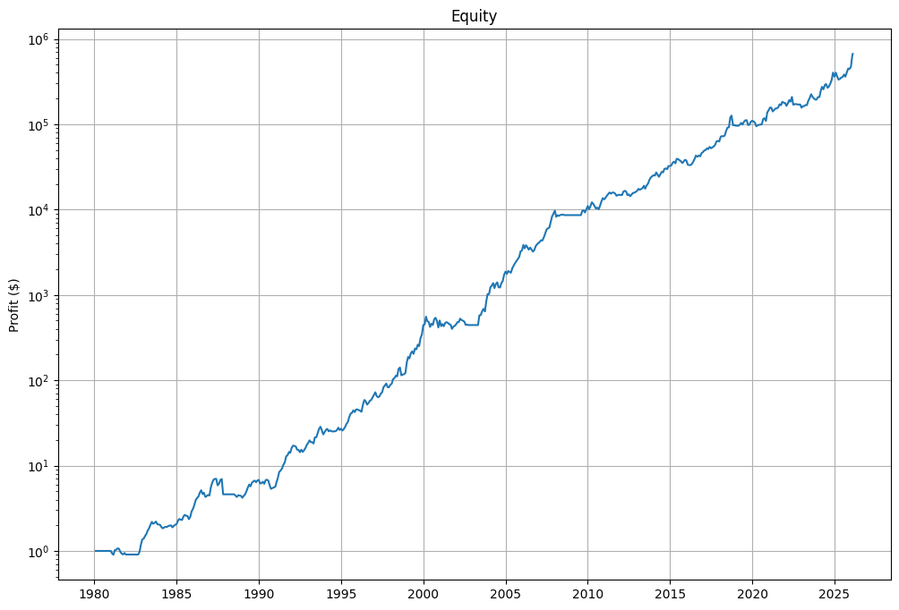
Evolution of Market Breadth Condition $Φ$
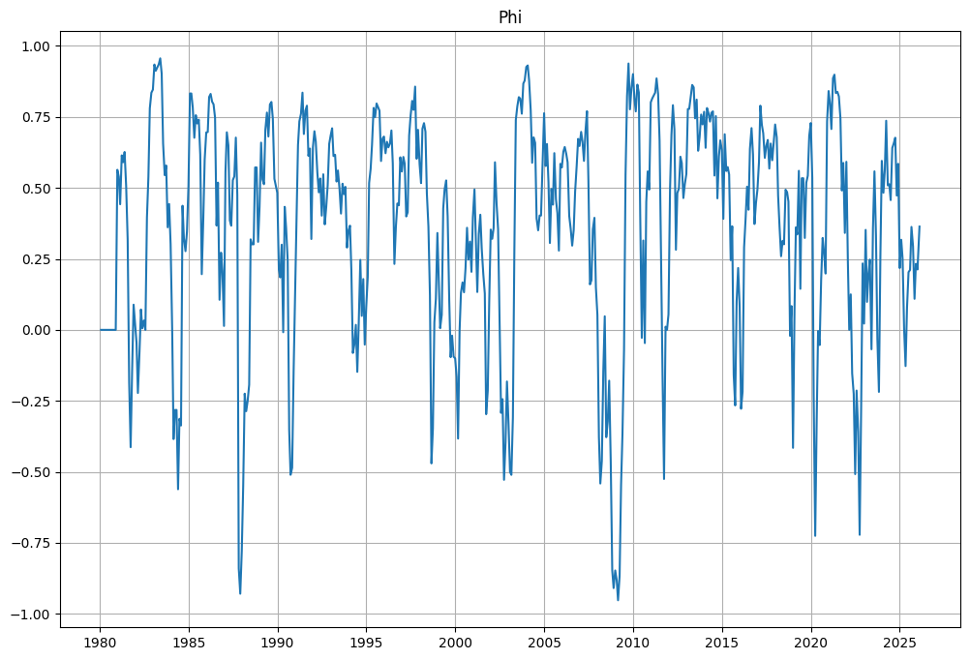
These results highlight the robustness of the strategy over multiple market cycles and confirm the added value of integrating a market-wide momentum condition into the asset selection process.

