**Maintaining Data Integrity Rules**

Data integrity refer to the result of database when it’s data is complete and accurate. It is important in the phase of the design. It’s making sure that error checking and validation are correctly used in the design of the database.

**Common relationships that are used within a relational database system**

* One-to-One – One row in table X can only have one matching row in table Y. Example;

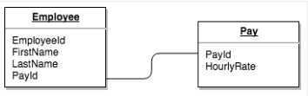

* Many-to-One / One-to-Many – One row in table X can have a matching rows in table Y and a row in table Y can only have one matching row in table X.

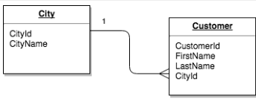

* Many-to-Many – Here, a row in table X can have many matching rows in table Y and a row in table Y can have many matching in table X.

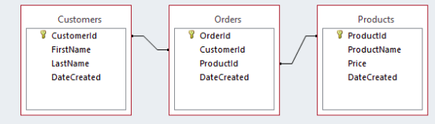

**How aggregate functions help the organization understand employee performance**

Aggregate functions can be used by various organizations to check on the performance of the employees. This can be achieved because the aggregate functions links factors that might affect employee morale and retention. Also, the aggregate functions helps to make a follow up of employees aspects such as salaries.



The function shown above helps the organization to explore it’s talent, since the most highly experienced employees always take a shorter period of time to complete the task given.

**Hashing algorithms: MD5 and SHA1**

The difference between the two is that in MD5 each round has it’s rotation count while in SHA1 they are same for all rounds. Also, in SHA1 words are always pre-processed while in MD5 each round always uses one of the 16 messages words. In the other hand, MD5 and SHA1 are not used in in the real cryptographic work such as encryption of the passwords. They use old algorithm in it’s hashing. Messages are being hashed before sending them to the appropriate receiver. This prevents hackers from interfering with the message being send.