**Planning Poker**

**-User Story-**

**Team:**

Miruna - Product Owner

Talida, Denisa, Alexandra, Mattia - Developer & Scrum Master

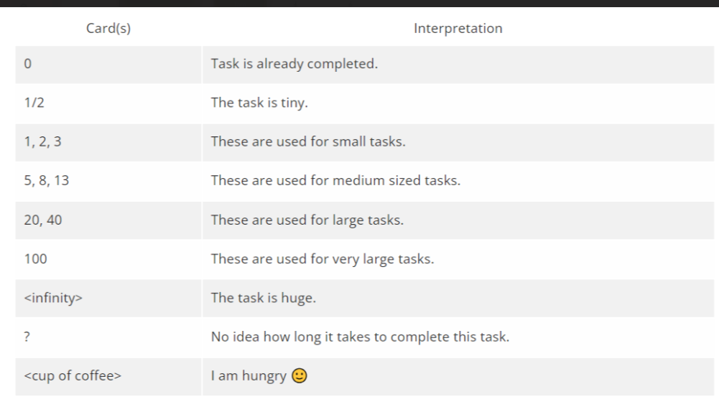

1. As a teacher I can start a meeting so that it would be easier to have online tutoring sessions.

| Estimators | Round 1 | Round 2 |
| --- | --- | --- |
| Talida | 8 - this user story uses an API integration and in general it does not require advanced knowledge and much time. | 20 |
| Denisa | 20 - this task requires a very good documentation for choosing an api for meetings | 20 |
| Alexandra | 13 | 20 |
| Mattia | 20 - this user story requires a series of steps to complete it | 20 |

1. As a teacher I can delete my announcements so that the announcements reflect my current status.

| Estimators | Round 1 |
| --- | --- |
| Talida | 1/2 |
| Denisa | 1/2 |
| Alexandra | 1/2 |
| Mattia | 1/2 |

1. As a user I can filter the teachers according to some criteria so that I will be able to find the right teacher.

| Estimators | Round 1 | Round 2 | Round 3 |
| --- | --- | --- | --- |
| Talida | 13 | 8 | 8 |
| Denisa | 5 - filtering is done with the filter function, directly in the frontend | 8 - filtering is done with the sort function, directly in the frontend | 8 |
| Alexandra | 13 | 8 | 8 |
| Mattia | 20 - the criteria for the filter functions should be more complex  and implemented in the interface in a nice way  so that the user can find a perfect match | 13 - the filter form must be complex | 8 |

1. As a user I can sort the teachers via name and rating points so that I can view them in a suitable order.

| Estimators | Round 1 | Round 2 |
| --- | --- | --- |
| Talida | 2 - the sort method has 2 sort criteria | 1 |
| Denisa | 1/2 | 1 |
| Alexandra | 1/2 - filtering is done with the sort function, directly in the frontend | 1 |
| Mattia | 2 | 1 |

1. As a user I can follow the presented steps that guide me how to use the platform so that I will know how to use the platform.

| Estimators | Round 1 |
| --- | --- |
| Talida | 2 |
| Denisa | 2 |
| Alexandra | 2 - following the presented steps for using the platform is a straightforward task that involves minimal complexity or effort |
| Mattia | 2 |

1. As a student, I can add, edit and delete reviews about my teachers so other students can select them based on my reviews.

| Estimators | Round 1 | Round 2 | Round 3 |
| --- | --- | --- | --- |
| Talida | 0 - this task has already been created for teachers | 1/2 - this task has already been created for teachers | 3 |
| Denisa | 3 - this task is one with several methods | 3 - this task must be adapted for students | 3 |
| Alexandra | 2 | 2 | 3 |
| Mattia | 3 | 3 | 3 |

1. As a user I can edit my profile and delete it so that I can customize my information and have control over my account.

| Estimators | Round 1 | Round 2 |
| --- | --- | --- |
| Talida | 3 -these functionalities must be created from scratch in a separate page in the profile | 3 |
| Denisa | 0 - this task is the same as the one above | 3 |
| Alexandra | 2 | 3 |
| Mattia | 2 | 3 |

1. As a teacher I can see the number of requests I have by their category so that it is easy for me to see them and respond if needed.

| Estimators | Round 1 | Round 2 |
| --- | --- | --- |
| Talida | 5 - we have a page with some simple cards where we put some records from database | 8 |
| Denisa | 8 | 8 |
| Alexandra | 13 - this task requires rigorous grouping by category | 8 |
| Mattia | 8 | 8 |

1. As a user I can access the top teachers list so I will select the best choice.

| Estimators | Round 1 | Round 2 |
| --- | --- | --- |
| Talida | 3 - the list contains some data sorted by the ranking (we need to create the function for calculating the rating). | 2 |
| Denisa | 1 - use the sort function and select the first 5 results | 2 |
| Alexandra | 2 | 2 |
| Mattia | 2 | 2 |

1. As a teacher, I can share videos with my students so that they understand better.

| Estimators | Round 1 | Round 2 |
| --- | --- | --- |
| Talida | 8 | 13 |
| Denisa | 8 - The complexity of implementing video sharing involves medium-sized effort due to the need for robust features and potential integration challenges | 13 |
| Alexandra | 13 | 13 |
| Mattia | 13 - The complexity of implementing video sharing functionality for teachers is considerable, involving intricate integration, security measures, and a seamless user experience. | 13 |

1. As a teacher I can assign homework to my students so that I can reinforce their learning and keep them organize user story

| Estimators | Round 1 | Round 2 |
| --- | --- | --- |
| Talida | 8 - the task consists in creating a new page where there are find a form for teacher to complete | 8 |
| Denisa | 8 | 8 |
| Alexandra | 13 - this task requires creating a new table in the database, a form and it should it should be complete in terms of the teacher's needs in the assignment as clearly as possible | 8 |
| Mattia | 13 | 8 |

1. As a user I can access the 'About us' page so that I can learn more about the Teach Us Web Application. user story

| Estimators | Round 1 | Round 2 |
| --- | --- | --- |
| Talida | 2 - this task requires a new page with a good series of information about our site | 1 |
| Denisa | 1/2 | 1 |
| Alexandra | 1/2 - the page is simple because it contains some informations that not require database information retrieval | 1 |
| Mattia | 2 | 1 |

1. As a user I can choose to stay logged in by pressing the 'Remember me' button so that I will not be logged out automatically when I exit the platform.

| Estimators | Round 1 | Round 2 |
| --- | --- | --- |
| Talida | 1 | 1/2 |
| Denisa | 1 | 1/2 |
| Alexandra | 3 - a token will be used | 1/2 |
| Mattia | ½ - it will never log out because we don't use expiration token | 1/2 |

1. As a student I can see every teacher's location on the map so that I can choose a suitable teacher based on his location.

| Estimators | Round 1 | Round 2 |
| --- | --- | --- |
| Talida | 20 | 13 |
| Denisa | 20 | 13 |
| Alexandra | 40 - the case where a teacher does not activate his location must also be dealt with | 13 |
| Mattia | 13 - an api will be used for the map | 13 - an api will be used for the map, teachers without location are not displayed |

1. As a teacher, I can create a ranking of my best students so that it is helpful to other teachers in accepting or rejecting students.

| Estimators | Round 1 | Round 2 | Round 3 | Round 4 |
| --- | --- | --- | --- | --- |
| Talida | 13- the teacher chooses 3 students from a list | 13 - teachers will see all the students they have worked with and will be able to choose 3 | 13 | 13 |
| Denisa | 100 - a complex way of choosing students must be found | 40 - there must be selection criteria for students | 20 | 13 |
| Alexandra | 20 | 13 | 13 - teachers choose based on personal preferences | 13 |
| Mattia | 20 | 20 | 13 | 13 |

1. As a user I can register using Facebook or Google account so that I can easily enter without using another password. user story

| Estimators | Round 1 |
| --- | --- |
| Talida | 1/2 - an api will be used |
| Denisa | 1/2 |
| Alexandra | 1/2 |
| Mattia | 1/2 |