1. a) Adresa IPv4 : 192.168.0.105

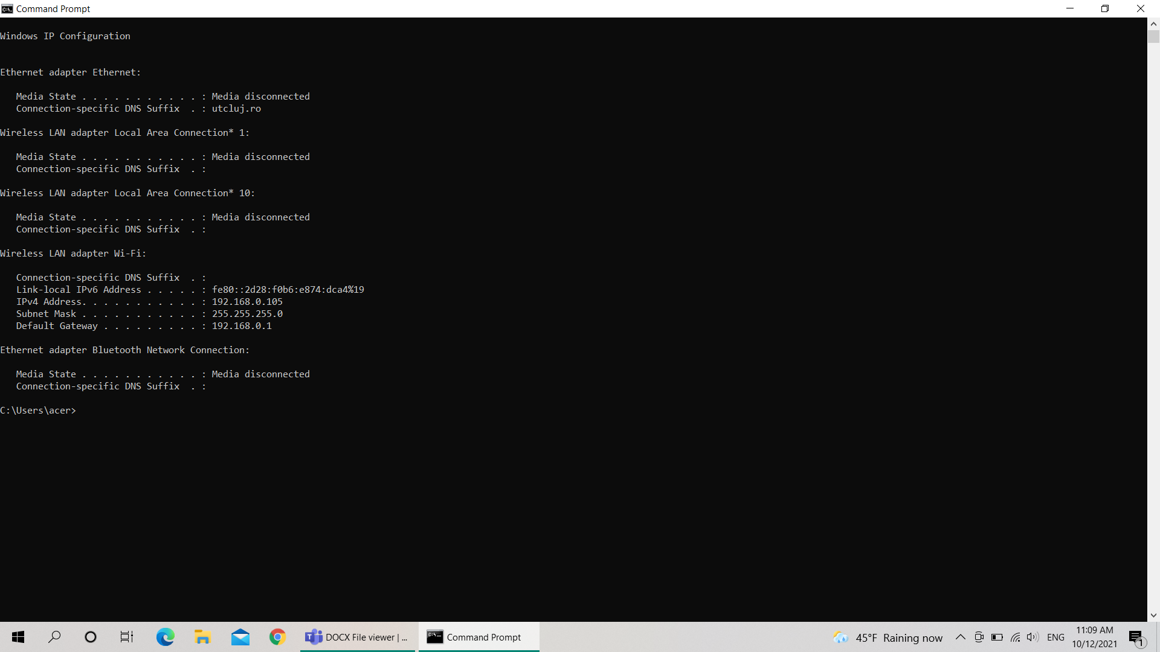

b)

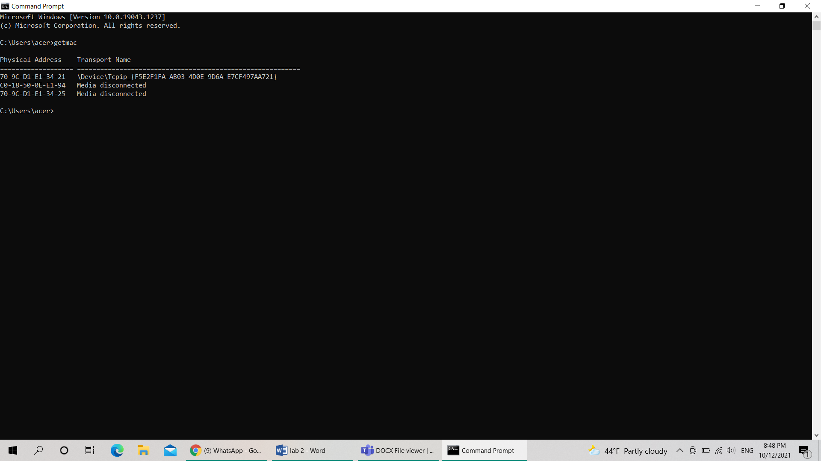

c) Interfețele de rețea pot fi : - tip grafic

- tip text

d)

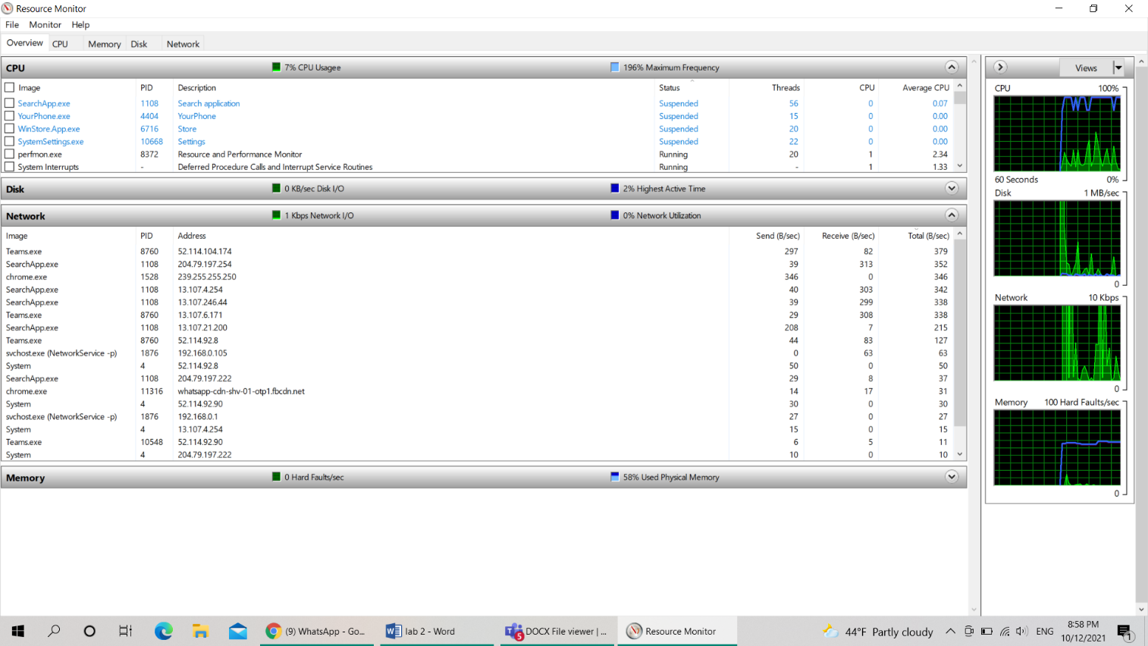

e)

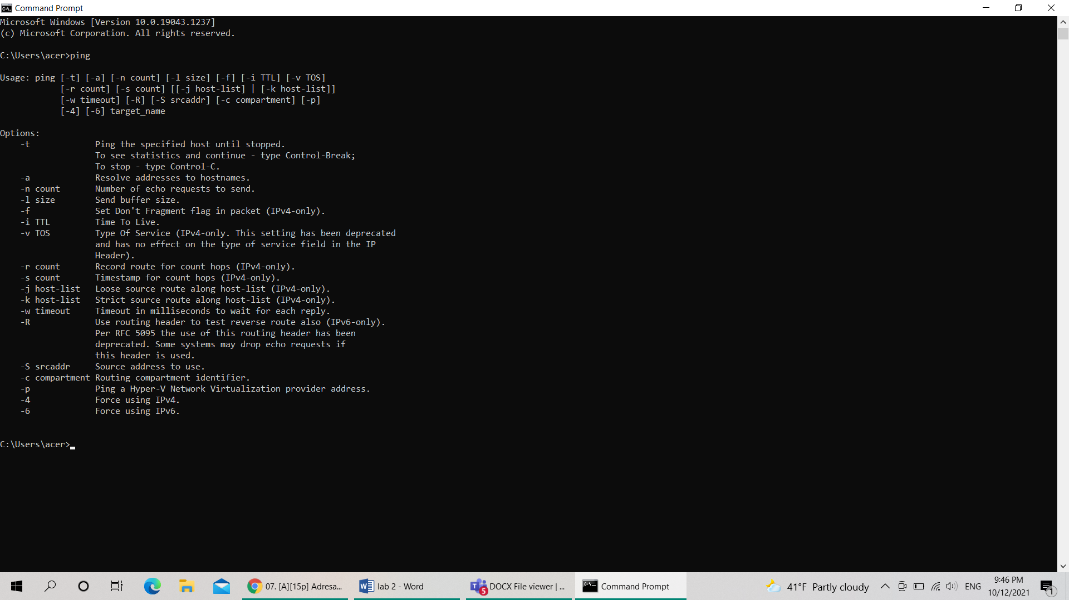

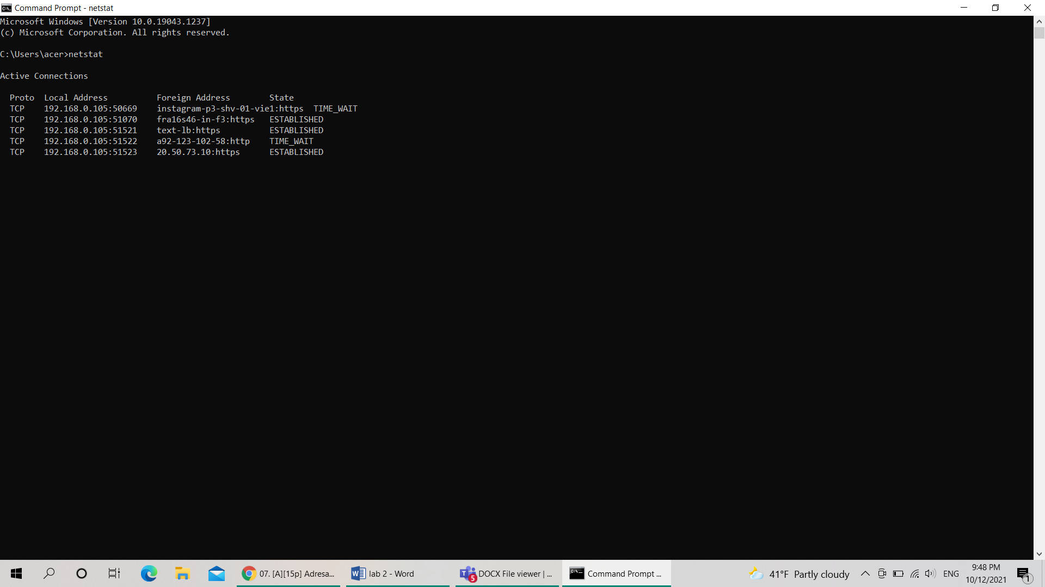

2.a) 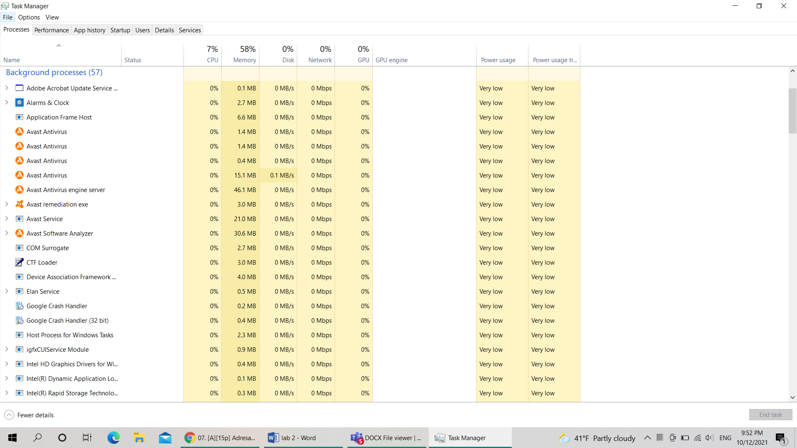

b) 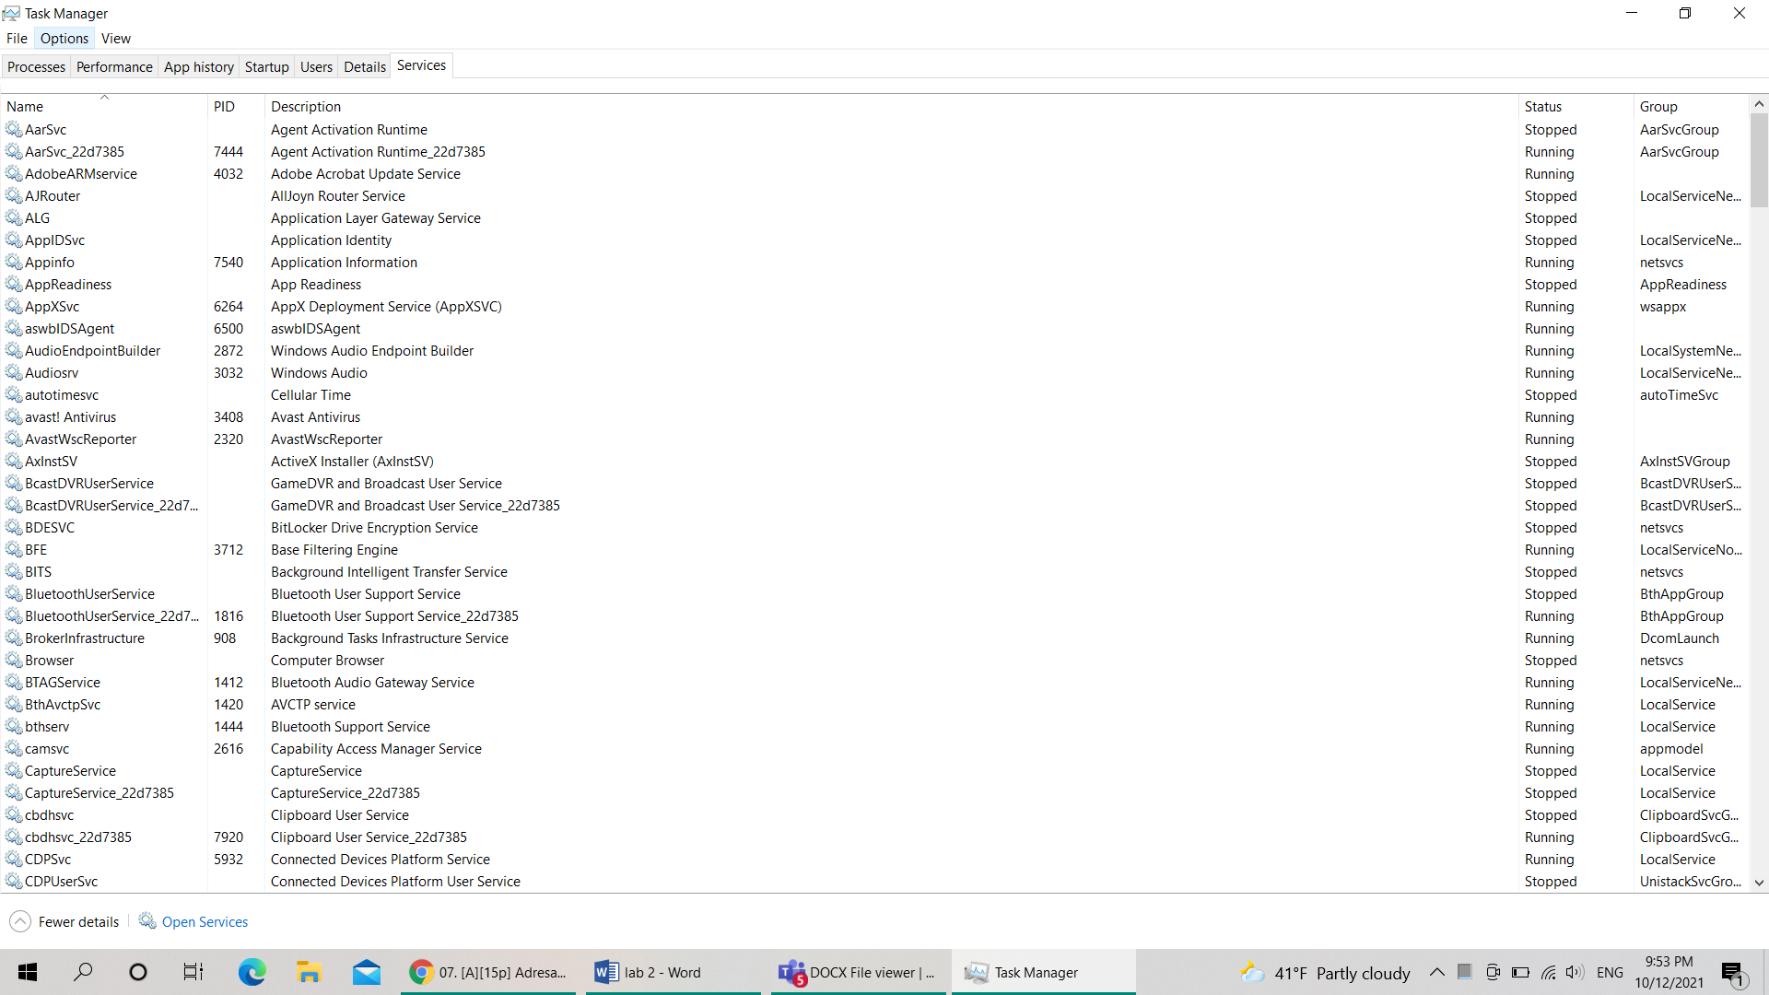

c) 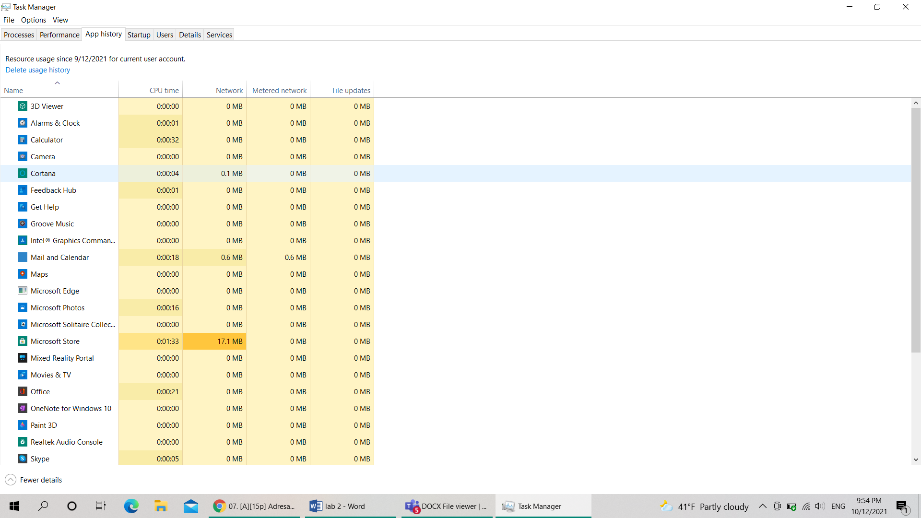

d)

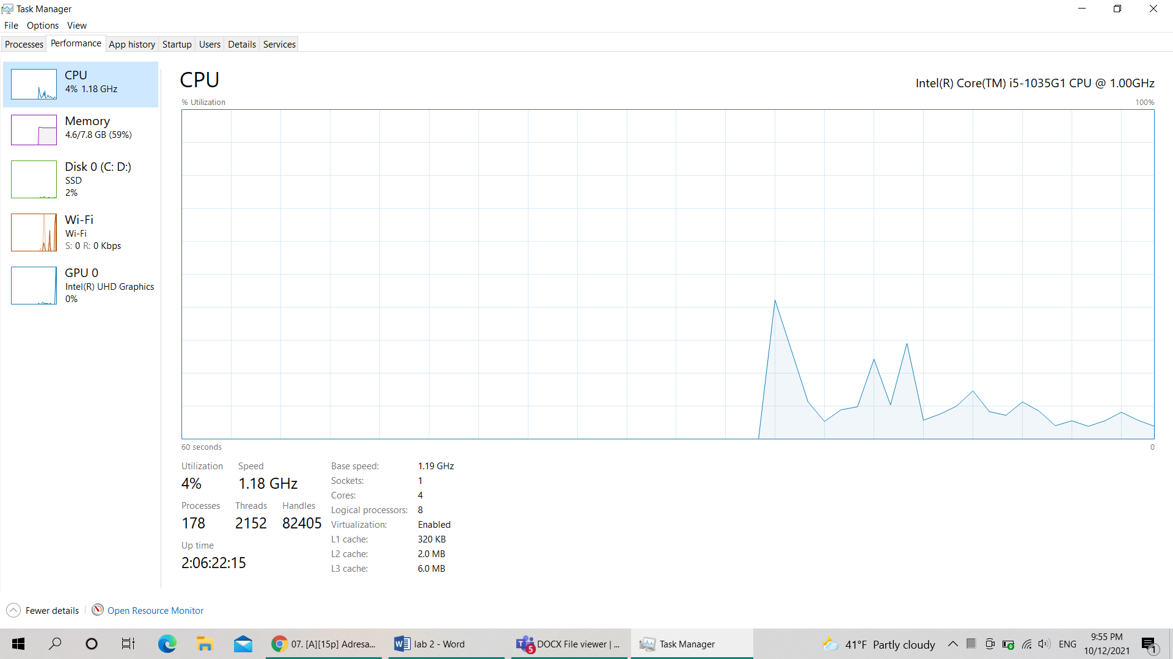

e)

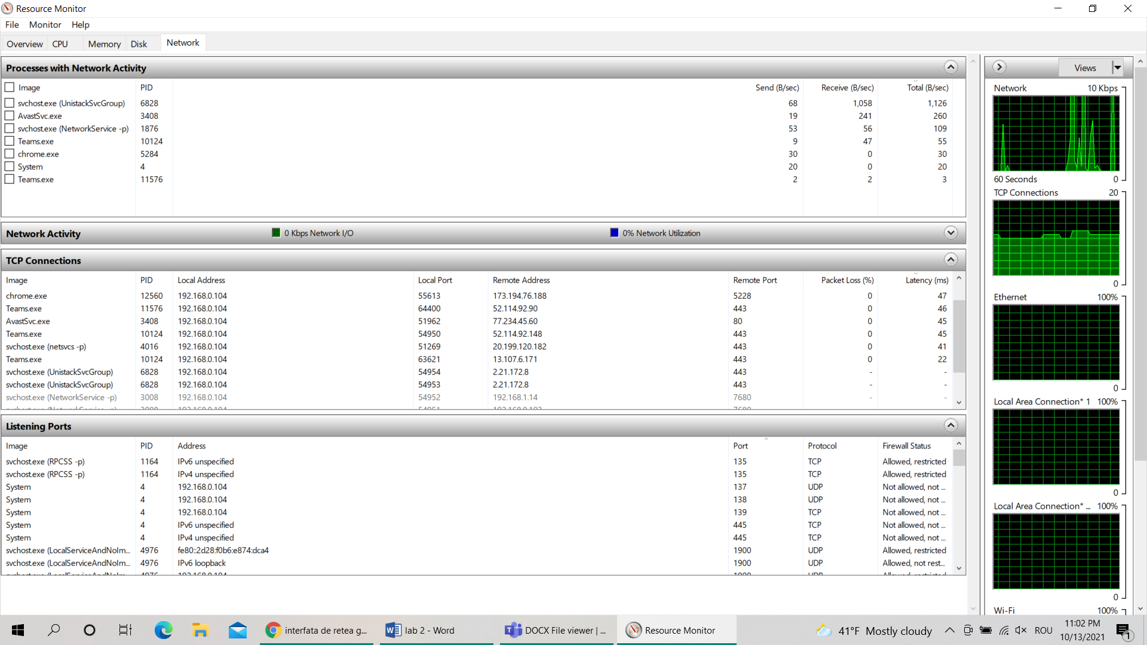

3.

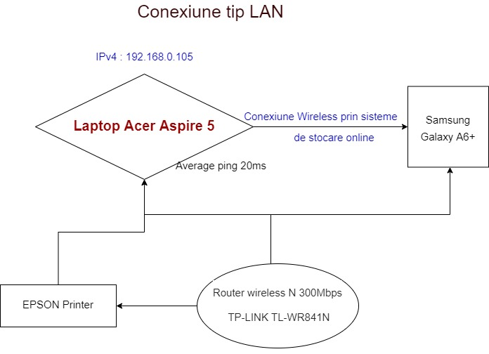

4.1. 1600×1200×8=15360000 biti=15360 Kbiti

* V==> t===274 s
* 1Mbps=1000kbiti

t==15,36 s

* 10 Mbps=10000kbiti

t==1,536 s

* 100Mps= kbiti

t==0,156 s

* 1Gbit= kbiti

t==0,0156

4.2. C52 = 10 topologii

topologii

1 topologie=100ms => topologii= ×100 ms=104857600 ms=104867,6 s