**Image Editing**

Image editing represents the action of altering the images, having the goal of improving the photograph after applying different operations: noise reducing, blurring, color adjustment and many more.

1.Image enhancement techniques can be divided into two categories:

* Spatial domain methods
* Point operations
* Histogram equalization and matching

2.Frequency domain methods

* Un sharp masking
* Homomorphic filtering

Point operations are defined as functions that are performed on each pixel of an image, independent of all other pixels in that image. Operations can be unary, meaning that a single image is modified, or they can be binary, which means that two images are combined in some manner. In certain situations, a point operation may be tertiary, implying that three images are used. Point operations are a very powerful class of image functions that can be cascaded one upon another to create interesting and useful results.

*Binarization of Image*

A binary image consists of pixels with two possible values: either white or black. This operation is useful when the image includes other colors then what is needed, such as in XEROX industry.

C:\Users\Pasca\AppData\Local\Microsoft\Windows\INetCache\Content.Word\eqnptin2.gif

where s is the new pixel value, r is the current pixel value and T is the mean value.

E.g.:

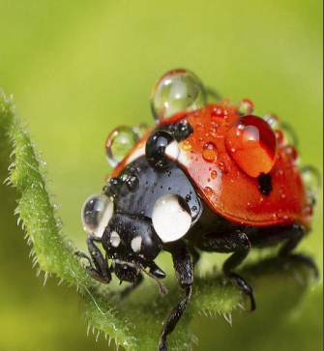 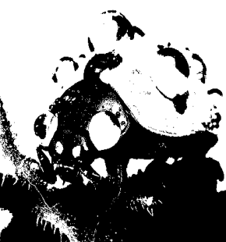

*Digital Negative*

In [photography](https://en.wikipedia.org/wiki/Photography), a negative is an image, usually on a strip or sheet of transparent plastic film, in which the lightest areas of the photographed subject appear darkest and the darkest areas appear lightest. This reversed order occurs because the extremely light-sensitive chemicals a camera film must use to capture an image quickly enough for ordinary picture-taking are darkened, rather than bleached, by exposure to light and subsequent [photographic processing](https://en.wikipedia.org/wiki/Photographic_processing).

The operation of inversing the image is useful when the negative is present, but we actually need the original picture.

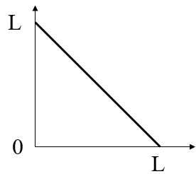

E.g.:

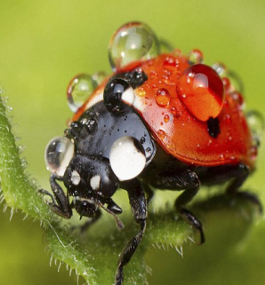

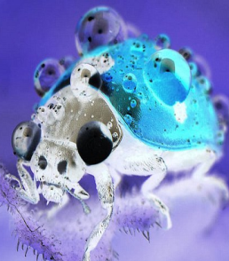

*Brightness/Contrast Adjustment*

Changing the contrast of an image, changes the range of luminance values present. Visualized in the histogram it is equivalent to expanding or compressing the histogram around the midpoint value.

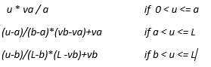

*f(u)*=

E.g.:



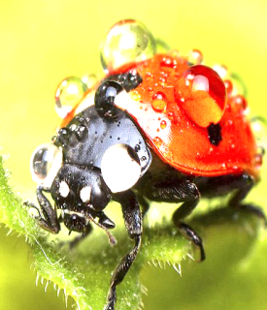

*Histogram*

The Histogram shows the total tonal distribution in the image. It's a frequency chart of the count of pixels of every tone of gray that occurs in the image. It helps us analyze, and more importantly, correct the contrast of the image.

Every pixel in the Color or Gray image computes to a Luminance value between 0 and 255. The Histogram graphs the pixel count of every possible value of Luminance, or brightness if it helps to think of it that way. Luminance is brightness the same way the human eye sees it, as opposed to absolute brightness. Anyway, the total tonal range of a pixel's 8-bit tone value is 0...255, where 0 is the blackest black at the left end, and 255 is the whitest white at the right end. The height of each vertical bar in the histogram simply shows how many image pixels have luminance value of 0, and how many pixels have luminance value 1, and 2, and 3, etc., all the way to 255 at the right end.

**Probability for a pixel to have a tone <= u:**

p(u) = (t (0) + t (1) + ... + t(u)) / T

E.g.:



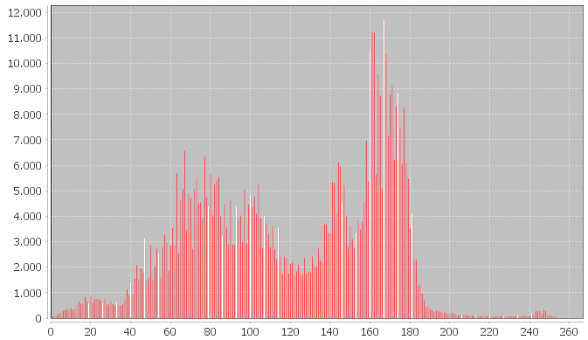

References:

<https://www.tutorialspoint.com/dip/brightness_and_contrast.htm>

<https://en.wikipedia.org/wiki/Binary_image>

<http://www.viz.tamu.edu/faculty/parke/ends489f00/notes/sec1_7.html>

<https://en.wikipedia.org/wiki/Negative_(photography)>