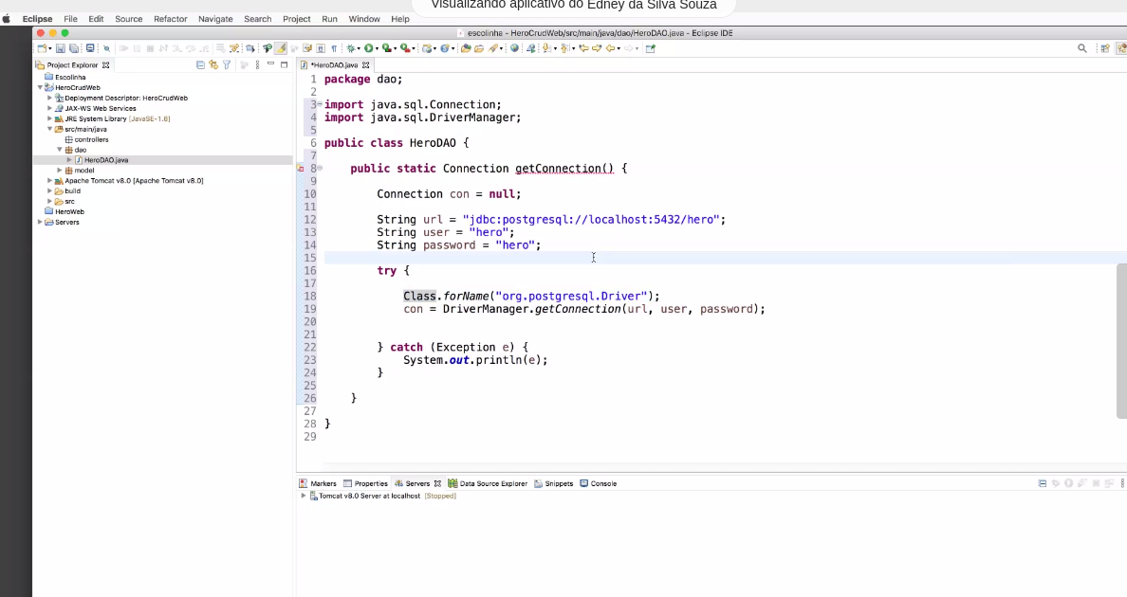
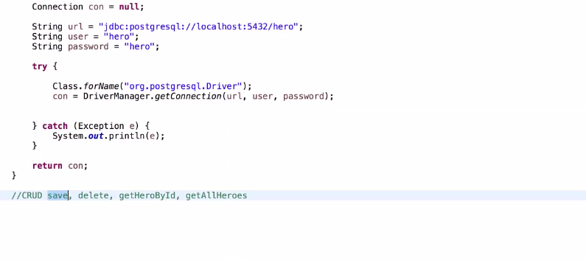

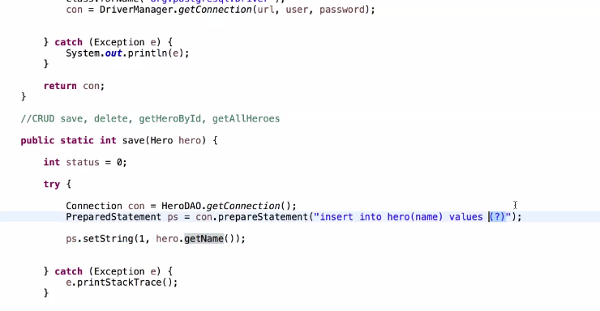
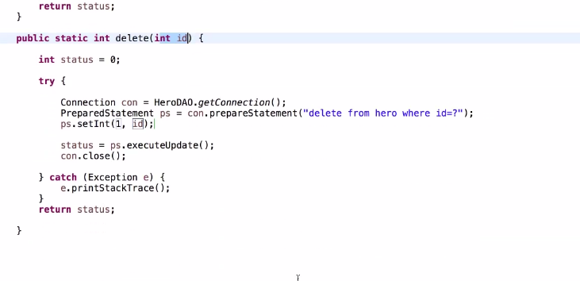

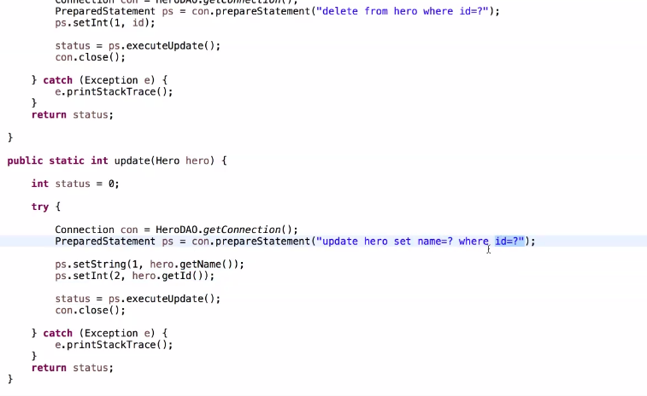

bd hero

role hero
pass hero

grant all hero

id auto pk unique
name varchar 5000

aua dia 17 ma8io

ver drawio (https://www.diagrams.net/ )

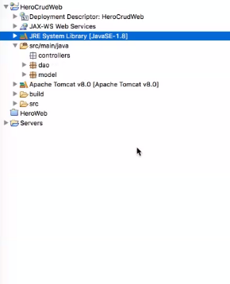
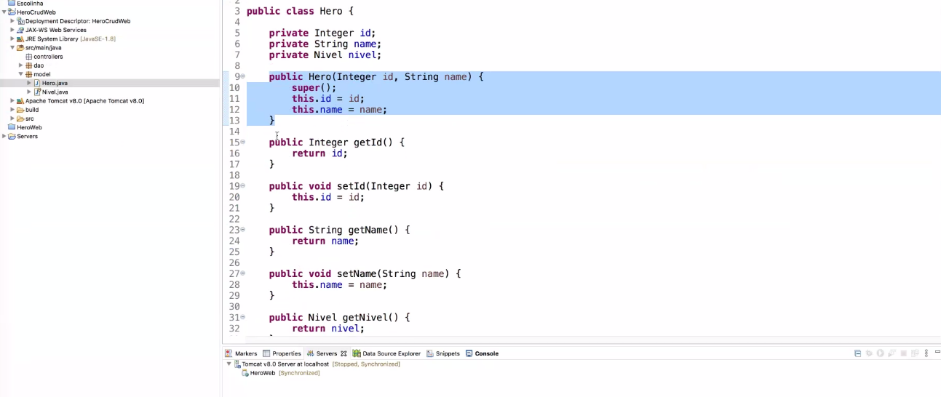
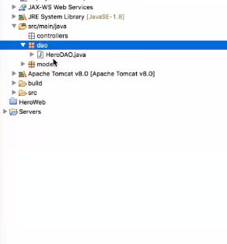

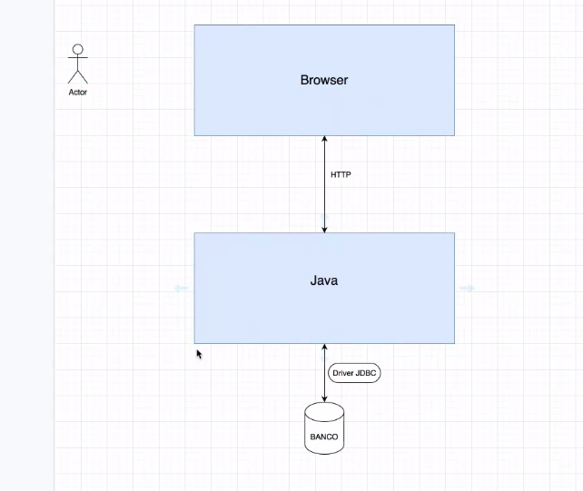

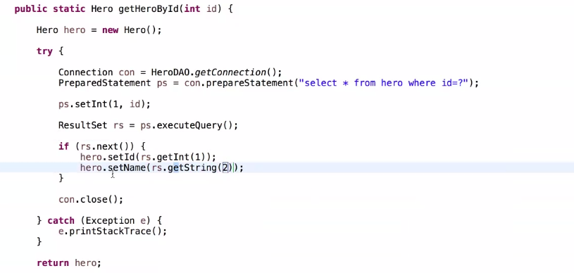

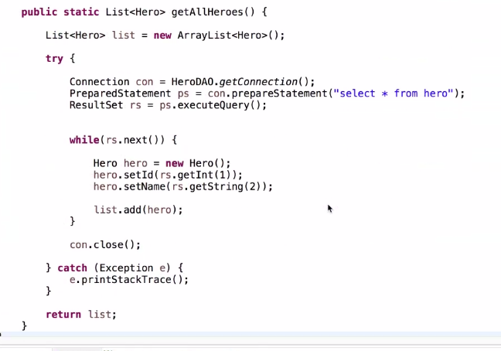
Finalizando o DAO

dica

CHEAT SHEET

INCLUIR LIB POSTGES NO DIRETORIO LIB
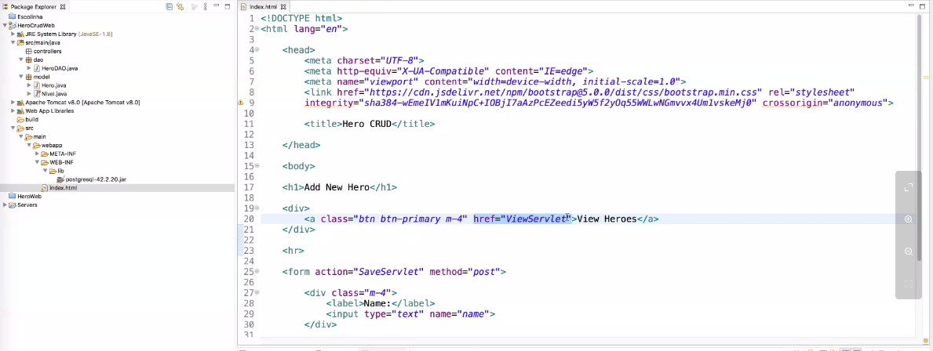

<link href="https://cdn.jsdelivr.net/npm/bootstrap@5.0.0/dist/css/bootstrap.min.css" rel="stylesheet" integrity="sha384-wEmeIV1mKuiNpC+IOBjI7aAzPcEZeedi5yW5f2yOq55WWLwNGmvvx4Um1vskeMj0" crossorigin="anonymous">

