Denis Doci

CS261

HWK11

Doci2

|  |  |  |  |  |  |
| --- | --- | --- | --- | --- | --- |
| Exchange Sort (measuring Miss Rate) | | | Block Size | |  |
|  |  | 1 | 2 | 4 | 8 |
|  | 4k | 19.60% | 23.10% |  | 44.60% |
|  | 8k |  |  |  |  |
| Cache Size | 16k |  |  | 28.60% | 38.70% |
|  | 32k |  | 14.70% | 25.80% | 35.90% |
|  | 64k |  | 14.80% |  | 35.90% |

|  |  |  |  |  |  |
| --- | --- | --- | --- | --- | --- |
| Quick Sort (measuring Miss Rate) | | | Block Size |  |  |
|  |  | 1 | 2 | 4 | 8 |
|  | 4k |  | 28.50% |  | 47.60% |
|  | 32k |  | 23.90% |  | 39.10% |
| Cache Size | 64k |  | 23.90% |  | 39.10% |

Data:

EXCHANGE SORT

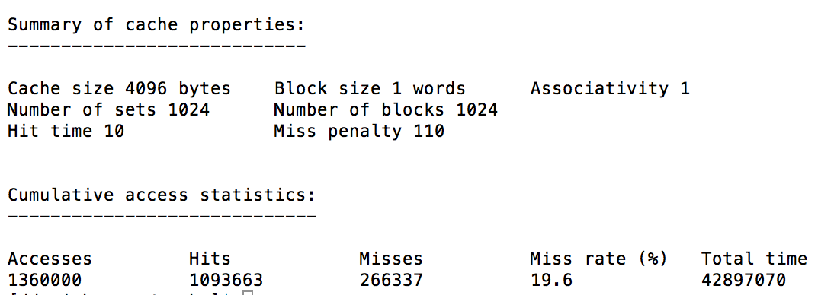

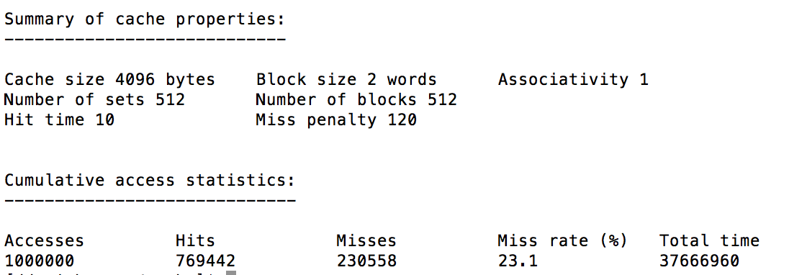

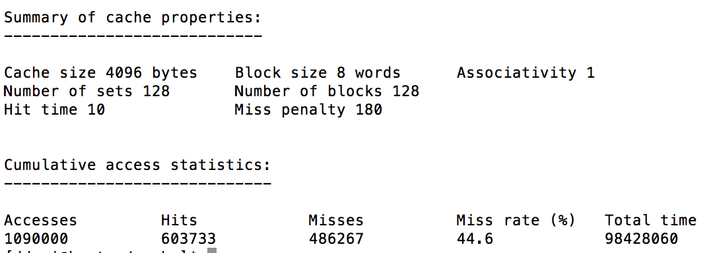

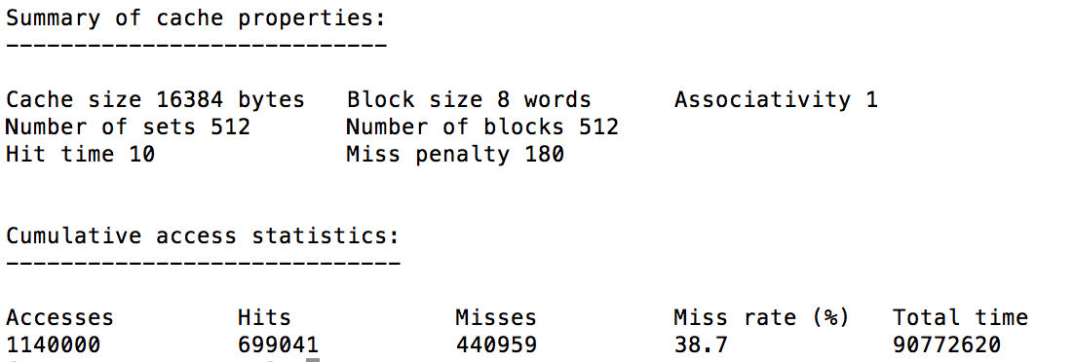

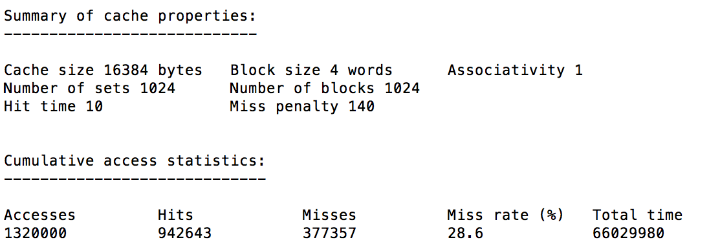

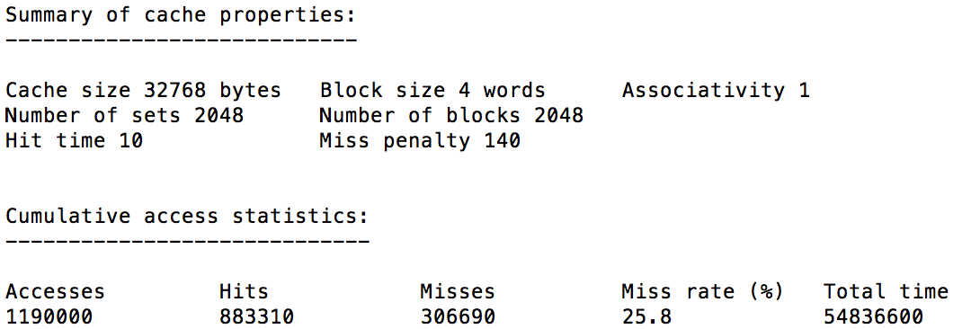-------------------------------------------------------------------------------------------------------------------------------

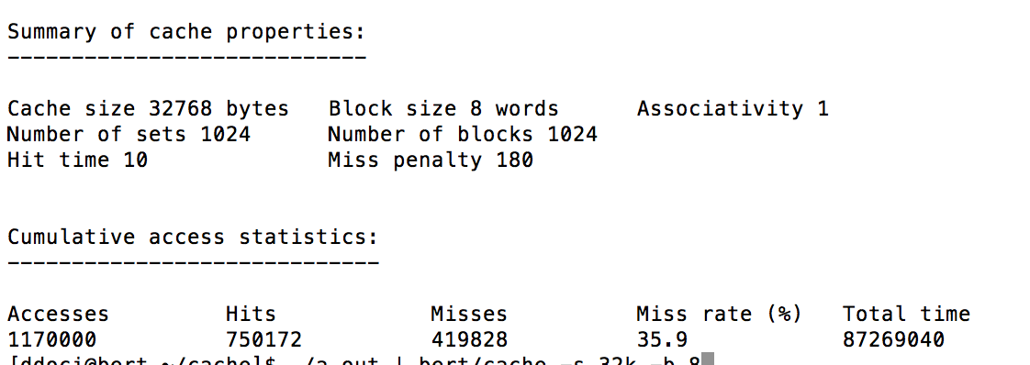-------------------------------------------------------------------------------------------------------------------------------

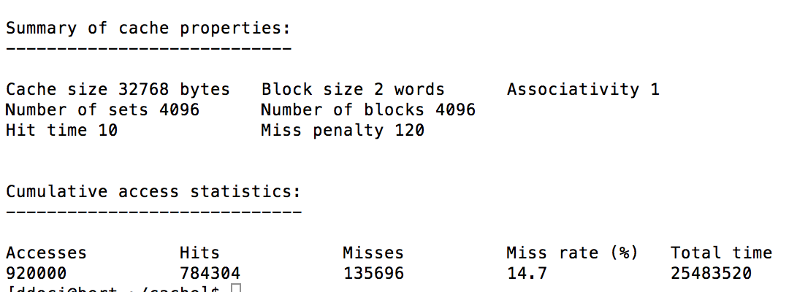

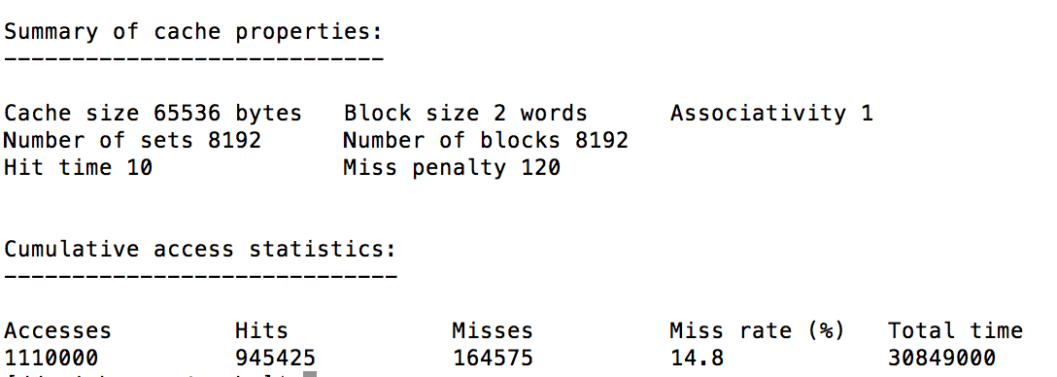

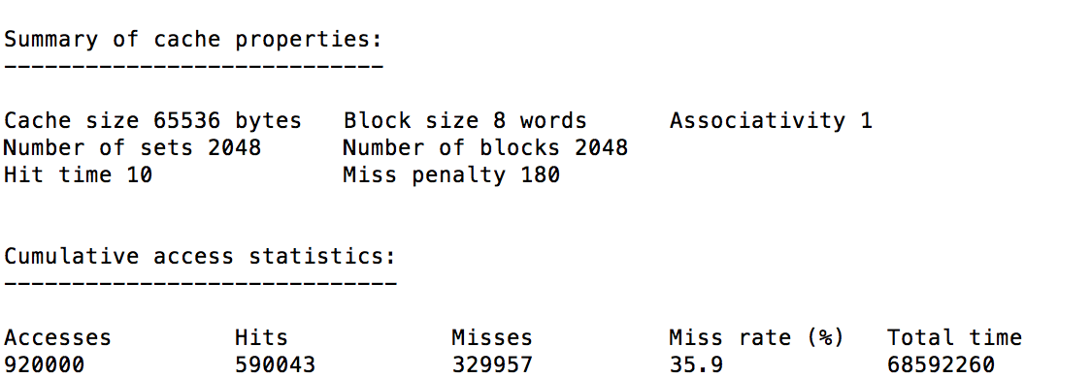

QUICKSORT

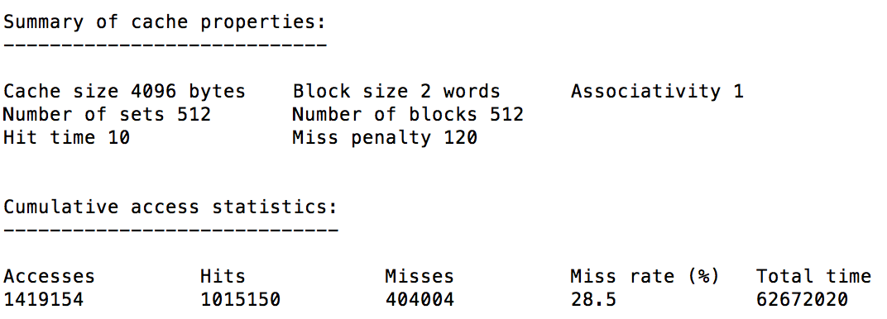

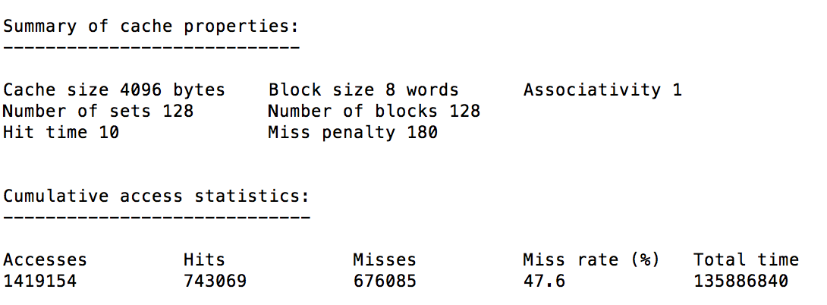

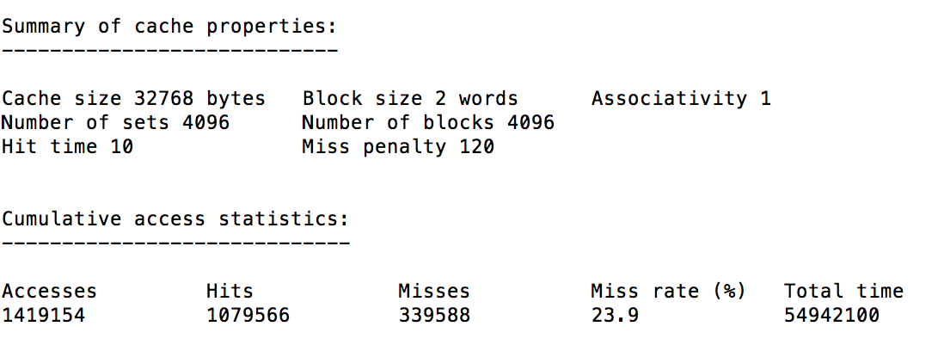

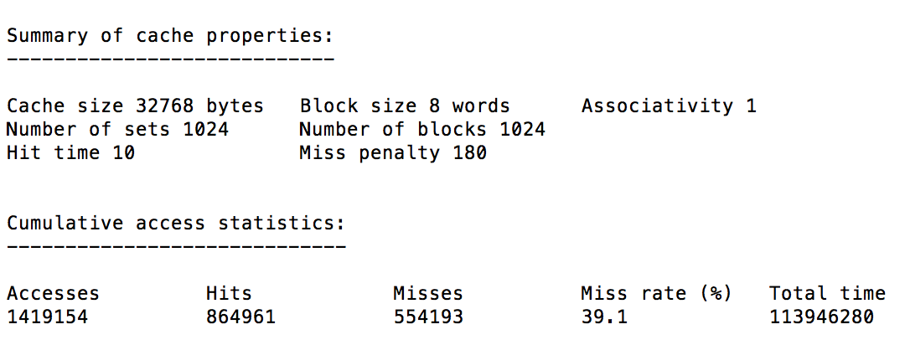

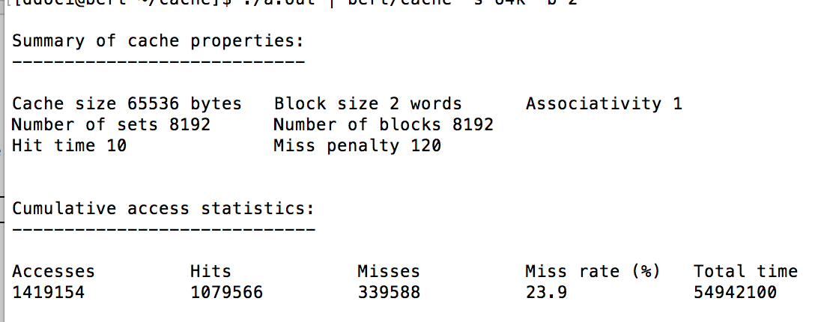

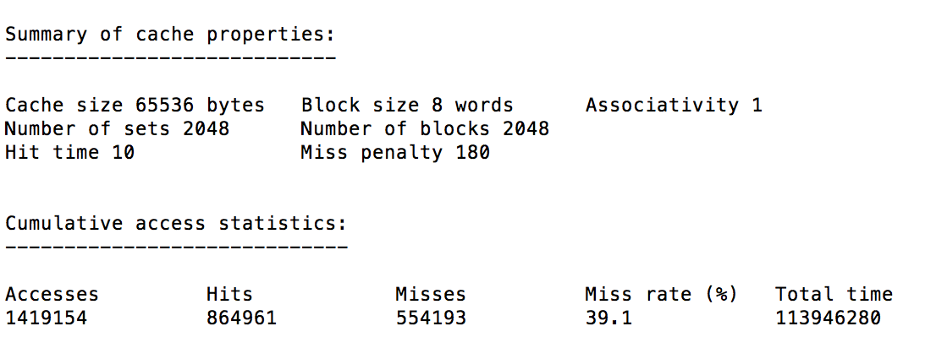

SORT.CC CODE WITH CHANGES

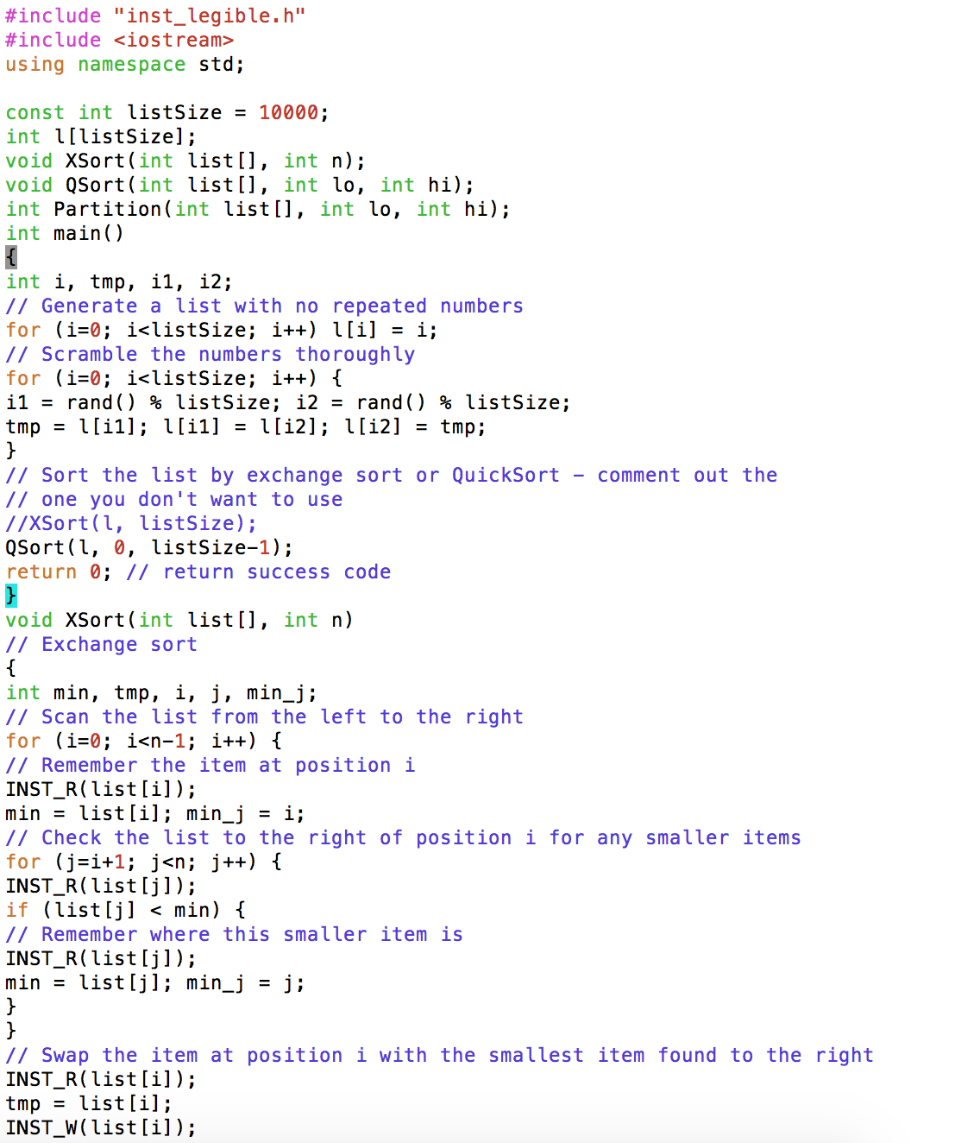

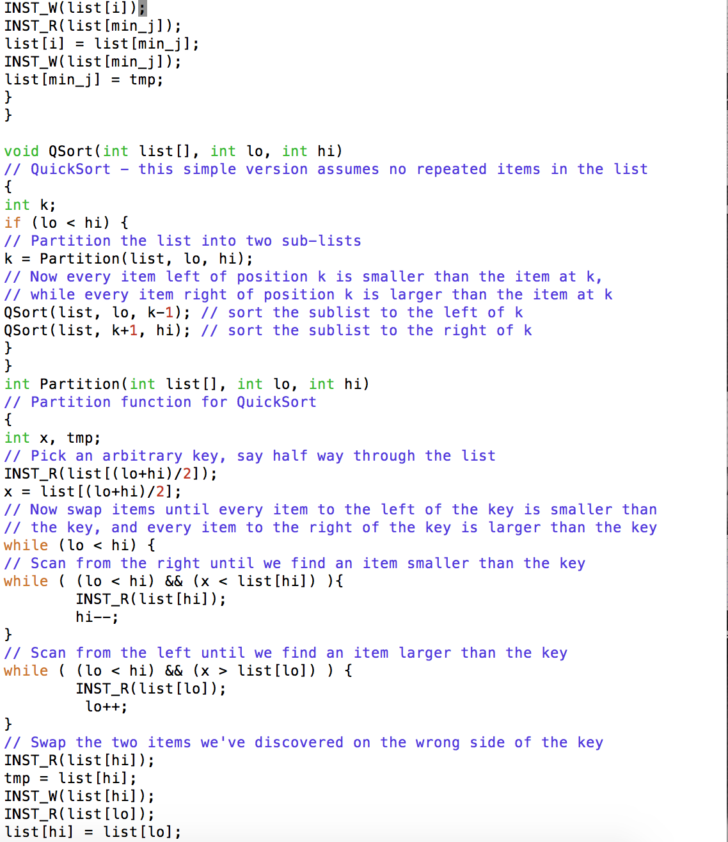//only one INST_W (mistake in screenshotting code)

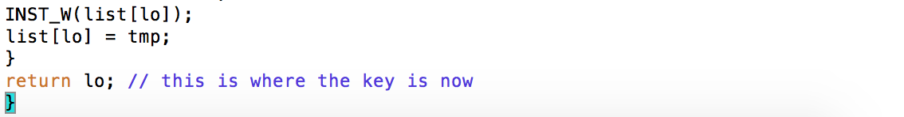Comments on Results

Miss Rates:

The general trend for miss rates in the code seems to be that as block size increases so does the miss rate. Also, as the cache size increases the miss rate tends to decrease. Also between the algorithms, it seems as though when the switch was made to quicksort from exchange sort, although the accesses decreased significantly, the miss rate actually increased. One interesting note was looking at the cache size increase in quicksort, as the cache increased the decrease in the miss rate became less significant.