Denis Doci

Partner: Katarzyna Krawczyk

Watson Report

CS 421

Watson Experience:

First off I’d like to say that getting the environment set up to use Watson conversation services was long and cumbersome. There were many problems along the way and the walk through failed to identify many issues with the downloads and installation process. For example,



That being said, after installing Watson conversation services were very easy to use and easy to

modify.

After installation, 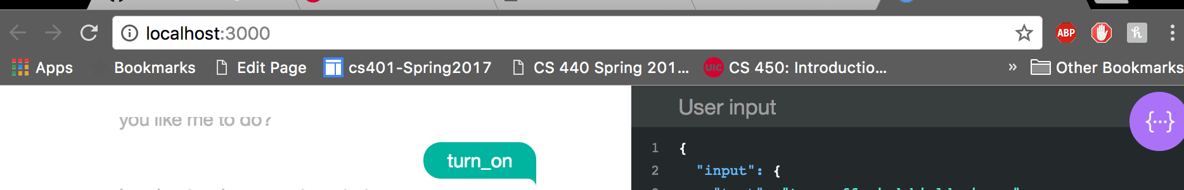

At first, we just played around with the existing chatbot to see what its behaviors were like.

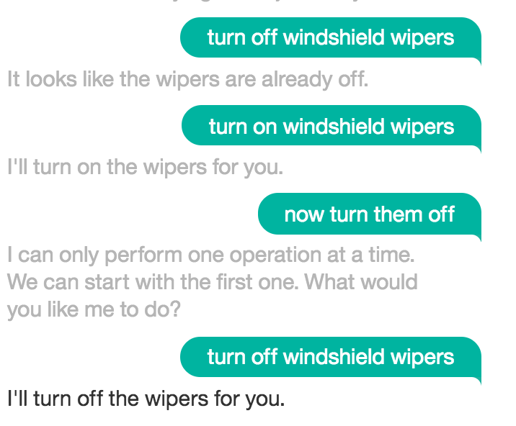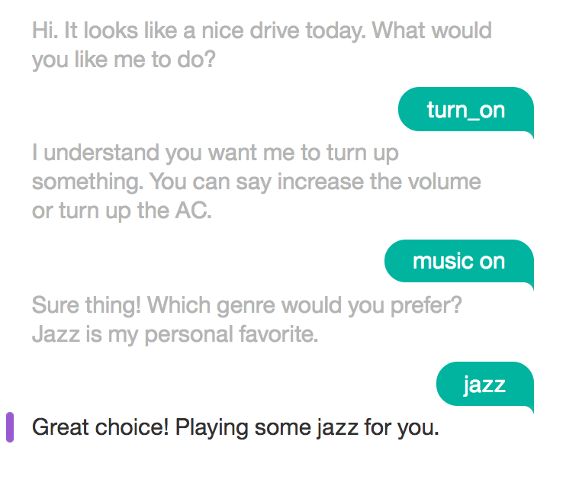

Once we got the look and feel of the of this, we decided to modify the look and feel of the application in the CSS and HTML files.

/Users/denisdoci/Desktop/Screen Shot 2017-03-29 at 4.33.33 PM.png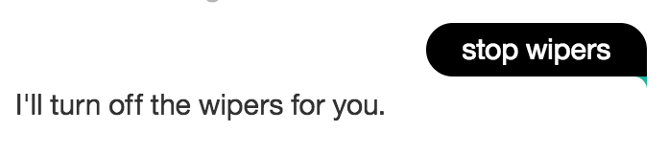

Once we did this we went accessed the services through the browser and changed some of the functionality of the application.

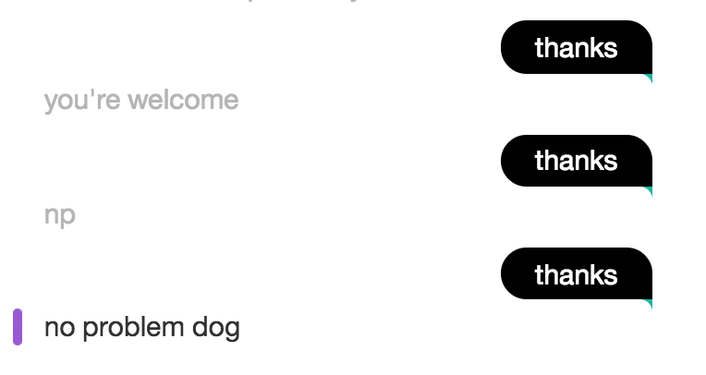

This was, in my opinion, the best part of the Watson services. Being able to easily access these tools to edit the logic in a user friendly manner showed the power of such a tool. This made up for the difficulty in installation. As a whole, this seems like a powerful tool with useful possible implementations.