# **Virtual History**

# 

# 

# 

# 

# 

# 

# **Prepared by:**

# **Group 9: Denis Doci, Pawel Zimmoch, Katarzyna Krawczyk, Alex Anderson**

# **CS 440**

# **at the**

# **University of Illinois Chicago**

# **Spring 2017**

# **I** **Project Description**

## **1** **Project Overview**

Our product is a virtual reality based history education system that allows students to view and interact with significant environments, events, and objects throughout history through the medium of a virtual reality museum.

## **2** **The Purpose of the Project**

### **2a** **The User Business or Background of the Project Effort**

Content

History education is mostly based around textbooks that attempt to cover a lot of material in a small amount of space. This reading can be tedious, especially when done for the purpose of remembering pure facts compared with actually understanding the context of the time and event. A virtual reality environment allows for an immersive experience that allows students to learn in a much more effective way.

Motivation

The lowering costs of virtual reality headsets and the rising popularity mean that this technology is quickly becoming within reach for our current education system. The power of virtual reality will have an immense effect on all fields of our current system.

Considerations

The education of a population is always a serious issue. Improvements in education consistently show improvements in a society. Any help in the process of acquiring knowledge will be beneficial, and history in particular usually lacks an element of participation for most people. Virtual reality will be used to bridge this gap, so better to build it now.

### **2b** **Goals of the Project**

Content

The goal of this project is to make educational information available in an effective method, benefiting those who learn by interaction, with an emphasis on detailed simulations that can be altered beyond that of the physical world.

Motivation

The current state of education quickly adapts to technology. By being at the forefront of the VR landscape we can establish a market presence in a quickly growing field and get a foothold on the VR education market. This will allow us to shape our product to the market while others are trying to get into the market.

Examples

We want to be able to create a museum without the limits of property and reality. One such example could be manufacturing techniques such as food production. We can stop the process at any time, display what is going on at a chemical level as well as social, and even compare different techniques from different time periods and places.

### **2c** **Measurement**

The main metrics used for success measurement are system adaptability and client response. Adaptability will measure our aggressiveness in marketing and deployment in the educational VR field. This is incredibly important as early adaption leads to favoritism and a common platform that is expensive to change. This initial investment will offer continuing returns for our platform and further development opportunities. Client response includes feedback from educators and students quantifying the system performance. Software and hardware adjustments can be created to maximize user happiness and therefore increase use.

## **3** **The Scope of the Work**

### **3a** **The Current Situation**

The desire of teachers everywhere is to find new and innovative ways of conveying information to their students. Currently, history is reduced down to texts in books, which might work for some, but is not an ideal way to learn for most. Giving teachers and students an additional way to learn would allow the students to have a better understanding of the knowledge base.

**3b** **The Context of the Work**

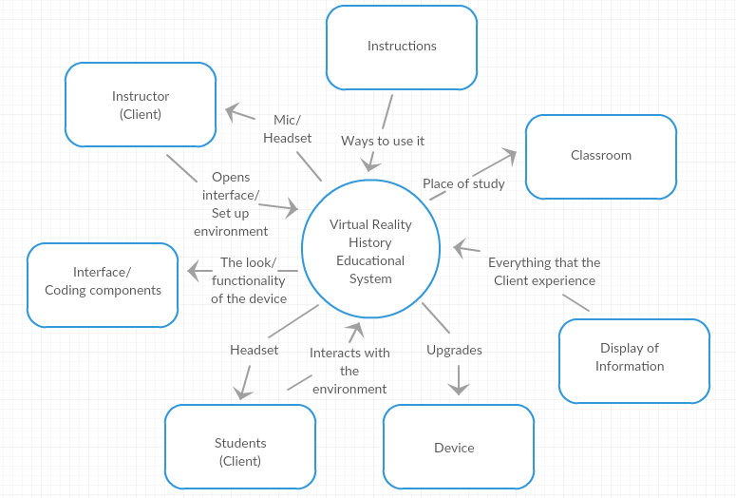

### **3c** **Work Partitioning**

Business Event List

Event Name Input and Output Summary

|  |  |  |
| --- | --- | --- |
| 1. Instructor distributes certain amount of headsets | Number of headsets for environment (in) | Record the number of headsets and set up the environment accordingly. |
| 2. Booted device checks for upgrades and upgrades if necessary | Upgraded VR device (out) | Device automatically upgrades to newest version of application |
| 3. Instructor selects specific environment | Selected environment (in) | The instructor selects a specific environment from a list of possible environments. |
| 4. Instructor selects audio setting | Mic/Headset (in) | The instructor at this point now selects an option between them lecturing or an automated lecture. |
| 5. Instructions get displayed | Instructions (out) | Instructions on how to use interface and device get displayed on user device |
| 6. Historical experience displayed | Display of information (out) | The actual display of the historical event or the historical era is presented to the user. |
| 7. Instructor launches quiz | Quiz (out) | The instructors now launch an optional quiz to test what the children learned through this experience. |
| 8. Send quiz data | Quiz (in) | Once quizzes are finished, send the statistics of these quizzes back to database to test efficacy. |

### **3d** **Competing Products**

The infancy of VR technology, especially in the educational realm means that there are many small competitors attempting to grab a foothold on the industry. Large education companies are also trying to establish themselves as the main content creators and are a much bigger threat because of their established networks, name-recognition, and client familiarity. Hardware wise, there are only a few developed platforms that most competing firms will use. Hardware development is usually costly and integration with current systems would be difficult meaning almost all competitors will be using a similar platform. Therefore the main competing points between us and other VR companies will be based on content, support, adaptability, and software design.

## **4** **The Scope of the Product**

The product delivered will be a hardware backend with a set amount of virtual reality headsets and sensors. Additional headsets can then be purchased separately. The software side will be sold in the form of a main educational museum software package with a general set of locations and information. Additional content packs including lesson plans and different areas can then be purchased as add-ons. Licensing will also be needed to authorize the amount of headset use and student use. Each student will be provided with an account which will tie in to software and hardware licensing. This allows us to keep the content up to date and to support further development costs.

**4a** **Scenario Diagram(s)**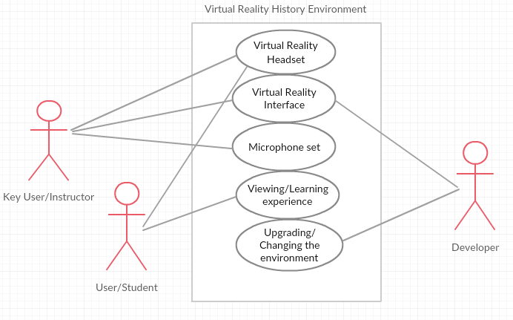

### **4b** **Product Scenario List**

1. Virtual reality headset setup
2. Virtual reality interface
3. Microphone set
4. Viewing experience
5. Upgrading environment

### **4c** **Individual Product Scenarios**

1. Virtual reality headset setup

Before the beginning of each session, users will be required to put on their virtual reality devices. This includes both the instructor and the students. This portion will establish the virtual classroom setting and determine the user set for the experience.

2. Virtual reality interface

Developers will create an interactive interface that users will use to engage with their environment. Throughout the experience the interface will provide options for side facts about the experience along with optional quizzes the instructor can choose to implement.

3. Microphone set

This is defined as the audio settings for the experience. The instructor is fitted with a microphone. When the lecture option is chosen, the instructor's audio from the microphone will overlay on top of the existing experiences audio. If it is not chosen, there will be an automated version for every experience.

4. Viewing Experience

The viewing experience is the actual ‘museum.’ The developers will render a virtual reality representation of a specific historical era. The user will be able to experience this era through their headset. This is not just one era, but instead a variety of eras can be chosen.

5. Upgrading environment

It is highly unlikely that the first release of the viewing experience will be without bugs. Developers will attempt to mitigate this by releasing periodic updates to experiences and templates. This is not limited to fixing bugs, but also improving the environments in making the more detailed and interactive. The users themselves will be able to download new upgrades and utilize them for their museum experience.

## 

## 

## **5** **Stakeholders**

### **5a** **The Client**

The main client would be the educational institutions. They will be the ones investing in the education of their students, which is what we are trying to help accomplish.

### **5b** **The Customer**

While education institutions will be the ones who purchase our product, it must be sold to the instructors. They will be the ones who request funding from the institutions, and they will be the ones who will help us sell our product.

### **5c** **Hands-On Users of the Product**

The main set of users would be students at the educational institutions. They may be of any age and education, depending on the scope of the project and the specific educational modules being used by the purchaser. They will interact with the simulations given in the project. They would not need to understand much about the process of educating, but simply follow the instructions provided by the teacher/program.

It is also expected that the teacher would also become a user of the program, in order to best extract the value of the program for the use in his classroom. We would expect that they would be knowledgeable of the information being taught, so accuracy in our information should be considered a significant priority.

A well-designed user interface would be able to accommodate both sets of users with consideration of their technical expertise. No programming should be expected of anyone, but a simple way to create lesson plans for the teachers.

### **5d** **Priorities Assigned to Users**

Learning institutions will make the decision on purchasing our product. Since they should be guided by the instructors, then the instructors should stand in as the key user. Also, instructors will have a better understanding of the effectiveness of the program, thus will be a key source of knowledge on making the best product.

Students will make the bulk of secondary users. Their use of the program is out of their hands, but can also give feedback that can benefit the program.

There might be more users of the program, if the program is made available to the general product. Without some insight into who these users might be, there is no foreseeable use in their requests.

### **5e** **User Participation**

The participation of the user will vary, depending on what specifically is being done with the program. Some displays in the museum will be completely passive, such as watching a simulation or observing an art piece. Other displays could be interactive, allowing users to adjust properties or trigger events to see how that would affect some object or event.

Instructors would have a more active role to play, given that they would have to set up what should be rendered, what should be allowed, and possibly taking control of adjustable variables in simulations to get specific ideas across to the students.

### **5f** **Maintenance Users and Service Technicians**

Maintenance personnel will be needed for both software and hardware sides of the product. Hardware maintenance packages will need to be included as the hardware devices will be physically handled. The sensitivity of the headsets and the cost involved mean that ongoing hardware support will almost certainly be required for our clients. Software support will most likely include helpdesk for usage related inquiries and technical support for questions relating to the operation of the hardware backend and any software glitches that the client might encounter. The cost of software support will be minimal in comparison to supporting the hardware issues that might arise.

### **5g** **Other Stakeholders**

In the future, as the product develops, there is a possibility that other institutions of learning might pick up this product, such as libraries and physical museums. Our consideration of this possibility and what it would mean for this product should be considered at a later date, if the event arises.

## **6** **Mandated Constraints**

### **6a** **Solution Constraints**

Description: The product will be used in current classrooms.

Rationale: The cost of building is beyond the value of this product.

Fit criterion: The product must be deployable in a classroom without being intrusive to the other uses of the classroom.

Description: The window of opportunity for this idea is short.

Rationale: Applying any idea to virtual reality and seeing what sticks could describe a significant portion of new software development projects.

Fit criterion: Use pre-made hardware and software when possible.

### **6b** **Implementation Environment of the Current System**

The product will consist of headsets for each student as well as one for the instructor. They would need to be supported by a computer, either one computer for each set or possibly one computer could support multiple headsets.

This would all have to fit inside a classroom, which will have multiple uses beyond our product. This would constrain the use of wires, as they quickly get in the way and could be a tripping hazard. Wireless technology should be used wherever possible.

### **6c** **Partner or Collaborative Applications**

Many companies like to associate themselves with education, especially if their current image is one of entertainment, since there seems to be greater esteem for those who help others more so than those who just serve up distractions. HTC Vive would not be out of the question, but more so Oculus because they are owned Facebook, and Facebook is in a constant state of improving their brand.

Software companies could be useful, especially companies who design physics engines. A company like Unity might like the opportunity to get their name associated with education, but even more so like the idea that they have something robust enough to simulate multiple periods of time in a detailed manner that can be manipulated in real time by multiple users.

### **6d** **Off-the-Shelf Software**

In order to maximize our performance with hardware, there is a nice appeal to using Linux as an operating system. Unity would also be a product that could be purchased to get our simulations started and modeled for testing and even through to production.

### **6e** **Anticipated Workplace Environment**

The users would likely use this product in a classroom, so accommodating a user in a sitting space would be a good idea. Movement in virtual realities have been done without the need of physically walking around, so we should easily get around any constraint that sitting might cause.

Also, a teacher would want to be able to talk to the students, so if headphones are used, they should not be noise cancelling, or a mic would be needed for the instructor.

### **6f** **Schedule Constraints**

The schedule for this product should be seen as ASAP. Even if a limited amount of modules are available at launch, a product should be available quickly. More modules could be promised for free, as well as other incentives to encourage rapid market growth before any possible competitors could get their products to market.

Big pushes for reinvestment into our product, such as new headsets or software packages, should be timed around Spring, so purchases could be made and training, shipping, and downloading available during the Summer, when schools might have more time and freedom for deployment.

### **6g** **Budget Constraints**

While a budget is necessary, the value added by bundling hardware with software should exceed the cost to produce. The hardware cost would be the biggest issue, but a strong push into collaboration with some headset manufacturer could do wonders on that front, as well as bulk purchasing negotiations.

The software costs could be mitigated by rolling out small packages at first, using early adopters to fund further software development, as well as using user feedback as to which parts of our scope to focus on developing.

## **7** **Naming Conventions and Definitions**

### **7a** **Definitions of Key Terms**

Device: Virtual reality hardware that the user is interfacing with.

Museum: Another term for the virtual environment created by developers that the users interact with. This could be a historical era or event.

Classroom: The physical environment that the device is deployed in. Referred to as a classroom because education is the targeted consumer.

Interface: Interactive display that the user utilizes to engage with the environment.

Environment: Current simulation that the virtual reality device is running. This could be a historical era of time or a specific historical event.

### **7b** **UML and Other Notation Used in This Document**

This document generally follows the Version 2.0 OMG UML standard, as described in,

M. Fowler, UML Distilled, Third Edition, Boston: Pearson Education, 2004. Exceptions are noted in their specific cases.

### **7c** **Data Dictionary for Any Included Models**

Oculus Audio SDK Plugins V1.1.3

Oculus Platform SDK V1.11.0

Instructor = lecturer || operator of system

## **8** **Relevant Facts and Assumptions**

### **8a** **Facts**

Many kids will learn better through interaction and a medium more associated with gaming.

Teachers want to engage students in any possible way.

### **8b** **Assumptions**

The main assumption being made at this time is that there is a desire to improve the education of students in the field of history. There will also need to be an assumption made about the expected budget of educational institutions towards projects such as ours.