BSU-Trace: A Smart Campus Resource Management System with Bottleneck Analytics and Predictive Forecasting

A Capstone Project
Presented to the Faculty of
College of Informatics and Computing Sciences
BATANGAS STATE UNIVERSITY
The National Engineering University
Lipa City

In Partial Fulfillment
of the Requirements for the Degree
Bachelor of Science in Information Technology
Business Analytics

By

Justine Kyle M. Balubal
Alex Denise R. Capute
Gian Carlo N. Diaz

Mr. Dioneces O. Alimoren
Adviser

<Month and year of degree conferral, not date of submission>

DEDICATION
This portion is optional but perhaps you have someone or some people who have inspired you to push on with your studies? A dedication would be a fitting way to acknowledge their impact on your success.

ACKNOWLEDGMENTS
The road to this point in your studies couldn’t have been traveled alone. Along the way, someone somewhere helped you. This is your chance to thank them.
By the way, exercise the liberty to be personal to reflect the sincerity of your gratitude.

Table of Contents
1. INTRODUCTION 10
1.1. Project Context 10
1.2. Purpose and Descriptions 12
1.3. Objectives of the Study 14
1.4. Scope and Limitations 15
1.5. Definition of Terms 17
2. REVIEW OF RELATED SYSTEMS/STUDIES 22
2.1. Technical Background 22
2.1.1. Web System Technologies 23
2.1.2. Analytics / Machine Learning 24
2.2. Related Literature 25
2.3. Related Studies 29
2.4. Related System 33
2.5. Synthesis 36
2.6. Conceptual Framework 37
3. DESIGN AND METHODOLOGY 41
3.1.1. Descriptive Analytics: Operational Transparency 42
3.1.2. Predictive Analytics: Administrative Forecasting 43
3.1.3. Decision Support: Optimized Allocation and Routing 43
3.2. Development Model 44
3.3. Requirements Analysis 46
3.4. System Design 49
3.4.2. Database Design 90
3.4.3. Trade-off and Multiple Attributes 94
3.5. Development 96
3.5.1. Software Development Tools 97
3.5.2. Hardware Development Tools 98
3.6. Testing and Evaluation 99
3.7. Deployment 110
3.7.1. Sustainability and Maintenance Plan 111
4. RESULTS AND DISCUSSION 113
4.1. Results by phase of study (Rephrase Objectives as title) 113
4.2. Verification studies 113
5. SUMMARY, CONCLUSIONS, AND RECOMMENDATIONS 115
5.1. Summary 115
5.2. Conclusions 115
5.3. Recommendations 116
REFERENCES 117

LIST OF TABLES
Table 3-1. Functional Requirements 82
Table 3-2. Non-Functional Requirements 86
Table 3-3. Hardware Requirements 89
Table 3-4. Software Requirements 90
Table 3-5. Trade Off 94
Table 3-6. Multiple Attributes 96
Table 3-7. Software Development Tools 97
Table 3-8. Hardware Development Tools 99
Table 3-9. Test Cases 103
Table 3-10. Evaluation Metrics 107

LIST OF FIGURES
Figure 2-1 Conceptual Framework 38
Figure 3-1. Agile Methodology (Kimei, 2024) 44
Figure 3-2. Existing Flowchart of Current Process of Offices 47
Figure 3-3. System Architecture of BSU-Trace 51
Figure 3-4. System Process Flowchart for BSU-Trace 54
Figure 3-5. Use Case Diagram for each End User and Functions 56
Figure 3-6. Context Flow Diagram (CFD) of BSU-Trace 60
Figure 3-7. Data Flow Diagram (DFD) - Level 1 63
Figure 3-8. DFD Level 2 – Document & Route Configuration (Process 1.0) 66
Figure 3-9. DFD Level 2 – QR-Hybrid Audit Tracking (Process 2.0) 68
Figure 3-10. DFD Level 2 – Van Scheduling & Management (Process 3.0) 70
Figure 3-11. DFD Level 2 – Predictive Analytics Engine (Process 4.0) 72
Figure 3-12. Data Pipeline for the BSU-Trace 74
Figure 3-13. Entity Relationship Diagram (ERD) 91

LIST OF EQUATIONS
Equation 3-1. Processing Time for each Document 76
Equation 3-2. Processing Time of each Office for Bottleneck Analysis 77
Equation 3-3. Estimated Date of Completion (EDC) 78
Equation 3-4. Time Series Forecasting 79
Equation 3-5. Root Mean Squared Error (RMSE) 80
Equation 3-6. Mean Absolute Error (MAE) 81
Equation 3-7. R-Squared ($R2$) 81
Equation 3-8. Mean Absolute Percentage Error 82

ABSTRACT
Insert your abstract here. This portion is not to be indented and should be clear, concise, and complete. As much as possible, limit the introductory part to a few sentences and make sure that the last sentence reiterates the achievement of the general objective of the research.

Keywords: at least five keywords related to study

INTRODUCTION

Project Context
The digital transformation of administrative operations has become a global standard for institutional efficiency. Research indicates that the integration of automated tracking systems in organizational workflows significantly reduces operational delays and enhances data integrity (Vărzaru & Bocean, 2024). Globally, the shift toward "Phygital" systems where physical assets are tracked via digital twins or QR-coded identifiers, allowing for real-time visibility and resource optimization in high-stakes environments like universities and government offices (Mele, Russo Spena, Marzullo, & Di Bernardo, 2023).
In the Philippines, the implementation of the "Ease of Doing Business and Efficient Government Service Delivery Act of 2018" continues to drive academic institutions toward paperless or digitally-augmented workflows. Recent studies within Philippine Higher Education Institutions (HEIs) highlight that adopting centralized resource management systems improves the accountability of administrative staff and streamlines the approval process for internal documents (Dres & Rabut, 2025). This national push for "Smart Campuses" emphasizes the need for analytical tools that can handle both document flow and institutional assets, including university vehicle fleets, specialized facilities like the Assemblyman Rafael R. Recto Gymnasium, and real-time inventory for general equipment.
At Batangas State University - Lipa Campus, administrative efficiency is central to supporting its growing faculty and staff population. Currently, the movement of critical documents such as Trip Tickets, Facility Reservation Slips, and Equipment Lending Forms relies on manual delivery across various offices. Local observations suggest that a centralized, analytical tracking system would significantly benefit the BSU Lipa community by providing transparency in document "dwell times" and ensuring that scheduling for vehicles, the Multimedia Room, and the Assemblyman Rafael R. Recto Gymnasium is systematically synchronized with approved requests, while providing real-time visibility for the availability of folding tables and monobloc chairs.
Despite the digital advancements in other sectors, BSU Lipa still faces an administrative "Black Hole" where physical documents requiring "wet signatures" become untraceable once submitted. There is no real-time mechanism for staff to monitor which office holds their paperwork, leading to frequent follow-ups and delays. Furthermore, the current system lacks integration between document approval processes and general resource management. This often results in scheduling conflicts where university vehicles, the Multimedia Room, or the Assemblyman Rafael R. Recto Gymnasium are reserved, but the necessary paperwork remains stuck in the approval pipeline. Additionally, the complexity of manual workflows often leads to user confusion regarding the specific office hierarchy required for different transactions, highlighting the need for a system that can provide both transparency and automated process guidance.
To address these inefficiencies, the researchers developed "BSU-Trace: A Smart Campus Resource Management System with Bottleneck Analytics and Predictive Forecasting." This system uses a QR-Hybrid tracking method to create a digital audit trail for physical papers and an integrated module to automate the scheduling and real-time availability monitoring of university vehicles, gymnasium facilities, and event inventory. A key innovation is the Automated Routing feature, which generates the configured office sequence based on the selected document type, while resource requests remain subject to GSO review and approval.

Purpose and Descriptions
The primary purpose of BSU-Trace is to eliminate the opacity of manual administrative processes and resource allocation at BSU Lipa. By providing a "Pizza Tracker" style interface for Faculty and Staff, the system restores confidence in the administrative workflow and ensures that urgent documents, requests for the Multimedia Room and Assemblyman Rafael R. Recto Gymnasium, and equipment lending requests (Folding Tables and Monobloc Chairs) move through the correct hierarchy without getting lost.
It bridges the gap between traditional "wet signature" requirements and modern digital tracking. To enhance user efficiency, the system uses Automatic Process Pathing to generate the configured office route when the user selects a document type, such as a reimbursement or facility request.
The system is designed as a Progressive Web App (PWA) to ensure accessibility across both desktop and mobile devices used by Office users. It bridges the gap between traditional "wet signature" requirements and modern digital tracking. By scanning unique QR codes at each office junction (Receive/Release), the system generates a granular dataset of document movement.
This solution was chosen specifically to address the disconnect between paperwork and physical resources. By integrating Business Analytics, the system identifies offices with longer average document dwell times through ranked analytics charts. It also generates Estimated Date of Completion (EDC) estimates using Ridge regression, a regularized linear regression model, when at least 20 qualifying records are available; otherwise, it uses a dwell-time-based estimate. Its current peak-demand forecasts cover vehicle and facility bookings using historical booking records. These analytics support GSO planning for vehicle and facility demand, alongside real-time inventory availability for folding tables and monobloc chairs.

Objectives of the Study
The general objective of this study is to develop BSU-Trace, an Analytical Resource Management System that optimizes administrative document tracking and the scheduling of campus resources including university vehicles, the Multimedia Room, and the Assemblyman Rafael R. Recto Gymnasium through QR-hybrid monitoring, automated routing, and machine learning-driven demand forecasting.
Specific Objectives:
- To design and implement a web-based platform with the following core functional components:
  - QR-Hybrid Document Audit Trail (Receive/Release Scanning)
  - Integrated Resource Scheduling Module
  - Automated Process Pathing
  - Real-time Status Notification System for Document Tracking
  - Bidirectional Feedback and Correction Module
  - Dynamic Referral Logic
- To integrate multi-level analytics to support proactive administrative management:
  - Descriptive: To generate office-level dwell-time summaries and ranked charts to identify offices with longer processing times.
  - Predictive: To use Ridge regression, a regularized linear regression model, for Estimated Date of Completion (EDC) forecasting, with a dwell-time-based fallback when historical records are insufficient.
  - Predictive: To forecast vehicle and facility booking demand from historical booking records.
  - Decision Support: To provide optimized resource allocation and automated routing recommendations.
- To evaluate the performance of the system based on:
  - ISO/IEC 25010:2023 System Quality Evaluation
  - Statistical Metrics: Utilizing RMSE, MAE, R-squared, and MAPE for validating predictive model accuracy.

Scope and Limitations
The scope of this study focuses on the development and implementation of BSU-Trace, a mobile-responsive web application designed to optimize administrative document tracking and comprehensive resource management at Batangas State University – Lipa Campus. The system features a QR-hybrid tracking mechanism that generates a digital audit trail for physical documents and provides a centralized platform for submitting requests for university vehicles, the Multimedia Room, and the Assemblyman Rafael R. Recto Gymnasium. Additionally, the system includes a real-time availability interface for GSO inventory, specifically folding tables and monobloc chairs, to streamline same-day inquiries and lending processes.
The platform includes an Integrated Resource Management module overseen by the GSO Admin. To ensure procedural accuracy, the system incorporates Automated Process Pathing, which generates the configured office sequence when the user selects a document type (e.g., Reimbursement or Equipment Loan). To enhance administrative oversight, the system generates EDC estimates using Ridge regression, a regularized linear regression model, when at least 20 qualifying document records are available; otherwise, it uses a dwell-time-based fallback. Its current peak-demand forecasts cover vehicle and facility bookings using historical booking data. System performance is rigorously evaluated using ISO/IEC 25010:2023 standards and statistical metrics including RMSE, MAE, R-squared, and Mean Absolute Percentage Error (MAPE) specifically for time-series accuracy.
This study is strictly limited to the administrative transactions and official business of BSU staff; it does not include student-related document processes or student organization requests. The accuracy of document tracking and dwell-time analytics depends on Office users consistently recording Receive and Release scans at designated offices, while vehicle and facility demand forecasts depend on complete and accurate booking records. Furthermore, while the platform facilitates digital monitoring, real-time inventory tracking, and status updates, it does not replace the legal requirement for physical "wet" signatures on official documents. Requests for university vehicles, the Multimedia Room, and the Assemblyman Rafael R. Recto Gymnasium are submitted through BSU-Trace and follow a "First Come, First Served" policy. Each request remains pending until the GSO manually reviews and approves it; approved requests are then reflected in the user's portal. Finally, the scope is confined to the BSU Lipa Campus and does not encompass inter-campus document routing or financial payment processing.

Definition of Terms
The following terms have been defined conceptually and operationally in order to ensure that the reader has a proper understanding of the variables and technical processes involved in the development of BSU-Trace: A Smart Campus Resource Management System with Bottleneck Analysis and Machine Learning. Although the conceptual definition provides a basic understanding of the terms, the operational definition specifically states the way the terms have been used in this study.
Bottleneck Analysis. A management tool used to identify constraints and inefficiencies in a system or process that limits its capacity and productivity (Turdibayeva, 2024). Operationally, it refers to BSU-Trace's analysis of average document dwell time by office, presented in ranked charts to identify offices with longer processing times.
Faculty user. An individual faculty member who uses a Faculty account to submit document and resource requests, select a document type, and track document and request status in BSU-Trace.
Office user. An authorized university employee who uses the Office account type to record document receipt and release, process approvals, enter correction remarks, and refer documents to other offices.
Progressive Web Application (PWA). An app that's built using web platform technologies, but that provides user experience like that of a platform-specific app . Operationally, it refers to the architecture of BSU-Trace that allows it to be accessed as a mobile-responsive interface by Office users and Faculty users on both desktops and smartphones.
Machine Learning. Machine learning is the subset of artificial intelligence (AI) focused on algorithms that can “learn” the patterns of training data and, subsequently, make accurate inferences about new data (Bermann, 2024). Operationally, it refers to BSU-Trace predictive models, including Ridge regression for EDC estimates and demand-forecasting methods for vehicle and facility bookings.
Phygital. (Physical plus Digital) is a marketing term that describes blending digital experiences with physical ones (Horwitz, 2023). Operationally, it refers to physical documents and resources linked to digital records through QR identifiers for institutional tracking and visibility.
Smart Campus. Smart Campus is an emerging trend that allows educational institutions to combine smart technologies with physical infrastructure for improved services, decision making, campus sustainability etc. (Polin, Yigitcanlar, Limb, & Washington, The Making of Smart Campus: A Review and Conceptual Framework, 2023). Operationally, it refers to the institutional environment that utilizes analytical tools to optimize the flow of administrative documents and campus resources.
Administrative “Black Hole”. “Black holes” are a common supply chain problem, caused as much by disjointed systems as by lack of visibility into data, processes and workflows. Operationally, it refers to the state of manual administrative workflows where physical documents requiring signatures become untraceable after submission, resulting in a lack of real-time monitoring and frequent delays.
Wet Signature. Also known as a physical signature, refers to the traditional method of signing a document with a pen, leaving behind an ink impression on the paper (Breault, 2025). Operationally, it refers to the legal requirement for physical ink signatures on official university documents, which the platform monitors digitally without replacing the hard copy.
“Dwell time”. is a term commonly used in the field of retail and transportation which refers to the duration of time an individual spends in a particular location or area (Isarsoft, 2025). Operationally, it refers to the elapsed time between a document's Receive and Release timestamps at an office, as recorded by BSU-Trace.
RMSE. Root Mean Squared Error is a commonly used accuracy evaluation metric in regression analysis that measures the average magnitude of the errors in a regression model (Kosourova, 2025). Operationally, it is used by the validation code to measure prediction errors for document completion-time estimates and vehicle and facility booking-demand forecasts, with greater weight on larger errors.
MAE. Mean Absolute Error is a regressive loss measure looking at the absolute value difference between a model’s predictions and ground truth, averaged out across the dataset (Burch, 2023). Operationally, it is used by the validation code to measure the average absolute error in predicted document completion times and weekly vehicle and facility booking counts.
R-squared. R-squared (R²) is defined as a number that tells you how well the independent variable(s) in a statistical model explains the variation in the dependent variable (Fernando, 2025). Operationally, it is used by the validation code to compare predicted and actual document completion times and weekly vehicle and facility booking counts.
MAPE. Mean absolute percentage error measures the average magnitude of error produced by a model, or how far off predictions are on average (Arize, 2023). Operationally, it is used in demand-forecast validation to express percentage errors for weekly vehicle and facility booking forecasts; zero actual values are excluded from the calculation.
Estimated Date of Completion (EDC). The date by which a document is expected to complete its route. Operationally, BSU-Trace estimates EDC at submission using Ridge regression when at least 20 qualifying historical records are available; otherwise, it uses a dwell-time-based fallback estimate.

REVIEW OF RELATED SYSTEMS/STUDIES
Chapter 2 reviews the literature and technical foundations for BSU-Trace. It situates the project within research on smart campuses, document tracking, resource scheduling, and analytics. The review distinguishes the system's vehicle and facility booking-demand forecasts from its real-time availability and lending functions for event inventory. It also examines research on configured document routing and bottleneck analysis before presenting the conceptual framework.

Technical Background
BSU-Trace combines QR-hybrid document tracking, configured office routes, vehicle and facility booking management, and equipment-inventory availability and lending. Its predictive components estimate document completion and forecast vehicle bookings separately and all facility bookings in one combined category; neither individual facilities nor inventory items receive separate demand forecasts. New vehicle, room, and gym bookings begin in Pending status. GSO checklist items control the initial approval state, and backend availability checks run before approval and vehicle or driver assignment. Resource requests follow a First-Come, First-Served policy.

Web System Technologies
The development of BSU-Trace uses a web-based, full-stack architecture to support responsive access and timely updates across document tracking and resource management. The frontend uses React 19 with Vite and Tailwind CSS to provide a mobile-responsive interface for Faculty and Office users. It presents document progress, booking information, and current GSO inventory availability. Dashboard visualizations use Chart.js with react-chartjs-2 and Recharts. The backend uses Node.js with Express 5 to manage application logic, including configured document routes. Socket.IO supports real-time resource-schedule updates, while PostgreSQL LISTEN supports document-status notifications. When an Office user provides remarks or initiates an Automatic Process Pathing update, the Faculty user receives a status notification.
Regarding data management, BSU-Trace stores document, booking, and inventory records in PostgreSQL and accesses them through the pg client and the DATABASE_URL connection setting. These records support document audit trails, booking schedules, and inventory balances. Vehicle, room, and gym requests begin in Pending status. GSO staff manually mark the required hard-copy items as received and verified in the booking checklist; completing all required checklist items changes the booking to Approved, while clearing an item returns it to Pending. The application records these checklist confirmations but does not store scanned clearance documents or a separate electronic approval by selected signatories. Before approval, the backend checks resource availability. Vehicle and driver assignments are limited to approved or active bookings and require another availability check; resource routes also check for booking overlaps and blackout periods. Inventory stock is updated through loan and return records.

Analytics / Machine Learning
Analytics in BSU-Trace serves two related purposes: descriptive analysis summarizes document-processing activity, while predictive methods estimate future booking demand. For the descriptive component, Receive and Release timestamps support office-level dwell-time summaries and ranked charts that show which offices have longer processing times. This view of completed transactions leads into the predictive side of the discussion, where historical data and forecasting methods provide context for the system's booking-demand projections.
Predictive analytics in BSU-Trace estimates document completion and booking demand. Prior research examines historical data for demand planning and time-series methods for order forecasting (Islam et al., 2021; Wang et al., 2021). For document completion, the production EDC model uses Ridge regression, an L2-regularized linear regression method, when at least 20 qualifying records are available; otherwise, it uses a dwell-time-based fallback. Booking forecasts cover the next 30 days for vehicles and all facility bookings as one combined category, not individual facilities or inventory items. The service uses weekly seasonal exponential smoothing when its data requirements are met and a recency-weighted weekday baseline otherwise. Forecasting guidance describes methods such as exponential smoothing (Hyndman & Athanasopoulos, 2021), and research finds that forecasting-method comparisons can vary by accuracy measure (Koutsandreas et al., 2022). Folding tables and monobloc chairs are tracked for availability and loans/returns rather than demand forecasting.

Related Literature
BSU-Trace responds to the wider shift toward smart campuses and transparent administrative workflows. Its QR-hybrid tracking connects physical documents with digital records, while its resource module handles vehicle and facility bookings and provides real-time inventory availability. Predictive functions estimate document completion, forecast vehicle bookings separately, and forecast all facility bookings in one combined category. Folding tables and monobloc chairs are tracked for availability and lending .
Expanding upon the shift toward "Smart Campuses," recent scholarship has increasingly focused on the strategic optimization of administrative resource allocation as a means to enhance institutional efficiency. Beyond simple tracking, modern frameworks now emphasize the integration of automated scheduling algorithms that analyze multi-departmental demand patterns to ensure that physical facilities and operational assets are utilized at maximum capacity. This transition from manual, siloed coordination to centralized digital environments allows for the reduction of human error and significantly lowers the "transaction costs" associated with processing high volumes of academic paperwork. By leveraging these intelligent systems, higher education institutions can move toward a proactive management model that prioritizes data-driven decision-making and aligns daily operations with long-term sustainability goals (Kayanja, Kyambade, & Kiggundu, 2025).
Building upon the need for digital audit trails, the integration of QR technology has evolved from simple data storage into a robust tool for real-time tracking and accountability. Contemporary systems use "Phygital" identifiers where physical assets are tracked via digital twins to provide visibility in high-stakes environments like universities. By scanning unique QR codes at each office junction, institutions can generate granular datasets of document movement, ensuring that physical papers remain traceable even when "wet signatures" are required. This "User-Centric Approach" significantly reduces the workload for office clerks while restoring faculty’s confidence in the administrative pipeline (Alabi, Lateef, Tewogbade, Ozoh, & Balogun, 2025).
However, simply tracking an item is insufficient if the system cannot identify why delays occur; this is where bottleneck analysis becomes essential. Modern frameworks utilize machine learning models to identify "dwell times" and pinpoint specific offices where paperwork stagnates. By analyzing these constraints, administrators can distinguish between procedural friction and personnel distribution issues, allowing for data-driven interventions (Park, Beridze, & Zulkifli, 2025).
Beyond examining processing delays, research on integrated resource scheduling illustrates how linked planning decisions can be considered together. Schiewe and Stinzendörfer (2022), for example, formulate public-transport line planning and vehicle scheduling jointly, bringing operating-cost considerations into earlier planning stages. Their study concerns transit operations, but it offers a relevant example of coordinating transport resources. BSU-Trace applies a related coordination principle to campus requests: vehicle and facility bookings remain Pending while GSO staff verify required hard-copy checklist items, and availability is checked before approval. Vehicle and driver assignments are restricted to approved or active bookings and require another availability check. Folding tables and monobloc chairs follow a separate inventory workflow, with availability and loan/return records instead of demand forecasts. This connection preserves the study's context while clarifying how BSU-Trace manages vehicle and facility requests and its event inventory.
Finally, the transition from reactive to proactive resource management is completed through the application of predictive analytics for demand forecasting across the entire institutional infrastructure. By utilizing Time Series Analysis and Linear Regression, systems can forecast Peak Demand for university vehicles, specialized facilities like the Multimedia Room and Assemblyman Rafael R. Recto Gymnasium, and folding tables and monobloc chairs are tracked for availability and lending rather than forecast as demand items. To ensure the statistical reliability of these insights, institutions are increasingly adopting the Mean Absolute Percentage Error (MAPE) alongside RMSE and MAE to validate time-series precision, providing a clear percentage-based metric for administrative decision-making. Ultimately, these refined models provide both the "Estimated Date of Completion" (EDC) and reliable demand forecasts that allow General Services Office (GSO) staff to plan personnel distribution and asset allocation with greater certainty and transparency. (Islam, Hossain, & Tusar, 2021).

Related Studies
This section presents a comprehensive review of recent academic research and empirical investigations that serve as the foundational evidence for the current project. These studies provide critical insights into the implementation of QR-hybrid tracking, the efficiency of machine learning for administrative forecasting, and the integration of comprehensive campus resource management within both global and local university ecosystems. By examining contemporary software solutions and analytical frameworks developed between 2021 and 2026, and relates them to BSU-Trace's current functions: document tracking, vehicle-booking forecasts and one combined facility-booking forecast, and real-time availability and lending records for folding tables and monobloc chairs.
The modernization of academic institutions is increasingly driven by the replacement of manual workflows with automated data processing, which research indicates can reduce processing times by up to 62%. Globally, these systems utilize integrated management models to create digital audit trails, enhancing data integrity and ensuring that tasks are sequenced without constant human intervention (Bhat, 2023). This international shift toward automation is heavily mirrored in the Philippine landscape, guided by the mandate of Republic Act No. 11032, also known as the Ease of Doing Business and Efficient Government Service Delivery Act of 2018. Local investigations at institutions like Catanduanes State University have validated that QR-coded tracking systems serve as a primary solution for eliminating manual logbook errors and preventing the perennial problem of misplaced documents (Acedo, Bola, & Morales, 2025). Furthermore, the integration of these tracking mechanisms has proven vital for reducing the administrative burden on general service offices; Philippine HEIs are increasingly adopting "digital twin" frameworks where digital records simplify complex administrative tasks alongside paper transcripts (Reyes, Almonte, Montano, & Armario, 2024).
Beyond simple tracking, contemporary software solutions now leverage machine learning to move from reactive to proactive planning. Studies in 2026 highlight that predictive learning analytics can forecast operational outcomes within 8 to 16 weeks of implementation (D2L, 2025). These models provide an "Estimated Date of Completion" (EDC) that allows staff to plan activities with greater certainty and transparency (Islam, Hossain, & Tusar, 2021). Ultimately, the integration of these models ensures that academic schedules and administrative commitments are met with high precision and accountability (Nishat, Ahsan, & Olsson, 2025). Descriptive analytical techniques, specifically Bottleneck Analysis, are utilized to perform pattern mining on administrative records through Heatmaps to uncover "dwell times" and identify systemic stagnation (Paredes, Bottleneck Analysis: Identify the Areas Causing Delays in Your Business, 2026). These data-driven methodologies allow governance to address friction in real-time, transforming a tracking tool into a strategic asset for growth (Guo, Xu, & Lin, 2025) (Porter & Oke, 2025). In the Philippines, this analytical focus is reflected in the push for "Smart Campus" construction, where 5G connectivity and high-speed digital resources are leveraged to enhance the overall stakeholder experience (Polin, Yigitcanlar, Limb, & Washington, The Making of Smart Campus: A Review and Conceptual Framework, 2023).
Optimizing physical campus operational asset is a critical component of institutional efficiency. International research, such as the study "Integrated Line Planning and Vehicle Scheduling for Public Transport," proposes simultaneous planning methods for "multi-depot" environments to minimize costs and scheduling conflicts (Schiewe & Stinzendörfer, 2022). This need for synchronization is supported by the Smart Campus Resource Information Management (SCRIM) framework, which analyzes infrastructure for maximum resource utilization (Li, Dahnil, & Saad, 2025). Centralizing these functions allows institutions to solve complex planning problems that were previously handled in isolation (Chen, He, & Zhong, 2022). Locally, the addition of "route functionality" in systems, as identified by research at the University of the Philippines, allows staff to visualize the exact path a document or resource must take through the university hierarchy (University of the Philippines Information Technology Development Center, 2022). Investigations into automated data entry for university assets further show that human error is markedly decreased when status updates are triggered by QR scans rather than manual entry (Sandeep, Sirisha, Chary, Ganesh, & Reddy, 2025). Consequently, organizations adopting these tracking-based strategies report a 40% faster response rate in resource allocation.
To ensure long-term viability, both global and local systems must adhere to rigorous technical standards. Research at Eastern Visayas State University emphasizes that digitized systems must follow quality metrics, such as ISO/IEC standards, to ensure user acceptance and reliability among campus personnel (Urmeneta & Agullo, 2021). This is echoed by the use of ISO/IEC 25010:2023 criteria to ensure that management tools remain functional and scalable for future growth (ISO/IEC, 2023). Security is also a shared priority; for example, a local study titled “A Real Time Tracking System for School Forms Using QR Codes with Watermarking Algorithm” explored integrating QR codes with digital watermarking to maintain the authenticity of physical papers (Rimando & Corpuz, 2022). Additionally, the accessibility of these tools has been enhanced by the widespread use of mobile technology. Local evaluations have verified that smartphone-based QR scanning is a cost-effective method for institutional monitoring, allowing office clerks to perform duties without expensive, specialized hardware (Perin, 2025). Ultimately, framework-driven developments, such as those using PHP Laravel, effectively bridge the gap between traditional "wet signature" cultures and modern administrative practices (Piloton Jr., Gamboa Jr., Dela Cerna, & Reyna, 2023).

Related System
This section explores existing technological solutions for comprehensive resource management and document monitoring, moving beyond simple vehicle scheduling to include facilities like the Multimedia Room and Assemblyman Rafael R. Recto Gymnasium. It focuses on the transition from traditional manual processes to "Phygital" systems, where physical assets and inventory are synchronized with digital twins for real-time visibility. By analyzing these frameworks, the researchers identify how Automatic Process Pathing and Machine Learning can be combined to move from passive data storage to active, data-driven management across all institutional assets.
The integration of Quick Response (QR) technology has significantly optimized document and material traceability in academic environments. The transition from traditional manual processes to "Phygital" systems, where physical assets are synchronized with digital twins, provides better visibility for institutional assets. Globally, systems like those developed at the University of California, Santa Cruz (UCSC) integrate QR codes with professional project management tools like Asana to provide real-time data accessibility and a digital audit trail for campus resources (Hernandez, et al., 2023). This shift is mirrored in the Philippines by systems such as DocTrack at the University of Northern Philippines (UNP), which features a centralized dashboard to manage "pending" and "received" documents, effectively reducing the manual labor involved in searching for physical folders (Castro, Quilon, & Arruejo, 2022). Similarly, the Apayao State College developed the Document Tracking and Archiving System (DTAS) to automate procurement-related workflows, providing automated status updates to users much like a commercial "pizza tracker" interface (Raralio, Manzano, & Lomibao, 2025). These local and foreign applications prove the viability of using web-based applications and QR technology to eliminate the common problem of untraceable physical records (Acedo, Bola, & Morales, 2025).
Modern administrative systems are moving beyond passive data storage toward active, data-driven management by incorporating Bottleneck Analysis to identify systemic inefficiencies and Machine Learning to forecast resource demands. Internationally, resource management platforms utilize interactive heatmaps to visualize organizational bottlenecks, pinpointing the variance in delay intensity across institutional assets such as vehicles, gymnasium facilities, and event inventory (Planview, 2026). In the Philippine context, the DMS-TM (Document Management System with Tracking and Monitoring) implemented at Manuel S. Enverga University Foundation addresses similar concerns by tracking document "dwell times" (Hermosa, Loteriña, & Sebuc, 2023). By analyzing how long a record stays in a particular office, these systems allow administrators to pinpoint specific junctions in the pipeline that cause administrative stagnation (Piloton Jr., Gamboa Jr., Dela Cerna, & Reyna, 2023).
To achieve a "Smart Campus" standard, institutions are adopting enterprise-level platforms that pair document automation with comprehensive process reporting through rule-based workflows and integrated analytics. Global standards set by platforms like Laserfiche and Revver use automated filing and pre-configured pathing to monitor high-volume workflows, such as resource requests for university vehicles, gymnasium facilities, and event inventory (Revver, 2026). These systems eliminate manual data entry errors through Automatic Process Pathing and provide a "single source of truth" for institutional governance. Locally, this level of integration is seen in the Smart Campus Management System (SCMS) used by various Philippine colleges to provide a unified digital environment for operational scheduling and resource allocation (Smart Creative Intelligent Technology Holdings Corporation, 2020). These systems ensure that institutional resources, such as university fleets and facilities, are only deployed once the necessary administrative clearances have been verified through a digital audit trail. By centralizing these functions, institutions are able to minimize scheduling conflicts and utilize data-driven insights to manage resource allocation more effectively.

Synthesis
The convergence of QR-hybrid technology and rule-based automation has redefined administrative accountability by creating a digital audit trail for physical documents and institutional assets. Recent studies emphasize that "Pizza Tracker" interfaces and Progressive Web Applications (PWAs) can improve workflow visibility and reduce the uncertainty associated with paper-based processes. Research indicates that intelligent systems can reduce manual processing times by up to 62% when they sequence tasks consistently. In BSU-Trace, digital tracking supports document movement and resource requests for vehicles and facilities, while GSO inventory records provide real-time availability for folding tables and monobloc chairs. Demand forecasts cover vehicle bookings and all facility bookings grouped into one combined category.
Furthermore, the integration of Bottleneck Analysis and Predictive Analytics transforms basic scheduling into a strategic management asset. Current literature suggests that resource allocation for the Multimedia Room, Assemblyman Rafael R. Recto Gymnasium, and vehicle fleet should not function in a vacuum; instead, scheduling must be synchronized with document approval workflows to prevent resource conflicts. In BSU-Trace, office-level dwell-time summaries and ranked charts identify offices with longer processing times. The production EDC model uses Ridge regression and a dwell-time fallback; booking-demand forecasts cover vehicle bookings and facility bookings grouped into one category. Inventory records track current availability and lending instead of forecasting demand. This analytical oversight, supported by MAE, RMSE, R-squared and MAPE metrics, ensures that demand forecasts for all GSO-managed resources are statistically grounded and synchronized with verified institutional clearances.

Conceptual Framework
The Conceptual Framework illustrates the iterative lifecycle of the BSU-Trace system, detailing how raw data is transformed into strategic intelligence through a structured Input-Process-Output (IPO) model. This framework establishes the theoretical foundation for a "Smart Campus" ecosystem, where operational logs are actively utilized to drive institutional efficiency through the synchronization of physical assets and digital workflows. By maintaining a continuous feedback loop, the system ensures that administrative actions are rooted in empirical data across all key university roles.
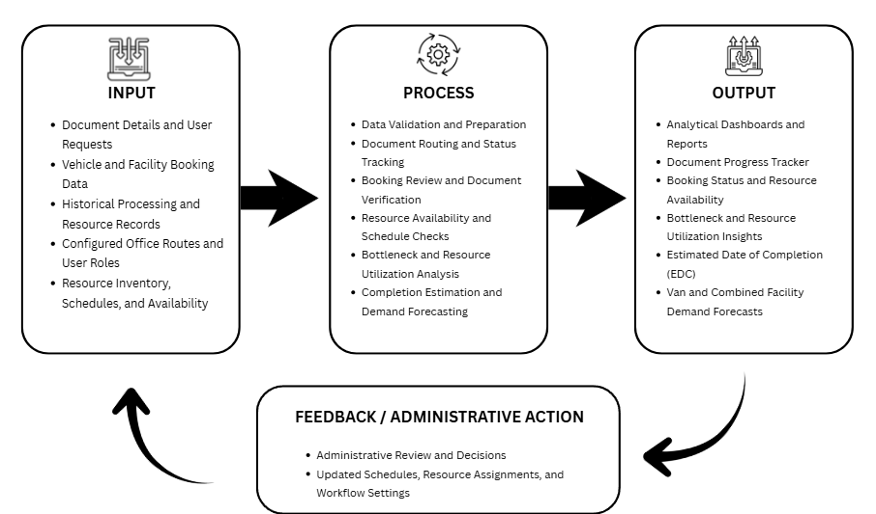
Figure 2-1 Conceptual Framework
The cycle begins with the Input phase, which provides the data needed for document tracking and resource management. The system gathers Document Details and User Requests, Vehicle and Facility Booking Data, and Historical Processing and Resource Records. These inputs cover document processing, bookings for university vehicles, the Multimedia Room and the Assemblyman Rafael R. Recto Gymnasium, and lending records for event inventory. Configured Office Routes and User Roles define the sequence of offices and the responsibilities of authorized users. Resource Inventory, Schedules, and Availability provide the operational information needed to review requests and plan resource use.
Building upon these inputs, the Process stage applies Data Validation and Preparation to organize records for system operations and analysis. Document Routing and Status Tracking follow configured office sequences and record processing actions, including receipt, signing, release, and requests for correction. Booking Review and Document Verification allow GSO staff to record the receipt and verification of required documents, while Resource Availability and Schedule Checks identify conflicts before approval or assignment. Bottleneck and Resource Utilization Analysis examine office dwell times and recorded resource use. Completion Estimation and Demand Forecasting produce Estimated Date of Completion (EDC) estimates for documents and demand projections for vans and combined facility bookings, using fallback estimates when the relevant model requirements are not met. The validation code uses Root Mean Squared Error (RMSE), Mean Absolute Error (MAE), R-squared, Mean Absolute Percentage Error (MAPE), and weighted Mean Absolute Percentage Error (wMAPE) to assess prediction errors and model fit for document completion times and booking demand.
The Output phase presents these results through role-based interfaces. Analytical Dashboards and Reports provide administrative summaries, while the Document Progress Tracker displays recorded office actions and document status. Booking Status and Resource Availability show the progress of requests and the availability of campus resources. Bottleneck and Resource Utilization Insights help administrators identify processing delays and patterns of resource use. Estimated Date of Completion (EDC) estimates support expectations for document processing, while Van and Combined Facility Demand Forecasts support GSO planning. Facility demand combines room and gymnasium bookings into one forecast category; event inventory is represented through availability and usage records. These outputs provide information for administrative review and scheduling decisions.
Finally, the Feedback Loop connects these outputs to Administrative Review and Decisions. Authorized administrators use the information to update Schedules, Resource Assignments, and Workflow Settings as operational needs require. These decisions feed back into the system inputs and processes through revised configurations and new processing, booking, and resource records. This cycle supports continued monitoring and informed planning while keeping changes to schedules, assignments, and workflows under the responsibility of authorized personnel.

DESIGN AND METHODOLOGY
This chapter outlines the design framework and methodological approach used in developing BSU-Trace: A Smart Campus Resource Management System with Bottleneck Analytics and Predictive Forecasting for Batangas State University - Lipa Campus. The methodology is structured to transition the campus from manual, paper-based workflows to a data-driven "Smart Campus" ecosystem. Unlike traditional tracking systems, the BSU-Trace framework integrates three core pillars of analytics: Descriptive (bottleneck heatmaps), Predictive (EDC and peak demand forecasting), and Decision Support (automated routing and resource allocation).
The system’s architecture is designed to synchronize the movement of physical documents with the deployment of institutional assets, including the university vehicle fleet, specialized facilities (Multimedia Room and Assemblyman Rafael R. Recto Gymnasium), and high-volume event inventory (folding tables and monobloc chairs). The project adopts an Agile methodology to allow for iterative development and continuous stakeholder feedback, ensuring that features like QR-hybrid monitoring and automated process pathing effectively eliminate administrative "black holes" while maintaining the university’s "First-Come, First-Served" policy.
  - Project Concepts
The development of BSU-Trace is anchored in a three-tier Business Analytics framework designed to transform raw administrative logs into strategic institutional intelligence. This structure ensures that campus-wide resource management covering university vehicles, specialized facilities (Multimedia Room and Assemblyman Rafael R. Recto Gymnasium), and event inventory is handled with data-driven precision.

Descriptive Analytics: Operational Transparency
This pillar focuses on providing real-time visibility into the current state of campus operations to eliminate the "administrative black hole". By utilizing a QR-hybrid tracking method, the system establishes a digital audit trail for physical documents, calculating "dwell times" by measuring the delta between "Receive" and "Release" timestamps at each office node. These individual records are aggregated to generate Bottleneck Heatmaps, which visually highlight specific office junctions experiencing systemic stagnation or procedural friction. Additionally, this layer provides a real-time availability interface for GSO inventory, such as folding tables and monobloc chairs, to streamline same-day inquiries and lending processes.

Predictive Analytics: Administrative Forecasting
This pillar leverages machine learning to transition from reactive troubleshooting to proactive planning. To restore confidence in the administrative workflow, Linear Regression models are utilized to forecast the Estimated Date of Completion (EDC) for pending paperwork by analyzing historical processing speeds and current queue volumes. Simultaneously, Time Series Analysis is employed to forecast Peak Demand across all GSO-managed assets, allowing the university to anticipate high-volume periods for vehicles and facilities. To ensure the statistical reliability of these insights, model performance is rigorously validated using RMSE, MAE, R-square, and Mean Absolute Percentage Error (MAPE).

Decision Support: Optimized Allocation and Routing
This pillar provides prescriptive guidance to improve administrative outcomes and reduce user error through rule-based automation. A core innovation is the Automated Process Pathing feature, which automatically suggests standardized office routes based on the document type, ensuring that Faculty users—even those unfamiliar with complex office hierarchies—can initiate requests with precision. These insights empower the GSO Admin to make data-driven decisions regarding fleet management and personnel distribution, ensuring the "First-Come, First-Served" policy is managed effectively. Furthermore, a bidirectional feedback loop allows Office users to provide digital remarks for "Return for Correction" status, ensuring Faculty users receive clear, actionable instructions for necessary adjustments.

Development Model
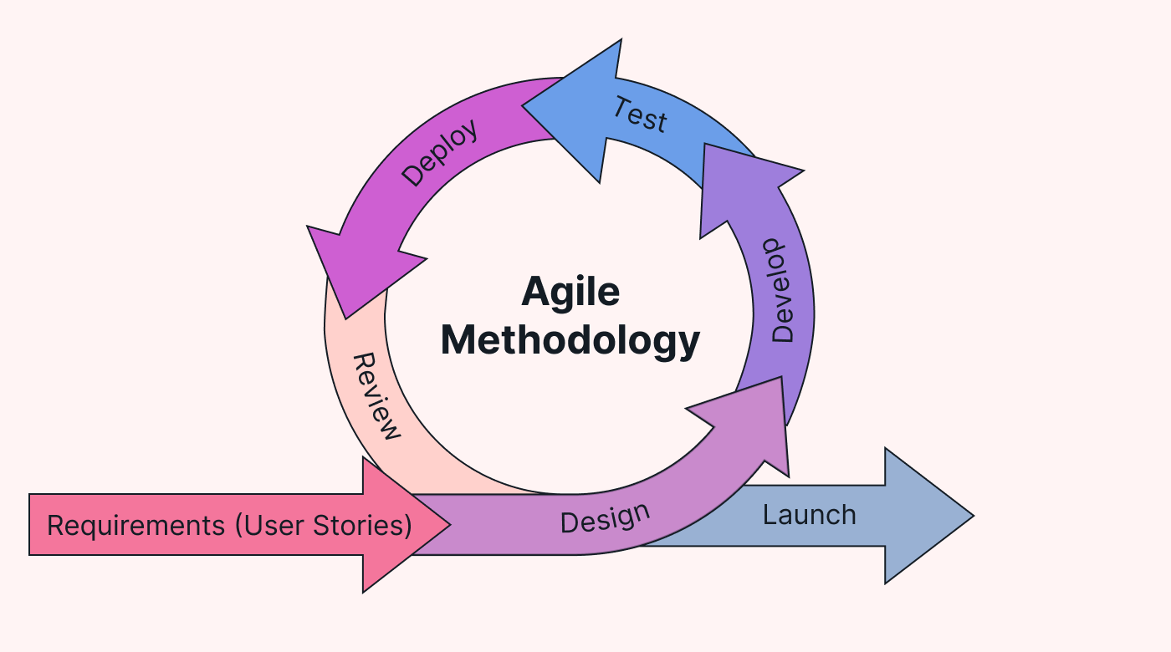
The researchers developed BSU-Trace using Agile Methodology, a framework designed to plan, implement, and manage the creation of software through iterative cycles. Agile methodology is a project management approach that divides work into short, manageable phases called sprints. It follows an iterative process where teams define goals for each sprint, develop and test their work, and gather feedback from stakeholders before proceeding to the next phase (Laoyan, 2025).
Figure 3-1. Agile Methodology (Kimei, 2024)
This approach was selected because it provides the flexibility needed to evolve the system’s diverse modules ranging from document audit trails to specialized facility scheduling based on the real-time needs of the BSU Lipa administrative staff. By breaking the project into smaller, functional increments, the team can ensure that core features, such as the QR-hybrid monitoring and machine learning forecasting, are refined and validated through repeated testing.
By employing Agile, the project gains strategic advantages in managing the parallel development of three distinct but integrated pillars: universal document tracking, facility and vehicle scheduling, and real-time inventory monitoring for high-volume assets like folding tables and monobloc chairs. The iterative nature ensures that critical features, such as the QR-hybrid mechanism and the Automated Process Pathing engine, are validated through repeated testing with Office users to ensure administrative accuracy.
Furthermore, Agile facilitates the gradual calibration of the system’s analytical core, ensuring that Linear Regression for EDC forecasting and Time Series Analysis for peak demand prediction are statistically reliable before full campus-wide integration. Ultimately, this structured yet flexible framework fosters a continuous feedback loop between the developers and stakeholders, ensuring the final Progressive Web App (PWA) is highly aligned with the university's goal of achieving a transparent, "Smart Campus" environment.

Requirements Analysis
The current administrative operations at Batangas State University - Lipa Campus rely on manual, decentralized processes that extend beyond document tracking to general resource management. While documents move via physical logbooks, facility reservations for the Multimedia Room and the Assemblyman Rafael R. Recto Gymnasium are similarly handled through manual coordination, often leading to scheduling overlaps.

Furthermore, the lending of event inventory, such as folding tables and monobloc chairs, lacks a real-time tracking mechanism, forcing staff to rely on same-day verbal or paper-based inquiries without visibility into current stock availability. This manual environment creates information silos where the status of a resource request remains unknown until physical papers are processed.
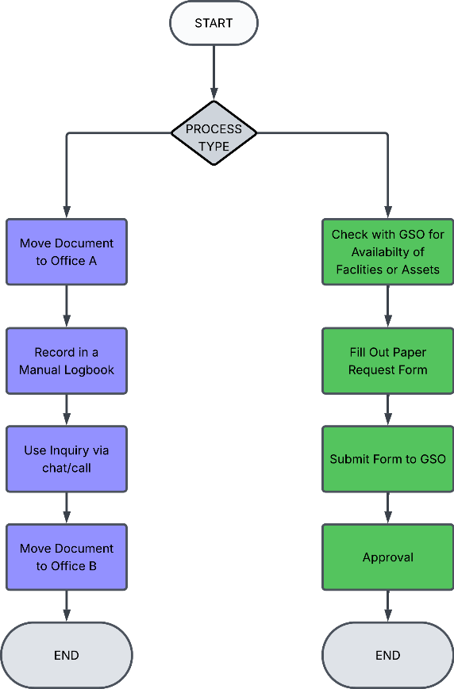
Figure 3-2. Existing Flowchart of Current Process of Offices
It shows how a request is processed using two manual procedures: document tracking and facility scheduling. The process starts when a request is created and then classified based on its type. If the request involves document tracking, the document is physically transferred between offices, recorded in a manual logbook, and its location is confirmed through calls or messages until it reaches its destination. If the request is for facility/asset scheduling, the requester first must check the availability through SMS or a phone call, then they fill out a paper form and submits it to the General Services Office where staff manually check again the availability of the facility/asset since it’s a first come first serve basis on who submits the completed required documents first, and then they send approval through SMS or a phone call. The process ends once the document is delivered or the facilities/assets are successfully scheduled.
The BSU-Trace system transitions fragmented administrative workflows into a unified, data-driven "Smart Campus" ecosystem. For Document Management, the system introduces a QR-hybrid tracking feature that assigns unique identifiers to physical files, creating a live audit trail that eliminates the need for manual status inquiries. This platform expands beyond simple document tracking to include an Integrated Resource Module that centralizes the reservation of university vehicles and specialized facilities, specifically the Multimedia Room and theAssemblyman Rafael R. Recto Gymnasium. To address GSO operational needs, a Real-Time Availability Interface is included for high-volume assets like folding tables and monobloc chairs, allowing staff to monitor current stock levels for same-day lending.
A critical innovation in this system is the Automated Process Pathing engine, which reduces user error by automatically generating the required office sequence based on the document type, such as Reimbursements or Facility Requests. Finally, the system leverages Machine Learning to perform Bottleneck Analysis via heatmaps and applies Predictive Analytics specifically Linear Regression for Estimated Date of Completion (EDC) and Time Series Analysis for Peak Demand across all managed assets to ensure proactive resource allocation and administrative transparency.

System Design
The system design for BSU-Trace establishes the technical framework and interactive logic required to bridge the gap between physical "wet signature" workflows and digital administrative oversight at Batangas State University – Lipa Campus. This phase transforms the identified functional requirements into a structured, four-layer architectural blueprint that guides the implementation of the universal QR-hybrid document tracking pillar and the comprehensive GSO resource management module. The presentation layer, built with React.js and styled for mobile responsiveness using Tailwind CSS, focuses on providing a "Pizza Tracker" style interface for faculty and staff to monitor document "dwell times" and the real-time availability of assets like the Multimedia Room, school gym, and event inventory. The application layer handles the system's core intelligence, utilizing Node.js and Express for backend operations including the Automated Process Pathing engine while integrating Python-based machine learning models. Specifically, these models utilize Linear Regression for forecasting "Estimated Dates of Completion" (EDC) and Time Series Analysis for predicting peak demand across all institutional resources. Finally, the data layer employs a relational database management system, PostgreSQL, to maintain the integrity of granular document audit trails, facility schedules, and inventory stock levels. This design ensures that the Progressive Web App (PWA) remains scalable, secure, and highly aligned with the university’s goal of achieving a transparent "Smart Campus" environment through standardized software quality evaluations like ISO/IEC 25010:2023.
System Architecture
The BSU-Trace System Architecture presents a high-level overview of the platform's core structure. It supports interaction among the ICT Admin, GSO Admin, Office users, and Faculty users through document tracking and resource scheduling.
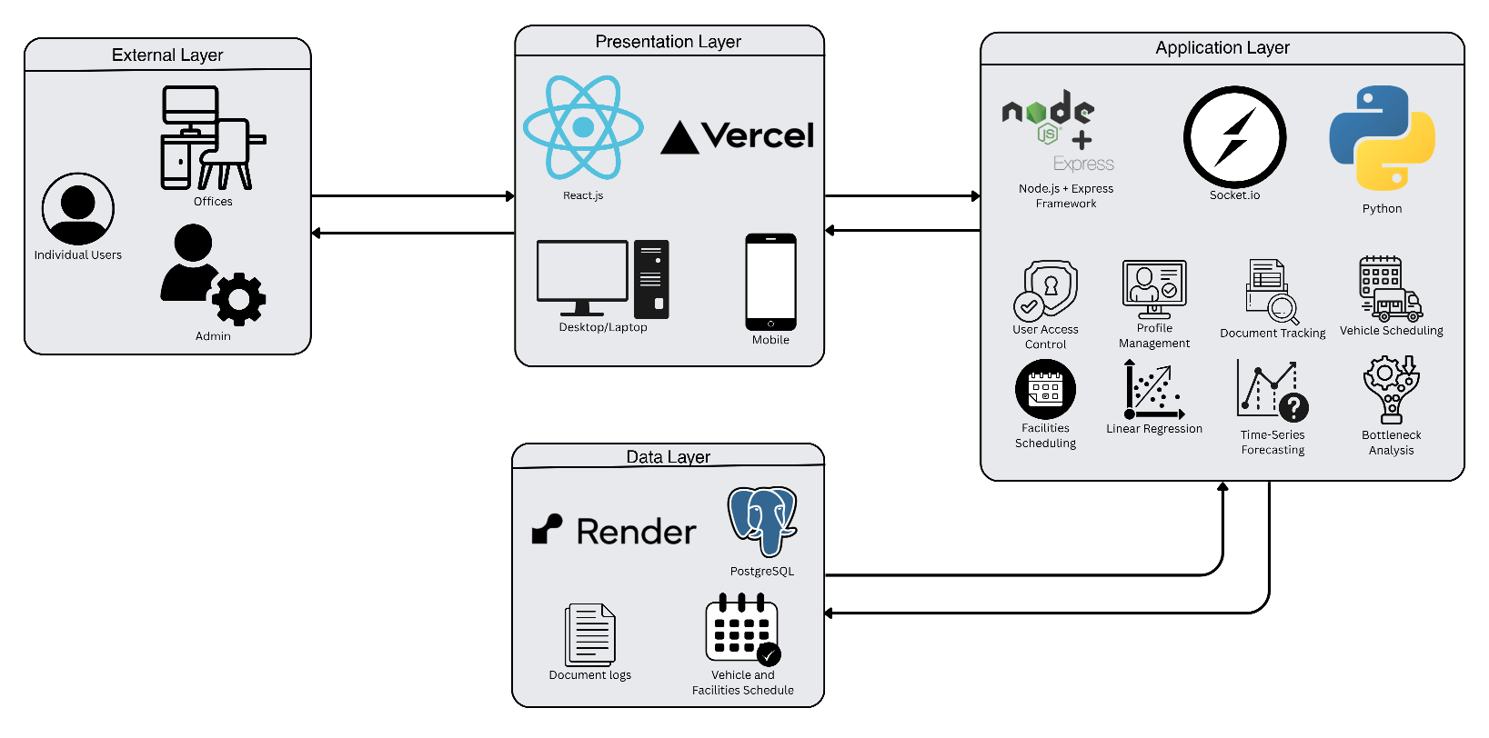
Figure 3-3. System Architecture of BSU-Trace
The BSU-Trace system architecture establishes a structured technical framework designed to bridge the gap between physical "wet signature" workflows and digital administrative oversight at Batangas State University – Lipa Campus. This design transforms identified functional requirements into a scalable four-layer architectural blueprint that supports the interaction between university stakeholders and the platform's core tracking and scheduling pillars. By utilizing a modular approach, the architecture ensures that the "administrative black hole" is eliminated through standardized data flows and high-performance cloud hosting.
The process begins at the External Layer, which serves as the primary interface for the diverse user roles defined in the system’s use cases. This layer is where individual users, such as a Faculty user, initiate document metadata configurations, specialized facility bookings for the Multimedia Room and school gym, or inventory inquiries for high-volume assets like folding tables and monobloc chairs. These external interactions are funneled directly into the Presentation Layer, a frontend built with React.js and hosted on Vercel to ensure seamless cross-platform accessibility. This layer is specifically optimized to deliver the "Pizza Tracker" style interface, providing Faculty users with real-time transparency into document "dwell times" and the live availability status of GSO-managed facilities and equipment.
Beneath the interface, the Application Layer functions as the system’s core intelligence, powered by a Node.js and Express framework. This layer manages essential business logic, including role-based access control (RBAC), user profile management, and the Automated Process Pathing engine, which recommends standardized office routes based on transaction titles. It integrates a Socket.io engine to facilitate a bidirectional feedback loop, enabling the instant transmission of qualitative remarks or referral notifications to the Faculty user when a document or resource request requires correction. Furthermore, this layer incorporates a Python component dedicated to advanced analytics, employing Linear Regression for EDC forecasting and Time-Series Analysis for predicting peak demand across all campus resources. These analytical tools empower the ICT Admin to calibrate models and provide the GSO Admin with statistically grounded forecasts for proactive fleet, facility, and inventory management.
The foundation of the architecture is the Data Layer, which employs a PostgreSQL relational database to maintain the system's "source of truth". This layer securely stores the granular document audit trails, vehicle and facility schedules, ensuring strict data integrity for all university transactions. The database supports the ICT Admin in performing maintenance and managing account permissions, while providing the historical logs required by the Application Layer to generate bottleneck heatmaps. By hosting these services on Render, the system achieves the high availability and secure data transmission necessary to meet ISO/IEC 25010:2023 quality standards, ensuring a reliable and transparent "Smart Campus" environment.
System Process Flowchart
The System Process Flowchart illustrates the operational logic and sequential steps involved in the BSU-Trace document tracking and comprehensive resource management life cycles. It maps the transition from user-initiated requests to administrative completion, highlighting the integration of QR-hybrid scanning, Automated Process Pathing, and multi-asset resource allocation.
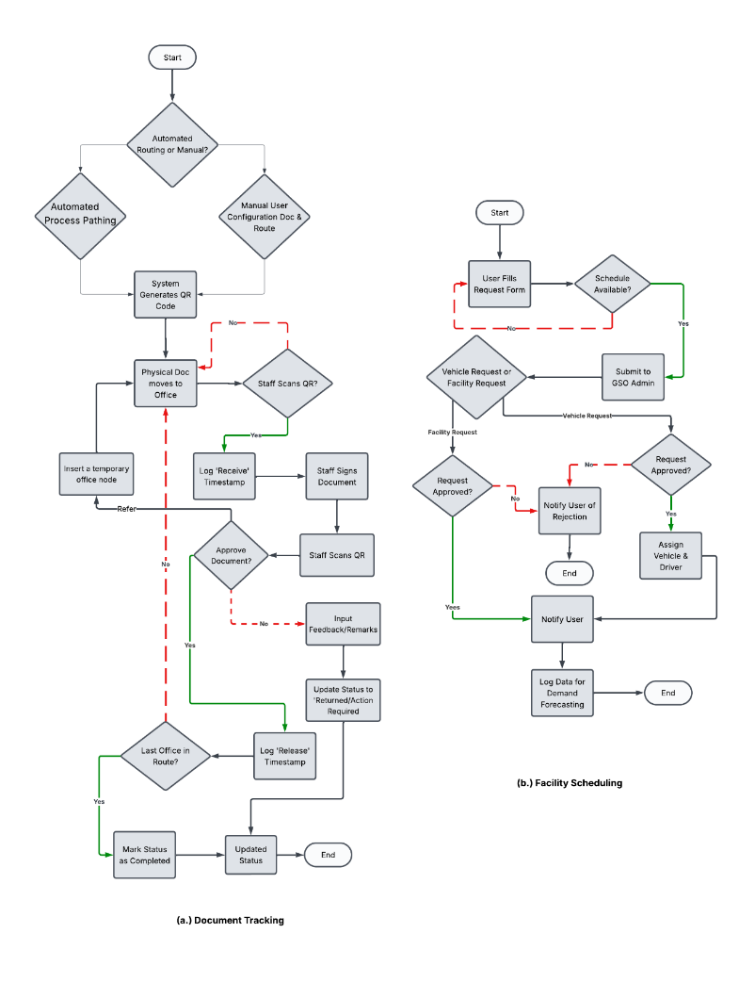
Figure 3-4. System Process Flowchart for BSU-Trace
The Document Tracking process initiates with the Faculty user selecting between a manual route or the Automated Process Pathing engine, which pre-configures the sequential routing path based on the document title to ensure procedural accuracy. Once the system generates a unique QR code for physical attachment, the document transitions between campus offices through a critical decision-making loop: Office users scan the QR code to log a "Receive" timestamp and, following physical signing, a second scan initiates validation. If approved, the system logs a "Release" timestamp and moves the workflow toward the next node; alternatively, an Office user may refer the document to a temporary office for prerequisite verification. In cases where approval is withheld, the Office user enters digital remarks, reverting the status to "Returned/Action Required" to notify the Faculty user of needed corrections, thereby eliminating the "administrative black hole" through granular feedback.
Complementary to document monitoring, the GSO Resource & Facility Management workflow delineates the administrative journey for university transportation, specialized facilities like the Multimedia Room and Assemblyman Rafael R. Recto Gymnasium, and real-time inventory for assets such as folding tables and monobloc chairs. This journey begins with a digital submission or availability check, followed by an automated system check for resource availability. The logic incorporates a critical manual oversight step where the General Services Office (GSO) reviews the request for final approval, ensuring that bookings for high-value facilities remain in a provisional state until physical document clearance is verified. Upon approval, the system facilitates the assignment of specific fleet assets, facility time-slots, or equipment counts, subsequently generating official trip tickets or reservation confirmations. This structured data entry ensures every campus resource deployment is digitally accounted for, providing the historical dataset required for Peak Demand forecasting across all institutional assets.
Use Case Diagram
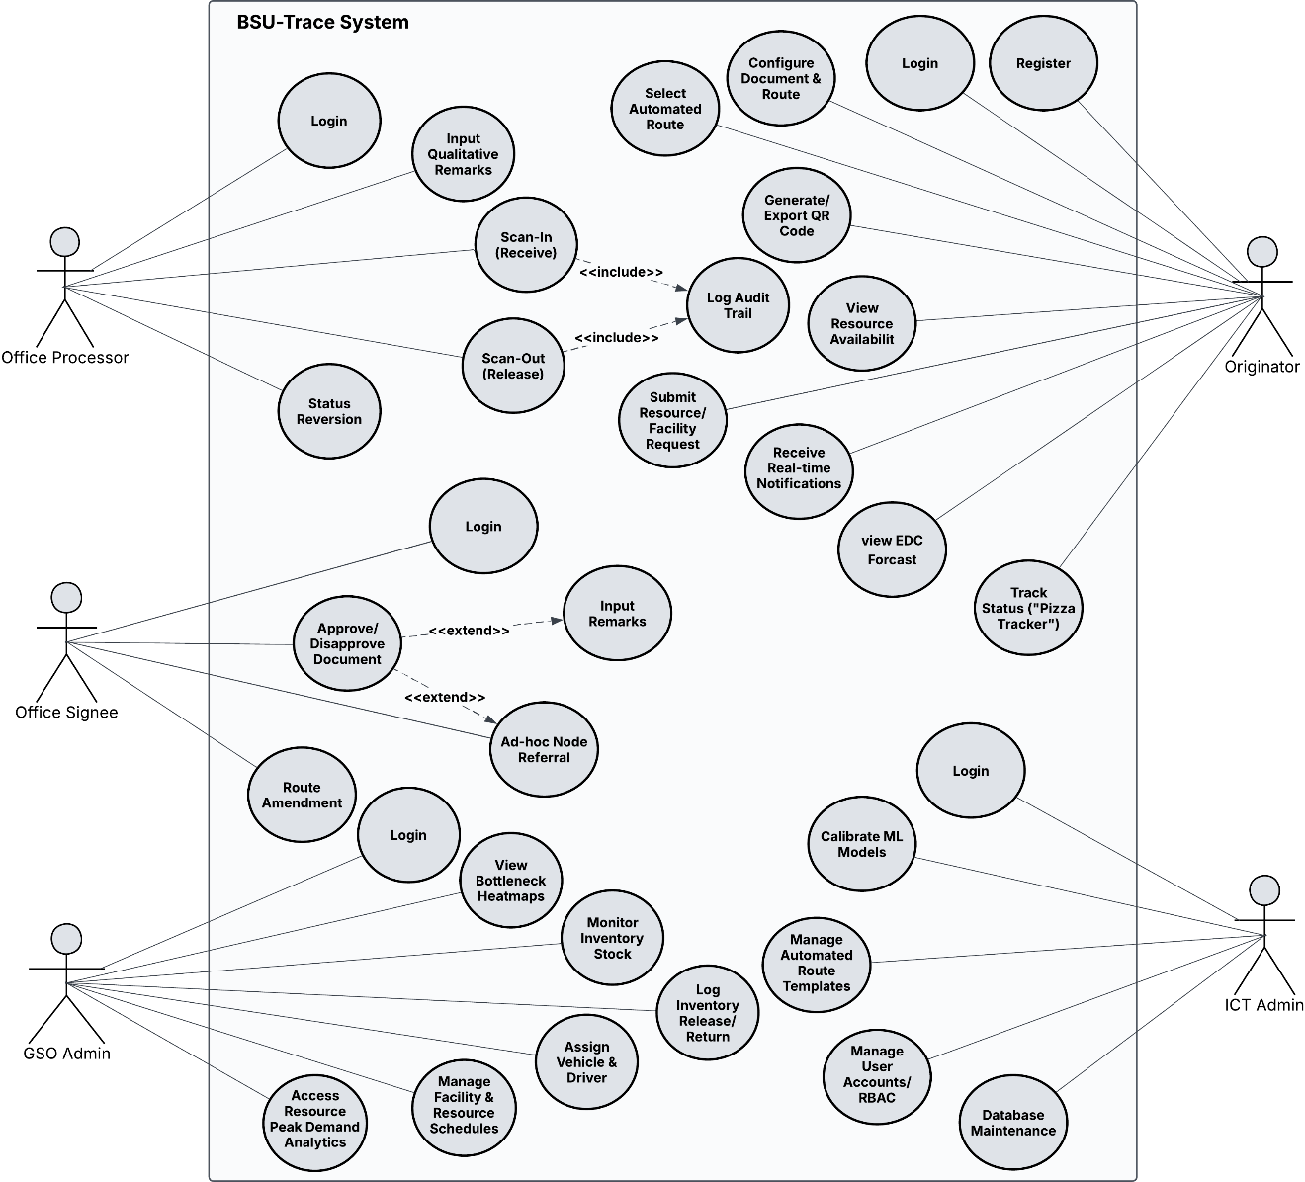

Figure 3-5. Use Case Diagram for each End User and Functions
The BSU-Trace Use Case Diagram identifies the system’s primary functionalities and illustrates how different user roles interact with the platform. It defines the responsibilities of each stakeholder within the analytical resource management system, emphasizing their roles in maintaining efficient campus operations and communication
The BSU-Trace Use Case Diagram (Figure 3-5) illustrates the distinct responsibilities and interactions within the analytical resource management system, categorizing functionalities to reflect the integrated administrative flow of Batangas State University. By digitizing manual campus inquiries and asset scheduling, the system facilitates a transparent, data-driven environment where physical document movement, specialized facility bookings, and inventory logistics are synchronized through a centralized platform. This integration ensures that every action, from a simple availability check to complex predictive forecasting, is captured within a unified digital framework.
The workflow begins with the Faculty user, an individual faculty member who initiates the process by registering and logging in. This user submits document details, selects a document type for the system-generated office route, tracks document progress through the "Pizza Tracker" interface, and views the Estimated Date of Completion (EDC) estimate. The Faculty user may also submit resource or facility requests for vehicles, the Multimedia Room, or the Gymnasium.
Building upon this initiation, Office users handle document receipt and release through QR scans, maintain the audit trail, and process document approvals, correction remarks, and referrals through one Office account type. The GSO Admin remains responsible for recording inventory releases and returns for items such as folding tables and monobloc chairs, and for reviewing resource requests and recording approved assignments.
High-level oversight is maintained by the GSO Admin, who ensures the logistical integrity of campus assets. This role focuses on resource optimization by performing Manage Facility & Resource Schedules, assigning specific fleet assets or facility slots, and monitoring inventory stock levels for general equipment. Crucially, the GSO Admin utilizes the platform’s analytical core to access Resource Peak Demand Analytics, allowing for proactive distribution of vehicles and facilities during high-volume periods. Accuracy for these forecasts is monitored using statistical metrics, including Mean Absolute Percentage Error (MAPE), to ensure reliable planning.
Finally, the ICT Admin manages the technical foundation of the "Smart Campus" ecosystem. This actor is responsible for Database Maintenance, managing user accounts via RBAC, and the critical task of Managing Automated Route Templates to ensure transaction paths remain accurate. Most importantly, the ICT Admin performs the Calibrate ML Models use case, where the predictive engines for EDC and peak demand are fine-tuned. By transforming raw operational logs into actionable intelligence, these administrators ensure that BSU-Trace effectively eliminates systemic bottlenecks and optimizes resource allocation across the entire university landscape.
Context Flow Diagram
The Context Diagram (Level 0) provides a high-level overview of how BSU-Trace interacts with its primary user account types: Faculty users, Office users, the ICT Admin, and the GSO Admin. It illustrates the system boundary and the flow of information among these users for document tracking and facility scheduling.
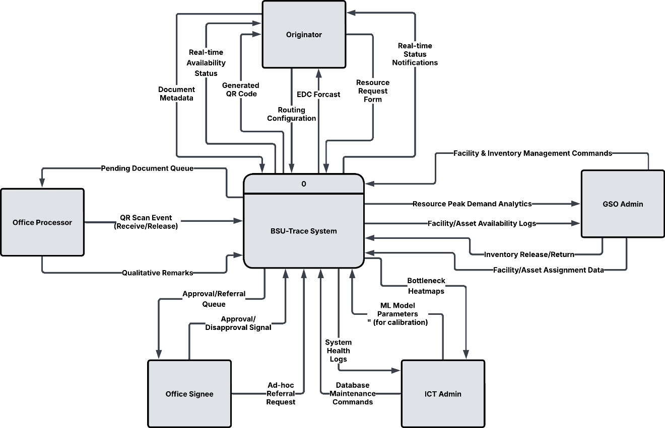

Figure 3-6. Context Flow Diagram (CFD) of BSU-Trace
The Context Flow Diagram (CFD) of BSU-Trace (Figure 3-6) illustrates the high-level data exchange between the centralized system and its external entities, establishing a clear boundary for the platform’s expanded "Smart Campus" information architecture. By acting as a central hub, the system synchronizes diverse data streams—ranging from physical document audit trails to specialized facility schedules—to facilitate a data-driven administrative environment. This interplay ensures that every user role, from Faculty users to specialized administrators, is equipped with the necessary inputs to drive university operations forward.
The administrative cycle begins with the Faculty user, an individual faculty member who submits document metadata, selects a document type, and submits resource request forms. In return, the system provides generated QR codes for physical attachment, an EDC estimate for planning, and real-time availability status for assets such as the Multimedia Room and the Gymnasium. The Faculty user can track a document or request from submission through its current status.
Office users interact with the system through one Office account type to manage document workflows. They record QR scan events (Receive/Release), enter remarks, and process approvals or referrals, while viewing the pending document queue. The ICT Admin and GSO Admin retain their respective administrative functions, including system oversight and resource-request review.
Beyond document tracking, the system facilitates complex logistical oversight through the GSO Admin, who serves as the sole manager for university assets. The GSO Admin manages university transportation and facilities by inputting Facility & Inventory Management Commands and Facility/Asset Assignment Data, while the system reciprocates with Resource Peak Demand Analytics and Facility/Asset Availability Logs for proactive planning. This centralized oversight ensures that the school gym, multimedia room, and vehicle fleet are managed with statistical precision, adhering to the university's "First-Come, First-Served" policy.
Finally, the ICT Admin maintains the platform's analytical core by inputting ML Model Parameters and Database Maintenance Commands, receiving System Health Logs and Bottleneck Heatmaps in return. This calibration process is essential for the Predictive Analytics Engine, as it allows the admin to fine-tune Linear Regression coefficients for document timelines and Time Series weights for seasonal resource surges. To ensure statistical reliability, the system evaluates performance using a suite of metrics: RMSE, MAE, and R-square measure prediction error and variance for document flow. Most significantly, the system integrates Mean Absolute Percentage Error (MAPE) specifically for time-series validation. By providing a percentage-based accuracy metric for assets like the school gym or vehicle fleet, MAPE empowers administrators with the clear, relative error data needed for proactive and precise campus-wide resource planning.
Data Flow Diagram
The Data Flow Diagram (DFD) illustrates the movement of information within BSU-Trace, showing how users interact with system processes and data stores. To provide a clear technical breakdown, the DFD is presented in a leveled hierarchy, moving from a general functional overview to a detailed decomposition of specific system logic.
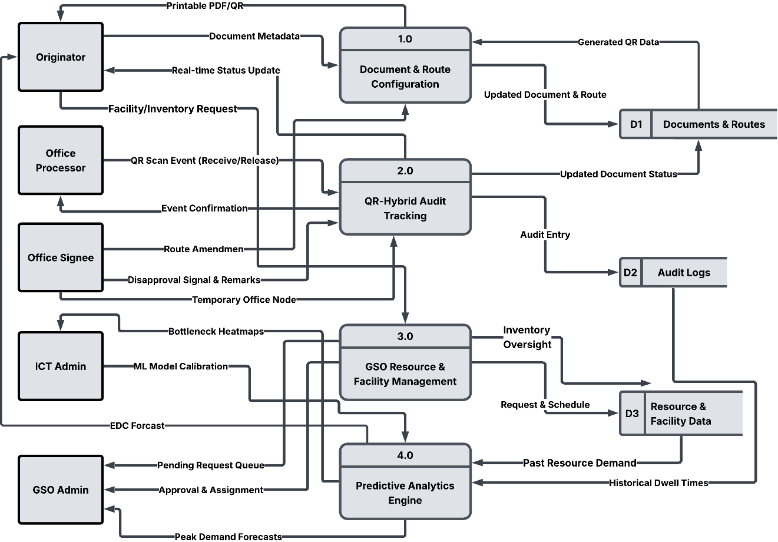
Figure 3-7. Data Flow Diagram (DFD) - Level 1
The Data Flow Diagram (DFD) Level 1 (Figure 3-7) illustrates the internal movement of information between external stakeholders, core system processes, and the centralized data stores that serve as the platform's "source of truth." By decomposing the system into four primary functional areas, the diagram reveals how data is captured, stored, and eventually transformed into intelligence. This architectural breakdown ensures that every administrative action is backed by a robust data management strategy.
The system's operation begins with Process 1.0 (Document & Route Configuration), where the Faculty user provides the primary input by submitting Document Metadata. This process commits an Updated Document & Route entry to the Documents & Routes (D1) data store, which simultaneously triggers the system to return Generated QR Data and a Printable PDF/QR back to the user. This foundational step establishes the digital twin of the document before it enters physical circulation.
Transitioning to active monitoring, Process 2.0 (QR-Hybrid Audit Tracking) handles the physical-digital handshake as items move across campus. When an Office user performs a QR Scan Event (Receive/Release) or provides Qualitative Remarks, the process records an Audit Entry directly into the Audit Logs (D2). This process is further enhanced by a Real-time Availability Status flow, providing the Faculty user with immediate visibility into the current stock of event inventory, such as folding tables and monoblock chairs.
Parallel to document movement, the platform manages campus logistics through Process 3.0 (GSO Resource & Facility Management). This workflow is triggered when a Faculty user submits a Resource Request Form for university vehicles, the Multimedia Room, or the school gym. These entries populate the Pending Request Queue for the GSO Admin, who provides Facility/Asset Assignment Data once physical document clearance is verified. All confirmed schedules and inventory logs are maintained in the Resource & Facility Data (D3) store to prevent scheduling conflicts.
Finally, the cumulative data from these activities is transformed into strategic intelligence by Process 4.0 (Predictive Analytics Engine). By pulling Historical Dwell Times from D2 and Resource Data from D3, the engine identifies systemic friction points. This process generates Bottleneck Heatmaps for the ICT Admin, Resource Peak Demand Analytics for the GSO Admin, and EDC Forecasts for the Faculty user. Through this integrated flow, BSU-Trace successfully converts raw transactional logs into the actionable insights required for university-wide resource optimization.
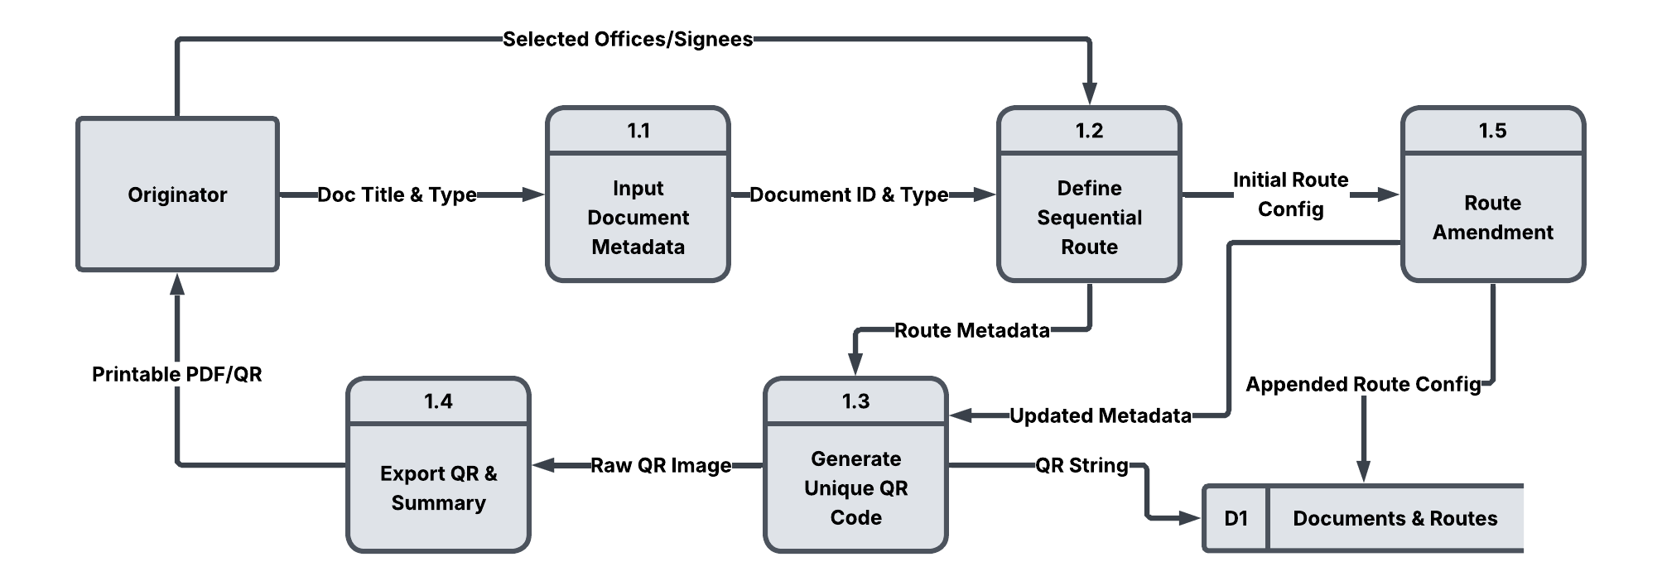
Figure 3-8. DFD Level 2 – Document & Route Configuration (Process 1.0)
The Data Flow Diagram (DFD) Level 2 for Process 1.0 (Figure 3-8) provides a granular "explosion" of the document and route configuration phase. This detailed view illustrates the transformation of user-defined parameters into a unique physical-digital tracking link, bridging the gap between traditional "wet signature" requirements and modern digital monitoring. By breaking down the configuration into five distinct sub-processes, the system ensures that every document is assigned a precise and immutable digital identity before it enters the university workflow.
The sequence begins with the Faculty user interacting with Sub-process 1.1 (Input Document Metadata) and Sub-process 1.2 (Define Sequential Route). During this initial stage, the system captures the Doc Title & Type and the selected offices and responsible Office users, subsequently forwarding the Document ID & Type to establish the document's framework. This foundational data allows the system to understand both the nature of the resource and its intended destination, setting the stage for more complex routing logic.
To accommodate the nuanced nature of university bureaucracy, the logic then transitions to Sub-process 1.5 (Route Amendment). This component receives the Initial Route Config and formalizes it while maintaining the flexibility to handle "ad-hoc" needs. Once the administrative path is confirmed, this sub-process commits the Appended Route Config to the Documents & Routes (D1) data store, ensuring that the "source of truth" reflects the most current routing requirements.
Following the finalization of the routing path, the system moves to Sub-process 1.3 (Generate Unique QR Code) to create the physical-digital link. Using Route Metadata and Updated Metadata, this stage produces a QR String for database synchronization within D1 and a Raw QR Image for the final export phase. Ultimately, Sub-process 1.4 (Export QR & Summary) provides the Faculty user with a Printable PDF/QR, ensuring the physical document is equipped with its "digital twin" and is fully prepared for university-wide tracking.
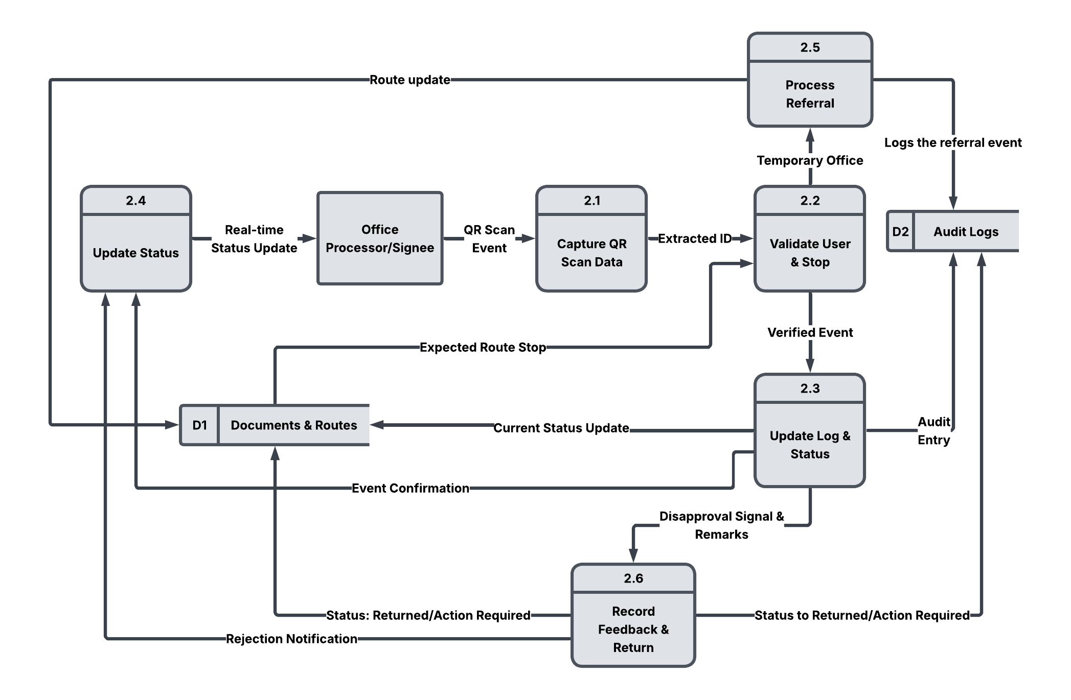
Figure 3-9. DFD Level 2 – QR-Hybrid Audit Tracking (Process 2.0)
The Data Flow Diagram (DFD) Level 2 for Process 2.0 (Figure 3-9) illustrates the logic of the hybrid scanning mechanism, transitioning the platform from a simple tracking tool to a dynamic administrative decision engine. This level of detail highlights how the system manages the "physical-to-digital handshake" that occurs whenever a document is moved or reviewed. By breaking down the tracking process into six specialized sub-processes, the system ensures that every scan is verified for authenticity before being committed to the institutional record.
The tracking sequence is triggered when an Office user initiates a QR Scan Event, which is processed by Sub-process 2.1 (Capture QR Scan Data) to produce an Extracted ID. This ID is immediately passed to Sub-process 2.2 (Validate User & Stop), which cross-references the data against the Expected Route Stop pulled from the Documents & Routes (D1) store. This validation step is critical as it ensures the chronological and legal authenticity of the audit logs, effectively preventing out-of-order scans or unauthorized entries.
Upon successful verification, the workflow branches to accommodate the diverse administrative scenarios encountered within the university hierarchy. For standard movements, Sub-process 2.3 (Update Log & Status) manages the Current Status Update in D1 and generates an Audit Entry for the Audit Logs (D2). However, to handle prerequisite signatures, the system incorporates Sub-process 2.5 (Process Referral). This sub-process identifies a Temporary Office and triggers a Route update back to the configuration module, effectively managing the "side-quests" required for external departmental verification while simultaneously Logging the referral event in D2.
In cases where a document requires correction, the logic shifts to Sub-process 2.6 (Record Feedback & Return) to capture a Disapproval Signal & Remarks. This ensures that qualitative feedback is digitized rather than lost in an "administrative black hole," pushing a Status: Returned/Action Required update to D1 and a corresponding entry to D2. Finally, these decision paths converge at Sub-process 2.4 (Update Status), which utilizes the system’s real-time communication engine to deliver Event Confirmations, Rejection Notifications, or Real-time Status Updates back to the stakeholders, providing the granular visibility necessary for a modern "Smart Campus" environment.
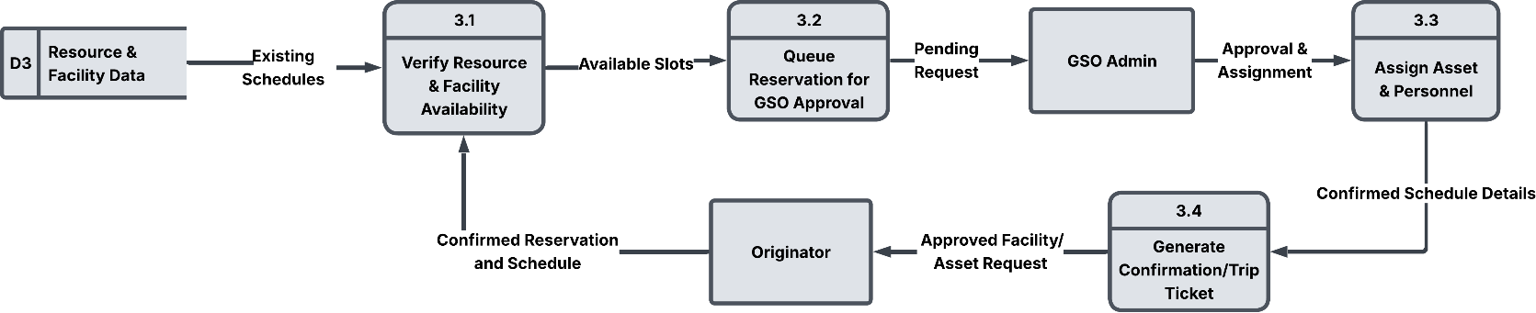
Figure 3-10. DFD Level 2 – Van Scheduling & Management (Process 3.0)

The Data Flow Diagram (DFD) Level 2 for Process 3.0 (Figure 3-10) provides a detailed explosion of the administrative lifecycle for all institutional assets, illustrating how the system manages the transition from a digital request to physical deployment. By isolating the management logic into four specialized sub-processes, the system ensures that the university vehicle fleet, the Multimedia Room, and the Assembly Recto Gymnasium are managed with automated precision. This structured flow effectively prevents scheduling conflicts and ensures that the "First Come, First Served" policy is maintained through a synchronized digital audit trail.
The process is initiated when the Faculty user submits the Travel Date & Destination or facility booking details, which are processed by Sub-process 3.1 (Verify Resource & Facility Availability). This sub-process pulls Existing Schedules from the Resource & Facility Data (D3) store to determine if the specific vehicle or room can accommodate the request. Once the system identifies Available Slots, the data is passed to Sub-process 3.2 (Queue Reservation for GSO Approval), which formalizes the request as a Pending Request for the GSO Admin.
Transitioning to administrative oversight, the GSO Admin reviews the queue and provides an Approval & Assignment signal once the required "wet signature" hard copies are verified. This manual clearance triggers Sub-process 3.3 (Assign Asset & Personnel), which records the final allocation of specific vehicles, drivers, or facility time-slots. The workflow concludes with Sub-process 3.4 (Generate Confirmation/Trip Ticket), which delivers the Approved Facility/Asset Request back to the Faculty user and updates the Resource & Facility Data (D3) store to prevent overlapping reservations.
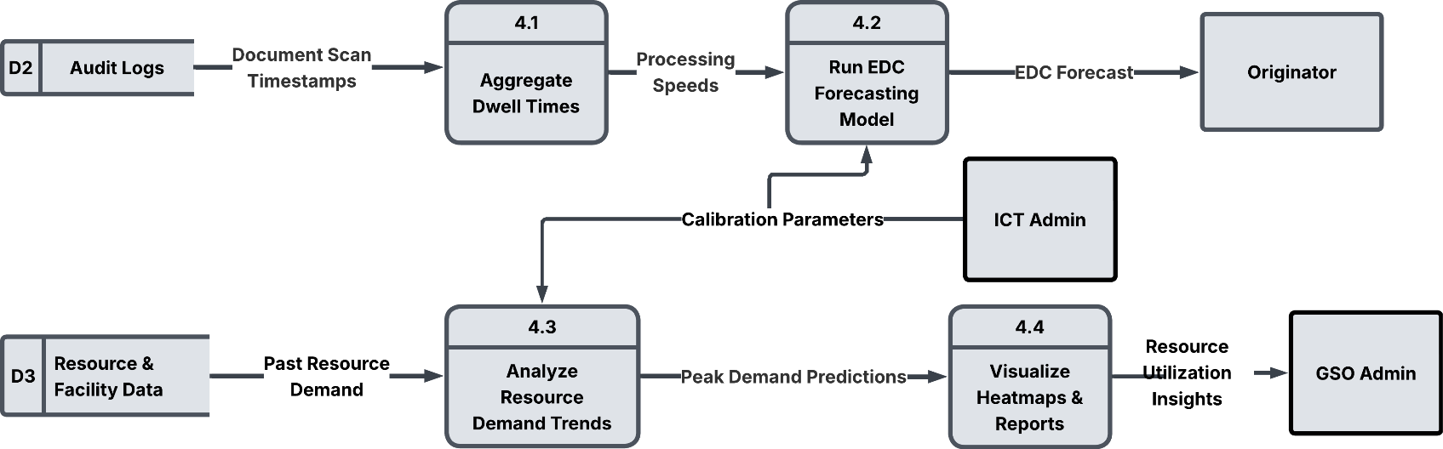

Figure 3-11. DFD Level 2 – Predictive Analytics Engine (Process 4.0)
The Data Flow Diagram (DFD) Level 2 for Process 4.0 (Figure 3-11) clarifies how the system transforms raw administrative logs into proactive management insights. By isolating the analytical workflow into four distinct sub-processes, the diagram illustrates the intelligence layer responsible for identifying systemic friction and forecasting campus-wide demand. This architecture allows the platform to move beyond simple data collection to complex predictive modeling, ensuring that university assets are allocated based on empirical evidence.
The analytical cycle begins with Sub-process 4.1 (Aggregate Dwell Times), which pulls Document Scan Timestamps from the Audit Logs (D2) to calculate office-level Processing Speeds. These metrics are then fed into Sub-process 4.2 (Run EDC Forecasting Model), where, guided by Calibration Parameters from the ICT Admin, the system generates an EDC Forecast for the Faculty user. This provides Faculty users with a statistically grounded estimate for document completion that accounts for the non-linear nature of university workflows.
Simultaneously, the system addresses logistical surges through Sub-process 4.3 (Analyze Resource Demand Trends). By accessing Past Resource Demand from the D3 store, this sub-process performs time-series analysis to generate Peak Demand Predictions across the vehicle fleet, gymnasium, and multimedia room. These mathematical outputs converge in Sub-process 4.4 (Visualize Heatmaps & Reports), delivering Resource Utilization Insights to the GSO Admin. To ensure the integrity of these insights, the system evaluates performance using RMSE, MAE, and R-square, with Mean Absolute Percentage Error (MAPE) specifically applied to validate the accuracy of time-series demand forecasts.
Data Pipeline
The BSU-Trace system utilizes a structured data pipeline specifically designed to optimize document processing and vehicle resource allocation across the campus. This pipeline bridges the gap between raw operational data and administrative decision-making by integrating descriptive analytics with predictive modeling to enhance overall institutional efficiency.
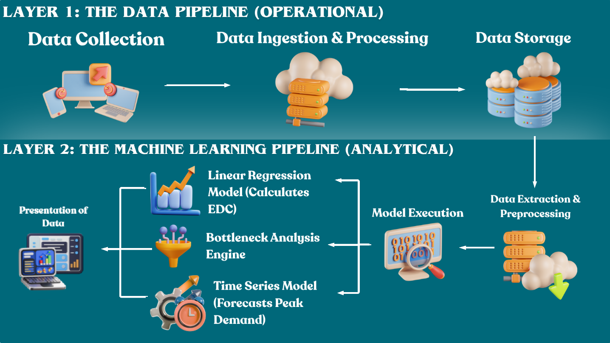
Figure 3-12. Data Pipeline for BSU-Trace
The BSU-Trace system utilizes a multi-layered data pipeline designed to transform raw administrative activities into high-fidelity datasets suitable for Business Analytics. This transition from operational data to analytical intelligence begins at the Data Collection Layer, which acts as the primary intake point for all campus-wide activities. The system captures document metadata, user interaction logs such as digital remarks, administrative logs from QR-hybrid scans, and resource booking data for vehicle requests. All collected information is funneled into a Central Database, which serves as the "single source of truth" for the university, ensuring that all records are organized and accessible for real-time auditing and subsequent analysis.
Once stored, the data undergoes a rigorous Data Cleaning and Preprocessing stage, which serves as a vital governance layer to ensure the reliability of the predictive models. During this phase, the system performs deduplication by removing identical log entries that might occur from accidental multiple QR scans. It also addresses missing values, such as incomplete "dwell times," and corrects inconsistent date and time formats to ensure uniform mathematical calculations across different campus office terminals. This stage is critical for maintaining data integrity, as it prevents inaccurate information from compromising the quality of the administrative audit trail.
The cleaned data then transitions to the Feature Engineering stage, where raw logs are converted into actionable performance metrics. To measure efficiency at a granular level, the system calculates the specific Processing Time for each document by measuring the delta between its "Exit" and "Entry" timestamps at specific office junctions. This calculation is represented by:
Processing Time=Exit Time−Entry Time
Equation 3-1. Processing Time for each Document
For higher-level management insights, the system aggregates these individual records to determine the overall performance of a department. This Average Processing Time per Office is the primary metric used for bottleneck detection, computed as:
$${\text{Average Processing Time}}_{office}=\frac{\sum_{i=1}^{n}{{\text{Processing Time}}_{i}}}{n},$$
Equation 3-2. Processing Time of each Office for Bottleneck Analysis
By deriving these specific features, the pipeline creates the necessary mathematical inputs for the analytical components of the system. These derived variables empower the Bottleneck Analysis Engine to identify systemic delays and provide the historical foundation for the machine learning models to forecast completion dates and vehicle demand.
From the feature-engineered dataset, the pipeline branches into two distinct analytical components designed to provide both descriptive and predictive oversight for campus operations. The Bottleneck Analysis Engine serves as the system’s descriptive core by identifying administrative delays across various offices. By comparing average processing times derived from historical logs, this engine generates Bottleneck Heatmaps that visually highlight specific office junctions with prolonged document "dwell times". These visualizations allow administrators to distinguish between minor procedural friction and significant systemic constraints in real-time.
Simultaneously, the pipeline applies Machine Learning Models to perform advanced predictive analytics. To restore faculty confidence in the administrative workflow, Linear Regression is utilized to forecast the Estimated Date of Completion (EDC) for pending paperwork. This model calculates the EDC by analyzing various features, including current processing speeds, the volume of the pending queue, and the specific office stage of the document. The mathematical representation of this forecast is:
$$y=β_{0}+β_{1}x_{1}+β_{2}x_{2}+⋯+β_{n}x_{n}$$
Equation 3-3. Estimated Date of Completion (EDC)
In this equation, y represents the predicted completion date, while $x_{1}$, $x_{1},x_{2},… x_{n}$are the input features, and $β_{0},β_{1},…,β_{n}$ are the coefficients learned by the system from historical administrative data.
Complementing the document tracking pillar, Time Series Forecasting is employed to predict future vehicle demand. This model allows the General Services Office (GSO) to plan transport resources efficiently by anticipating peak-demand periods. The prediction of demand at a specific time (t) is determined by the following model:
$$Y_{t}=T_{t}+S_{t}+E_{t}$$
Equation 3-4. Time Series Forecasting
Here, $Y_{t}$ is the predicted demand, $T_{t}$ represents the long-term trend of vehicle requests, $S_{t}$ captures recurring seasonal variations (such as semester starts or event weeks), and $S_{t}$ accounts for random noise or unforeseen fluctuations. By integrating these predictive engines, the pipeline transforms the BSU-Trace system from a passive monitoring tool into a proactive strategic asset for campus management.
To ensure the statistical reliability and practical utility of the BSU-Trace platform, the pipeline incorporates a rigorous evaluation phase followed by an insight delivery layer. This final stage of the pipeline is essential for maintaining the high-performance standards required for a smart campus environment, as it validates the accuracy of the data-driven insights before they reach university stakeholders.
In pursuit of assessing the accuracy and precision of the predictive models, specifically the Linear Regression for document completion and Time Series Analysis for vehicle demand, the system utilizes standard regression metrics. By leveraging these benchmarks, researchers can measure the performance of the algorithms and ensure they effectively capture the non-linear complexities of campus administrative workflows.
The system calculates the RMSE to measure the square root of the average squared differences between predicted values and actual outcomes. This metric is particularly valuable because it penalizes larger errors more significantly, ensuring that the models remain highly reliable for forecasting critical document deadlines.
$$RMSE=\sqrt{\frac{1}{n}\sum_{i=1}^{n}{(}y_{i}-{\hat{y}}_{i})^{2}}$$
Equation 3-5. Root Mean Squared Error (RMSE)
To provide a clear interpretation of the average forecasting error, the system employs the MAE. By averaging the absolute differences between the predicted and actual values, the MAE offers a straightforward assessment of how many days or hours the system’s forecasts deviate from reality.
$$MAE=\frac{1}{n}\sum_{i=1}^{n}{∣}y_{i}-{\hat{y}}_{i}∣$$
Equation 3-6. Mean Absolute Error (MAE)
Furthermore, the R-squared ($R^{2}$) metric is used to evaluate the model's explanatory power. It measures how well the regression models explain the variability in document "dwell times" or vehicle demand patterns, ensuring that the predictive intelligence is grounded in meaningful historical data rather than random noise.
$$R^{2}=1-\frac{∑(y_{i}-{\hat{y}}_{i})^{2}}{∑(y_{i}-\overset{ˉ}{y})^{2}}$$
Equation 3-7. R-Squared ($R^{2}$)
The final phase of the integrated pipeline involves the consolidation of all analytical outputs into a user-centric reporting layer. These outputs which include descriptive Bottleneck Heatmaps, predictive EDC forecasts, and seasonal vehicle demand reports are delivered through Analytical Dashboards and Reports. By combining descriptive analytics with predictive modeling, this layer empowers university administrators, particularly the General Services Office (GSO), with actionable insights. This data-driven approach allows for precise decisions regarding fleet management and personnel distribution, effectively enhancing operational efficiency and resource management across the campus.
MAPE is utilized as the primary validator for resource scheduling because it expresses error as a percentage, making it easier for GSO administrators to interpret the reliability of demand forecasts for different scales of resources whether predicting the count of vehicle requests or the frequency of facility bookings. By keeping the MAPE within a specific threshold, the system ensures that the scheduling intelligence is grounded in high-precision historical patterns.
$$MAPE=\frac{1}{n}\sum_{t =1}^{n}{\left|\frac{{Actual}_{t}- {Forecast}_{t}​}{{Actual}_{t}}\right|x 100\%}$$
Equation 3-8. Mean Absolute Percentage Error
The final phase involves the consolidation of all analytical outputs into a user-centric reporting layer. These outputs including Bottleneck Heatmaps, EDC forecasts, and Facility/Vehicle Demand Reports are delivered through Analytical Dashboards. This allows for precise data-driven decisions regarding fleet management, venue preparation, and personnel distribution across the campus.

    - Software Requirements Specifications
The Software Requirements Specifications (SRS) section defines the detailed requirements that BSU-Trace must fulfill. It documents the functional and non-functional components necessary to ensure the platform effectively supports administrative document tracking, vehicle scheduling, and facility/resource management at Batangas State University – Lipa Campus. These requirements serve as the foundation for guiding system development, aligning features with stakeholder needs, and ensuring compliance with software quality standards.

Functional Requirements
The functional requirements describe the specific capabilities of the BSU-Trace system. The platform provides four user-facing account types: Faculty user, Office user, GSO Admin, and ICT Admin. Each account type has role-based functions that support oversight of university workflows and resources.
Table 3-1. Functional Requirements
Module / Category | System Feature | Functional Description
User Management | Registration and Authentication | Users (Faculty users, Office users, GSO Admin, and ICT Admin) must authenticate through a secure login system to access their respective dashboards.
User Management | Role-Based Access Control (RBAC) | The system restricts access based on user type; for instance, only office clerks can perform "Scan-In/Out" actions, while GSO personnel manage the vehicle fleet.
Universal Document Tracking | QR-Hybrid Audit Trail | Each physical document (Trip Tickets, Requisition Slips) is assigned a unique QR code. Office clerks scan these codes at every junction to record "Receive" and "Release" status.
Universal Document Tracking | "Pizza Tracker" Interface | Provides Faculty users with a real-time, granular view of their document's current location and historical path through the university hierarchy.
Universal Document Tracking | Real-time Notifications | Automated status updates are sent to Faculty users once a document moves to a new office node.
 | Dynamic Referral | Allows authorized Office users to temporarily divert the document to an external office for prerequisite verification before final approval
Resource & Facility Scheduling | Integrated Scheduling Module | A centralized interface for requesting university vehicles, specialized facilities (Multimedia Room, Gym), and event inventory (tables, chairs).
Resource & Facility Scheduling | Provisional Booking Logic | All resource requests (vehicles/facilities) remain "provisional" until the GSO Admin verifies physical travel or event documents, aligning digital requests with university protocols.
GSO Operations | Resource Allocation & Assignment | Enables GSO Admins to formally allocate specific assets (e.g., a specific vehicle/driver or a specific facility wing) to confirmed requests.
Predictive Administrative Intelligence | Bottleneck Analysis (Descriptive) | Generates heatmaps to visualize "dwell times," identifying specific offices where paperwork frequently stagnates.
Predictive Administrative Intelligence | EDC Forecasting (Predictive) | Utilizes Linear Regression models to provide an "Estimated Date of Completion" (EDC) based on historical processing times.
Predictive Administrative Intelligence | Demand Forecasting (Predictive) | Employs Time Series Analysis (ARIMA/LSTM) to predict peak-day demand for both vehicle requests and facility usage, assisting the GSO in proactive resource distribution.
Administrative Feedback Loop | Digital Remarks & Disapproval Handling | Allows Office users to input specific comments or reasons when a document is not signed; the system logs these remarks in the audit trail and notifies the Faculty user.
 | Status Reversion (Return for Correction) | Enables the system to revert a document's status to "Action Required," allowing the Faculty user to stop the tracking process, make adjustments, and restart the route based on provided feedback.
Dynamic Workflow Management | Ad-hoc Node Referral | Enables an Office user to pause the primary sequential route and refer a document to an external office for a prerequisite signature; once the external node scans the document "out," it returns to the referring office's queue
 | Sequential Route Amendment | Allows authorized processors to insert a temporary tracking node into the DOCUMENT_ROUTES table to account for unforeseen departmental verifications required before final approval.
System Maintenance | Calibrate ML Models | This is a System Admin (ICT Admin) function that allows for the high-level adjustment and retraining of the system's analytical engines. This ensures that the precision of bottleneck heatmaps and demand forecasting reports remains accurate as more campus data is collected.

Non-Functional Requirements
The non-functional requirements define the performance standards, security measures, and usability targets needed to ensure that BSU-Trace functions reliably in a high-stakes university environment.
Table 3-2. Non-Functional Requirements
Module / Category | System Feature | Functional Description
Performance | Responsiveness | As a Progressive Web App (PWA), the system must provide a mobile-responsive interface that loads quickly on both desktop and smartphone browsers.
Performance | Real-Time Synchronization | Status updates from QR scans must reflect in the Faculty user's dashboard with minimal latency using asynchronous requests.
Security | Data Integrity | The system must maintain a secure, tamper-proof relational database (PostgreSQL) to ensure the legal authenticity of document audit trails.
Security | Authentication | Sensitive administrative data must be protected via encrypted login protocols. The System Admin (ICT Admin) shall possess the highest level of override and calibration authority, including the exclusive right to retrain machine learning models.
Usability | User-Centric Design | The interface must be intuitive enough for office clerks to perform scans without requiring specialized hardware or extensive technical training.
Usability | Cross-Device Accessibility | The system must remain functional across the varied hardware used by campus personnel, from standard office desktops to personal mobile devices
Reliability and Scalability | System Quality Standards | The platform's performance must be evaluated against ISO/IEC 25010:2023 criteria to ensure it remains scalable for future inter-campus routing.
Reliability and Scalability | Fault Tolerance | Automated backup routines are essential to prevent the loss of critical administrative logs in the event of system failure.

    - Hardware and Software Requirements
The development of BSU-Trace: A Smart Campus Resource Management System with Bottleneck Analysis and Machine Learning marks a digital shift in how university operations are managed. By integrating two critical campus functions, office-to-office document tracking and vehicle scheduling, this system was developed to address the traditional delays associated with manual record-keeping and unpredictable transportation timelines.
To achieve a "smart" campus environment, the system utilizes Machine Learning to identify performance "bottlenecks," such as departments where documents frequently stall or peak hours when vehicle demand exceeds capacity. Unlike traditional tracking systems that rely on expensive GPS hardware, BSU-Trace focuses on a streamlined, cost-effective approach using manual status updates and QR-based "digital handshakes" to monitor movement across the campus.
The following Hardware and Software Requirements outline the minimum technical infrastructure necessary to deploy and maintain BSU-Trace. These specifications ensure that the server can handle complex analytical processing while providing a lightweight, accessible interface for office staff and drivers across various campus terminals and mobile devices.
Hardware Requirements
The hardware for BSU-Trace is designed to be accessible, utilizing the university’s existing computers and mobile devices rather than requiring expensive, specialized equipment. The system's infrastructure focuses on providing a stable environment for real-time tracking, ensuring that office workstations and smartphone cameras can effectively process QR-based document hand-offs.

Table 3-3. Hardware Requirements
Category | Minimum Specifications | Propose
Server CPU | Intel Core i5 (10th Gen) or AMD Ryzen 5 | Processes ML bottleneck analysis and document logs.
Server RAM | 16 GB DDR4 | Supports concurrent office-to-office transactions.
Server Storage | 256 GB SSD | Stores document trail logs and vehicle schedule history.
Office Terminals | Any PC/Laptop with 4 GB RAM | Used by office staff to "Receive" or "Release" documents.
Scanning Device | USB QR Code Scanner or Smartphone Camera | Scans document tracking codes for office hand-offs.
Network | Stable Campus Wi-Fi or 4G LTE | Synchronizes document status across different offices.

Software Requirements
The software framework follows a modern web-based architecture to ensure that the platform is responsive and secure. By integrating a user-friendly frontend with a robust backend and relational database, the system maintains high data integrity for all administrative logs.
Table 3-4. Software Requirements
Category | Requirement | Specification/Tools
Operating System | Server-side | Windows Server 2022
Web Server | Hosting | Vercel or Render
Web Browser | Client-side (User) | Google Chrome, Mozilla Firefox, Microsoft Edge (Latest Versions)
Connectivity | User Access | Active Internet Connection

Database Design
The database design for BSU-Trace utilizes a relational model to ensure strict data integrity across the expanded "Smart Campus" ecosystem. By centralizing diverse campus assets into a unified schema, the system eliminates information silos and provides a single "source of truth" for institutional oversight. The logical associations between entities, represented through Crow’s Foot Notation, facilitate the synchronization of physical document clearances with the deployment of university resources.
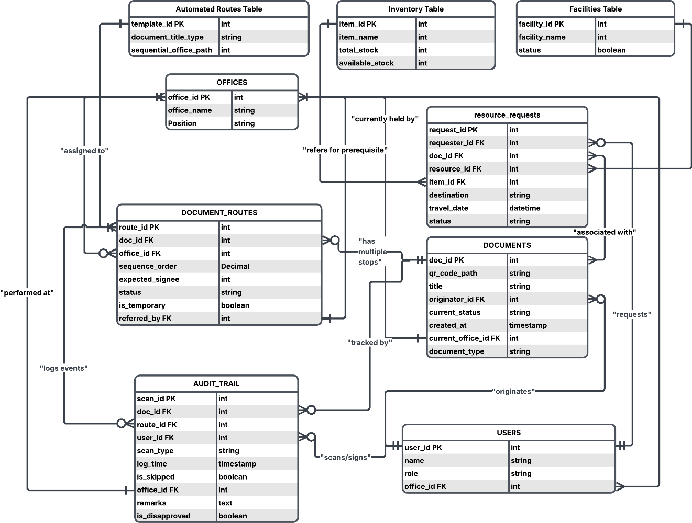
Figure 3-13. Entity Relationship Diagram (ERD)
The USERS and OFFICES tables form the foundation of the database schema. The current implementation includes internal role identifiers such as system_admin, gso_admin, office_processor, office_signee, and office_individual. These identifiers represent system permissions and operational functions; they do not describe separate user-facing Office Processor and Office Signee account types. In the user-facing account model, document-handling functions are performed through one Office account, while the individual faculty member uses a Faculty account. The OFFICES table provides a directory of campus units, with users linked to offices so authorized personnel can perform their assigned functions. The relationships also allow the system to identify the office currently handling a document or resource request and provide status visibility to the Faculty user.
Building upon this structure, document management is handled through the DOCUMENTS and DOCUMENT_ROUTES tables. To address the need for automated process guidance, the Automated Routes Table stores pre-configured office hierarchies based on document_title_type, allowing the system to suggest standardized paths for common transactions. For custom or non-linear workflows, the DOCUMENT_ROUTES table maintains flexibility through a decimal-based order, enabling "referred for prerequisite" actions where temporary office stops are inserted for "side-signature" verifications. Real-time monitoring is facilitated by the AUDIT_TRAIL table, which records every "Receive" and "Release" scan performed at office junctions. This table captures granular log_time and remarks, providing the "Pizza Tracker" interface with the data needed for transparent status notifications and ensuring unsigned documents are returned with clear instructions rather than stalling in an "administrative black hole".
Transitioning to comprehensive resource allocation, the resource_requests table centralizes the scheduling of the university fleet, specialized facilities via the Facilities Table (Multimedia Room and Gymnasium), and high-volume event equipment through the Inventory Table (monoblock chairs and folding tables). To prevent logistical conflicts, these requests are logically linked to their associated approval documents in the DOCUMENTS table. This ensures that the GSO Admin only assigns assets and personnel once the necessary administrative clearances have been verified through the digital audit trail, keeping bookings in a "provisional" state until final document approval is reached.
Finally, the cumulative data stored within the AUDIT_TRAIL and resource_requests tables provides the essential features for the system’s analytical core. By calculating "dwell times" and aggregating referral delays, the system generates Bottleneck Heatmaps to identify high-stagnation offices. Furthermore, these historical timestamps provide the dataset for Linear Regression models to forecast the Estimated Date of Completion (EDC) and Time-Series Analysis to predict Peak Demand across all campus resources. Collectively, the BSU-Trace database schema provides a secure, normalized, and data-driven structure that optimizes campus resource management through precise tracking and proactive analytics.

Trade-off and Multiple Attributes
The development of the BSU-Trace platform involves evaluating several trade-offs to balance system performance, administrative accountability, and the technical complexity of integrating machine learning into a campus-wide environment. System design requires making choices between competing constraints to ensure the final Progressive Web App (PWA) meets the university's operational goals. The tables below outline the key trade-offs and quality attributes identified during the planning phase.
Table 3-5. Trade Off
Trade-Offs | Description | Implication
Real-Time Intelligence vs. Server Complexity | Integrating Socket.io for instant status notifications and Python-based ML for bottleneck analysis increases system intelligence. | Higher server resource requirements and increased complexity in managing concurrent backend processes.
Granular Audit Trail vs. Manual Effort | Relying on manual "Scan-In" and "Scan-Out" actions ensures a high-integrity digital twin for physical papers. | Tracking accuracy is strictly dependent on the diligence of office clerks at each designated node.
PWA Accessibility vs. Hardware Independence | Choosing a Progressive Web App (PWA) architecture allows access across all devices without an app store. | Eliminates the need for specialized hardware but requires a stable campus Wi-Fi or LAN connection for real-time sync.
Predictive Accuracy vs. Data Volume | Utilizing advanced Time Series (ARIMA/LSTM) for vehicle demand forecasting provides high precision. | Requires a significant volume of historical administrative logs to train the models effectively.

The trade-offs analyzed for BSU-Trace represent the strategic balancing of system performance, technical complexity, and manual operational effort to ensure that the final platform remains highly aligned with the university's goal of achieving a transparent and efficient "Smart Campus" environment.
Table 3-6. Multiple Attributes
Attributes | Specific Goals and Metrics
Performance | - Real-time update of document status upon QR scan.  - High-speed rendering of Bottleneck Heatmaps for administrators.
Security | - Role-based access control (RBAC) to ensure only authorized clerks scan documents.  - Maintenance of referential integrity in the PostgreSQL database for official audit trails.
Usability | - Intuitive "Pizza Tracker" style interface for faculty and staff.  - Mobile-responsive design using Tailwind CSS for on-the-go tracking.
Reliability | - Adherence to ISO/IEC 25010:2023 system quality evaluation criteria.  - Robust error handling for offline scans or network disruptions.
Business Value | - Elimination of the "Administrative Black Hole" through digital traceability of documents.  - Data-driven GSO decision-making regarding facilities and vehicle schedule management.

Development
The development phase of BSU-Trace focuses on the technical realization of the universal document tracking and vehicle scheduling pillars. This stage involves the integration of a robust suite of software tools and hardware workstations designed to facilitate the Agile development model. By utilizing component-based frontend frameworks and asynchronous backend processing, the development process ensures that the Progressive Web App (PWA) remains highly performant and capable of transforming raw operational logs into actionable administrative intelligence.

Software Development Tools
BSU-Trace was developed using a suite of software tools for a modern web-based architecture to support a responsive, high-performance user interface for document tracking and vehicle scheduling.
Table 3-7. Software Development Tools
Component | Technology | Purpose
Frontend | React.js | Creates the interactive, responsive screens users see for tracking and scheduling.
Backend | Node.js & Express | The "brain" of the app that handles requests and connects the frontend to the database.
Database | PostgreSQL | Stores all document histories and logs in an organized, reliable way.
Data & AI | Python (Pandas, Scikit-learn) | Analyzes data to find "bottlenecks" (where documents or vans are getting stuck).
QR System | Qrcode library | Generates unique codes for documents so they can be scanned at every stop.
Development | VS Code | The coding environment where the developers write and test the software.
Deployment | Vercel or Render | The cloud platforms that host the app so users can access it online.

Hardware Development Tools
The hardware infrastructure for BSU-Trace is a web-based document management system designed to work on existing university computers, removing the need for specialized mobile hardware. It focuses on high-speed performance, QR-based tracking, and campus-wide compatibility. By using the university’s internal network, the system ensures fast and reliable data synchronization across all office workstations.
Table 3-8. Hardware Development Tools
Category | Specification | Purpose
Development Workstations | High-performance Laptops/Desktops (Intel Core i7 or AMD Ryzen 7, 16GB RAM) | To handle concurrent local server operations and machine learning model training.
Input Devices | Standard USB or Wireless QR Code Scanners | To test the document tracking workflow and web-based scanning interface.
Testing Devices | Various Office Desktops and Laptops | To ensure cross-device compatibility of the web platform across campus.
Network Infrastructure | Local Area Network (LAN) or Campus Wi-Fi | To simulate and optimize real-time chat and data synchronization within the university environment.

Testing and Evaluation
Testing Phase
The testing phase serves as a critical stage to ensure the BSU-Trace platform meets quality standards and operational reliability for the Batangas State University – Lipa Campus. Rigorous evaluation methods are applied to identify and resolve performance issues, verify system integration between the document tracking, facility and vehicle scheduling pillars, and assess overall behavior under various campus administrative conditions. Usability, security, and scalability are thoroughly tested to ensure a smooth experience for Faculty users and Office users, while final assessments confirm the platform's readiness to eliminate the "administrative black hole".
Performance
System performance is evaluated to measure how efficiently the platform handles multiple users performing simultaneous actions, such as QR-hybrid scanning and real-time status updates. Load and stress testing determine system stability during peak administrative hours when numerous documents are moving across office junctions. Specific attention is given to the responsiveness of the "Pizza Tracker" style interface to ensure minimal latency for Faculty users.
Reliability
Reliability testing involves extended operation under simulated real-world conditions to ensure system stability and uptime during periods of high document volume and vehicle requests. The system must demonstrate high resilience, ensuring that critical data records, such as the digital audit trails and vehicle booking logs, are accurately saved and consistently retrieved even during network fluctuations.
Usability
Usability testing evaluates the navigation flow, interface clarity, and feature intuitiveness of the Progressive Web App (PWA). Feedback from various user roles, including the ICT Admin, GSO Admin, Office users, and Faculty users, helps identify design improvements for the QR scanning module to ensure it remains user-friendly for clerks without requiring specialized technical training.
Efficiency
Efficiency assessment examines resource utilization and processing speed, particularly for the system’s analytical core. Metrics such as execution time for Linear Regression models (for EDC forecasting) and Time Series Analysis (for vehicle and facility demand prediction) verify that these modules operate smoothly without degrading the overall user experience.
Maintainability
The system structure, built on a three-tier model using React.js, Node.js, Python, and PostgreSQL is evaluated for its capacity to support easy modifications and feature enhancements. This ensures that the platform can be updated with low risk to accommodate future requirements, such as expanding the scope of monitoring to inter-campus document routing or additional resource modules.
Portability
Portability testing verifies system accessibility across the varied hardware used by campus personnel. The platform must demonstrate consistent performance and responsive design across standard office desktops, laptops, and personal mobile devices used for on-the-go tracking, ensuring the PWA remains functional regardless of the operating system or browser.
Test Cases
The following test cases are designed to validate the core functional and analytical components of BSU-Trace, a Smart Campus Resource Management System for Batangas State University – Lipa Campus. This testing phase ensures the seamless integration of the QR-hybrid document audit trail and the vehicle scheduling module. Following the Agile methodology, these scenarios verify that the system effectively eliminates the "administrative black hole" by providing real-time transparency and data-driven insights through Machine Learning.

Table 3-9. Test Cases
Test Case ID | Scenario | Expected Result/Output
TC_01 | Verify Login Using Valid Credentials:  - Input valid email and password credentials.  - Click the "Login" button. | Success Login Notification; auto-redirect to the User Dashboard.
TC_02 | Verify Login Using Invalid Credentials:  - Input invalid email and password credentials.  - Cick the “Login” button. | The system denies access, displays an "Unauthorized Access" error, and redirects the user to the login page.
TC_03 | Verify QR Code Generation for New Document:  - Log in as a Faculty user.  - Configure document metadata and routing path.  - Click "Submit/Generate". | The system generates a unique QR code for physical document attachment.
TC_04 | Verify Document "Scan-In" (Receive):  - Log in as an Office user.  - Navigate to the scanning module.  - Scan the QR code of a physical document upon arrival. | Success "Receive" Notification; system logs the 'Receive' timestamp in the audit trail.
TC_05 | Out-of-Order QR Scanning:  - Log in as an Office user for "Office C".  - Attempt to scan a document that is currently logged as "Received" in "Office A" but not yet "Released". | The system rejects the scan and displays an error message stating the document must be released from the previous node first.
TC_06 | Verify Document "Scan-Out" (Release):  - Log in as an Office user.  - Sign the physical document.  - Scan the QR code to release it to the next office. | Success "Release" Notification; system logs the 'Release' timestamp and notifies the Faculty user.
TC_07 | Invalid QR Code Detection:  - Log in as an Office user.  - Navigate to the scanning module.  - Scan a QR code not generated by the BSU-Trace system (e.g., a commercial product barcode). | The system identifies the code as invalid and provides an "Unknown Document" error without creating an audit log entry.
TC_08 | Verify Real-Time "Pizza Tracker" Progress:  - Log in as an Individual Staff (Faculty user).  - Navigate to the "My Documents" tracking interface.  - View the progress bar of a recently scanned document. | Granular view of the document's current office location and historical dwell times.
TC_09  TC_10 | Verify Provisional Resource Booking (Vehicle & Facility):  - Submit a request for a University Vehicle or University Facilities.  - Check the status of the booking while paperwork is pending.  Verify Facility Resource Allocation:  - GSO Admin selects a provisional facility booking.  - Click the “Confirm” button | The booking remains in a "provisional" state until final document clearance is verified.  The booking remains in a "provisional" state until GSO Admin verifies physical document clearance.
TC_11 | Verify Bottleneck Heatmap Generation:  - Log in as an Admin (GSO).  - Navigate to the Analytics Dashboard.  - View the descriptive bottleneck analysis report. | Heatmap correctly visualizes offices with high document dwell times.
TC_12 | Verify EDC (Estimated Date of Completion) Forecast  - Navigate to a pending document's status page.  - View the predicted completion date. | Linear Regression model displays forecasted EDC based on historical logs.
TC_13 | Verify Peak-Day Vehicle Demand Forecast  - Log in as an Admin.  - Run the Predictive Demand module.  - View the time-series forecasting chart. | A forecast of vehicle request demands displayed in the analytical dashboard.
TC_14 | Verify Real-Time Notification System:  - Office user scans a document out.  - Check the Faculty user's account notifications. | Instant notification sent to the Faculty user confirming movement to the next node.
In summary, the testing and evaluation phase of BSU-Trace validates the system’s ability to eliminate the "administrative black hole" by providing a high-integrity digital audit trail and multi-resource management. Through the successful execution of TC_01 and TC_02, the platform confirmed that security protocols effectively manage access, granting entry to authorized stakeholders while denying unauthorized users. The core document tracking functionality, verified through TC_03, TC_04, and TC_06, demonstrated that the unique QR-hybrid method accurately logs "Receive" and "Release" timestamps at every office junction, ensuring physical paperwork remains traceable throughout the university hierarchy. Furthermore, the system’s error-handling logic was confirmed in TC_05 and TC_07, which prevented out-of-order scans and rejected invalid QR codes to preserve the chronological and legal authenticity of the audit logs.
The integration of the resource scheduling module with the document workflow was successfully validated in TC_09 and TC_10. These tests confirmed that requests for both University Vehicles and University Facilities (such as the Multimedia Room or Gymnasium) correctly remain in a "provisional" state until the GSO Admin verifies physical document clearance, thereby preventing logistical conflicts and ensuring administrative compliance. From a user perspective, TC_08 and TC_14 confirmed that the "Pizza Tracker" interface and real-time notification system provide Faculty users with immediate, granular visibility into movement and status updates. Finally, the analytical core was proven effective through TC_11, TC_12, and TC_13, which verified the generation of bottleneck heatmaps and predictive forecasts for document completion dates and peak-day resource demand. Collectively, these results indicate that BSU-Trace meets the ISO/IEC 25010:2023 system quality standards required for a transparent and proactive "Smart Campus" environment.
Table 3-10. Evaluation Metrics
Quality Characteristic / Criteria | 5 | 4 | 3 | 2 | 1
I. Functional Suitability
1. The system provides all necessary functions for document tracking. | ☐ | ☐ | ☐ | ☐ | ☐
2. The QR-code generation and scanning meet the project requirements. | ☐ | ☐ | ☐ | ☐ | ☐
3. The system correctly identifies and records document locations. | ☐ | ☐ | ☐ | ☐ | ☐
4. The resource management features (vehicles) work as intended. | ☐ | ☐ | ☐ | ☐ | ☐
II. Performance Efficiency
5. The system responds quickly when scanning or searching for records. | ☐ | ☐ | ☐ | ☐ | ☐
6. Dashboards and reports load within an acceptable time frame. | ☐ | ☐ | ☐ | ☐ | ☐
7. The system handles multiple simultaneous users without slowing down. | ☐ | ☐ | ☐ | ☐ | ☐
8. Database queries for historical audit trails are processed efficiently. | ☐ | ☐ | ☐ | ☐ | ☐
III. Compatibility
9. The system exchanges data smoothly between the frontend and backend. | ☐ | ☐ | ☐ | ☐ | ☐
10. The system operates alongside other university software without conflict. | ☐ | ☐ | ☐ | ☐ | ☐
11. The software functions correctly on various hardware (PCs, tablets). | ☐ | ☐ | ☐ | ☐ | ☐
12. APIs and integration points are consistent and reliable. | ☐ | ☐ | ☐ | ☐ | ☐
IV. Interaction Capability (Formerly Usability)
13. The "Pizza Tracker" interface is easy to understand for all users. | ☐ | ☐ | ☐ | ☐ | ☐
14. Users can navigate the system with minimal training or guidance. | ☐ | ☐ | ☐ | ☐ | ☐
15. The system provides clear feedback or alerts after a user action. | ☐ | ☐ | ☐ | ☐ | ☐
16. The visual design is organized and prevents user error during entry. | ☐ | ☐ | ☐ | ☐ | ☐
V. Reliability
17. The system is available for use whenever the staff needs access. | ☐ | ☐ | ☐ | ☐ | ☐
18. The system performs its functions without unexpected crashes. | ☐ | ☐ | ☐ | ☐ | ☐
19. Data is saved correctly even if there is a brief internet disruption. | ☐ | ☐ | ☐ | ☐ | ☐
20. The system can be restored quickly if a minor error occurs. | ☐ | ☐ | ☐ | ☐ | ☐
VI. Security
21. Only authorized personnel can access sensitive document records. | ☐ | ☐ | ☐ | ☐ | ☐
22. User login credentials are handled and stored securely. | ☐ | ☐ | ☐ | ☐ | ☐
23. The system strictly enforces all five defined user roles to prevent unauthorized access | ☐ | ☐ | ☐ | ☐ | ☐
24. The system protects against unauthorized data modification. | ☐ | ☐ | ☐ | ☐ | ☐
VII. Maintainability
25. The researchers can easily update the system with new features. | ☐ | ☐ | ☐ | ☐ | ☐
26. Faults in the system can be identified and fixed quickly. | ☐ | ☐ | ☐ | ☐ | ☐
27. The system architecture is modular and easy to manage. | ☐ | ☐ | ☐ | ☐ | ☐
28. Changes in one part of the system do not cause bugs in others. | ☐ | ☐ | ☐ | ☐ | ☐
VIII. Flexibility (Formerly Portability)
29. The interface adjusts properly to different screen sizes (Responsive). | ☐ | ☐ | ☐ | ☐ | ☐
30. The system works consistently across Google Chrome, Edge, and Safari. | ☐ | ☐ | ☐ | ☐ | ☐
31. The system can be easily migrated to a different server if needed. | ☐ | ☐ | ☐ | ☐ | ☐
32. The system can adapt to different types of university documents easily. | ☐ | ☐ | ☐ | ☐ | ☐
IX. Safety
33. The system prevents data loss that could harm administrative operations. | ☐ | ☐ | ☐ | ☐ | ☐
34. The system protects the privacy of staff and office information. | ☐ | ☐ | ☐ | ☐ | ☐
35. The software avoids actions that could lead to system-wide corruption. | ☐ | ☐ | ☐ | ☐ | ☐
36. User interactions are designed to avoid data entry errors or hazards. | ☐ | ☐ | ☐ | ☐ | ☐

Deployment
The deployment plan for BSU-Trace outlined the approach for transitioning the platform from development to operation at Batangas State University – Lipa Campus. The plan covered integration and testing of the QR-hybrid document tracking and vehicle scheduling systems, including their hosting environments on Vercel and Render, before the planned campus-wide launch. It aimed to minimize implementation risks and support a stable, secure, and user-friendly experience through planning and iterative validation.

Sustainability and Maintenance Plan
Maintenance Plan
The maintenance strategy for the BSU-Trace platform focuses on ensuring continuous system functionality, data integrity, and analytical precision through scheduled daily, weekly, and monthly activities. Daily tasks include log inspections of QR "Scan-In" and "Scan-Out" actions to ensure data synchronization and system health checks. Weekly maintenance involves applying security patches to the Node.js and Python backends and reviewing application performance metrics. Monthly operations include full system diagnostics, PostgreSQL database optimization, and retraining the machine learning models (Linear Regression and Time Series) with new administrative data to maintain forecasting accuracy. Furthermore, the sustainability plan includes formal training sessions for office clerks and a structured turnover of system documentation and source code to the university’s ICT department to facilitate long-term technology transfer.
Risk Management Plan
The risk management strategy identifies potential technical, operational, and external threats that could affect the performance of the smart campus ecosystem. To mitigate technical risks, robust cloud-based server infrastructure and regular stress testing are employed to detect bottlenecks in the QR scanning module proactively. Security risks, such as unauthorized access to document audit trails, are minimized through encrypted login protocols and strict Role-Based Access Control (RBAC). Operational risks, particularly the dependence on manual "Scan-In/Out" actions by office clerks, are managed through continuous user feedback integration and performance monitoring to prevent "administrative black holes". External risks, including campus Wi-Fi disruptions or hosting service outages, are addressed by utilizing the reliable Vercel and Render platforms and implementing automated backup routines for all critical administrative logs.

RESULTS AND DISCUSSION
Introductory paragraph

Results by phase of study (Rephrase Objectives as title)
Name the phases of your study and give the results. Have as many headings as necessary depending on the number of experiments or studies you did. Provide the discussions.
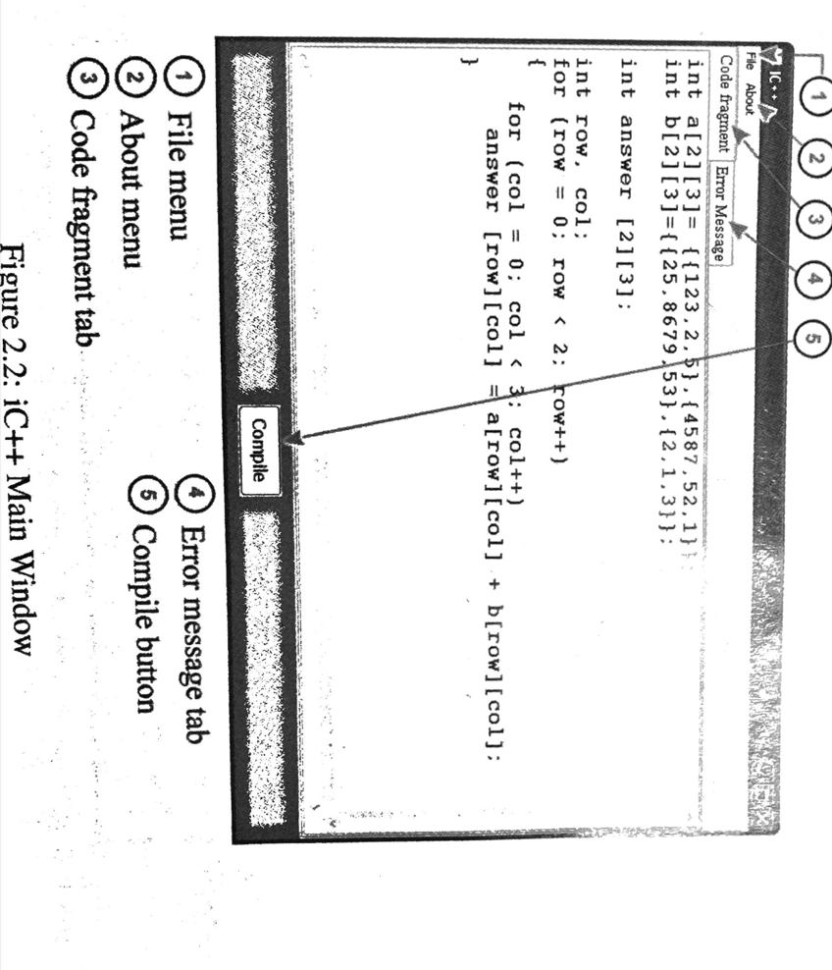

Verification studies
The headings above are only suggestive. Follow what is appropriate for your research work.

SUMMARY, CONCLUSIONS, AND RECOMMENDATIONS
Introductory Paragraph

Summary
Provide a rather concise summary of the research work.

Conclusions
The conclusions are direct statements that would prove the achievement of the specific objectives. The conclusions should have a one-to-one correspondence to the specific objectives, i.e. if you have 4 specific objectives (a to d) then you should have 4 conclusions (1 to 4).
The chapter on conclusion and recommendations is the last chapter of the undergraduate capstone project documentation. In this chapter, a summary of the results and recommendations for a more extensive work are written.
For an undergraduate senior capstone project, the results of the usability tests are worth mentioning. Which parts of the overall system are now software-driven? Did the use of custom-made software improve the overall performance of the system? Measurements of the performance should be highlighted and presented unambiguously. In terms of percentage, how many of the target users accept the system? What is the level of satisfaction they have on the system? Is the amount of software development effort commensurate to the eventual level of user acceptance of the developed software? Which aspects of the overall system are now software-driven? Which parts of the system need automation or further software support? Software or system deployment plan should be part of the list of recommendations.

Recommendations

REFERENCES
Acedo, G. G., Bola, J. G., & Morales, A. S. (2025). Web-Based Document Tracking System for Catanduanes State University with QR-Code Technology: In Alignment with Republic Act No. 11032. Journal of Information Systems Engineering and Management, 469–477.
Alabi, A., Lateef, H., Tewogbade, A., Ozoh, P., & Balogun, F. (2025). Design and Implementation of an Enhanced QR-Code Based Attendance System. Journal of Computing and Social Informatics, 20.
Arize. (2023, February 8). Mean Absolute Percentage Error (MAPE): What You Need To Know . Retrieved from Arize: https://arize.com/blog-course/mean-absolute-percentage-error-mape-what-you-need-to-know/
Awoke, S., Diro, A., Tadesse, G., Belay, M., & Abebe, D. (2023). Machine Learning-Based Classification and Risk Factor Analysis of Rabies in Humans and Animals. PLOS Neglected Tropical Diseases, 12.
Bermann, D. (2024, May 22). What is machine learning? Retrieved from IBM: https://www.ibm.com/think/topics/machine-learning
Bhat, J. (2023). Automating Higher Education Administrative Processes with AI-Powered Workflows. International Journal of Emerging Trends in Computer Science and Information Technology, 11.
Breault, E. (2025, February 6). Wet Signature vs E-sign – When Can You Switch to a Digital Signature Workflow? Retrieved from Malbek: https://www.malbek.io/blog/wet-signature
Burch, D. (2023, September 1). Mean Absolute Error In Machine Learning: What You Need To Know. Retrieved from Arize: https://arize.com/blog-course/mean-absolute-error-in-machine-learning-what-you-need-to-know/
Castro, F. V., Quilon, E. R., & Arruejo, A. C. (2022). DocTrack: A Dynamic Document Tracking System for the University of Northern Philippines. Journal of Innovative Technology Convergence, 23–34.
Chen, S., He, Z., & Zhong, J. (2022). Integrated Framework for Bus Timetabling and Scheduling in Multi-Line Operation Mode. Applied Sciences, 9.
codezup. (2024, December 13). Express.js and Node.js: A Comprehensive Guide to Development. Retrieved from https://codezup.com/express-js-node-js-comprehensive-guide/
D2L. (2025, October 29). Predictive Learning Analytics: The Ultimate Guide for 2026. Retrieved from D2L Blog: https://www.d2l.com/blog/boost-corporate-learning-predictive-analytics/
DocuXplorer. (2026, January 8). 10 Best Document Management Systems for 2026. Retrieved from DocuXplorer: https://www.docuxplorer.com/blog/10-best-document-management-systems-for-2026
Dres, O., & Rabut, B. (2025). A Web-Based File Management System for Efficient File Organization. Psychology and Education: A Multidisciplinary Journal, 228.
Duldulao, J.-R. R., & Duldulao, A. V. (2024). Innovating Administrative Processes: Online Systems Development for a State University. J. Electrical Systems (Journal of Electrical Systems), 15.
Fernando, J. (2025, October 2). R-Squared: Definition, Calculation, and Interpretation. Retrieved from Investopedia: https://www.investopedia.com/terms/r/r-squared.asp
GeeksforGeeks. (2026, March 14). SQL Vs NoSQL - Which Database to Choose in System Design? Retrieved from GeeksforGeeks: https://www.geeksforgeeks.org/system-design/which-database-to-choose-while-designing-a-system-sql-or-nosql/
Guo, Z., Xu, H., & Lin, Q. (2025). Automated Identification and Spatial Pattern Analysis of Urban Slow-Moving Traffic Bottlenecks Using Street View Imagery and Deep Learning. ISPRS International Journal of Geo-Information, 14.
Hermosa, K. R., Loteriña, V. C., & Sebuc, J. A. (2023). DOCUMENT MANAGEMENT SYSTEM WITH TRACKING AND MONITORING IN MANUEL S. ENVERGA UNIVERSITY FOUNDATION-CANDELARIA INC. International Journal of Advanced Research in Computer Science, 13.
Hernandez, C., Aslankoohi, E., Frolikov, P., Li, H., Kurniawan, S., & Rolandi, M. (2023). Implementing QR codes in academia to improve sample tracking, data accessibility, and traceability in multicampus interdisciplinary collaborations. PLOS ONE, 18.
Horwitz, L. (2023, June 12). Phygital. Retrieved from Tech Target: https://www.techtarget.com/searchcustomerexperience/definition/phygital
Hyndman, R. J., & Athanasopoulos, G. (2021). Forecasting: Principles and Practice (3rd ed.). OTexts. https://otexts.com/fpp3/
Isarsoft. (2025, July 10). What is Dwell Time. Retrieved from Isarsoft: https://www.isarsoft.com/knowledge-hub/dwell-time
Islam, M. R., Hossain, M. N., & Tusar, M. Z. (2021). Predictive Analytics in Supply Chain Management: A Review of Business Analyst-Led Optimization Tools. Review of Applied Science and Technology, 39.
ISO/IEC. (2023). ISO/IEC 25010:2023 Systems and software Quality Requirements and Evaluation (SQuaRE) — Product quality model. Geneva, Switzerland: International Organization for Standardization.
Kayanja, W., Kyambade, M., & Kiggundu, T. (2025). Exploring digital transformation in higher education setting: the shift to fully automated and paperless systems. Cogent Education, 15.
Kimei. (2024, December 12). What Is Agile Software Development? Agile Methodology Overview. Retrieved from KIMEI Global: https://kimei-global.com/blogs/what-is-agile-what-is-scrum
Kosourova, E. (2025, June 30). RMSE Explained: A Guide to Regression Prediction Accuracy. Retrieved from Data Camp: https://www.datacamp.com/tutorial/rmse
Koutsandreas, D., Spiliotis, E., Petropoulos, F., & Assimakopoulos, V. (2022). On the selection of forecasting accuracy measures. Journal of the Operational Research Society, 73(5), 937–954. https://doi.org/10.1080/01605682.2021.1892464
Laoyan, S. (2025, December 9). What is Agile methodology? (A beginner’s guide). Retrieved from asana: https://asana.com/resources/agile-methodology
Li, S., Dahnil, D. P., & Saad, S. (2025). A Survey of Smart Campus Resource Information Management in Internet of Things. IEEE Access, 25.
Mele, C., Russo Spena, T., Marzullo, M., & Di Bernardo, I. (2023). The phygital transformation: a systematic review and a research agenda. Italian Journal of Marketing, 27.
Menghnani, M. (2025). Advancing PWA Accessibility: The Impact of . TIJER - International Research Journal, 7.
Nishat, M. M., Ahsan, A., & Olsson, N. O. (2025). Applying Machine Learning for Predictive Analysis in Project-Based Data: Insights into Variation Orders. Journal of Information Technology in Construction (ITcon), 807–825.
Paredes, R. (2025, October 14). Bottleneck Analysis: Finding Business Delays. Retrieved from SafetyCulture: https://safetyculture.com/topics/bottleneck-analysis
Paredes, R. (2026, April 28). Bottleneck Analysis: Identify the Areas Causing Delays in Your Business. Retrieved from SafetyCulture: https://safetyculture.com/topics/bottleneck-analysis/
Park, J.-H., Beridze, G., & Zulkifli, F. N. (2025). Machine Learning Identification of Innovation Bottlenecks: A Behavioral Analytics Approach Using Gradient Boosting Models. International Journal of Innovation Management and Organizational Behavior (IJIMOB), 10.
Perin, M. A. (2025). Technology-Assisted Attendance Monitoring: A Case Study on QR Code System Usability and Performance. Journal of Technology-Assisted Learning, 115–123.
Piloton Jr., A. L., Gamboa Jr., G. Z., Dela Cerna, M. A., & Reyna, R. A. (2023). Development of Records Tracking Management System with QR Code. International Journal for Multidisciplinary Research (IJFMR), 1–14.
Planview. (2026). Resource Heat Map: Visualize Resource Planning in AdaptiveWork. Retrieved from Planview: https://www.planview.com/products-solutions/products/adaptivework/resource-heat-map/
Polin, K., Yigitcanlar, T., Limb, M., & Washington, T. (2023). The Making of Smart Campus: A Review and Conceptual Framework. Buildings, 891.
Polin, K., Yigitcanlar, T., Limb, M., & Washington, T. (2023, March). The Making of Smart Campus: A Review and Conceptual Framework. Retrieved from ResearchGate: https://www.researchgate.net/publication/369640918_The_Making_of_Smart_Campus_A_Review_and_Conceptual_Framework
Polin, K., Yigitcanlar, T., Limb, M., & Washington, T. (2023, March). The Making of Smart Campus: A Review and Conceptual Framework. Retrieved from ResearchGate: https://www.researchgate.net/publication/369640918_The_Making_of_Smart_Campus_A_Review_and_Conceptual_Framework
Porter, V., & Oke, P. (2025). Predictive analytics in strategic decision-making: Applying machine learning to transform market signals into growth execution. GSC Advanced Research and Reviews, 156-164.
Progressive web apps. (2023). Retrieved from Mozilla: https://developer.mozilla.org/en-US/docs/Web/Progressive_web_apps
Raralio, D. G., Manzano, W. Q., & Lomibao, A. N. (2025). Development of Document Tracking and Archiving System for Procurement Management Office's Purchase Request in Apayao State College. International Journal of Research and Scientific Innovation (IJRSI), 1290–1308.
Revver. (2026). Document Workflow Automation Software. Retrieved from Revver: https://www.revverdocs.com/document-workflow-automation/
Reyes, E. R., Almonte, R. G., Montano, M. R., & Armario, N. O. (2024). Efficiency Assessment and Design Proposal for Computerized Student Record Management System in Higher Education Institutions. ACM (Association for Computing Machinery). Tokyo, Japan: ACM (Association for Computing Machinery).
Rimando, M. K., & Corpuz, R. R. (2022). A Real Time Tracking System for School Forms Using QR Codes with Watermarking Algorithm. Journal of Artificial Intelligence, Machine Learning and Neural Network, 24–33.
Sandeep, G., Sirisha, M., Chary, M. R., Ganesh, M. S., & Reddy, A. A. (2025). QR Scan-Based Intelligent System for School Bus Tracking. Journal of Microwaves and Antenna Applications (JMAA), 1–11.
Schiewe, P., & Stinzendörfer, M. (2022). Integrated Line Planning and Vehicle Scheduling for Public Transport. 10th International Network Optimization Conference (INOC) (p. 6). Aachen, Germany: OpenProceedings.org.
Smart Creative Intelligent Technology Holdings Corporation. (2020, March 22). Education Sector Philippines – Smart Campus Management System. Retrieved from https://smartcreativeit.com/portfolio-item/education-sector-philippines-smart-campus-management-system/
Turdibayeva, K. (2024, July 16). Bottleneck Analysis Explained – Steps, Benefits & Tools. Retrieved from processmaker: https://www.processmaker.com/blog/bottleneck-analysis-explained/
University of the Philippines Information Technology Development Center. (2022, January 1). The UP Document Tracking System (DTS). Retrieved from https://itdc.up.edu.ph/news/the-up-document-tracking-system-dts
Urmeneta, J. C., & Agullo, J. M. (2021). Digitized Document Tracking System Using QR-Code. International Journal of Engineering Research & Technology (IJERT), 546–550.
Vărzaru, A. A., & Bocean, C. G. (2024). Digital Transformation and Innovation: The Influence of Digital Technologies on Turnover from Innovation Activities and Types of Innovation. Systems, 25.
Wang, C.-C., Chien, C.-H., & Trappey, A. J. (2021). On the Application of ARIMA and LSTM to Predict Order Demand Based on Short Lead Time and On-Time Delivery Requirements. Processes, 1157.
Zhang, H., & Zhang, W. (2025). RETRACTED: Advancing enterprise risk management with deep learning: A predictive approach using the XGBoost-CNN-BiLSTM model. PLOS ONE, e0319773.

APPENDICES

Appendices are blocks of relevant data and information presented at the end of the documentation. Appendices are usually included in the complete documentation book but not in most research articles. Note that research articles presented in conferences or published in academic journals are typically subject to page limitations set by the conference organizers or journal publishers. In most textbooks and reference books, an appendix section gives the readers additional explanations on topics or discussions pointed out in its main body. If the full explanation of a theory, technology, or other context will clutter the main discourse of the book, it may be relegated to the appendix area. It is important that the appendix chapter is cited in the main body to provide context on why the said material is included in the appendix.
In undergraduate capstone project documentation, the following are typically included in the appendix area:
(Always provide at least one paragraph to introduce the material being provided in each of the appendix chapters.)
Complete or relevant software source code. Aside from the source code, this should include the source code comments and compilation commands (better yet include a Makefile). The source code listing must show the line number at its leftmost side. An example is shown below:
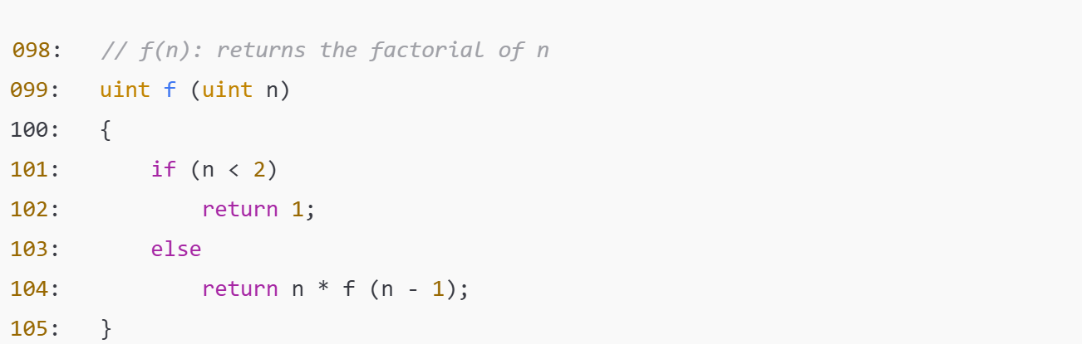
Documentation of interviews. This should include the interview date, venue, names, complete transcripts, photographs, and relevant communications. The official communications are important to establish the fact that the interviewee gave permission that the interview transcript will be used in the documentation.
Software regression tests. The software regression tests should show that all the functions and procedures in the source code are in fact tested and passed quality assurance.
Relevant math theorems and proofs. Unless really needed, the relevant math theorems and proofs must simply be cited and the primary source of information be listed in the references.
Software user's manual. The user's manual should include information on how a typical user would use the software. You have to provide separate sections for the superuser, database administrator, encoder, or a non-privileged user.
Software installation procedure. This chapter should provide the superuser or systems administrator with the relevant procedures on how to install the software successfully in a computer system. This should include a section on troubleshooting. The latter should enumerate typical installation problems and suggestions on how to solve them.
Turnitin Result
Grammarian Certification

BIO NOTE
.

