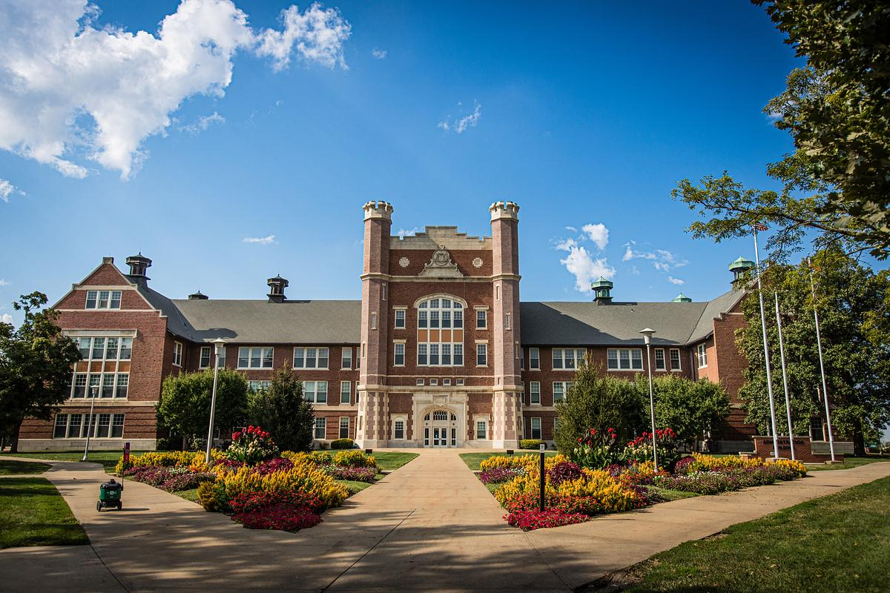

Course Number

Course Name
Fall 2023

COURSE SYLLABUS



Course Title
Course Prefix, Number and Title goes here.

Course Credit
Content goes here.

Placement in Curriculum
Content goes here.

Prerequisites
Content goes here, if any.

Course Professors

Lead Professor
Name:
Title:
Phone:
Email:
Office Hours:
Office
Location:

Associate Professor
Name:
Title:
Phone:
Email:
Office Hours:
Office Location:

Course Description
Content goes here. (From the course catalog)

Course Rationale
Content goes here.

Course Outcomes

[List all learning outcomes. Then indicate the method(s) you will use to assess how students will accomplish each outcome. Any Northwest Core class must include the NW competencies identified by the department/school and approved by DCM for that course. The NW competencies are these: Communication; Critical Thinking; Managing Information; Valuing; Global, Cultural, Social and Environmental Learning; Teamwork and Leadership.]

Student Learning Outcomes | Assessment Methods

Materials

Textbook or supplementary materials
Content goes here.

Other Resources
Content goes here.

Course Outline and Expectations
Content goes here.

List specifically what will be graded and how points will be distributed. Could also include required minimum hours of out-of-class work for every one hour of faculty instruction.

Instructional Methods and Techniques

Content goes here.
Some examples: lecture, class discussions, small group work, individual/group work, learner presentations, and professional guest speakers.

Participation
Students are expected to participate in all classes as specified in the course syllabi for each course.

Attendance Policy

Course Communication Policy
Content goes here.

Course Communication Guidelines (Netiquette)
Content goes here.

Technology Requirements

Computer/Technology Requirements
Content goes here.

Northwest Online (Canvas)
Content goes here.

Access to Northwest Online

Web Conferences/Synchronous sessions
Content goes here.

Grading and Evaluation

Final Grade Calculation
Assessments | Percentages
Total Percentage for Course

Blanket Statement on when assignments/assessments are due should go here as well as instructor feedback and turn-around time on assignments and assessments.

Grading
In determining the final course grade, the following scale is used:

xxx = A
xxx = B
xxx = C
xxx = F

Content goes here.

Rubrics
Content goes here.

Late Work Policy
Content goes here.

Use of Artificial Intelligence Policy

Course Evaluation
At the end of this course, students are encouraged to complete a course evaluation that will be distributed to them via email and through a course link.

Course Topics
Module 0 | Content goes here.
Module 1 | Content goes here.
Module 2 | Content goes here.
Module 3 | Content goes here.
Module 4 | Content goes here.
Module 5 | Content goes here.
Module 6 | Content goes here.
Module 7 | Content goes here.

Additional Course Information
Syllabus Subject to Change
While information and assurances are provided in this course syllabus, it should be understood that content may change in keeping with new research and literature and that events beyond the control of the instructor could occur. Students will be informed of any substantive occurrences that will produce syllabus changes.

