**Diferencia Valence Dependiente / Tratamiento independiente**

**Valance**

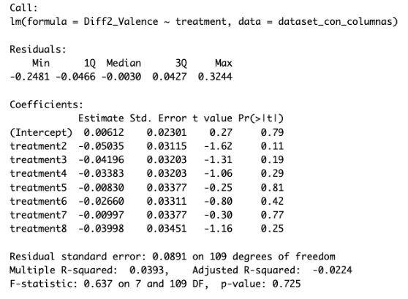

**Arousal**

**Diferencia Valence Dependiente / sitio independiente**

**Valance**

**Arousal**

**Diferencia Valence Dependiente / video independiente**

**Valance**

**Arousal**

**Diferencia Valence Dependiente / t_perfil (perfil, producto) independiente**

**Valance**

**Arousal**

**Diferencia Valence Dependiente / t_video (video, texto) independiente**

**Valance**

**Arousal**

**Valance (calculado en sitios web WiX) Dependiente / treatment independiente**

**Valance (calculado en sitios web WiX) Dependiente / sitios  independiente**

**Valance (calculado en sitios web WiX) Dependiente / video (1,0)   independiente**

**Valance (calculado en sitios web WiX) Dependiente / t_perfil (perfil,producto)   independiente**

**Valance (calculado en sitios web WiX) Dependiente / t_video (texto,video)   independiente**

