**TRATAMENTO DE EXCEÇÕES**

Checked - Erros recuperáveis

Obriga try-catch ou throws

Unchecked - Erros irrecuperáveis

Não obriga try-catch/throws

Normalmente filhas de RuntimeException

Possui throw implícito

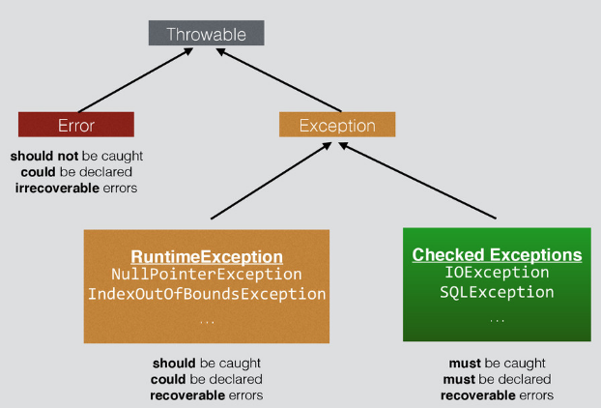

**9. Which of the following statements are true? (Choose all that apply)**

A. Checked exceptions are intended to be thrown by the JVM (and not the programmer).

B. Checked exceptions are required to be caught or declared.

C. Errors are intended to be thrown by the JVM (and not the programmer).

D. Errors are required to be caught or declared.

E. Runtime exceptions are intended to be thrown by the JVM (and not the programmer).

F. Runtime exceptions are required to be caught or declared.

|  |  |  |  |
| --- | --- | --- | --- |
| PLANO DE ESTUDOS | | | **DIAS** |
| Chapter 1: Java Building Blocks | 09/04/2018 | 15/04/2018 | 7 |
| Chapter 2: Operators and Statements | 16/04/2018 | 22/04/2018 | 7 |
| Chapter 3: Core Java APIs | 23/04/2018 | 29/04/2018 | 7 |
| Chapter 4: Methods and Encapsulation | 30/04/2018 | 06/05/2018 | 7 |
| Chapter 5: Class Design | 07/05/2018 | 13/05/2018 | 7 |
| Chapter 6: Exceptions | 14/05/2018 | 20/05/2018 | 7 |
| Simulados / Revisão | 21/05/2018 | 29/05/2018 | 9 |

**19.** Bytecode is in a file with which extension?

**A.** .bytecode

**B.** .bytes

**C.** .class

**D.** .exe

**E.** .javac

**F.** .java

**20.** Which of the following are checked exceptions? (Choose all that apply)

**A.** Exception

**B.** IllegalArgumentException

**C.** IOException

**D.** NullPointerException

**E.** NumberFormatException

**F.** StackOverflowError