**Software Requirements Specification (SRS)**

**Job Hiring Platform**

**Version 1.0**

**1. Introduction**

**1.1 User Story**

**As a**:

* Job Seeker (student, professional, or fresher)
* Employer (HR manager, recruiter, or company)
* Admin (system administrator)

**I want to**:

* Job Seeker: Search and apply for jobs, track applications easily.
* Employer: Post jobs, manage applicants, schedule interviews.
* Admin: Monitor platform, verify employers, handle complaints.

**So that**:

* Job seekers can find relevant opportunities quickly.
* Employers can recruit qualified candidates efficiently.
* The system runs smoothly and securely with proper moderation.

**Acceptance Criteria:**

* Job seekers should be able to apply within 2 clicks.
* Employers must be verified before posting jobs.
* Applications must notify both job seeker and employer.
* Users should get real-time updates for application status.

**1.2 Purpose**

The purpose of this platform is to provide a **centralized digital solution** for connecting job seekers and employers. It simplifies the hiring process by allowing job postings, applications, tracking, and communication in one secure platform.

**1.3 Scope**

* Automated job posting and application system.
* Candidate profile & resume management.
* Employer verification and job moderation.
* Application tracking and notifications.
* Admin oversight with analytics and reports.

**1.4 Overview**

The Job Hiring Platform is a web + mobile application that acts as a marketplace for recruitment. Job seekers create profiles and apply for jobs, while employers post openings and shortlist candidates. Admins ensure system security, user verification, and compliance.

**2. Overall Description**

**2.1 Product Perspective**

* Replaces manual hiring processes (email, offline applications).
* Works as an independent system but integrates with **email/SMS gateways, payment gateways** (for premium posts).
* Cloud-based, scalable for large user bases.

**2.2 Product Functions**

* **Job Seeker**: Register, upload resume, search jobs, apply, track status.
* **Employer**: Register company, post jobs, filter candidates, schedule interviews.
* **Admin**: Manage users, verify employers, monitor activities, generate reports.

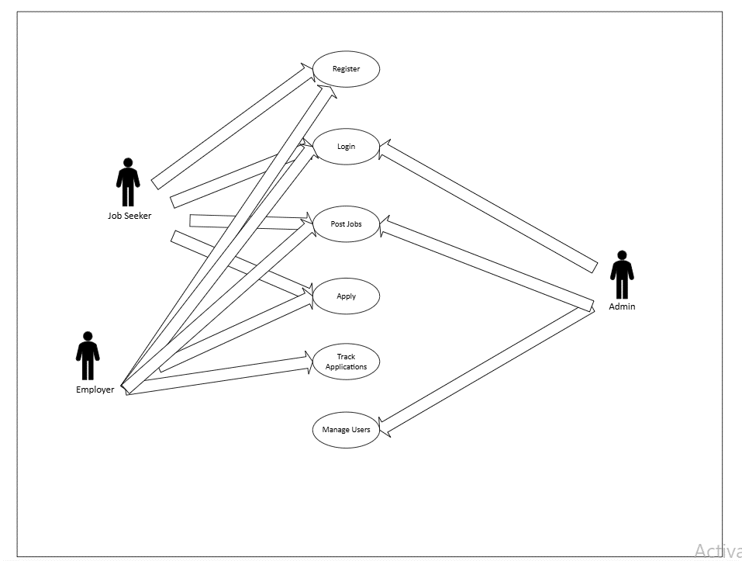

**2.3 User Characteristics**

1. **Job Seekers** – Require minimal technical skills, just basic internet usage.
2. **Employers** – HR/recruiters, moderate computer knowledge, job posting experience.
3. **Admins** – Technically skilled, manage platform security & compliance.

**2.4 Constraints**

* Employer verification required before job posting.
* GDPR compliance for data handling.
* Internet connection needed.

**2.5 Assumptions & Dependencies**

* Users will provide accurate profile/job details.
* Employers will respond to applications.
* Dependent on third-party email/SMS APIs.

**3. Specific Requirements**

**3.1 Functional Requirements**

**F1: Job Seeker Registration & Login**

* Input: Email/phone, password/social login.
* Processing: Verify credentials, store securely.
* Output: Successful login or error message.

**F2: Profile & Resume Upload**

* Input: Resume file, personal details.
* Processing: Store resume and link with profile.
* Output: Updated profile visible.

**F3: Job Search & Filtering**

* Input: Keywords, location, salary range, category.
* Processing: Database query with filters.
* Output: List of matching jobs.

**F4: Apply for Job**

* Input: Click on job + attach resume.
* Processing: Record application, notify employer.
* Output: Confirmation to job seeker + notification to employer.

**F5: Track Application Status**

* Input: Job seeker opens “My Applications.”
* Output: Status displayed (Applied, Shortlisted, Rejected, Interview).

**F6: Employer Registration & Verification**

* Input: Company details, registration documents.
* Processing: Admin verifies authenticity.
* Output: Employer account activated or rejected.

**F7: Post & Manage Job Listings**

* Input: Job title, description, requirements.
* Processing: Save job listing to database.
* Output: Job visible to seekers.

**F8: View & Filter Applicants**

* Input: Employer selects job & applies filters.
* Processing: System retrieves relevant applicants.
* Output: List of candidates shown.

**F9: Employer–Candidate Communication**

* Input: Employer sends message/invite.
* Processing: Store and deliver notification.
* Output: Candidate receives message/notification.

**F10: Admin User Management**

* Input: Admin selects user account.
* Processing: Approve, suspend, or delete.
* Output: Updated account status.

**F11: Admin Complaint Handling**

* Input: Reported job/user details.
* Processing: Review & take action.
* Output: Warning, suspension, or deletion.

**F12: Admin Monitoring & Analytics**

* Input: Admin dashboard access.
* Output: Reports on users, jobs, applications.

**3.2 Non-Functional Requirements**

* **Performance**: Search results under 2 seconds.
* **Security**: SSL/TLS encryption, hashed passwords.
* **Reliability**: 99.9% uptime.
* **Usability**: Easy-to-use UI, mobile-first design.
* **Maintainability**: Modular code for easy updates.

**3.3 Design Constraints**

* Software must be lightweight (fast loading).
* Cloud hosting should be cost-optimized.
* Must run on multiple devices (web + mobile).