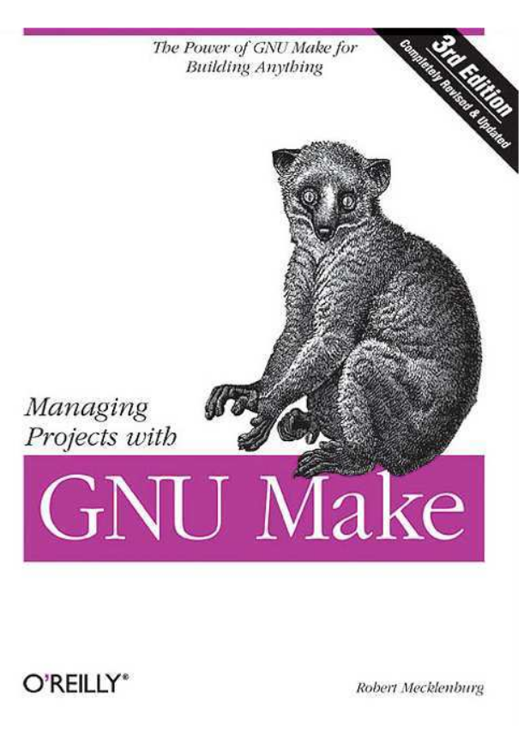

Open Book Content
From: http://oreilly.com/catalog/make3/book/

License/Copyright
Table of Contents
About the Author/Colophon

Part I. Basic Concepts
Chapter 1: How to write a Simple Makefile
Chapter 2: Rules
Chapter 3: Variables and Macros
Chapter 4: Functions
Chapter 5: Commands
Part II. Advanced and Specialized Topics
Chapter 6: Managing Large Projects
Chapter 7: Portable Makefiles
Chapter 8: C and C++
Chapter 9: Java
Chapter 10: Improving the Performance of make
Chapter 11: Example Makefiles
Chapter 12: Debugging Makefiles
Part III. Appendixes
A. Running make
B. The Outer Limits
C. GNU Free Documentation License--
GNU Project--Free Software Foundation (FSF)
Index

Part 1

기본 개념

In Part I, we focus on the features of make, what they do, and how to use them properly. We begin with a brief introduction and overview that should be enough to get you started on your first makefile. The chapters then cover make rules, variables, functions, and finally command scripts.
When you are finished with Part I, you will have a fairly complete working knowledge of GNU make and have many advanced usages well in hand.

