Group 7
Employee Management and Report Generator System

Software Design Document

Name (s): James Bantug, Denis Joseph, Anas Tanveer, Keemani Pedro
Date: (04/26/2026)

TABLE OF CONTENTS
1.0 INTRODUCTION 4
1.1 Purpose 4
1.2 Scope 4
1.3 Overview 4
1.4 Reference Material 4
1.5 Definitions and Acronyms 4
2.0 SYSTEM OVERVIEW 4
3.0 SYSTEM ARCHITECTURE 4
3.1 Architectural Design 4
3.2 Decomposition Description 5
3.3 Design Rationale 5
4.0 DATA DESIGN 5
4.1 Data Description 5
4.2 Data Dictionary 5
5.0 COMPONENT DESIGN 5
6.0 HUMAN INTERFACE DESIGN 5
6.1 Overview of User Interface 5
6.2 Screen Images 6
6.3 Screen Objects and Actions 6
7.0 REQUIREMENTS MATRIX 6
8.0 APPENDICES 6

INTRODUCTION

Purpose
This Software Design Document (SWDD) describes the architecture, data design, and component structure of the Employee Management System. The system is a Java-based console application connected to a MySQL database using JDBC. It allows administrators to manage employee records, update information, and generate payroll reports.

Scope
The system provides a minimal working UX for a basic employee management system for a company with fewer than twenty full-time employees. Its primary goals are to facilitate employee data management (CRUD operations) and generate specific financial reports. This system does not require user logon or authorization functionality.

Overview
This document includes system architecture, data design, component design, and user interface description. It explains how the system is structured and how each component interacts with the database and user interface.

SYSTEM OVERVIEW

The Employee Management System is a console-based Java application that connects to a MySQL database. It allows a user (admin) to manage employee records including adding, searching, updating, and generating payroll reports. The system is divided into modular classes for better maintainability:
Main (UI controller)
SearchForEmployee
UpdateEmployeeData
UpdateEmployeeSalary
ReportGenerator
ChangeEmployeeTable
Each module communicates with the database using JDBC.

SYSTEM ARCHITECTURE

Architectural Design
The system follows a modular structure partitioning responsibilities between the User Interface, the Application Logic, and the Data Repository .
- Presentation Layer (UX): Console base JAVA interface for user interactions .
- Logic Layer: Java classes handling business rules and data processing.
- Data Layer: MySQL database for persistent storage of employee and payroll data.

Decomposition Description
Subsystems:
Main System Controller
Handles menu navigation
Employee Management Module
Update employee data
Search employee
Salary Management Module
Salary updates (range & individual)
Reporting Module
Pay reports by job title and division
Database Schema Module
Adds/removes SSN column

Sequence Flow Example:
User → Search Module → SQL Query → Database → Result → Display

Design Rationale
The system uses modular decomposition to separate concerns. JDBC was chosen for direct database interaction due to simplicity and control. A console-based interface was selected to reduce complexity and focus on backend logic rather than UI design.

Alternative (GUI with JavaFX) was rejected due to increased implementation complexity and time constraints.

DATA DESIGN

Data Description
The system stores employee and payroll information in MySQL tables:
- Employee data (name, SSN, salary, email)
- Payroll data (earnings, pay dates)
- Job and division data (for reporting)
Data is processed using SQL queries through JDBC.

Data Dictionary

Entity | Type | Description
empid | INT | Employee ID
Fname | VARCHAR | First Name
Lname | VARCHAR | Last Name
email | VARCHAR | Employee email
ssn | VARCHAR(9) | Social Security Number
salary | DOUBLE | Employee salary
pay_date | DATE | Payroll date
earnings | DOUBLE | Pay amount

COMPONENT DESIGN
Implementation of the range-based salary increase:
FUNCTION updateSalaries():
FOR EACH employee WHERE Salary >= 58000 AND Salary < 105000:
NewSalary = Salary * 1.032
UPDATE employees SET Salary = NewSalary
END FUNCTION

HUMAN INTERFACE DESIGN

Overview of User Interface

The user interacts with the system to search for employees by name, SSN, or empid and to view/generate reports.

Screen Images
Display screenshots showing the interface from the user’s perspective. These can be hand­ drawn or you can use an automated drawing tool. Just make them as accurate as possible. (Graph paper works well.) 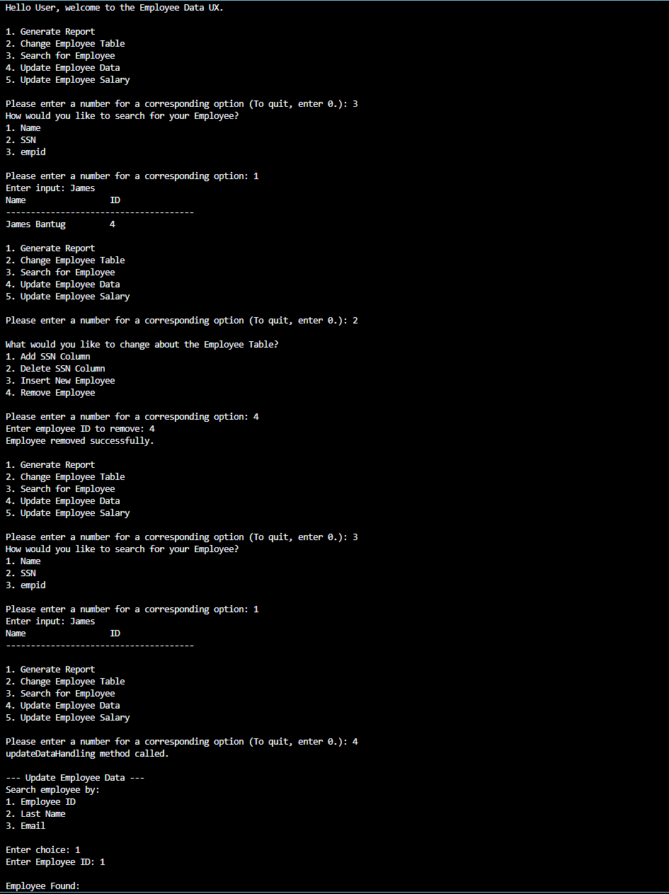

Screen Objects and Actions

On screen the UX shows a menu where the user can select which action they want, and the program will send queries to the MySQL database on DBeaver depending on what the user inputs.

REQUIREMENTS MATRIX
Requirement | Component
Search Employee | SearchForEmployee
Update Employee | UpdateEmployeeData
Salary Update | UpdateEmployeeSalary
Generate Reports | ReportGenerator
Modify Table | ChangeEmployeeTable

APPENDICES

This section is optional.

Appendices may be included, either directly or by reference, to provide supporting details that could aid in the understanding of the Software Design Document.

