MAKERERE UNIVERSITY

**COLLEGE OF AGRICULTURAL AND ENVIRONMENTAL SCIENCES (CAES)**

**SCHOOL OF FORESTRY, ENVIRONMENTAL AND GEOGRAPHICAL SCIENCES**

**DEPARTMENT OF ENVIRONMENTAL SCIENCES**

**ASSESSMENT OF ECOSYSTEM BASED ADAPTATION PRACTICES AMONG CROP FARMING COMMUNITIES IN RUKIGA DISTRICT**

**BY**

**AYAMBA DINAH**

**19/U/0201**

**1900700201**

**Supervisor**

**DR.ELLEN KAYENDEKE**

**A DESSERTATION SUBMITTED TO THE DEPARTMENT OF ENVIRONMENTAL MANAGEMENT IN PARTIAL FULFILMENT OF THE REQUIREMENTS FOR AWARD OF BACHELOR OF ENVIRONMENTAL SCIENCE OF MAKERERE UNIVERSIT**

# 

# 

# DECLARATION

I AYAMBA DINAH hereby declare that this dissertation titled **“Assessment of ecosystem-based adaptation among crop farming communities in Rukiga district”** is a result of my hard work and commitment and its original has never been submitted to any university or academic institution for any award.

Signature

Date......../........./........

# APPROVAL

# This is to satisfy that this research work has been submitted for examination with my approval as university supervisor

# SUPERVISOR’S NAME…………………………………………………………………

# SIGNATURE…………………………….. DATE……………………………………….

# LIST OF ACRONYMS

EbA- Ecosystem-based Adaptation

MAAIF-Ministry of Agriculture Animal Industry and Fisheries

UNFCCC-United Nations Framework of Convention on Climate Change

UNEP-United Nations Environmental Program

IPCC-Intergovernmental Panel on Climate Change

NAPs-National Adaptation Plans

CBD-Convention on Biological Diversity

NGOs-Non-Governmental Organizations

PDM- Parish Development Model

# List of tables and figures.

# ACKNOWLEDGEMENT

First and foremost, I thank the Almighty God for the gift of life that he has provided to me to complete this work.

My sincere thanks goes to my supervisor Dr.Ellen Kayendeke who supervised me till the end of this dissertation, madam, I will always appreciate your guidance.

I also extend my sincere thanks to my greatest friends, Niwamanya Rebecca, Kebiraro Beatrice, Babirye Jane Francis, Birungi Sarah, Namuli Lydia and Namulwana Florence who were there for me both in bad and good situations.

Sincere thanks also goes to my grandmother Kyomuhendo Jane and my uncle Mr. Tweheyo Parphra and his wife, Mbabazi Ester.

I acknowledge these people for raising, caring, supporting and educating me since my childhood and without them, I would be nowhere. May the almighty God bless you for me.

# ABTRACT

Climate change pose a significant risk to crop cultivating communities since they depend on rainfall for the growth of their crops. This makes Rukiga district to remain highly susceptible to food insecurity and this deteriorates the health and diet of the people in the district and increased levels of poverty.

Kashambya sub-county in Rukiga district which is found in the south western part of Uganda is experiencing climate change which is manifested by the occurrences of several drought and heavy rains that washed away all the crops and destroyed the infrastructures this year. The study was conducted in the two parishes of Bucundura and Rutenje. The small crop farmers in those parishes are subsistence farmers and depend on rainfall for the growth of their crops.

The study explored various EbA practiced among the crop farming communities in Rukiga district in averting crop failure due to extreme weather events. The Taro Yamane formula was used to select the 100 households from the two parishes of Bucundura and Rutengye and four villages were selected i.e. Bweyo, Katagata, Rwakinyonyozi and Kantambala.10 key informants were selected and primary data was collected to evaluate whether there was a linkage between government led interventions and EbA practices. Quantitative data was analyzed in SPSS Using descriptive statistics while qualitative data was analyzed using thematic analysis.

Among the twenty one EbA practices that were identified, the study established that 99% of the crop farmers practiced intercropping as an adaptation practice in a way to avert crop failure due to drought and flash rains. Irrigation and live fencing were the least practiced EbA practice in Bucundura and Rutenje parishes taking only 0.2% and 0.2% respectively of the crop farmers.

# TABLE OF CONTENTS

Contents

DECLARATION iii

APPROVAL iv

This is to satisfy that this research work has been submitted for examination with my approval as university supervisor iv

SUPERVISOR’S NAME………………………………………………………………… iv

SIGNATURE…………………………….. DATE………………………………………. iv

LIST OF ACRONYMS 1

List of tables and figures. 2

ACKNOWLEDGEMENT 3

ABTRACT 4

TABLE OF CONTENTS 5

CHAPTER ONE 9

INTRODUCTION 9

1.1Background 9

1.2 Problem statement 10

1.3 Objectives 11

1.3.1 Main objective 11

1.3.2Specific objectives 11

1.4 Research questions. 11

1.5 Justification of the study. 12

CHAPTER TWO 13

LITERATURE REVIEW 13

2.1 Climate change in Uganda. 13

2.2 Impacts of climate change on crop production 14

2.3 Ecosystem-based adaptation practices in crop production. 16

2.4 Benefits of ecosystem based practices in crop production 17

2.5 Perceptions of crop farmers towards EbA practices. 18

2.6 Linkage between community practices and government led interventions in EbA among crop farmers 19

CHAPTER THREE 21

MATERIALS AND METHODS 21

3.1 Description of the study area. 21

3.1.1 Location of the study area 21

3.1.2 Climate 22

3.1.3 Vegetation 23

3.1.4 Description of topography and soils. 23

3.1.5 Social economic environment 23

3.2 Study design 24

3.3 Study population. 24

3.4 Data source and data collection tools 25

3.5 Data analysis 25

CHAPTER FOUR 26

RESULTS 26

4.1 Ecosystem-based adaptation practices 26

4.1.1 Socio-economic and demographic characteristics of the respondents 26

Table 1: Socio-economic and demographic characteristics of respondents 26

4.1.2 The economic-based adaptation practices percentages in Bucundura and Rutengye parishes, Kashambya sub-county in Rukiga district. 27

Table 2: The percentages of the ecosystem-based adaptation practices practiced in Rukiga district in anticipation of drought. 27

Table 3: The percentages of ecosystem-based adaptation practices practiced in Rukiga district in anticipation of flash rains 28

4.2 The perceptions of the crop farmers towards ecosystem-based adaptation practices in Kashambya sub-county, Rukiga district. 29

4.2.1 Socio-economic characteristics of the respondents with the reasons for the choice of the EbA practices in Rukiga district. 29

Table 4: The reasons for the choice of the EbA practices in Rukiga district. 29

4.2.2 The reasons for not adopting the ecosystem-based adaptation techniques in the anticipation of drought. 31

A bar graph was used to summarize the reason respondents gave for not adopting the ecosystem adaptation techniques in Rukiga district. 31

Table 4: The percentages showing how the crop farmers in Rukiga district learnt about the EbA practices in the anticipation of drought to avert crop failure. 32

4.3 The linkage between community practices and government led interventions for adaptation to climate change among crop farming communities in Rukiga district. 32

4.3.1 Crop cultivators dealing with drought. 32

4.3.2 Crop cultivators dealing with flash rains. 33

CHAPTER FIVE 34

DISCUSSION OF FINDINGS 34

5.1 Ecosystem- based adaption practices. 34

5.2 Perception of crop farmers towards EbA practices in Rukiga district. 35

CHAPTER SIX 36

CONCLUSIONS AND RECOMMENDATIONS 36

6.1 Conclusion 36

6.2 Recommendations. 36

References 37

APPENDIX 1 42

QUESTIONNAIRE 42

Appendix i 48

Appendix ii 49

Appendix iii 49

Appendix iv. 50

Appendix v 50

# 

# 

# CHAPTER ONE

# INTRODUCTION

## 1.1Background

Climate change has been a global challenge and has affected many countries. Most especially developing countries, whose economies depend mainly on rain-fed agriculture as their backbone and a source of food for their people (Yugi et al. 2022). The current and expected effects of climate change vary among regions and nations. These have affected the livelihoods of the people, food security and ecosystems taking into account gender as an important vulnerability factor (MOFAN Netherlands 2018).

Crop farming communities are more susceptible to climate change impacts since they depend on rainfall which is always unavailable and unreliable. The most significant climate change impacts which affects crop farming communities across the world are; changes in temperature, rainfall and the frequency or intensity of extreme weather events such as prolonged drought and floods from heavy rains which affect crops by destroying them hence reducing crop production (Hossain et al. 2019) This results into increased hunger and reduction of household income and a fall in the standards of living of the people (Vignola et al. 2015). The crop farmers are also limited to credit from the farmer’s cooperatives. This hinders them from adapting to climate stress (Harvey et al. 2017).

The global climate is changing rapidly and many countries are planning how best they adapt to the changing climatic conditions. The main approach is engineered towards Ecosystem-based Adaptation (EbA) practices for poor countries whose people mainly depend on the natural resources for their livelihoods(Vignola et al. 2009).

Ecosystem-based Adaptation is defined by the United Nations Convention on Biological Diversity (CBD), as the use of biodiversity and ecosystem services as an adaptation strategy to enable the crop farmers to adopt to the negative impacts of climate change (Reid and Kutegeka, 2012). Ecosystem-based adaptation practices that are carried out by the crop farmers according to Harvey et al., (2015), include the use cover crops to prevent loss of moisture from the soil by

increased radiation, terracing to prevent soil erosion by reducing the speed of surface runoff, planting trees along the slopes and using live fences to break strong winds, diversifying crops, planting drought resistant crops, using organic fertilizers to improve on the soil fertility, mulching, rainwater harvesting and storing. According to (Id, Udas, and Bhatta 2022), EbA practices have resulted into increased crop yields and crop productivity, income generation from the sale of the surplus, improved diets through increased food security.

Ecosystem-based adaptation is a proposed strategy for crop farmers who do not have the capacity to adopt to the new and emerging technologies. These require external inputs such as the use of fertilizers to increase and obtain higher yields, herbicides to control and kill weeds, pesticides to kill pests and irrigation (Harvey et al. 2017).

Despite the fact that the ecosystem-based adaptation practices have been in use among crop farmers from generation to generation, they have not used them fully as a mean and a strategy to adapt to the changing climatic conditions. Therefore, the aim of this study is to access current ecosystem-based adaptation practices among crop farming communities, and community perceptions about their effectiveness.

## 1.2 Problem statement

Rukiga district, which is located in the highlands of Kigezi region in South western part of Uganda, is comprised of crop farming communities who mainly depend on rainfall for the growth of their crops (Magunda 2020). These crop farming communities are considered to be more susceptible to climate change conditions since rainfall nowadays is unpredictable hence unreliable. This makes it hard for the crop farmers to plan for their agricultural activities since they mainly rely on rain fed agriculture. This results into uncertainties in predicting weather events such as floods, dry spells and shifts in the onset and offset of rains (de Pinto et al. 2020).

Unlike in the past, where crop farmers used to predict rainfall and they would plant their crops in time. Due to the changes in the weather conditions, droughts have become more frequent, soil

erosion and landslides have also increased and floods in valleys. This is because the crop farmers do not have enough information and knowledge to effectively adapt to EbA practices and be able to deal with the adverse impacts of climate change. Therefore, food insecurity in Rukiga district has continued to be a problem. This results into increased levels of malnutrition deficiency diseases such as marasmus and kwashiorkor especially in the young children leading to poor health and stunted growth (Sinclair, Mikulcak, and Lossack 2021). Therefore; this research will help in providing more information about EbA to crop farmers in Rukiga district and how to use them and adapting to climate variations. .

## 1.3 Objectives

### 1.3.1 Main objective

The main objective is to generate information that is useful in improving the capacity of crop farming communities to adopt to climate change

### 1.3.2Specific objectives

* To evaluate existing ecosystem-based adaptation practices among crop farming households in Rukiga district.
* To access the perception of small holder crop farmers towards ecosystem-based adaptation practices and technologies in Rukiga district.
* To assess the linkage between community practices and government led interventions for adaptation to climate change among crop farming communities in Rukiga district.

## 1.4 Research questions.

1. What EbA practices exist among the crop farming communities in Rukiga district?

2. How do small holder crop farmers perceive and understand ecosystem -based adaptation practices in Rukiga district?

3. For how long have the households been using the EbA practices?

4. For what purposes are the EbA practices among crop farming communities in Rukiga district employed?

5. Which EbA practices are popular among the crop farming communities in Rukiga district?

6. Which EbA practices among the crop farming communities are promoted by the local government of Rukiga district?

## 1.5 Justification of the study.

The information on ecosystem-based adaptation practices will be helpful to the local government of Rukiga district and relevant ministries such as the Ministry of Agriculture, Animal Industry and Fisheries in decision making and addressing proper adaptation practices to crop farmers against climate change.

The study will also contribute to Uganda’s attainment of the SDGs by 2030 such as climate action, zero hunger, no poverty, good health and wellbeing since the crop farmers will be availed with more information on various and favorable EbA practices in adapting to climate change. The crop farmers will also know more on how to use EbA practices that lead to improved crop production. This results into improved food security, diets, wellbeing and high level of household income from the sale of surplus produce.

Since crop farmers in Rukiga district are generally poor and are highly susceptible to the impacts of climate change, this study on ecosystem- based adaptation practices will generate more information on the adaptation practices to crop farmers hence improving their capacities against adverse impacts of climate change.

# CHAPTER TWO

# LITERATURE REVIEW

## 2.1 Climate change in Uganda.

According to Lone et al.(2017), climate change is a change in the state of the climate that can be identified by change in the mean and its variability of its properties and can persist for a long period of time usually decades. Agricultural being the backbone of Uganda’s economy, it’s estimated that 72% of the Ugandan population is employed in the agricultural sector. Most of the farmers in Uganda, carry out agriculture on a subsistence basis with a few surplus left for market (Shivakumar, Taliotis, and Howells 2019).According to Uganda climate action report for 2016,agriculture contributes 25% of its Gross Domestic Product (GDP)(Department of Foreign Affairs and Trade 2016). Less than 3% of the agricultural crop land in Uganda is under irrigation and the rest of the land that is used for crop production depends on rainfall which is always seasonal and predictable. This means that most of the crop farmers in Uganda depend on the precipitation which is always is seasonal.

About 95%of the crops grown in the country such as bananas, coffee, maize, beans, sorghum, all depend on rainfall which is always seasonal putting food production at a high risk. This results into increased levels of food insecurity in Uganda. Cropping regions especially in the west and northwest appear to have been affected due to reduced rainfall totals and this puts food production in Uganda at a high risk.(Funk et al. 2012). It is observed that Uganda receives rainfall throughout the year which varies between 500 to 2800mm with an average of 1180mm with the highest rainfall totals being received in the southern parts of the country and lowest in the north (Department of Foreign Affairs and Trade 2016).

According to (MAAIF 2018), Uganda continues to experience a rise in temperature and the projected annual rainfall totals is likely to cause an increase and extended rainfall amounts during the dry seasons. This is means that Uganda will have to experience short dry seasons as well as the occurrence of weather extreme events such as floods and landslides especially in eastern Uganda in the districts of Mbale and Bududa and the western part of the county in Kigezi highlands and Rwenzori Mountains in Kasese. This will affect crop production due to crop damages and crop failure**.**

Also the Uganda’s geographical location makes it vulnerable to climate change. Being crossed by the equator, Uganda experiences the humid equatorial climate which is characterized by heavy rainfall especially in March, April and September. These cause crop damages failures and outbreak of crop pests.

## 2.2 Impacts of climate change on crop production

Climate change is the most global challenge to crop farmers. According to (Belloumi 2014), climate change refers to the change in the state of the climate that can be identified by changes in the mean or variability of its properties and that persists for extended periods. The African continent suffers most from the impacts of climate change and it’s said that the mostly affected people are the small-rural farmers due to their marginal location, limited information on climate change and other essential farming resources. This results into increased vulnerability and food insecurity (Ubisi et al. 2017).

East Africa climate change impacts include frequent droughts which lead to water shortage, increased incidences of crop pests and diseases leading to a decline in crop yields. Crop farmers are already facing the adverse impacts of the changing climatic weather patterns. Climate change affect crop production through both direct and indirect impacts on the crop/plant growth (Benedict and Zefc 2011). Research has shown that the impacts of climate change are occurring rapidly than before on the globe.

In Uganda crop farmers face a wide range of agricultural production risks i.e. both climate and non-climate related risks such as the limited use of external inputs, soil erosion, and crop failure. Rainfall patterns vary both within and between seasons making it difficult for the crop farmers to plan properly especially timely planting of crops leading to crop failures leading to food insecurity which poses a high risk to the livelihood of crop farmers (Mubiru et al. 2018). Crop production is carried out by selecting crops that are able to grow and survive in the original climatic conditions of the area. This means that crop production depends on the climate of a given area. Climate change affects crop production by a changing the flowering and harvesting seasons, abandoning areas that are hit by the adverse climate change impacts and searching for those that are able to support crop growth, increased incidences of pest and disease outbreak to crops, reduced incomes from surplus of crop production (Kim 2010).

Impacts of climate change on crop production are characterized by changes in rainfall patterns, increase in number of seasons with decreased rainfall and increased temperature which result into frequent droughts and heat stress thus lowering crop productivity. The intergovernmental panel on climate change (IPCC) indicated that the increase in weather extreme events such as temperature rise, drought and floods that severely affect crop production hence threatening food security in LDCs resulting into famine.

The rising temperatures leads to precipitation changes and increased the rate of evapo-transpiration reducing soil moisture thus making the crop lands to unable to support various crops. Warmer temperatures tend to make some crops grow more quickly and this reduces on the yields in some crops because of rapid growth which reduces sees maturity in maize seeds and the nutritional value (Faulkner and Change 2012). High temperatures and drought conditions affect the flowering of crops especially maize and beans since the crop farmers depend on rained agriculture. This is because a rise in temperature is associated with greater vapor deficits which leads to moisture stress thus affecting the flowering and shortens the growth period.

Increase in precipitation pattern levels also affects crop production. Crop production is highly affected by heavy rains which damage the crops for examples landslides often destroy crops in the mountainous areas of south western Uganda. Some crops such as beans are highly affected by the fungal diseases when there is excessive rainfall at flowering and pod formation (MAAIF 2018). Increase in because heavy rainfall causes soil erosion of the top soil, landslides and flooding. This results into the destruction of the entire croplands due to loss of soil fertility and water logging which retards crop growth (Wubie 2015).

Reduced levels of precipitation could result into a fall in the amounts of rainfall which increases the risks of drought occurrences thus increasing water stress to crops. It results into moisture stress especially the agricultural drought which increases crop water stress and results into drying off of the crops.

Without climate change the prices of certain agricultural crops of more importance such as maize will increase due population growth but climate change results into additional prices of such crops due to scarcity and failure to produce. This is because continued failure of crops lead to a decrease in the harvest and this restrains the local communities’ access to food and reduce house hold income (Vesco et al. 2021).

The rising temperatures also provide favorable conditions for the multiplication of pests and diseases especially aphids and blight wilts which attack and destroy farmers’ crops. For example the Samo’s experience of Taro leaf blight in 1993 led to 95% reduction in Taro production and it took 16 years to obtain varieties that are resistant to resume its exports (Fakava 2012).

## 2.3 Ecosystem-based adaptation practices in crop production.

EbA is defined as the use of biodiversity and ecosystem services to help people adapt to the adverse effects of climate change including sustainable management, conservation and restoration of ecosystems. It’s part of an overall strategy that takes into account the multiple, social and cultural benefits for local communities. EbA approaches help vulnerable communities increase their capacity to adapt to the impacts of climate change and build resilience of the ecosystems on which their livelihoods and welfare depend (Cc et al. 2015).

EbA is considered to be among the fastest growing adaptation practices around the world based on its cost- effectiveness, multiple benefits and a wide range of applications in different landscapes. This is because they are safe, reliable, accessible and affordable. Examples of EbA approaches include planting early maturing crops, planting improved varieties of seeds that can endure the harsh climate, mixed farming practices, agro forestry, crop rotation, mulching and compost making. These practices have the capacity to transform the degraded farmland ecosystems and be able to meet house hold needs such as increased food production and income from the sale of surplus crop products (Muthee et al. 2021).

Many people especially the crop farmers acknowledge the importance of ecosystems as key components of adaptation. This is because ecosystems provides a foundation of many adaptation practices to the poor people from which they derive their livelihoods and climate change mitigation (Reid and Alam 2014). EbA practices are not new; they have been used by the people from generation to another. In the recent years, it’s when they have been given much more attention as means of lessening climate change impacts on various societies. This is because EbA practices are considered to be low regret because they do not cause any harm to both the people and the ecosystems. EbA are more cost effective, accessible and affordable compared to technology because they provide multiple social, economic and environmental benefits for example, ensuring that rural communities have secure and adequate access to food water and energy (Munang et al. 2013).

Many countries are promoting and encouraging the use of EbA to deal with the changing climatic conditions e.g. mixed farming to maintain soil fertility and conserve water, mulching to conserves soil moisture and reduce solar radiation, terrace farming to reduce surface runoff. However the use of EbA practices towards fighting climate change has been given more attention recent years (Agol et al. 2021). This is because most crop farmers are still unaware, due to lack of information on the capacities and limits of ecosystems in the context of climate change. Since the current literature review tends to focus on the benefits of ecosystem- based adaptation practices only. The crop farmers do not know which EbA practices should be used on various landscapes due to limited information on those that do exist (Irshad et al. 2019).

## 2.4 Benefits of ecosystem based practices in crop production

According to Vignola et al. (2015), EbA refers to the strategies that improve farm management practices and ensure that crops have the capacity to adopt to climate variations. EbA practices are aimed at assisting crop farmers to adapt to climate change based on the conservation, restoration and management of biodiversity, ecosystem processes. These give crops the capacity to produce high crop yields under the changing climatic conditions.

EbA practices help to improve the farmer’s livelihoods by meeting their needs for example agro forestry increase food production of crop farmers. This is through continues provision of ecosystem services on which crop farming or cultivation depends on or relies on such as nutrient recycling pollination of crops. This helps to maintains crop production in the situation of climate variations (Harvey et al. 2015).

Crop farmers have been able to acknowledge and use traditional knowledge and practices for adapting to the changing climatic conditions basing on what they have experienced already such as terracing and mulching to withstand weather extreme events such as drought and heavy rainfall. EbA practices are cheap to use compared to infrastructure based adaptation and this results into multiple socio-economic, environmental and cultural benefits (Reid and Alam 2014).

EbA practices reduce the level of poverty among crop farmers thorough providing multiple benefits of mitigation and protection against climatic change conditions. Crop farmers are able to obtain income from the sale of the surplus food hence helping them to improve on their livelihood (Munang et al. 2013). EbA practices for example the use of organic manures increases soil fertility and restores back the degraded crop lands. This also reduces GHG emissions from the use of inorganic fertilizers and pesticides which contain a lot of inorganic compounds.

## 2.5 Perceptions of crop farmers towards EbA practices.

EbA practices have been used by the farmers as strategies of adapting to climate change and they were encouraged by United Nations Framework for Convention on Climate Change (UNFCCC). The use of EbA has been based on the indigenous knowledge of the farmers (Anafo et al. 2020). Crop farmers use the indigenous knowledge on the ecosystems to react towards the impacts of climate change and its patterns. They use their knowledge based on their culture, beliefs and traditional practices towards proper management of the environment. Indigenous knowledge is derived from the indigenous people and would be passed from generation to another revealing information to people on how they should live with one another and the environment in relation to the ecological relationships that are within ecosystems (Kupika et al. 2019).

Farmers still consider EbA practices to be traditional practices yet it is considered to be a win-win factor in which both the farmers and ecosystems benefit and be able to cope up with climate change. This is because crop farmers have limited information on the various existing EbA practices and on how to use them on different landscapes (Irshad et al. 2019).

## **2.6 Linkage between community practices and government led interventions in EbA among** crop farmers

The government institutions, NGOs and policies help to provide and encourage the use of EbA through providing detailed information about EbA to communities and crop farmers. They also assist the communities in making decisions, extends assistances to crop farmers at cheaper costs in form of provision of seeds at subsidized prices (Irshad et al. 2019). This helps to increase farmers’ awareness on the various EbA practices.

Government supports EbA projects that address the capacities to adopt to climate change impacts for example better agricultural practices such as terracing, growing crops following the contour lines and, mulching were introduced in Mount Elgon which is always suffering from severe droughts, landslides, surface runoff and flooding. This has resulted into increased crop production and a rise in the level of income to those farmers who had practiced and used EbA practices (Reid and Kutegeka, 2018.) People have the capacity to adapt to impacts of climate change and government led interventions have resulted into better cooperation in between community members.

United Nations Environment Program (UNEP) (2021) also argued that countries should incorporate EbA practices into their National Adaptation Plans (NAPs) especially when planning for adaptation strategies for climate change. This is done by placing communities at the center by allowing them to fully participate in planning, policy and development of adaptation strategies. This is because policies and adaptation strategies in adapting to ecosystem approaches help communities to take ecosystems’ roles as part of their own development and resilience. The coping strategies show how government led interventions and communities address ways of coping up to climate change through various means that incorporate ecosystems by considering EbA as part of day today adaptation strategies. This is done by providing the benefits and problems involved in using the EbA in managing climate risks.

Working with the government technical and extension officers has provided a platform for building up the linkage between the government and the communities. This leads into acquisition of skills especially in soil and water conservation and imparts farmers with the knowledge through regular visits from one farmer to another. This has resulted into increased understanding and improves the capacity of farmers to practice what they have learnt and acquired from the district extension officers (Global, Eba, and In, 2015).

Government led intervention such as NGOs and extension services increase farmers’ motivation towards EbA practices such as agro forestry and intercropping. These practices can be provided through trainings and provision of seedlings to farmers. These shape the farmers to adapt to EbA through regular interactions and working together. For example the growing of cocoa had reduced forest cover in Ghana but the government of Ghana NGO’s and universities came out and introduced various interventions that aimed at increasing production at the same time reducing environmental impacts such as practicing agro forestry (Isaac et al. 2021).

# CHAPTER THREE

# MATERIALS AND METHODS

## 3.1 Description of the study area.

## 3.1.1 Location of the study area

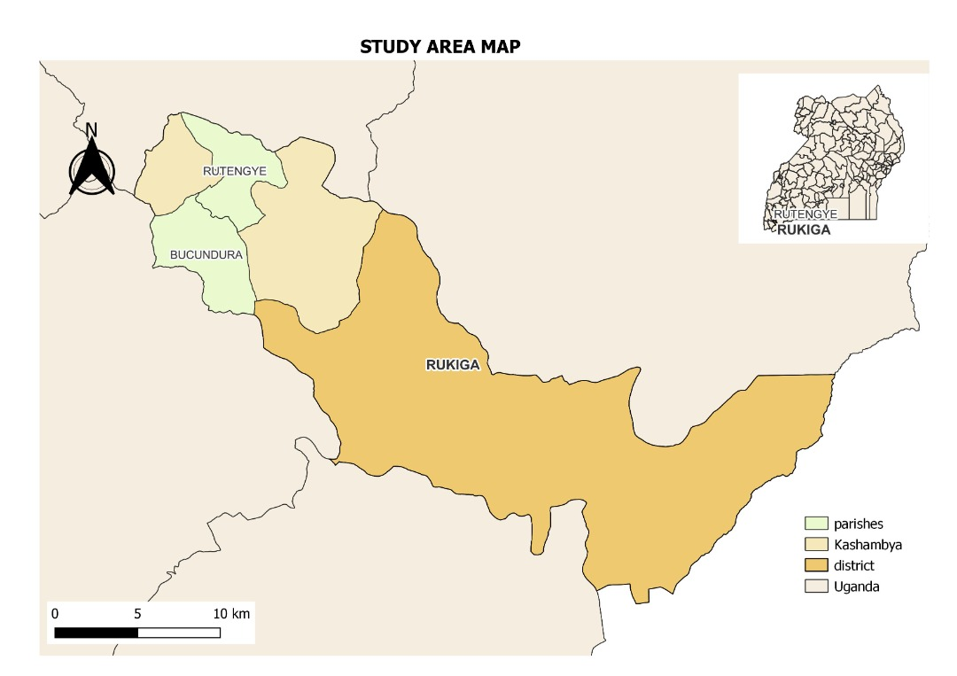

The study was conducted in Kashambya sub-county in Rukiga district in Kigezi sub region in south western Uganda. Rukiga district has only one county, plus four sub counties and two town councils. Before 1st July 2017, Rukiga district was a county in Kabale district.

As of august 2017, Rukiga district is made up the following sub counties of Bukinda, Kamwezi, Rwamucucu and Kashambya. Muhanga town council completes the best of administrative subdivisions in Rukiga. The district is predominantly rural with the majority of the inhabitants engaged in agriculture especially crop farming. The town of Mparo where the district headquarters are located became a town council on 1st July 2017, the day Rukiga attained a district status.

The district is small covering an area of 426.3 sq.km bordered by Ntungamo district in the east, the republic of Rwanda to the south east, Kabale district to the south west, Rubanda district to the north west and Rukungiri district to the north. Muhanga, the largest town in the district is about 35.5km (22mi) by road, North West of Kabale, the largest city in Kigezi sub-region. This is about 43km (27mi), by road, south west of Ntungamo along the Mbarara-Ntungamo-Kabale-Katuna road. Muhanga is approximately 374kms (232mi) by road, southwest of Kampala, the largest city of Uganda.

It’s located at an elevation of 1764 meters above sea level with coordinates 010110S and 300 06E.The district has 28parishes and 293 villages. The august 2014 census and household survey enumerated the population of Rukiga district by then which was a county at 100,726 people.

Kashambya sub-county was selected because it’s one of the sub-counties in Rukiga district that experiences weather extreme events. This affects crop farming communities in the sub-county since they rely on rain fed agriculture thus are highly vulnerable to climatic change variations.

### 3.1.2 Climate

The climate in Rukiga district is bimodal and the first rains are heavy and stretch from March to May. It is in this season that various crop varieties which have a short growing season are planted such as beans, peas, Irish potatoes and cabbages are grown. The short moderate rains are rains are received in the months of October and November. While June and July and august are generally are the driest months of the year with July getting no rain fall at all and it is in this period that people are harvesting Irish potatoes, sorghum and beans. The mean annuals vary from 800-1000mm although frequent below average epochs do exist (Nseka et al. 2021) .

However, the district now experiences significant changes in seasons and rainfall amounts are reducing. This is attributed to a high rate of deforestation and swamp reclamation due to the increased population pressure.

### 3.1.3 Vegetation

The vegetation of Rukiga district was characterized by montane forests in the past centuries. Due to the increased population pressure in the district, the vegetation has been degraded, cut down for charcoal production and fuel wood causing depletion of montane forests except for the few vegetation patches surviving under protection (Nseka et al. 2021). The rest of the vegetation cover within Rukiga district is very poor. Most of the hill slopes are bare with some parts covered with planted eucalyptus**.**

### 3.1.4 Description of topography and soils.

The district’s topography is generally hilly with steep slopes that drain in a number of streams and a few rivers that flow thriftily. The sloping landscape has good drainage conditions and therefore no limitation to agriculture. The poorly drained areas such as wetlands and swamps have been reclaimed or cleared for the cultivation of Irish potatoes and cabbages and for the establishment of dairy farms (“I | Page” 2019). The district is gifted with volcanic fertile soils to peats oils which support a prosperous agricultural economy.

### 3.1.5 Social economic environment

Agriculture is the main economic activity carried in the district which employs over 70% of the population. Cultivation is mainly carried out on a small scale and it is mainly subsistence farming. Much of the crops grown are consumed locally and these are sorghum, bananas, Irish potatoes, sweet potatoes, beans and cabbages.

The population of the district is growing at an alarming rate with low levels of education and high levels of poverty. This has resulted into the reclamation and encroachment of the existing wetlands such as the Bucundura wetland is no longer in existence and the Rushebeya-kanyabaha wetland which is the largest wetland in the district, is highly encroached on. This is aimed at in getting land for crowing crops such as Irish potatoes and sorghum. All have contributed to the climate change in the district thus lowering the ability of crop farmers to adopt to the changing climatic patterns, yet the district used to be gifted with many wetlands but they are no longer in existence.

## 3.2 Study design

Data was obtained through field observations using a checklist to obtain key information. Face to face interviews and questionnaires with both open and closed ended questions were availed to the respondents to gather both quantitative and qualitative data at a single point in time. This enabled the researcher to obtain information quickly about EbA practices carried out by crop farmers, and perception towards EbA practices among crop farmers.

Key informants interview were used to obtain information from the district production officer and agricultural officer and the local leaders especially local government chairpersons such as LC1, LC2 and LC 3 chairpersons. This was aimed at proving whether there is a linkage between community practices and government led intervention in EbA practices among crop farmers.

## 3.3 Study population.

The study was conducted in Kashambya sub-county. Kashambya sub-county has six parishes i.e. Bucundura, Rutenge, Kafunjo, Kitanga, Kitunga and Nyakashebeya. Bucundura parish and Rutenje parish were chosen because they are among the parishes in the sub county that experience that have climate change. The climate change impacts were mainly attributed to increased land degradation such as swamp reclamation for example the Bucundura wetland is no longer in existence and the indigenous trees that used to exist on the hill slopes were cut down for charcoal production and replaced with eucalyptus. Last year and this year, Bucundura parish experienced heavy rains that washed away all the bridges in the parish making it difficult for the crop farmers to transport their produce to the nearest markets.

Four villages i.e. Bweyo, Katagata, Rwakinyonyozi were selected from the respective parishes with a total of 676 households and a sample of size of 100 households was selected. The sample size was calculated using Taro Yamane formula.

That is;

n=N/1+N (e) 2

Where;

n is the sample size which is 100 households

N is the population under study of 676 households

1 is constant ands

e signifies the margin error which is 0.09 at a confident level of 91%

## 3.4 Data source and data collection tools

Before administering the questionnaire, the head of the household was informed about the aim of the study and asked of his or her consent to provide the necessary information for the questions contained in the collection tools.

The survey questionnaires were administered and discussed with the responded especially those who were unable to read and write.

## 3.5 Data analysis

The data from the questionnaires were coded and analyzed using SSPS and Microsoft excel packages. The results were interpreted using descriptive statistics including frequencies and percentage of the various households which practice ecosystem based adaptation practices.

A cross tabulation perception of crop farmers towards EbA practices and the reason why they practice them. While a thematic analysis was used to determine whether there was as linkage between community practices and government led interventions in EbA practices among crop farmers.

# CHAPTER FOUR

# RESULTS

## 4.1 Ecosystem-based adaptation practices

### 4.1.1 Socio-economic and demographic characteristics of the respondents

The percentages of the socio-economic characteristics were obtained and presented in table 1. The percentages considered were sex, age, marital status, land ownership and size of the household, of the respondents.

## Table 1: Socio-economic and demographic characteristics of respondents

|  |  |  |  |  |  |  |  |
| --- | --- | --- | --- | --- | --- | --- | --- |
| **Characteristic Category** | | | | **Frequency** | | **Percentage** | |
| Sex Male | | | | 24 | | 24.0 | |
| Female | | | | 76 | | 76.0 | |
| Age | | 18-25 | | 7 | | 7.0 | |
| 25-35 | | 31 | | 31.0 | |
| 35-45 | | 32 | | 32.0 | |
| 45-55 | | 9 | | 9.0 | |
| >55 | | 21 | | 21.0 | |
| Marital status | | Married | | 66 | | 66.0 | |
| Single | | 20 | | 20.0 | |
| Divorced | | 1 | | 1.0 | |
| Widowed | | 13 | | 13.0 | |
| Land ownership | | Yes | | 99 | | 99.0 | |
| No | | 1 | | 1.0 | |
| Size of household | 1-5 | 79 | | 79.0 | |
| 5-10 | 21 | | 21.0 | |

Results showed that most of the respondents were female doubling the percentage of males, whereas the married respondents were dominant in the marital categories of the respondents.

Most of the respondents owned land on which they carryout different activities, and most of the households had members between one and five.

### 4.1.2 The economic-based adaptation practices percentages in Bucundura and Rutengye parishes, Kashambya sub-county in Rukiga district.

Different ecosystem based adaptation practices adopted by farmers were analyzed and presented in table 2. Their corresponding percentages were also obtained and tabulated.

## Table 2: The percentages of the ecosystem-based adaptation practices practiced in Rukiga district in anticipation of drought.

|  |  |  |
| --- | --- | --- |
| **Ecosystem-based adaptation practices** | **Frequency** | **Percentage** |
| Intercropping  Crop diversification  Crop rotation  Grow fast maturing crops  Mulching  Biological control of pests  Grow cover crops  Irrigation  Shifting cultivation at wetland edges  Home gardens  Use of organic manure  Fallowing | 99  39  49  65  66  1  37  1  5  11  91  31 | 20.0  7.9  9.9  13.1  13.3  0.2  7.9  0.2  1.0  2.2  18.4  6.3 |

Most of the respondents adopted intercropping as the adaptation practice in the anticipation of drought since it had the highest percentage of the responses. Growing fast maturing crops was the second highest practice to be adopted by the respondents, whereas irrigation was the least adopted practice. This is because most of the crop farmers in Rukiga district depend on rainfall for the growth of their crops

## Table 3: The percentages of ecosystem-based adaptation practices practiced in Rukiga district in anticipation of flash rains

|  |  |  |  |  |  |
| --- | --- | --- | --- | --- | --- |
| Ecosystem-based adaptation  Practices | |  | | | |
| Frequency | | Percentage | |
|  | Intercropping | | 99 | | 23.1 | |
| Growing of cover crops | | 80 | | 18.6 | |
| Growing tree crops | | 2 | | 0.5 | |
| Live fencing | | 1 | | 0.2 | |
| Planting trees on bare land | | 20 | | 4.7 | |
| Construction of pits and dams | | 40 | | 9.3 | |
| Growing of water tolerant crops | | 10 | | 2.3 | |
| Terracing | | 95 | | 22.1 | |
| Growing crops in mounds | | 23 | | 5.4 | |
| Staking of beans | | 51 | | 11.9 | |
| Construction of trenches | | 8 | | 1.9 | |

Most of the respondents had adopted to intercropping as an adaptation practice in the anticipation of flash rains since it had the highest percentage of responses. Terracing was the second highest practice to be adopted by the respondents, whereas live fencing was the least adopted practice.

## 4.2 The perceptions of the crop farmers towards ecosystem-based adaptation practices in Kashambya sub-county, Rukiga district.

### 4.2.1 Socio-economic characteristics of the respondents with the reasons for the choice of the EbA practices in Rukiga district.

Socio-economic characteristics of the respondents were cross tabulated with the reasons for the choice of the techniques namely affordability, acceptability and availability as summarized in the table below.

## Table 4: The reasons for the choice of the EbA practices in Rukiga district.

|  |  |  |  |  |  |  |
| --- | --- | --- | --- | --- | --- | --- |
| **Characteristic Category** | | | | **Reasons for choice of the technologies** | | |
| **Affordable** | **Acceptable** | **Available** |
| Village | Bweyo | % within Village | | 100.0% | 74.1% | 44.4% |
| Rwakinyonyozi | % within Village | | 100.0% | 72.0% | 76.0% |
| Katagata | % within Village | | 88.9% | 66.7% | 66.7% |
| Kantambala | % within Village | | 100.0% | 79.3% | 44.8% |
| Age | 18-25 | | % within Age | 100.0% | 57.1% | 42.9% |
| 25-35 | | % within Age | 96.8% | 64.5% | 51.6% |
| 35-45 | | % within Age | 96.9% | 78.1% | 65.6% |
| 45-55 | | % within Age | 100.0% | 75.0% | 62.5% |
| >55 | | % within Age | 100.0% | 85.7% | 52.4% |
| Sex | Male | | % within Sex | 100.0% | 79.2% | 54.2% |
| Female | | % within Sex | 97.3% | 72.0% | 57.3% |
| Level | None | | % within  Education level | 96.3% | 77.8% | 55.6% |
| Primary | | % within Education level | 98.4% | 72.6% | 58.1% |
| Secondary | | % within Education level | 100.0% | 66.7% | 55.6% |
| Tertiary | | % within Education level | 100.0% | 100.0% | 0.0% |

From the results of the cross tabulation, all the socio economic characteristics were found to be highly associated with affordability as the main reason for the choice of the techniques. However, the tertiary level of education was found to be associated with both affordability and acceptability as the reasons.

### 4.2.2 The reasons for not adopting the ecosystem-based adaptation techniques in the anticipation of drought.

## A bar graph was used to summarize the reason respondents gave for not adopting the ecosystem adaptation techniques in Rukiga district.

**Figure 1: Reasons for not practicing the ecosystem adaptive techniques**

From Figure 1, most of the respondents gave a reason that adaptive techniques don’t work for them, and that’s the reason as to why they don’t adopt it. In addition, some farmers gave a reason that they didn’t know about adaptive practices, and thus being the second highest response. The least reason given was that the practices were labor intensive and thus discouraging them from adopting those techniques.

## Table 4: The percentages showing how the crop farmers in Rukiga district learnt about the EbA practices in the anticipation of drought to avert crop failure.

|  |  |  |  |
| --- | --- | --- | --- |
| How crop farmers learnt the EbA practices | |  | |
| Frequency | Percentage |
|  | Relative | 99 | 38.1 |
| Friends | 62 | 23.8 |
| School | 9 | 3.5 |
| Government extension officer | 51 | 19.6 |
| LC1 | 15 | 5.8 |
| Cultural practice | 24 | 9.2 |

Results showed that most of the respondents had learnt the EbA practices from relatives since it had the highest percentage of the responses. Friends had also played an important role in teaching the crop farmers the EbA practices and was the second highest percentage of the responses. School was the considered to be the least where the respondents learnt the EbA practices from.

## 4.3 The linkage between community practices and government led interventions for adaptation to climate change among crop farming communities in Rukiga district.

### 4.3.1 Crop cultivators dealing with drought.

From the agricultural officer of Kashambya sub-county, she said that crop farmers are always advised to plant their crops early enough at the start of the rainy seasons so that the crops mature fast before the onset of the droughts. She also continued to say that the crop farmers in Kashambya sub-county are given drought resistant seeds especially of maize and beans. Due to the fact the district mainly depend on agriculture as the main activity, crop farmers used to get support from NAADS in form of improved seed varieties and they would also get farming equipment to use in farming such as hoes and watering cans.

Rukiga district is a rural district with the majority of its inhabitants being crop farmers, the local government plans and programs have been in place to support the crop farmers positively. For example there is a new program of the Parish Development Model (PDM), which has been introduced by His Excellency the President of the Republic of Uganda. The crop farmers in the Rukiga district have been advised to form small groups called enterprises from where they would access the bean seeds which are high yielding and are drought resistant. The beans grown in the district are Nabe 12C, commonly known as sugar beans, the red mottled Nabe 26C, Nabe 27C which are pink in color, Nabe 28C, Nabe 29C among others.

From the LCIII Kashambya sub-county, said that when these beans are properly staked, they can produce more yields by producing more pods doubling the yields from the short beans. He continued to say that these beans are also resistant to harsh weather conditions especially drought and are resistant to pests and diseases.

From the woman councilor Bucundura parish said that crop farmers are allowed to grow crops around Konyo wetland but the crop farmers were complaining that the government is always against them.

### 4.3.2 Crop cultivators dealing with flash rains.

From the LCII, Bucundura parish, says that the crop farmers in his parish are always advised to plant fast maturing crops such as cabbages, beans and Irish potatoes which grow and mature fast before rains become too much. For example cabbages and Irish potatoes take only three months to reach maturity. Though sometimes the rains become too much and heavy and washes away everything since the area is very mountainous and hilly.

# CHAPTER FIVE

# DISCUSSION OF FINDINGS

## 5.1 Ecosystem- based adaption practices.

The study shown that there are different EbA practices practiced among the crop farming communities in rukiga district in the anticipation of drought and flash rains to avert crop failure. The results shown that intercropping was the most practiced approach with 99% of the respondents. This was because the crop farmers in Rukiga district have small land due to population and it’s divided into many small plots. Therefore they consider growing many crops together as the only solution to reduce on food shortage and labor so that they produce various crop products at the same time and in one season. The crops intercropped in the area are beans with bananas, beans with maize and beans with Irish potatoes. For example in Bucundura and Rutengye parishes, the annual crop based farming system makes most crop farmers to practice intercropping.

Similarly,(Agriculture and Working, 2021) noted that when two or more crops are planted together, they support each other by either proving nutrients to one another. For example the bananas provide shade to beans and beans improve soil fertility by fixing in nitrogen in the soil.

The study also revealed that most of the crop farmers in Rukiga district were not practicing irrigation as an adaptation strategy to fight drought. This meant that they will continue to suffer from the impacts of prolonged dry spells. Though the government of Uganda has promoted irrigation, but, it’s still less than 1% of the agricultural households that practice irrigation (Wanyama et al. 2017). The crop farmers also indicated that the place being too hilly with the positioning of terraces in the area also limit agricultural technologies such as irrigation.

The study also indicated that most of the crop farmers in Rukiga district were practicing terracing in the anticipation of flash rains to avert crop failure since the area is generally hilly with a rugged terrain. Terraces help in soil conservation by reducing the speed of surface runoff hence control soil erosion. According to Miiro 2001, using terraces were part of the adapting strategies to crop growing to the steep terrain of south western Uganda. Though some of the crop farmers are destroying them to get access to fertile soils since those terraces are not always disturbed.

In the adaptation to the changing weather events, most of the crop farmers in Rukiga district had resorted to the growing of the climbing beans which are staked. Crop farmers plant climbing beans on many acres of land because they are resistant heavy rainfall and pests and diseases bear more pods and yields doubles that of short beans. The beans grown in Rukiga district are Nabe 12C, Katuna and Nyiramuhondo (Thuijsman and Giller 2017). Though the increased adoption of the growing of climbing beans in the area has increased soil erosion due to increased demand of trees used as staking materials.

## 5.2 Perception of crop farmers towards EbA practices in Rukiga district.

The study revealed that most of the people irrespective of age, marital status and education level had a positive attitude towards EbA practices .This is because the area is densely populated with problems of land fragmentation, high levels of poverty and food shortage and the crop farmers are working hard in order to develop and secure food for the ever increasing family sizes.

# CHAPTER SIX

# CONCLUSIONS AND RECOMMENDATIONS

## 6.1 Conclusion

* This study revealed the most practiced EbA practices in Rukiga district in the anticipation of drought and flash rains were intercropping, growing of fast maturing crops, mulching, terracing, bean staking and use of organic manure.
* While irrigation, biological pest control and live fencing are least practiced. This is because they are labor intensive for example irrigation and most of the farmers did not know some of the EbA practices such as biological pest control.
* Other EbA practices such as planting trees on bare land does not work to most of the crop farmers. This is because the tree species planted are mainly exotic for example eucalyptus and its growth removes and inhibits the growth of other forms of vegetation leaving the hill slopes with no vegetation cover hence the increased soil erosion in the area.
* Increased population pressure is the contributing factor to the less uptake of some of the EbA practices like crop rotation and fallowing since the land is fragmented.
* The study has shown that the crop farmers learnt most of the EbA practices from relatives and friends.

## 6.2 Recommendations.

* Sensitization of crop farmers in Rukiga district by the District Agricultural Officer and District Environmental Officer to ensure increased awareness about some of the EbA practices for example home gardens, irrigation and use of trenches.
* The local government of Rukiga district should introduce and provide favorable tree species for example caliandra and sesbania which restores nitrogen, provides a vegetation cover and hold the soil together.
* More research is also needed on the various EbA practices in fighting the significant impacts of climate change on crop production.

# References

Agol, Dorice, Hannah Reid, Florence Crick, and Hausner Wendo. 2021. “Ecosystem-Based Adaptation in Lake Victoria Basin ; Synergies and Trade-Offs.”

Agriculture, Guidance, and Technical Working. 2021. “Intercropping Agriculture System,” 1–6.

Anafo, Humphrey, Kenneth Peprah, Francis Issahaku, and Malongza Bukari. 2020. “Smallholder Farmers ’ Perception on Ecosystem-Based Approaches for Remedying Land Degradation in Nabdam District , Ghana Smallholder Farmers ’ Perception on Ecosystem-Based Approaches for Remedying Land Degradation in Nabdam District , Ghana,” no. July. https://doi.org/10.15243/jdmlm.

Belloumi, Mounir. 2014. “AGRODEP Working Paper 0003 Investigating the Impact of Climate Change on Agricultural Production in Eastern and Southern African Countries,” no. April.

Benedict, Oyiga, and Chijioke Zefc. 2011. “Implication of Climate Change on Crop Yield and Food Accessibility in Sub ­ Saharan Africa.”

Cc, A, C C F Ij, O To, I Tc, and C Ock. 2015. “ADAPTATION MAPPING ANALYSIS REPORT EbA MAPPING ANALYSIS REPORT |,” no. November.

Department of Foreign Affairs and Trade, Irish Aid. 2016. “Uganda Climate Action Report For 2015,” 1–12. https://www.irishaid.ie/media/irishaidpublications/UGA-Country-Climate-Action-Reports-Uganda-2015.pdf.

Fakava, Viliami T. 2012. “‘ CLIMATE CHANGE IMPACT ON AGRICULTURE AND FOOD SECURITY ’ • Challenge for Agriculture & Food Security • Significance of Agriculture • Impacts of Climate Change on Agriculture • Climate Change Adaptations • FAO Assistance to Climate Change,” no. October.

Faulkner, Joshua W, and Climate Change. 2012. “Agricultural Adaptation to Climate Change : Improving Resilience in Row Crop Production,” 1–7.

Funk, Chris, Jim Rowland, Gary Eilerts, and Libby White. 2012. “A Climate Trend Analysis of Uganda.” *Famine Early Warning Systems Network-Informing Climate Change Adaptation Series* Fact Sheet (2012–3062): 1–4.

Global, T H E, Mountain Eba, and Programme In. n.d. “Making the Case for Ecosystem-Based Adaptation : THE GLOBAL MOUNTAIN EBA PROGRAMME IN.”

Harvey, Celia A, Francisco Alpízar, Jacques Avelino, Pavel Bautista-Solis, José Mario Cárdenas, Camila I Donatti, M Ruth Martínez-Rodríguez, et al. 2015. “Can Ecosystem-Based Adaptation Help Smallholder Farmers Adapt to Climate Change?” *Climate Smart Agriculture 2015: Global Science Conference*, no. Ici: 2015.

Harvey, Celia A, M Ruth Martínez-rodríguez, José Mario, Jacques Avelino, Bruno Rapidel, Camila I Donatti, and Sergio Vilchez-mendoza. 2017. “Agriculture , Ecosystems and Environment The Use of Ecosystem-Based Adaptation Practices by Smallholder Farmers in Central America” 246 (June): 279–90. https://doi.org/10.1016/j.agee.2017.04.018.

Hossain, Mohammad Shakhawat, Lu Qian, Muhammad Arshad, Shamsuddin Shahid, Shah Fahad, and Javed Akhter. 2019. “Climate Change and Crop Farming in Bangladesh: An Analysis of Economic Impacts.” *International Journal of Climate Change Strategies and Management* 11 (3): 424–40. https://doi.org/10.1108/IJCCSM-04-2018-0030.

“I | Page.” 2019, no. June.

Id, Kiran Bhusal, Erica Udas, and Laxmi Dutt Bhatta. 2022. “Ecosystem-Based Adaptation for Increased Agricultural Productivity by Smallholder Farmers in Nepal,” 1–16. https://doi.org/10.1371/journal.pone.0269586.

Irshad, Syed, Ali Shah, Jiehong Zhou, and Ashfaq Ahmad. 2019. “Ecosystem-Based Adaptation ( EbA ) Practices in Smallholder Agriculture ; Emerging Evidence from Rural Pakistan.” *Journal of Cleaner Production* 218: 673–84. https://doi.org/10.1016/j.jclepro.2019.02.028.

Isaac, Marney E, Hanson Nyantakyi-frimpong, Evans Dawoe, and Luke C N Anglaaere. 2021. “Farmer Networks and Agrobiodiversity Interventions : The Unintended” 26 (4).

Kim, Chang‐Gil. 2010. “The Impact of Climate Change on the Agricultural Sector : Implications of the Agro ‐ Industry for Low Carbon , Green Growth Strategy and Roadmap for the East Asian Region Table of Contents.” *Low Carbon Green Growth Roadmap for Asia and the Pacific*, 1–51. https://www.unescap.org/sites/default/files/5. The-Impact-of-Climate-Change-on-the-Agricultural-Sector.pdf.

Kupika, Olga Laiza, Edson Gandiwa, Godwell Nhamo, and Shakkie Kativu. 2019. “Local Ecological Knowledge on Climate Change and Ecosystem-Based Adaptation Strategies Promote Resilience in the Middle Zambezi Biosphere Reserve, Zimbabwe.” *Scientifica* 2019. https://doi.org/10.1155/2019/3069254.

MAAIF. 2018. “National Adaptation Plan for the Agricultural Sector,” no. November: 92. https://www.agriculture.go.ug/.

Magunda, Matthias. 2020. “Situational Analysis Study for the Agriculture Sector in Uganda Situational Analysis Study of the Agriculture Sector in Uganda,” no. July.

Miiro, Richard. 2001. “Factors Enhancing Terrace Use in the Highlands of Kabale District , Uganda,” 356–61.

MOFAN Netherlands. 2018. “Climate Change Profile in Uganda.”

Mubiru, Drake N, Maren Radeny, Florence B Kyazze, Ahamada Zziwa, James Lwasa, James Kinyangi, and Catherine Mungai. 2018. “Climate Risk Management Climate Trends , Risks and Coping Strategies in Smallholder Farming Systems in Uganda.” *Climate Risk Management* 22 (October 2016): 4–21. https://doi.org/10.1016/j.crm.2018.08.004.

Munang, Richard, Ibrahim Thiaw, Keith Alverson, Musonda Mumba, Jian Liu, and Mike Rivington. 2013. “Climate Change and Ecosystem-Based Adaptation : A New Pragmatic Approach to Buffering Climate Change Impacts Climate Change and Ecosystem-Based Adaptation : A New Pragmatic Approach to Buffering Climate Change Impacts.” *Current Opinion in Environmental Sustainability* 5 (1): 67–71. https://doi.org/10.1016/j.cosust.2012.12.001.

Muthee, Kennedy, Lalisa Duguma, Judith Nzyoka, and Peter Minang. 2021. “Ecosystem-Based Adaptation Practices as a Nature-Based Solution to Promote Water-Energy-Food Nexus Balance.”

Nseka, Denis, Frank Mugagga, Hosea Opedes, Patience Ayesiga, Hannington Wasswa, Isaac Mugume, Alex Nimusiima, and Faridah Nalwanga. 2021. “Environmental & Socio-Economic Studies The Damage Caused by Landslides in Socio-Economic Spheres within the Kigezi Highlands of South Western Uganda,” 23–34. https://doi.org/10.2478/environ-2021-0003.

Pinto, Alessandro de, Nicola Cenacchi, Ho Young Kwon, Jawoo Koo, and Shahnila Dunston. 2020. “Climate Smart Agriculture and Global Food-Crop Production.” *PLoS ONE* 15 (4): 1–19. https://doi.org/10.1371/journal.pone.0231764.

Reid, Hannah, and Sarder Shafiqul Alam. 2014. *Ecosystem-Based Approaches to Adaptation Evidence from Two Sites in Bangladesh*.

Reid, Hannah, and Sophie Kutegeka. n.d. *Ecosystem-Based Approaches to Adaptation : Strengthening the Evidence and Informing Policy*.

Shivakumar, Abhishek, Constantinos Taliotis, and Mark Howells. 2019. “The Impact of Climate Change on Crop Production in Water and Energy Implications.”

Sinclair, Fergus, Friederike Mikulcak, and Harald Lossack. 2021. “ECOSYSTEM-BASED ADAPTATION IN AGRICULTURE,” no. November.

Thuijsman, Eva, and Examiner Ken Giller. 2017. “Adaptation of Improved Climbing Bean ( Phaseolus Vulgaris L .) Technologies in the Ugandan Highlands Table of Contents,” no. January.

Ubisi, Nomcebo R, Paramu L Mafongoya, Unathi Kolanisi, Obert Jiri, and Open Access. 2017. “Smallholder Farmer ’ s Perceived Effects of Climate Change on Crop Production and Household Livelihoods in Rural Limpopo Province , South Africa,” 27–38. https://doi.org/10.1515/cass-2017-0003.

UBOS. 2014. “Uganda National Population and Housing Census Report: Population Growth Rates -Non-Household Population and Sex Composition of the Population.” *UBos*, 73.

Vesco, Paola, Matija Kovacic, Malcolm Mistry, and Mihai Croicu. 2021. “Climate Variability, Crop and Conflict: Exploring the Impacts of Spatial Concentration in Agricultural Production.” *Journal of Peace Research* 58 (1): 98–113. https://doi.org/10.1177/0022343320971020.

Vignola, Raffaele, Celia Alice, Pavel Bautista-solis, Jacques Avelino, Bruno Rapidel, Camila Donatti, and Ruth Martinez. 2015. “Agriculture , Ecosystems and Environment Ecosystem-Based Adaptation for Smallholder Farmers : De Fi Nitions , Opportunities and Constraints.” *“Agriculture, Ecosystems and Environment”* 211: 126–32. https://doi.org/10.1016/j.agee.2015.05.013.

Vignola, Raffaele, Bruno Locatelli, Celia Martinez, and Pablo Imbach. 2009. “Ecosystem-Based Adaptation to Climate Change : What Role for Policy-Makers , Society and Scientists ?,” 691–96. https://doi.org/10.1007/s11027-009-9193-6.

Wanyama, Joshua, Herbert Ssegane, Isaya Kisekka, Allan John Komakech, Noble Banadda, Ahamada Zziwa, Tobias Oker Ebong, Charles Mutumba, Nicholas Kiggundu, and Ronald Kato Kayizi. 2017. “Irrigation Development in Uganda : Constraints , Lessons Learned , and Future Perspectives” 143 (1). https://doi.org/10.1061/(ASCE)IR.1943-4774.0001159.

Yugi, B Rian A, E Mmanuel O Laoluwa E Resanya, A Ugustine O Mondi O Nyango, F Austin K Atchele O Gou, E Ucharia C Hidinma O Koro, and C Harles O Binwanne O Koye. 2022. “Review of Meteorological Drought in Africa : Historical Trends , Impacts , Mitigation Measures , and Prospects” 179: 1365–86. https://doi.org/10.1007/s00024-022-02988-z.

# APPENDIX 1

## QUESTIONNAIRE

I am Ayamba Dinah, a student at the Department of Environmental Management, Makerere University and wishes to carry out a research study on various EbA practices amongst crop farming communities in Rukiga district. The purpose of this study is to generate information on the ecosystem based adaptation practices being carried out amongst crop cultivating communities in Rukiga district.

The information you will provide will be confidential and it will be used only for academic purposes at Makerere University

**Village of the respondent…………………………………………………………………………..**

**Parish……………………………………………………………………………………………………**

**Sub county……………………………………………………………………………………………..**

**District…………………………………………………………………………………………………..**

**GPS position…………………………………………………………………………………………………..**

**SOCIO-ECONOMIC &DEMOGRAPHIC DATA**

1. Age:
2. Sex: 1) Male 2) Female
3. Marital status: 1) Married 2) Single 3) Divorced 4) Widowed
4. Head of household: 1) Male 2) Females 3) Child (below 18)
5. Household head formal Education: 1)None 2)primary 3) secondary 4)tertiary
6. Land ownership: 1) own land 2) Rent 3) Communal
7. If you individually own the land, how big is your farmland...
8. If communally owned, do you freely/always access it? 1) Yes………. 2) No………….
9. Household size………………………………………………………………
10. Main Activity…1) livestock………2) Crop…………3) Mining………….4) Trade……..5) other………………
11. Ethnicity:
12. Years in farming:
13. Do you belong to any farmer’s group? 1) Yes…….. 2) No……….
14. Access to a water body for irrigation?

**ECOSYSTEM-BASED ADAPTATION PRACTICES CURRENTLY PRACTICED**

1. Do you experience extreme weather events (excessive rains, prolonged drought?)

2. Are the extreme weather events severe? 1) Yes 2) No

3. How often do you experience them? 1) Every season, 2) once a year 3) every year

4. What sort of damage do you normally get?

a) For crops: 1) plants Drying 2) stunted growth 3) poor yields 4) seed rot 5) other

b) For animals: 1) dying 2) starvation 3) other specify…..

* How do you normally recover from losses that occur due to extreme weather events

5. What practices in anticipation of drought do you undertake to avert crop failure? (Water/moisture, temperature, soil fertility, pests)

|  |  |  |  |  |
| --- | --- | --- | --- | --- |
| **Practices** | **Yes or No** | **Reason for choice of the practice**(affordable1/ acceptable2/ available3/ other specify4) | **Reason for not Practicing** (Expensive1, did not know about it2, small land3, Does not work for me4**)** | **How did you learn about it?** (Relative 1/ Friends2/ School3/ Gvt Extension Officer4, LC15, Parish Chief6, Religious leader7, farmer groups8**,** cultural practice9 |
| Intercropping |  |  |  |  |
| Crop diversification |  |  |  |  |
| Crop rotation |  |  |  |  |
| Grow fast maturing crops |  |  |  |  |
| Shade tree planting |  |  |  |  |
| Mulching |  |  |  |  |
| Biological control of pests |  |  |  |  |
| Grow cover crops |  |  |  |  |
| Grow tree crops |  |  |  |  |
| Grow crops under trees |  |  |  |  |
| Irrigation |  |  |  |  |
| Shifting cultivation at wetland edges |  |  |  |  |
| Home gardens |  |  |  |  |
| Use of organic manure |  |  |  |  |
| Fallowing |  |  |  |  |

\

6. Why are you using or not using the particular practices? (Use Table above)

7. What practices in anticipation of flash rains do you undertake to reduce crop failure?

(too much moisture before harvesting, post-harvest storage and preservation, temperature, pest control, weeds).

|  |  |  |  |  |
| --- | --- | --- | --- | --- |
| **Practices** | **Yes or No** | **Reason for choice of the practice**(affordable1/ acceptable2/ available3/ other specify4) | **Reason for not Practicing** (Expensive1, did not know about it2, small land3, Does not work for me4**)** | **How did you learn about it?** (Relative 1/ Friends2/ School3/ Gvt Extension Officer4, LC15, Parish Chief6, Religious leader7, farmer groups8**,** cultural practice9 |
| Intercropping |  |  |  |  |
| Grow cover crops |  |  |  |  |
| Grow tree crops |  |  |  |  |
| Live fencing |  |  |  |  |
| Planting trees on bare land |  |  |  |  |
| Construction of pits and dams |  |  |  |  |
| Growing of water tolerant crops (yams, sugarcanes) |  |  |  |  |
| Terracing |  |  |  |  |

8. Why are you using or not the particular practices? (Use Table above)

**Relationship between community practices and government-led interventions**

**Interview guide for Key informants**

**(Potential participants: LC1s, Parish Chiefs, LC3s, District Production Officers, Agricultural Officers)**

Position of Key Informant……………………………………………………………….

Responsibility as far as farmers are concerned…………………………………………...

CROP CULTIVATORS DEALING WITH DROUGHT

1. What advice do you give to crop farmers in anticipation of drought?

2. How does government prepare crop farmers in anticipation of drought?

3. Are there specific local government plans and programs that aim at preparing farmers to deal with crops in case of drought?

CROP FARMERS DEALING WITH FLASH RAINS

1. What advice do you give to crop farmers in anticipation of flash rains?

2. How does government prepare crop farmers in anticipation of flash rains?

3. Are there specific local government plans and programs that aim at preparing farmers to deal with flash rains?

## Appendix i

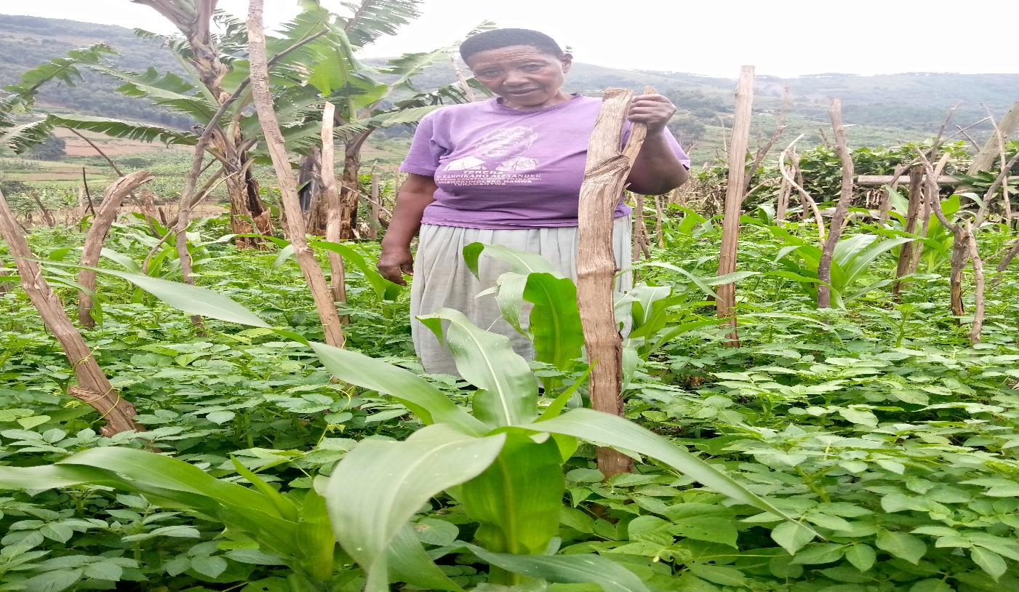

One of the crop farmers in Bucundura parish in Rukiga district showing how she practices intercroping as seen in the photo above.

## Appendix ii

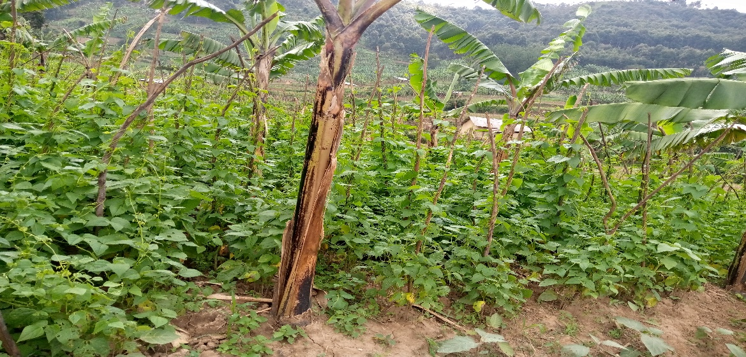

## Appendix iii

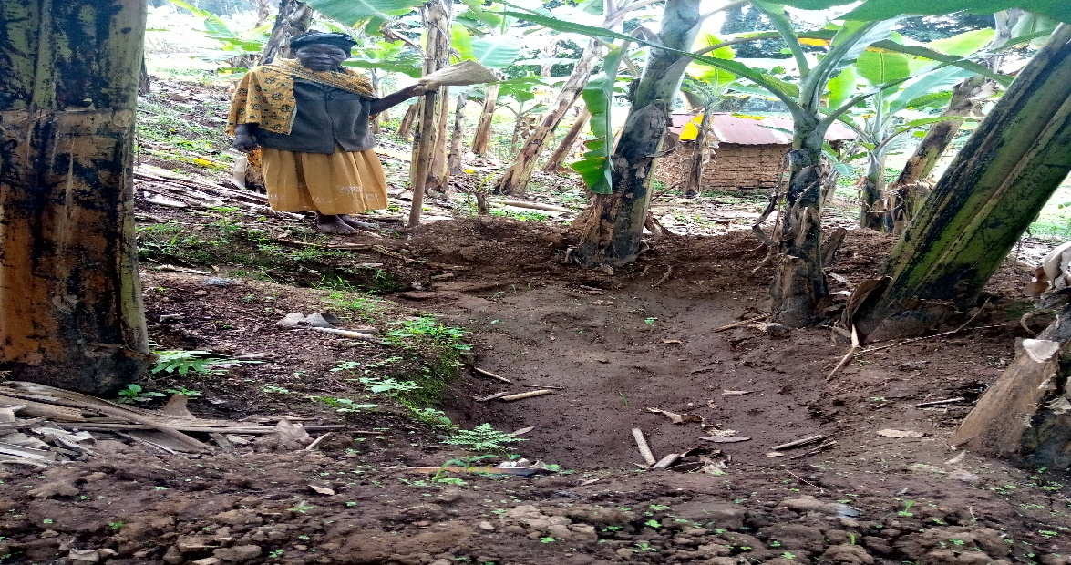

One of the crop farmers in Rutenje parish in Rukiga district showing how uses the trenches in a banana plantation to reduce on surface runoff and encourages infiltration

## Appendix iv.

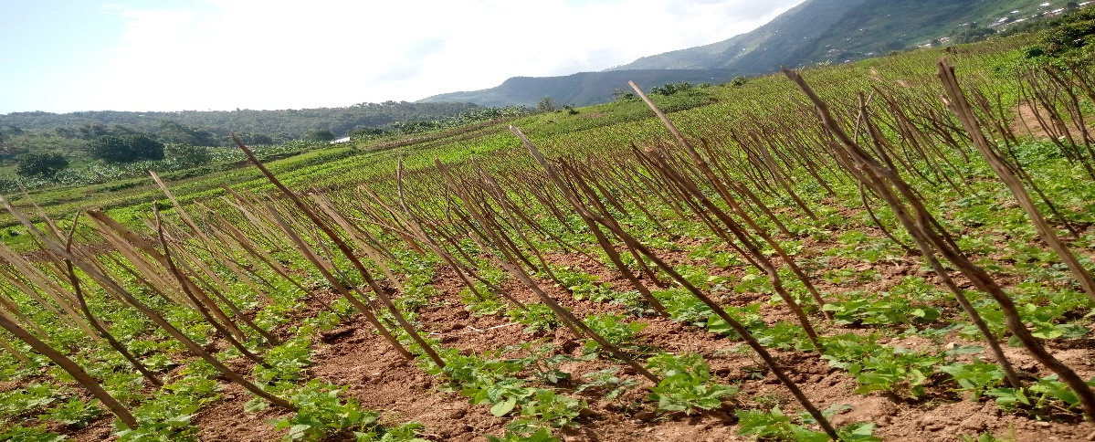

Bean staking and terracing in Bucundura parish in Rukiga district

## Appendix v

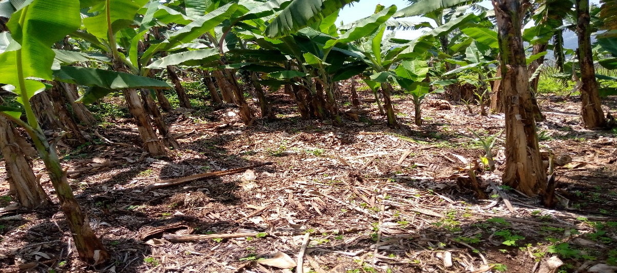

Mulching in Rutengye parish in Rukiga district