|  |  |  |
| --- | --- | --- |
| 1 | Top navigation menu. “Мой мир” button | //span[contains(text(),'Мой Мир')] |
| 2 | Top navigation menu. “Все проекты” dropdown | //span[@id='PH_projectsMenu'] |
| 3 | Search. Top menu. “Картинки” button | //a[contains(text(),'Картинки')] |
| 4 | Search. Search icon | //label[@class='search__icon'] |
| 5 | Search. “Найти” button | //input[@id='search:submit'] |
| 6 | Search. Bottom menu. “Леди” button | //a[@name='clb644064'] |
| 7 | Search. Bottom menu. “…” button | //span[@name='clb818633'] |
| 8 | Mailbox block. Calendar icon-link | //span[@id='cal'] |
| 9 | Mailbox block. Login field | //input[@placeholder='Имя ящика'] |
| 10 | Mailbox block. “Запомнить” checkbox | //input[@name='saveauth'] |
| 11 | Mailbox block. “Облако” link | //a[@name='clb36949235'] |
| 12 | News block. “СПОРТ” link | //a[@name='clb571759'] |
| 13 | News block. Advert banner | //div[@class='news-item o-media news-item_tgb news-item_long_title tgb']  OR  //div[@class='tabs__content']/following-sibling::div[1] |
| 14 | Info block. Dollar rate | //div[@class='informers__item informers__item_rates']//a[1] |
| 15 | Info block. “Диск-О” banner | //div[@class='notify__body']/parent::div/parent::div  OR  //div[@class='well notify i-link-no-deco i-absolute m-bordered m-animated-shadow m-animated-borderless notify_out'] |
| 16 | Footer. “О компании” link | //a[@name='clb660352'] |

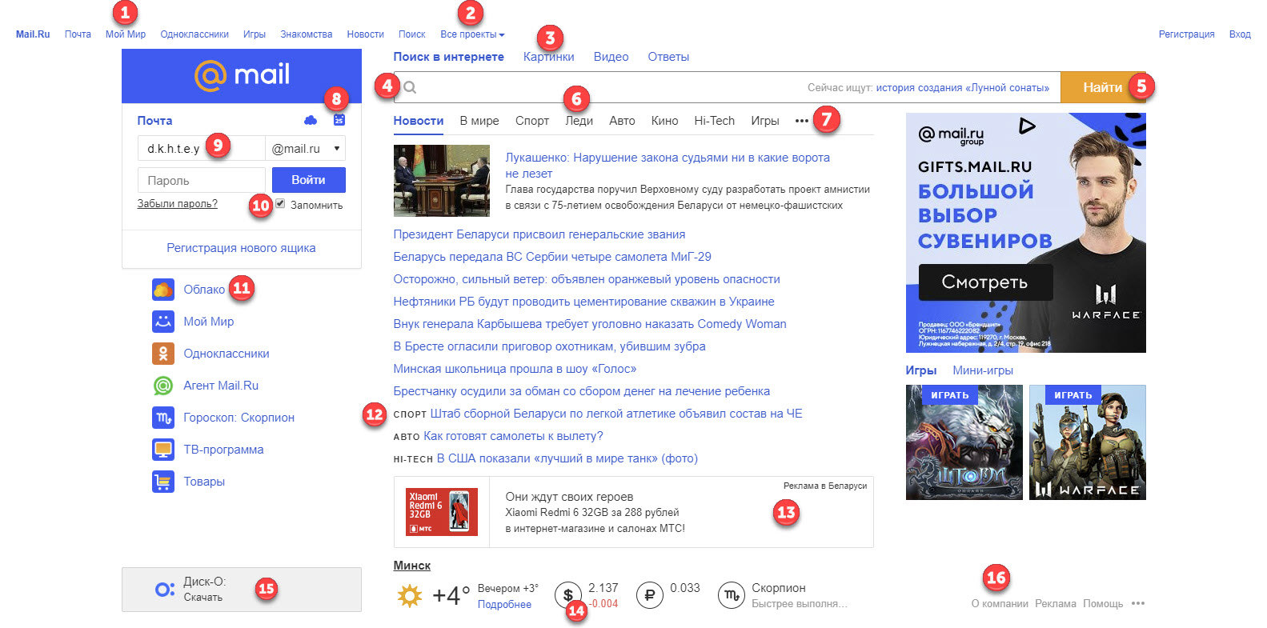

Case1.Mailbox block. Login to the mail with valid creds

As an unauthorized user

1. Navigate to https://mail.ru/
2. Input existing login (//input[@id='mailbox:login'])
3. Input existing password for login from step 2 (//input[@id='mailbox:password'])
4. Click “Войти” button (//input[@value='Войти'])

Exp. Result: link with xpath //i[@class='x-ph__menu__button__text x-ph__menu__button__text_auth'] contains login from step2

Case2. Mailbox block. Login to the mail with invalid creds

As an unauthorized user

1. Navigate to <https://mail.ru/>
2. Input not existing login (//input[@id='mailbox:login'])
3. Input any password (//input[@id='mailbox:password'])
4. Click “Войти” button (//input[@value='Войти'])

Exp. Result: User redirected to the https://e.mail.ru/login?captcha=1&fail=1&email=sdfsdf%40mail.ru#filters

Case3. Mailbox block.”Забыли пароль?” link functionality

As an unauthorized user

1. Navigate to https://mail.ru/
2. Click.”Забыли пароль?” link (//a[@name='clb615191'])

Exp. Result: Restore password page is opened in new tab (page url: https://e.mail.ru/password/restore/)