
CUR/F001
MACHAKOS UNIVERSITY
OFFICE OF THE CHAIRMAN

(DEPARMENT OF COMPUTING AND INFORMATION TECHNOLOGY)
INDUSTRIAL ATTACHMENT SECTION
DEPARTMENT’S ATTACHMENT REPORT FORMAT
DIPLOMA/ DEGREE ATTACHMENT REPORT FORMAT
The final attachment report will consists of the following key sections:
TITLE PAGE
On top should bear the title of the attachment report. The title should be short, precise, concise and clear (Not more than 15 words). It should also relate to the subject matter of the attachment and be capturing the reader’s attention at a glance.
Specifically, the title page should contain the following information:
- Course of study
- Name and registration number of the student on attachment
- Host institution for the attachment
- Period for the attachment
- Supervisor/Assessor
- Date for the report submission

ACKNOWLEDGEMENT
Have a word of thanks to all those who have assisted you while on attachment especially, the supervisor and the management of the host institution.
EXECUTIVE SUMMARY
The purpose of the executive summary is to give an interested reader a compact summary of the report or content. It should be a summary, synopsis or gist of the whole work presented and should be one paragraph, double spaced with no quotations or references and at most 400 words.
TABLE OF CONTENTS
This page serves as the structure pattern of the report and should come immediately after the executive summary. All major sections (chapter level headings) including references and appendices must be included. The headings as listed in the table must be worded exactly as they appear in the body of the report. The wording and presentation (i.e. capitalization, special fonts and characters) use for all entries in the table of contents must match exactly the one used in the text.
SAMPLE TABLE OF CONTENTS (TOC)
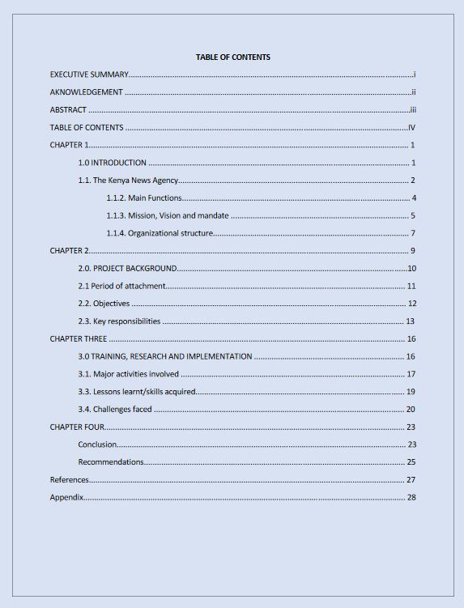
1.0 CHAPTER ONE: INTRODUCTION
1.1. History of the organization
1.2. Main functions or core activities of the host organization
1.3. Vision, mission statement and core values of the institution.
1.4. Organizational structure of the host institution
1.5. Duties and responsibilities of the key personnel in the organization. (Especially in the department attached)

2.0 CHAPTER TWO: OVERVIEW OF THE HOST ATTACHMENT DEPARTMENT
This is the specific department within the host institution in which the student is attached.
2.1. Key functions/ activities of the department.
2.2. Staff establishment of the department in terms of the number of employees
2.3. Student’s main objectives for the attachment exercise.
2.4. Attachées assigned routine duties and department’s participation forums.
3.0 CHAPTER THREE: EVALUATION OF THE ATTACHMENT PERIOD
3.1. Success/ failure of the attachment exercise vis- a – vis student’s main objectives.
3.2. Challenges encountered by the student during the attachment period.
3.3. How the challenges were overcome /solved.
3.4. Recommendations as to how the attachment exercise can be improved by the University / campus.
BIBLIOGRAPHY/ REFERENCES
Includes the consulted sources that need to be acknowledged.
Appendix recommendation letter/release letter any other.

NOTE: Bonus tips
This guide is only a rough but standard guide on how to write an internship report or an industrial attachment report. You are free to include any additional details as shall be directed by Machakos University or the institution offering attachment
In addition, you are required to format your report based on the rules of standard formats such as APA and MLA. Some of the standard formats include
- Font type: Times New Roman
- Font size: 12
- Double line spacing
- Justified paragraphs
- Bold titles.
Finally, endeavor to write at least 15 pages including everything for your report to be tangible.

