Laboratory work No. 2

**Goal of research:**

Operation with a 7-segment indicator using GPIO.

**Software:**

STM32CubeIDE.

**General information:**

The 7-segment indicator is one of the most popular and simple types of displaying Arabic numerals and other symbols. The indicator is a set of LEDs with either anode or cathode combined, depending on the type. Each segment can be controlled individually.

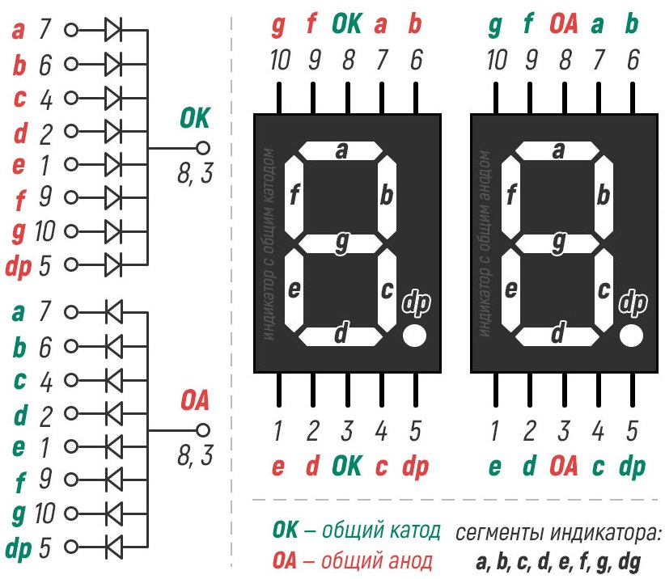

For example, let's take a display with a common cathode and 2 digits. First we output 0; for this purpose connect pins 7, 6, 4, 2, 1, 9 (a, b, c, d, e, f - respectively) to "+" of power supply through resistors, and pins 3, 8 to "-" (GND). To output 1 - connect pins 6, 4 (b, c) to "+". The other digits can be output in the same way.

**The order of work:**

*Part I. Program development using a code generator.*

1. Run STM32CubeIDE, in the opened window select the path to your working folder. There should be no Russian letters in the path to the working folder and the project name. In this folder all laboratory works should be stored.

2. Based on the documentation, determine the type of indicator (with common cathode or anode). Study the diagram of connecting the indicator to the microcontroller debugging board.

3. Initialize the microcontroller pins required to control the indicator.

4. Develop a program to output numerals on a single digit.

5. Develop a program so that when the red button is pressed, the value on one digit of the indicator increases, and when the blue button is pressed, the value decreases.

6. Develop a program to output numerals on all digits.

7. Develop a program so that when the red button is pressed, the value on the indicator increases, and when the blue button is pressed, the value decreases.

*Part II. Program development using registers.*

1. Start STM32CubeIDE, in the opened window choose the path to your working folder. There should be no Russian letters in the path to the working folder and the project name. In this folder all laboratory works should be stored.

2. Based on the documentation, determine the type of indicator (with common cathode or anode). Study the diagram for connecting the indicator to the microcontroller debug board.

3. Initialize the pins of the microcontroller necessary for controlling the indicator.

4. Develop a program to output numerals on a single digit.

5. Develop a program to output numerals on all digits.

**Tasks**

1. Perform all of the steps in Part I.

2. If possible, complete all activities in Part II.

Demonstrate all assignment items one by one to the instructor.