Laboratory work No. 6

**Goal of research:**

Servo motor control.

**Software:**

STM32CubeIDE, Matlab.

**General information:**

Schematic of the system being developed:

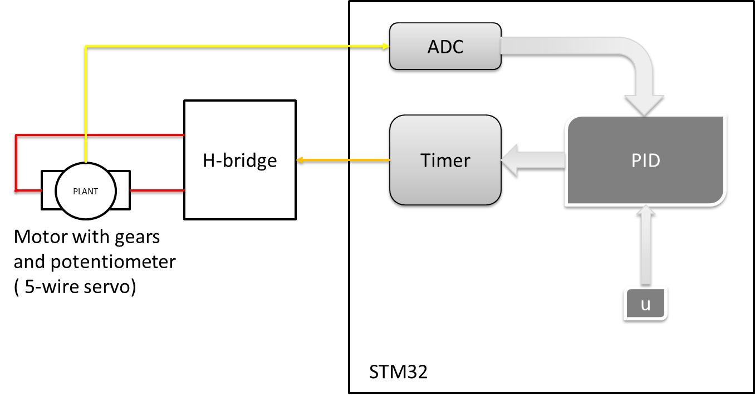

*Required HAL functions*

Running the timer in PWM generation mode.

*HAL_TIM_PWM_Start(htim, Channel)*

* *htim* – the pointer to the configuration structure of TIM_HandleTypeDef type;
* *Channel* – timer channel.

Changing the value of the comparison register (PWM duty cycle).

*__HAL_TIM_SET_COMPARE(__HANDLE__, __CHANNEL__, __COMPARE__)*

* *__HANDLE__* – the pointer to the configuration structure of TIM_HandleTypeDef type;
* *__CHANNEL__* – timer channel;
* *__COMPARE__* – the value of the comparison register.

Running ADC.

*HAL_StatusTypeDef HAL_ADC_Start(ADC_HandleTypeDef* hadc)*

* *hadc* is the pointer to the configuration structure of type ADC_HandleTypeDef.

Receiving data from ADC

*uint32_t HAL_ADC_GetValue(ADC_HandleTypeDef* hadc)*

* *hadc* is the pointer to the ADC_HandleTypeDef configuration structure.

Running ADC when working with DMA:

*AL_ADC_Start_DMA(hadc, pData, Length)*

* *hadc* is the pointer to a configuration structure of type ADC_HandleTypeDef;
* *pData* is the pointer to an array for storing data;
* *Length* is the amount of data to be transferred by DMA.

**The order of work:**

*Part I. Program development using a code generator.*

1. Start STM32CubeIDE, in the opened window choose the path to your working folder. There should be no Russian letters in the path to the working folder and the project name. In this folder should be stored all laboratory works.

2. This work should be done on the basis of work 4 and partially 5.

3. Based on the documentation it is necessary to determine to which pins are connected to the servo drive and the external potentiometer.

4. In the graphical initialization window of the controller (name.IOC), it is necessary to adjust the frequency of the processor according to the variant. The clock source must be an external quartz resonator.

5. In the graphical initialization window of the controller (name.IOC), you must configure the pins defined in the previous step to generate PWM, control the direction of rotation of the servo motor.

6. In the graphical controller initialization window (name.IOC), set the Prescaller, Counter Period for the Motor Timer defined in the previous step. The frequency of the PWM signal should be 1kHz.

7. In the graphical initialization window of the controller (name.IOC), configure the ADC to read data from 2 channels infinitely in scan mode, enable DMA for data transfer from ADC. Configure DMA to work in cyclic mode.

8. Implement the following program algorithm:

- Set the position of the servo drive using an external potentiometer;

- Determine the actual position of the servo drive shaft from the data received from the potentiometer on the motor;

- Implement in a periodic interrupt from the timer:

* calculation of a new control action for the motor;
* set a new control action for the motor by changing the value of the comparison register;
* sending a data packet consisting the position and the actual position to Simulink.

**Tasks:**

1. Perform all of the steps in Part I.

Demonstrate all assignment items one by one to the instructor.

**Variants:**

|  |  |
| --- | --- |
| Variant no. | Frequency |
| 1 | 180 |
| 2 | 170 |
| 3 | 160 |
| 4 | 150 |
| 5 | 140 |
| 6 | 130 |
| 7 | 120 |
| 8 | 110 |
| 9 | 100 |
| 10 | 175 |
| 11 | 165 |
| 12 | 155 |