Laboratory work No. 7

**Goal of research:**

Gain skills in working with SPI.

**Software:**

STM32CubeIDE, Matlab.

**General information:**

In electronics, a register is a device that can store a small amount of data for quick access. Registers are usually an assembly of D-triggers, which are elementary memory cells. Data can be written to a register either sequentially or in parallel. Registers of the first type are called shift registers, of the second type - parallel.

You can read data from the register simultaneously from all cells. This property is used to control a large number of LEDs/indicators.

A register is called a shift register because when each new bit is added to it, all other bits are shifted aside.

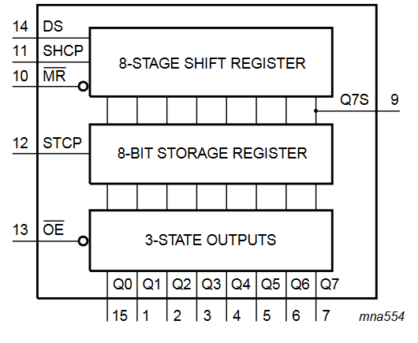  
Fig. 1 – Functional schematic diagram of a shift register circuit.

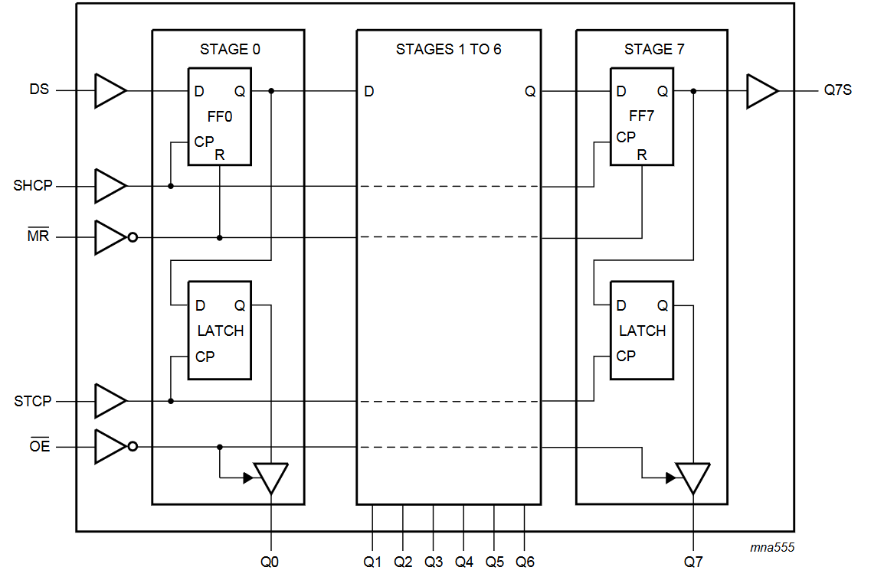  
Figure 2. - Logic diagram of a shift register.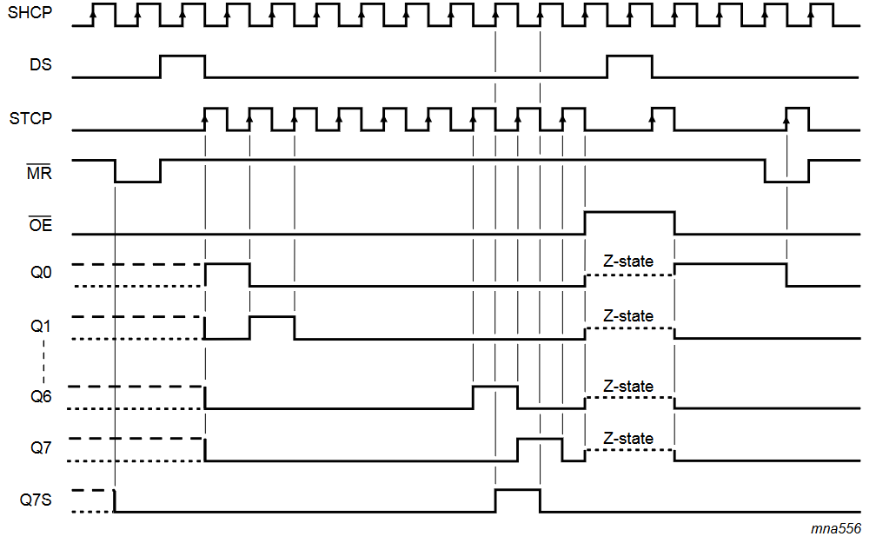  
Figure 3 - Time diagram of the shift register.

Suppose that in the initial state the register is already filled with some eight bits. Let's write eight new bits into it: 11011010.

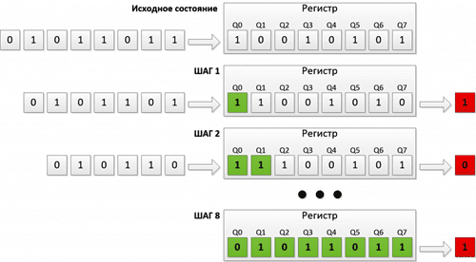

As you can see, after two iterations, two new bits appeared at the beginning of the register, and two bits in the last cells disappeared. On the eighth cycle the whole register was filled with new bits.

Registers can be connected in a chain. In this case, the displaced bit from the first register will not be lost, but will be written to the beginning of the next register. This increases the number of available pins.

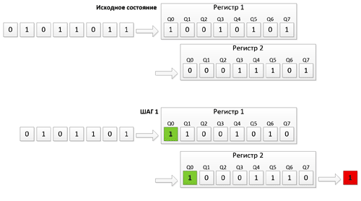

*Required HAL functions*

Transmission data through SPI using DMA.

*HAL_StatusTypeDef HAL_SPI_Transmit_DMA(SPI_HandleTypeDef *hspi, uint8_t *pData, uint16_t Size)*

* *hspi* – the pointer to the configuration structure of SPI_HandleTypeDef type;
* *pData* – the pointer to the array of transmitted data of uint8_t format;
* *Size –* number of bytes to be transferred.

**The order of work:**

*Part I. Developing a program using a code generator.*

1. Start STM32CubeIDE, in the opened window select the path to your working folder. There should be no Russian letters in the path to the working folder and the project name. In this folder should be stored all laboratory works.

2. This work should be done on the basis of work 6.

3. Based on the documentation, determine which pins the shift registers are connected to and which SPI block in the microcontroller is used to control them.

4. In the graphical initialization window of the controller (name.IOC), it is necessary to set the pins of the microcontroller connected directly to the 7-segment indicator in the input mode.

5. In the window of graphical initialization of the controller (name.IOC), it is necessary to configure the pins defined in step 3, to work with shift registers (line SS should be configured as an output and controlled manually).

5. On the 7-segment display board, the SR_OE jumper must be set to 1 and the SR_MR jumper must be set to 0.

6. Implement the following program algorithm:

- Controlling the servo drive and sending data to matlab is saved from the 6th work;

- The data display in matlab should be in degrees;

- Develop an algorithm to display the servo position in degrees on a 7-segment display using shift registers.

**Tasks:**

1. Perform all of the steps in Part I.

Demonstrate all assignment items one by one to the instructor.