BUS ID_VEHICLE = 0
DIRECT ID_DIRECTION = 1
RETURN ID_DIRECTION = 2

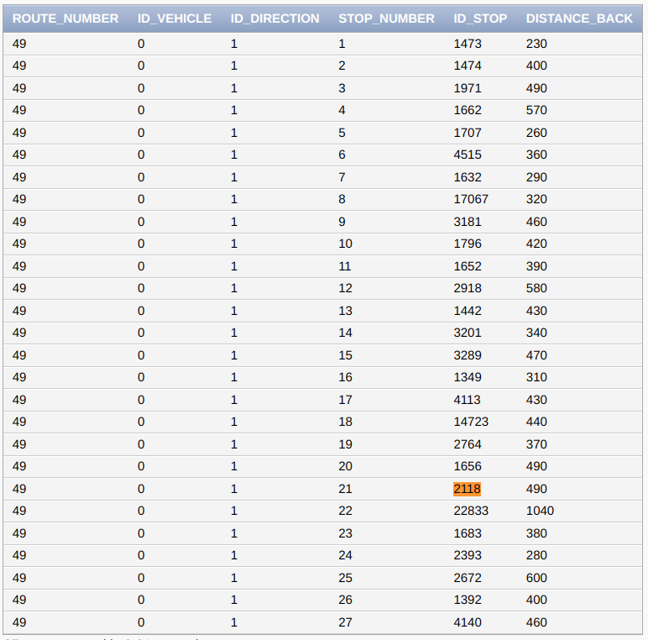
COMMAND:
SELECT SUM(DISTANCE_BACK) FROM ROUTE_BY_STOPS
WHERE ROUTE_NUMBER=49 AND ID_VEHICLE=0 AND ID_DIRECTION=1 AND STOP_NUMBER<=21 AND STOP_NUMBER>6
ORDER BY STOP_NUMBER ASC;

SUM = 6230 meters
speed = 10 km\h = 166.666 met\min
time = 37,38 min = 37 min

