**Java Assessment – Coding exercise**

Repository link: <https://github.com/deniskirylo/Nuno_Dainius_Assessment>

Application description:

Web application built in Java with Spring boot, PostgreSql for database, and React.js on the front/end.

**Acceptance criteria**

1. SQL management screenshot with the result of the script execution when you create the table

*Postgres initial table*

1. Postman or any API consumer tool, with a screenshot of the evidence of your post calls to fill out your table

*Post request*

*Get request*

*Delete request*

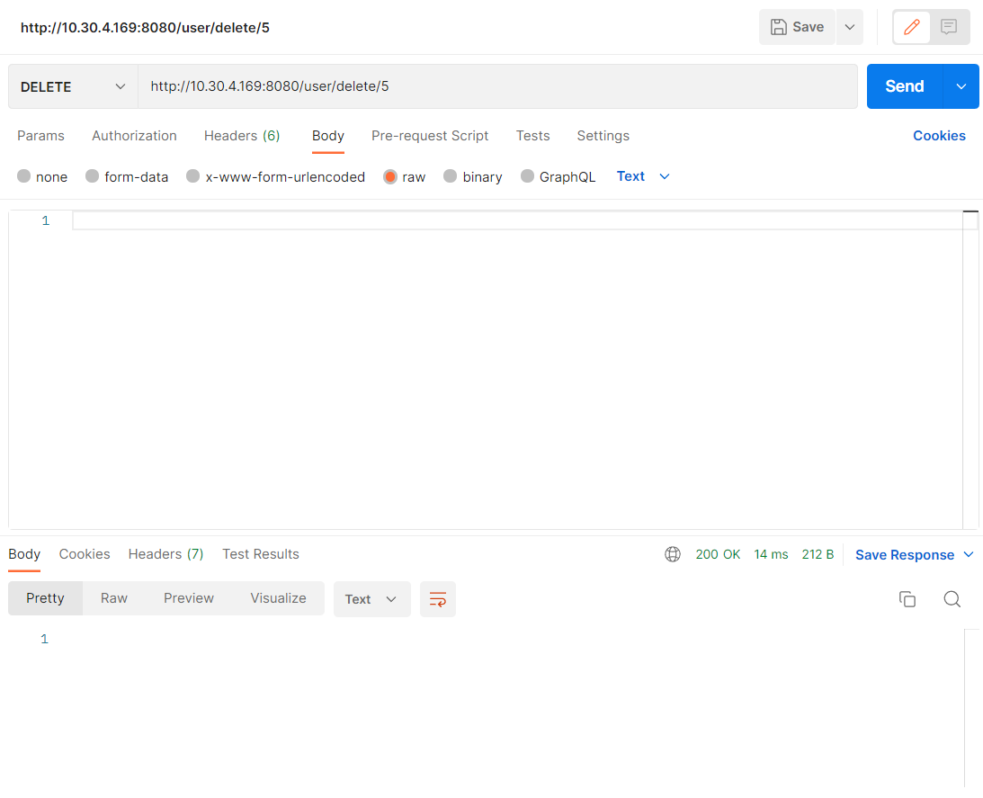

1. SQL management screenshot showing the data inserted with the rest service

*Inserting data in the react app*

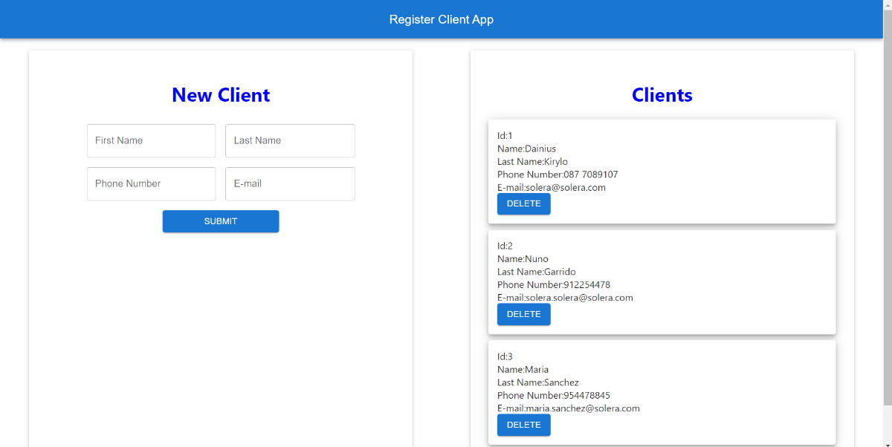

*Updated table*

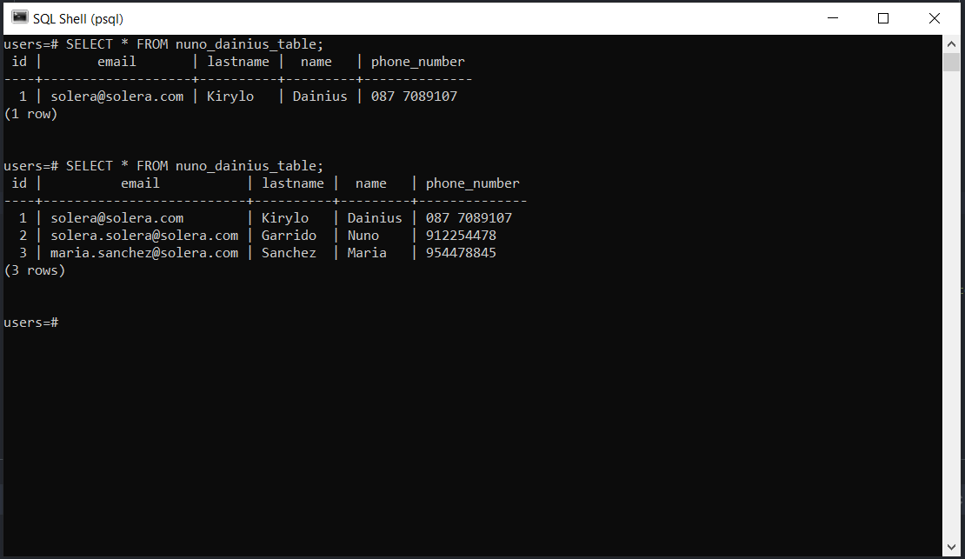

1. Java application execution screenshot with the information from your table (localhost site using get action)

*Spring boot table creation*

