ID-PET - Decentralized application

1) Context

This is a simple example of a decentralized application based on unique non-fungible tokens on the Ethereum ERC721 blockchain.

Its main goal is to identify pets on the Ethereum blockchain.

2) Overview of ID-PET

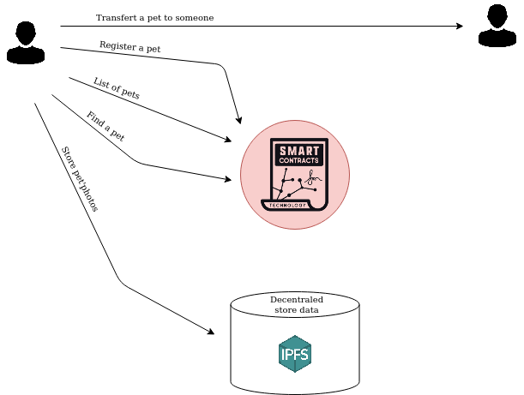

3) Details of the application

4) Technical implementation

4.1) Smart contract

The smart contract is written in Solidity and based on the standard ERC721 token.

4.2) Frontend

4.2.1) Structure of the application

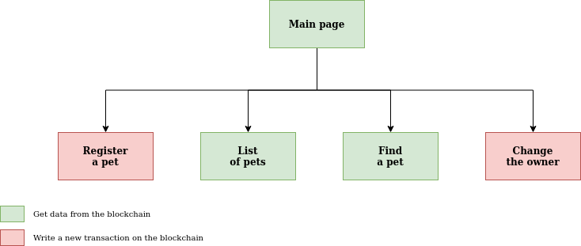

The frontend of the application used react.

* dateformat@3.0.3
* ipfs-http-client47.0.1
* react@16.13.1
* react-dom@16.13.1
* react-qr-scanner@0.0.10
* react-router-dom@5.2.0
* react-scripts@3.4.3"
* validator@13.1.17
* web3@1.3.0

5) References

<http://erc721.org/>

<https://solidity.readthedocs.io/en/v0.6.8/>

<https://www.trufflesuite.com/>

<https://openzeppelin.com/contracts/>

