**Project plan**

Homo Bradypous symbioticus

*Customer - Eleni*

***Team “Orange”***

**Inhoudsopgave**

1. Project Assignment 3

1.1 Context 3

1.2 Goal of the project 3

1.3 The assignment 3

1.4 Scope 3

1.5 Conditions 3

1.6 Finished products 3

1.7 Research questions 4

2. Approach and Planning 5

2.1 Approach 5

2.2 Research methods 5

2.3 Breakdown of the project 5

2.4 Time plan 5

3. Project organization 6

3.1 Team members 6

3.2 Communication 6

3.3 Test environment 6

3.4 Configuration management 6

4. Finance and Risks 7

4.1 Cost budget 7

4.2 Risks and fallback activities 7

5. Other 8

# 1. Project Assignment

## 1.1 Context

Client for the project – Eleni. She works in the interfaces of visual arts and collaborative projects and art education. Eleni creates a lot of projects which she wants to represent on the Internet. She also would like to collect and share other user’s projects.

1.2 Goal of the project

The main goal of the project as stated by the client is ‘to restore the connectivity between our social relations’ by using a creative and artistic approach for the design of the website.

Make a portfolio for a woman that works in the realm of interfaces of visual arts and collaborative projects and also as an art teacher. The portfolio should represent the client, but focusing on her works, rather her biography facts. The website must speak for itself and be extension of her art, but also be a place for other artist to share their works.

## 1.3 The assignment

The assignment is to deliver the client’s requirements – different projects, which at first sight contain a brief information (name, time, place, who is involved and for what reason). You can interact with them, taking you a page dedicated to the selected project, all presented in an artistic and original way, giving inspiration to the users (animations, micro interactions).

## 1.4 Scope

Making a website for collecting different projects, a sort of blog or archive/database for different art pieces, exhibitions, movements, etc.

## 1.5 Conditions

Team Conditions:

1. The content discussed in the meetings remains in the meetings.

2. Take the meetings seriously - the content of each meeting will be specified in advance.

3. All decisions will be put to a vote. Every vote is the equally valuable. In the case of a disagreement, discussions will be held to a new resolve.

4. If someone is not doing their job properly or not taking it seriously, they will be informed, and a solution will be suggested. If the problem persists, the team is allowed to execute their participation.

5. If a member is executed, other members of the team must share the duties of the original member.

6. All members must attend all meetings. (If unable to attend the meeting in person, they must attend via an online platform)

7. Tasks division will be decided by all team members.

8. The participation in all meetings without valid reasons is unallowed. (The validity of it will be determined by the other team members)

9. Clear communication is expected from all team members.

10. All team members are expected to meet the deadlines

# 2. Approach and Planning

## 2.1 Approach

Our team uses Scrum approach. We have a stand up meeting every day, so that we can have insight on the group progress. Each Tuesday we have a meeting with all teammates to discuss main points and do a retrospective.

## 2.2 Research methods

## 2.3 Breakdown of the project

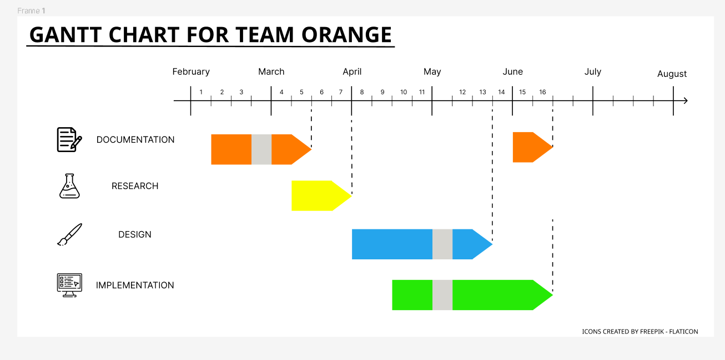

## 2.4 Time plan

|  |  |  |  |
| --- | --- | --- | --- |
| **Phasing** | **Effort** | **Start** | **Ready** |
| 1. Documentation | Low | Week 1 | Week 6 |
| 1. Research | Low | Week 5 | Week 8 |
| 1. Design | High | Week 8 | Week 13 |
| 1. Implementation | High | Week 10 | Week 16 |

# **3.** **Project Organization**

## 3.1 **Team members**

|  |  |  |  |
| --- | --- | --- | --- |
| **Name** | **Roles** | **Tasks** | **Strengths/Weakness** |
| **Anna Bobrovska** | **UI/ UX Designer** | User Research &  Create Prototypes and Final Design | **Strengths:**   * User Research (conduct interviews, create surveys...) * Skills for UI design (Creating prototypes, final design...) * Problem-Solving * Good Team Player * Creating original ideas   **Weaknesses:**  - Sometimes have problems with coding   * Sometimes I’m nervous to give feedback to my colleagues, so they don't get offended |
| **Denislav Dimitrov** | **Developer** |  | **Strengths:**   * Web development (functionality, appropriate design, animations) * Communicative * Problem-solving * Coming up with innovative and creative ideas   **Weaknesses:**   * Sharing my progress with other teammates for everyone to stay in touch * Procrastination |
| **Fahid** |  |  |  |
| **Mirena Veleva** |  |  | **Strengths:**   * Communicative * Creative * Open to constructive criticism   **Weaknesses:**   * Still have troubles with coding * Sometimes too straightforward with people |
| **Simeon Grigorov** | **Designer** |  | **Strengths:**  - Critical thinking  - Good at designing  - Patient  - Understands coding on a  decent level  **Weaknesses:**  - Bad concentration  - Bad time management  - Sometimes I struggle to  remember stuff |
| **Tihomira Miteva** | **Maintainer** | Track ongoing work and make sure that it gets reviewed and merged in a timely manner | **Strengths:**   * Comunicative * Good at teamwork * Creative * Openminded * Good listener * Finishing tasks before the deadline   **Weaknesses:**   * Sometimes hard to concentrate * Dealing with the time separation |
| **Yavor Aldev** | **Developer** | Website functionality | **Strengths:**   * Able to achieve ideas that I or others have come up with in * Good communication with others and keeping team on track for timely goal completion * Come up with a lot of ideas, especially when bouncing off others   **Weaknesses:**   * Sometimes I have difficulties expressing my ideas for design * When I don’t have an immediate idea for a design for something, I have trouble getting started or looking at inspiration |
|  |  |  |  |

## 3.2 **Communication**

Main communication with the team and teachers will be in person at the university. Online communication among the teammates will be in WhatsApp and Microsoft Teams with the teachers and coaches.

## 3.3 **Test environment**

## 3.4 **Configuration management**

All documents are going to be placed in a shared folder in MS One Drive. The files with the code are going to be uploaded into a Git Lab repository by the developers to maintain everything structured and make sure there is no lost files and code.