PUF Information System

Contents

1. Introduction 2

2. Requirements 2

2.1 Problem Statement 2

2.2 Product Position Statement 2

2.3 Stakeholder Summary 2

2.4 Product Overview 3

2.5 Other Product Requirements 5

3. Planning and organization 5

3.1 Contacts 5

3.2 Working time 5

3.3 Project Methodology 5

3.4 Project Planning 5

3.5 Meetings 6

3.6 Project Approach 7

3.7 Project roadmap 7

3.8 Technical Environments 7

3.9 Definition of Ready (DoR) 7

3.10 Definition of Done (DoD) 8

4. Practices 8

5. Design 8

6. Implementation 8

7. Statement of the Final result 8

# Introduction

This document is to describe the implementation of PUF Information System which is an assigned project as part of Project Management course of MINF16 Soft program.

# Requirements

## Problem Statement

|  |  |
| --- | --- |
| The problem of | There is no information system to manage, connect, communicate and collaborate effectively among students, faculties and back office. |
| affects | Students, Faculties, Back office. |
| the impact of which is | There is no unique and centralized data.  There is no strictly connection between stakeholders.  There is no fully supported functions/activities system for stakeholders. |
| a successful solution would be | a comprehensive open source ERP for educational institutes. |

## Product Position Statement

|  |  |
| --- | --- |
| For | Students, Faculties, Back office. |
| The PUF Information System | is a comprehensive open source ERP for educational institutes. |
| That | provides the educational institute for managing different kinds of activities related to management and other collaborative efforts among students, faculties and back office. |
| Unlike | * School Dude * Power School * Frontline Insights Platform * School Time |
| Our product | is an open source application for education institutes based on Odoo and OpenEduCat ERP. It contains all major features those are necessary for managing an educational institute online. It will be customized to fit the requirements of PUF. |

## Stakeholder Summary

| **Name** | **Description** | **Responsibilities** |
| --- | --- | --- |
| Students | Registered students of PUF or potential students | Mostly follow their profile and study progress in the system. For potential students, they can only see the public website of PUF where they can have detail information of programs of PUF. |
| Faculties | Professors from France or Vietnam who participate in PUF courses | They can follow up their timetable, manage the class attendance, provide exam and final results for students in the system. |
| Back Office | PUF Back Office Staffs who manage the management activities. | They will be in charge of maintance of the system such as profiles, financial, website, management activities, etc. |

## Product Overview

|  |  |  |  |  |
| --- | --- | --- | --- | --- |
| **No** | **Features** | **Description** | **Priority**  **(1/2/3)** | **Planned Release** |
| 1 | Configuration | System provides facility to make some basic configuration. There are five features for basic configuration that you can configure.   * Facility :- Specify different facilities of an institute. * Categories :- Specify the religions. * Activity Types :- Specify different activities which is held in an institute. * Scholarship Types :- Configure different scholarship types. * Achievement Types :- You can also configure the achievement type details. | 3 |  |
| 2 | Enrollment / Admission | Before the Enrollment of a student an Admission Register is created for each course. All the admissions for that course falls in respective Admission Register. | 2 |  |
| 3 | Student | System provides the fully developed module especially manage the details of the Student. You can manage student profile starting from creating a record for a student to manage his/her profile till the end of his academic session. | 1 |  |
| 4 | Faculty | System is fully integrated application which provides a facility to manage the faculty information. | 1 |  |
| 5 | Parent | System allows you to store the details of the Parents and their Students. | NA |  |
| 6 | Course / Batch | Course Management helps you to provide the start up data of courses that will be taught in an institute. Course management includes configuration of course and batch.   * Configure Course * Configure Batch | 1 |  |
| 7 | Assignment | System provides the facility to configure the assignment type. List of all the assignment type are displayed here. | 2 |  |
| 8 | Classroom | Configuration of class room helps you to provide the start up data of class rooms of an institute. | 1 |  |
| 9 | Financial / Fees | Configuration of fees helps you to provide the start up data of fees according to the courses of an institute. | 3 |  |
| 10 | Time Table | System is fully integrated application which provides a facility to manage the timing details. | 1 |  |
| 11 | Attendances | System provides the Attendance maintanance facility for an institute.To maintain attendance ,attendance register is created for particular batch and course. | 1 |  |
| 12 | Library | System provides the facility to configure library management.To begin this, you need to configure some data in order to make it working. We refer to this as Configuration. You can configure the data for library like,   * Media Type- That is assigned to a book.For example course book , reference book ,magazine. * Publisher- List of publications of which books you have in library. * Authors- List of authors whose books are available in library. * Library Card Type- Specify the type of library card type.For example Bachelor Degree Card , Master Degree Card. | NA |  |
| 13 | Exam and Results | System provides the facility to configure exam related details like Exam types and Exam Rooms. The goal of giving a facility to configure the exam type is,institute may take different types of exam. Better to make it configurable and let Administrators configure these details.   * Exam Type :- Using this, you can configure the types of exams. * Exam Room :- Here you can specify the exam room details that can be used while there are exams in institute. * Grade Configuration :- Here you can specify different grade which is used in student's result for grade system. | 1 |  |
| 14 | Events | Event management system enable institute organize and inform students and faculties about the events. | 3 |  |
| 15 | News | To keep students and faculty members informed about all happening going around the campus is just a click away using the System’s news publishing. | 3 |  |

## Other Product Requirements

|  |  |  |
| --- | --- | --- |
| **Requirement** | **Priority** | **Planned Release** |
| Data history/revision | 1 |  |
| Supporting English/Vietnamese | NA |  |
| Website Design | 2 |  |

# Planning and organization

## Contacts

|  |  |  |  |  |
| --- | --- | --- | --- | --- |
| **No** | **Name** | **Email** | **Phone** | **Location** |
| 1 | Nguyen Huu Minh Huy | [nguyenminhhuy@gmail.com](mailto:nguyenminhhuy@gmail.com) | +84 0909091402 | HCMC, Vietnam |
| 2 | Vo Hoang Dat | [denislour@gmail.com](mailto:denislour@gmail.com) | +84 01689995095 | HCMC, Vietnam |
| 3 | Trang Ngo | [anna.ngo13@gmail.com](mailto:anna.ngo13@gmail.com) | +84 01686963493 | HCMC, Vietnam |
| 4 | Quoc Pham | [quocpp@hotmail.com](mailto:quocpp@hotmail.com) | +84 01234999700 | HCMC, Vietnam |
| 5 | Prof. Fabien Baldacci | [fabien.baldacci@u-bordeaux.fr](mailto:fabien.baldacci@u-bordeaux.fr) | NA | Bordeaux, France |

## Working time

|  |  |  |  |  |  |  |  |
| --- | --- | --- | --- | --- | --- | --- | --- |
| **Location** | **Mon** | **Tue** | **Wed** | **Thu** | **Fri** | **Sat** | **Sun** |
| Vietnam (UTC/GMT +7) | 7pm-9pm | 7pm-9pm | 7pm-9pm | 7pm-9pm | 7pm-9pm | NA | NA |
| France (UTC/GMT +1) | 1pm-3pm | 1pm-3pm | 1pm-3pm | 1pm-3pm | 1pm-3pm | NA | NA |

## Project Methodology

Agile Scrums methodology is partially applied to run the project. The process is as below:

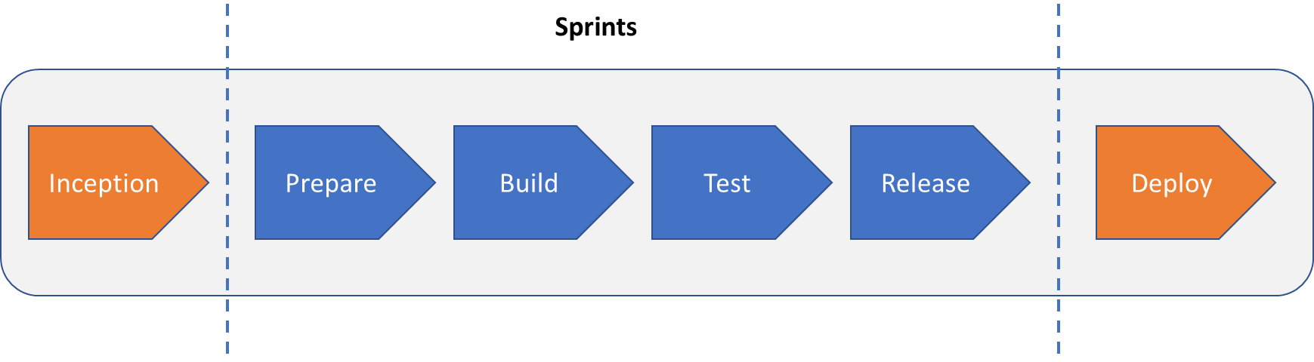

## Project Planning

|  |  |
| --- | --- |
| **Milestone** | **Detail** |
| Project start date | 09 Mar 2018 |
| Project end date | 30 Jun 2018 |
| Inception phase | From 09 Mar 2018 to 16 Mar 2018 |
| Sprint duration | Every 3 weeks |
| Deploy | TBD |

Due to restricted timeline, we are not planning to implement all modules of OpenEduCat but only the highest priority ones. The estimated project plan is as below:

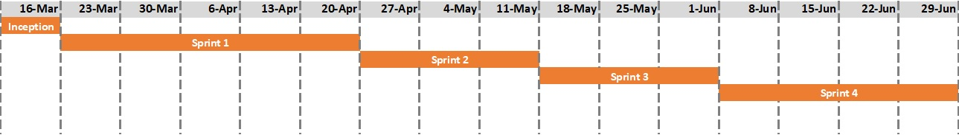

## Meetings

|  |  |
| --- | --- |
| **Meeting** | **Detail** |
| Daily Stand-Up Meeting (DSTUM) | **Participants**: Vietnam team  **Objectives**: discuss about how you achieve the objectives the day before and what you will do this day to achieve the objectives.  **When**: every day at 7pm (Vietnam time)  **Duration**: max 15 mins |
| Weekly Report Meeting | **Participants**: Vietnam team and Prof. Fabien  **Objectives**: summarize the past week, report the activities completed by the teams, list the next activities, raise/update risks and issues.  **When**: every Friday at 7pm (Vietnam time), 1pm (France time)  **Duration**: 30 mins – 60 mins |
| Demo Session | **Participants**: Vietnam team and Prof. Fabien  **Objectives**: to go through system functional before starting new Sprint and to get feedbacks/requirements from Prof. Fabien on user stories.  **When**: before starting new Sprint, 7pm (Vietnam time), 1pm (France time)  **Duration**: max 60 mins |
| Sprint Planning | **Participants**: Vietnam team  **Objectives**: to review and define user story points for what will be implemented in Sprint as well as user story assignment for each members in team  **When**: at the beginning of a Sprint  **Duration**: max 60 mins |
| Sprint Review | **Participants**: Vietnam team and Prof. Fabien  **Objectives**: to review and evaluate the last Sprint on what we have done/could do better/any risks or issues we had  **When**: after finishing a Sprint  **Duration**: max 60 mins, 7pm (Vietnam time), 1pm (France time) |

## Project Approach

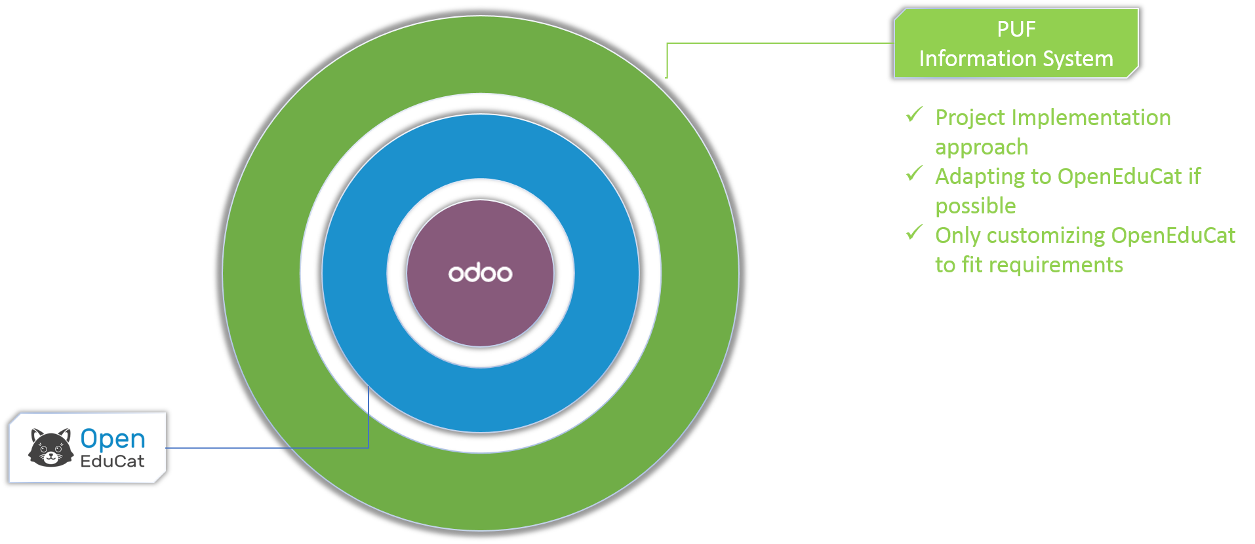

## Project roadmap

To be finalized with client.

## Technical Environments

|  |  |  |
| --- | --- | --- |
| No. | Name | Description |
| 1 | Odoo v10.0.20180308 | Odoo is a suite of open source business apps that cover all your company needs: CRM, eCommerce, accounting, inventory, point of sale, project management, etc. Odoo's unique value proposition is to be at the same time very easy to use and fully integrated.  URL: <https://www.odoo.com/> |
| 2 | OpenEduCat Community v10.0.3.0.0 | OpenEduCat is a product developed by Tech-Receptives Solutions Pvt. Ltd., an expert company focusing in providing unique open source solutions. In due course we accumulated a team of strong, experienced, creative, talented and dedicated engineers and designers. Its products apply unique and powerful technology that helps educational institutes manage, connect, communicate and collaborate effectively among students, faculties and back office.  URL: <https://www.openeducat.org/page/aboutus> |
| 3 | PyCharm Community v2017.3.4 | Python IDE for Professional Developers  URL: <https://www.jetbrains.com/pycharm/> |
| 4 | PostgreSQL Database v1.22.1 | PostgreSQL is a powerful, open source object-relational database system. It is mandatory DB system for Odoo package.  URL: <https://www.postgresql.org/> |
| 5 | Github | All the source code and document will be managed by Github where all members can access and modify if necessary. Detail information is as below:  URL: <https://github.com/> |

## Definition of Ready (DoR)

Definition of Ready is a set of agreements that lets everyone know when something is ready to begin, e.g., when a user story is ready to be taken into a sprint, or when all necessary conditions are right for a team to start a sprint. For more information, please refer to: <https://systemagility.com/2011/05/17/definition-of-ready/>

**Definition of Ready for a User Story**

* User Story defined
* User Story Acceptance Criteria defined
* User Story dependencies identified
* User Story sized by Delivery Team
* Scrum Team accepts User Experience artefacts
* Performance criteria identified, where appropriate
* Person who will accept the User Story is identified
* Team has a good idea what it will mean to Demo the User Story

**Definition of Ready for a Sprint**

* The Sprint Backlog is prioritized
* The Spring Backlog contains all defects, User Stories and other work that the team is committing to
* No hidden work
* All team members have calculated their capacity for the Sprint
* Fulltime on project = X hours per day
* All User Stories meet Definition of Ready

## Definition of Done (DoD)

1. User story clarity and Acceptance Criteria for User story agreed within the Sprint team
2. Development Environment ready
3. Code produced in accordance with Coding standards. If code isn’t clean in all these respects, developing functionality in future sprints will take more and more time.
   1. Code commented, checked in and run against current version in source control
   2. Code should not contain clever programming tricks. (should be easily debugged and bereft of any technical debts in future)
   3. Code should be easy to read and maintain.
   4. Code should be refactored to remove any duplicate or ill structured code.
4. Peer reviewed and meeting development standards
5. Builds without errors
6. Builds with limited and acceptable number of warnings
7. Unit tests written and passed. (Not applicable)
8. Functional Test passed
9. Product/Sprint Backlog Updated
10. Deployed to system test environment and passed system tests and performance tests where applicable.
11. Package, Class and Architecture Diagrams updated.
12. All bugs closed.
13. Passed UAT (User Acceptance Testing) and signed off as meeting the requirements per the customer
14. Any build/deployment/configuration changes implemented/documented/communicated.
15. Relevant documentation/diagrams produced and/or updated

# Practices

# Design

# Implementation

# Statement of the Final result