Service Oriented Architecture CA2

**Name**: Denis Mooney

**Student ID**: D00219727

**API Platform:** POSTMAN

**Tables in SQL Server**: Attractions, Facilities. (FacilityID exists as a PK in the facilities table and FK in the Attractions table i.e. One -> Many relationship)

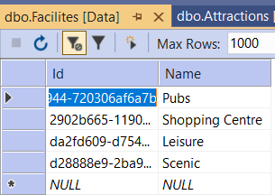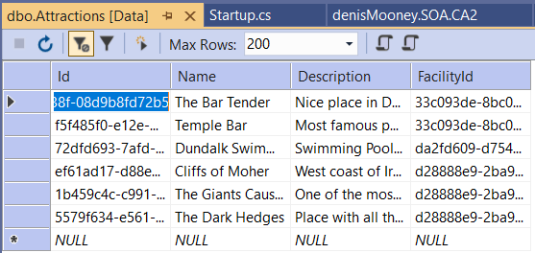

The created API Implements the CRUD functions -> e.g.

* Creating a facility/attraction
* Retrieving Facilities & Attractions by ID
* Deleting a record.
* Updating a record

1. 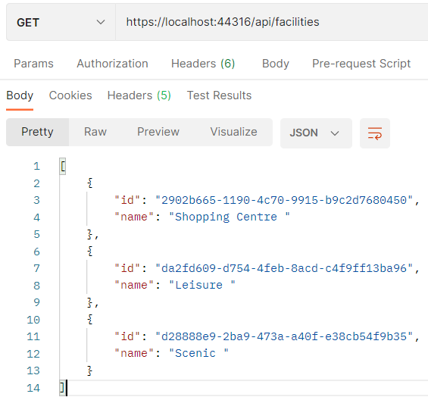Get All Facilities/Attractions

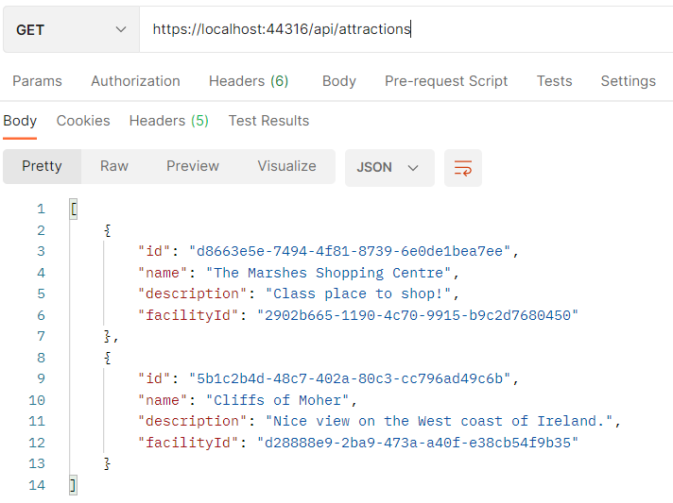

2 (i). Add Facility

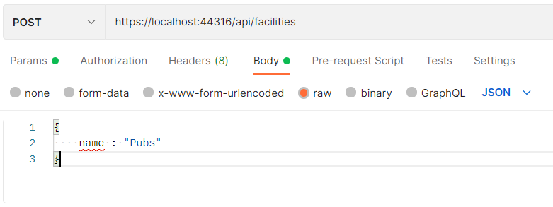

2 (ii). Facilities after Inserting

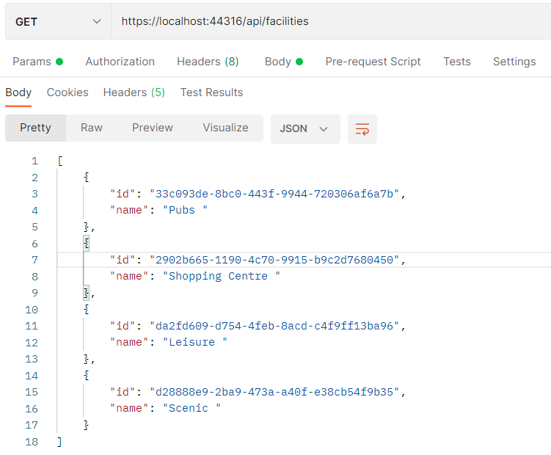

3. Deleting a record (attraction)

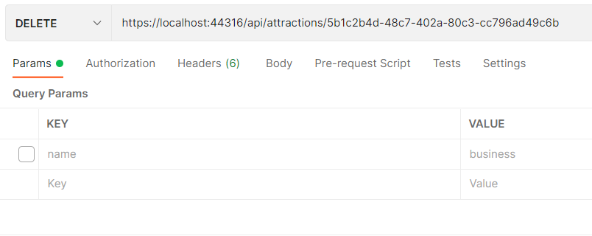

Deleting a record involves performing a DELETE request using an ID.

4. Update Attraction (using PUT method)

