Defect 1
Summary:​ The​ ​ name​ ​ entered​ ​ in​ ​ the​ ​ case​ ​ of​ ​ questioning​ ​ may​ ​ contain​ ​ hundreds​ ​ of characters.
Defect​ ​ Description:​ ​
When​ ​ we​ ​ enter​ ​ the​ ​ question,​ ​ it​ ​ is​ ​ necessary​ ​ to​ ​ enter​ ​ the​ ​ user​ ​ name.​ ​ We can​ ​ enter​ ​ a​ ​ whole​ ​ text,​ ​ meaning​ ​ there​ ​ is​ ​ no​ ​ character​ ​ input​ ​ limit. Detailed​ ​ Steps:​ ​ We​ ​ open​ ​ the​ ​ airport.md​ ​ page​ ​ after​ ​ entering​ ​ the​ ​ "ask​ ​ question"​ ​ section,​ ​ after entering​ ​ the​ ​ mail,​ ​ the​ ​ question​ ​ you​ ​ want,​ ​ the​ ​ code​ ​ represented,​ ​ and​ ​ in​ ​ the​ ​ name​ ​ of​ ​ the​ ​ name we​ ​ write​ ​ a​ ​ text​ ​ of​ ​ a​ ​ few​ ​ tens​ ​ or​ ​ even​ ​ hundreds​ ​ of​ ​ characters.​ ​ We​ ​ notice​ ​ that​ ​ there​ ​ is​ ​ no​ ​ error, and​ ​ the​ ​ question​ ​ has​ ​ been​ ​ sent. Actual​ ​ Result:​ ​
The​ ​ question​ ​ was​ ​ successfully​ ​ addressed. Expected​ ​ Result:​ ​ Error,​ ​ which​ ​ says​ ​ that​ ​ the​ ​ character​ ​ input​ ​ limit​ ​ is​ ​ being​ ​ exceeded.
Platform:​ ​ Windows​ ​ 8.1
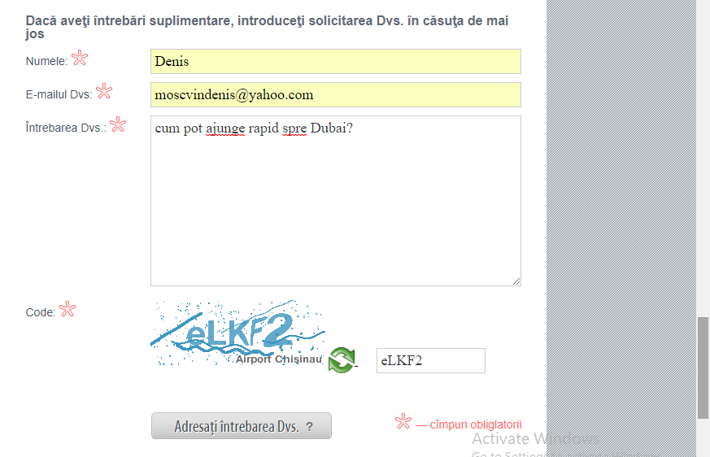

Date​ ​ Raised:​ ​ 12.02.2018
Reported​ ​ by:​ ​ MOSCVIN DENIS
Severity:​ ​ Moderay
Priority:​ ​ High

Defect 2
Summary:​ ​ Missing​ ​ hotline,​ ​ when​ ​ we​ ​ open​ ​ through​ ​ another​ ​ browser Defect​ ​
Description:​ ​ When​ ​ accessing​ ​ airport.md​ ​ in​ ​ another​ ​ browser​ ​ (Internet​ ​ Explorer),​ ​ we​ ​ do not​ ​ show​ ​ the​ ​ contact​ ​ number​ ​ well​ ​ and​ ​ it​ ​ is​ ​ totally​ ​ missing​ ​ hotline@airport.md.
Detailed​ ​ Steps:​ ​ We​ ​ open​ ​ another​ ​ browser(Internet​ ​ Explorer)​ ​ that​ ​ we​ ​ have​ ​ in​ ​ the​ ​ computer, we​ ​ access​ ​ airport.md,​ ​ we​ ​ notice​ ​ the​ ​ difference.
Actual​ ​ Result:​ ​ Do​ ​ not​ ​ show​ ​ hotline@airport.md. Expected​ ​ Result:​ ​ Hotline@airport.md​ ​ must​ ​ be​ ​ included​ ​ next​ ​ to​ ​ the​ ​ site​ ​ name.
Platform:​ ​ Windows​ ​ 8.1
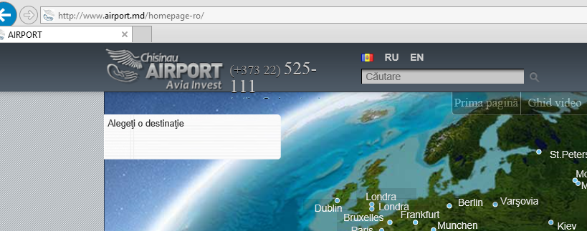
Date​ ​ Raised:​ ​12.02.2018
Reported​ ​ by:​ ​ Moscvin Denis
Severity:​ ​ Moderay
Priority:​ ​ High
Defect 3
Summary:​ ​
Not​ ​ all​ ​ of​ ​ the​ ​ text​ ​ is​ ​ visible​ ​ in​ ​ the​ ​ news​ ​ box​ ​ and​ ​ in​ ​ the​ ​ button:​ ​ ask​ ​ your​ ​ question​ ​ in Internet​ ​ Explorer.
Defect​ ​ Description:​ ​ In​ ​ the​ ​ News​ ​ box,​ ​ all​ ​ the​ ​ top​ ​ of​ ​ the​ ​ text,​ ​ and​ ​ in​ ​ the​ ​ button​ ​ where​ ​ it​ ​ should be​ ​ written,​ ​ ask​ ​ your​ ​ question,​ ​ just​ ​ write​ ​ the​ ​ word:​ ​ ask.
Detailed​ ​ Steps:​ ​ Go​ ​ to​ ​ the​ ​ airport.md​ ​ site,​ ​ move​ ​ the​ ​ page​ ​ a​ ​ little​ ​ down​ ​ the​ ​ page.​ ​ observe​ ​ the defect.
Actual​ ​ Result:​ ​ We​ ​ see​ ​ that​ ​ the​ ​ text​ ​ is​ ​ not​ ​ completely​ ​ visible.
Expected​ ​ Result:​ ​ The​ ​ entire​ ​ text​ ​ must​ ​ be​ ​ visible,​ ​ like​ ​ in​ ​ another​ ​ browser,​ ​ such​ ​ as​ ​ Internet Explorer.
Platform:​ ​ Windows​ ​ 8.1
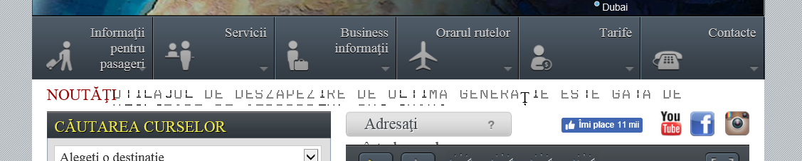

Date​ ​ Raised:​ ​ 15.02.2018
Reported​ ​ by: Moscvin Denis
Severity:​ ​ Moderay
Priority:​ ​ High.

Defect 4
Summary: Incorrect writing in the news compartment.
Defect Description:
In the novelty section, a shrift is used that does not support the use of the letters in Romanian, in the given case ț , from the words: deszapezire and generatie.(for the Romanian language of the site) Steps to Reproduce:
1.Click on the window with the name : the first page.
2.Use the mouse to lower the page until we get to the line - news.
3.We read the text.
Actual Result: “UTILAJ DE DESZAPEZ IRE DE ULTIMA GENERATIE ESTE GATA DE ”
Expected Result: ”UTILAJ DE DEZĂPEZIRE DE ULTIMĂ GENERAȚIE GATA DE”
Platform : Windows 8.1 Google Chrome
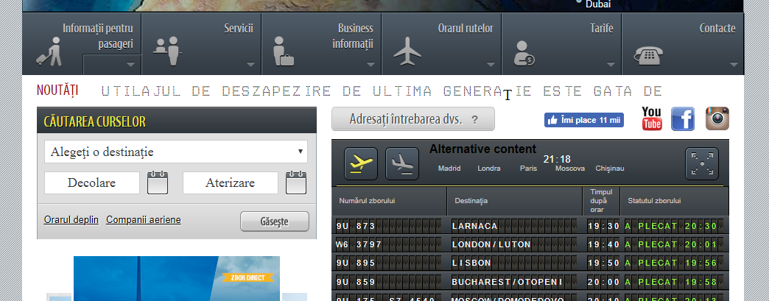
Severity:​ ​ Moderay
Priority:​ ​ High
Date​ ​ Raised:​ ​ 15.02.2018
Reported​ ​ by:​ ​ Moscvin Denis

Defect 5
Summary:​ ​
The​ ​ text​ ​ is​ ​ placed​ ​ over​ ​ one​ ​ of​ ​ the​ ​ tables. Defect​ ​
Description:​
​ When​ ​ we​ ​ enter​ ​ the​ ​ compartment​ ​ where​ ​ we​ ​ ask​ ​ the​ ​ question,​ ​ the​ ​ text "Ask​ ​ your​ ​ question?"​ ​ is​ ​ placed​ ​ above​ ​ the​ ​ table​ ​ below,​ ​ the​ ​ defect​ ​ is​ ​ encountered​ ​ in​ ​ Internet Explorer.
Detailed​ ​ Steps:​ ​
We​ ​ go​ ​ to​ ​ another​ ​ browser,​ ​ in​ ​ our​ ​ case​ ​ Internet​ ​ Explorer,​ ​ we​ ​ access airport.md​ ​ after​ ​ entering​ ​ the​ ​ questions​ ​ room​ ​ and​ ​ we​ ​ notice​ ​ on​ ​ the​ ​ bottom​ ​ left​ ​ the​ ​ defect described​ ​ above.
Actual​ ​ Result:​ ​ The​ ​ message​ ​ is​ ​ placed​ ​ on​ ​ the​ ​ table.
Expected​ ​ Result:​ ​ The​ ​ message​ ​ should​ ​ be​ ​ placed​ ​ above​ ​ the​ ​ table​ ​ in​ ​ the​ ​ box​ ​ to​ ​ the​ ​ right.
Platform:​ ​ Windows​ ​ 8.1.
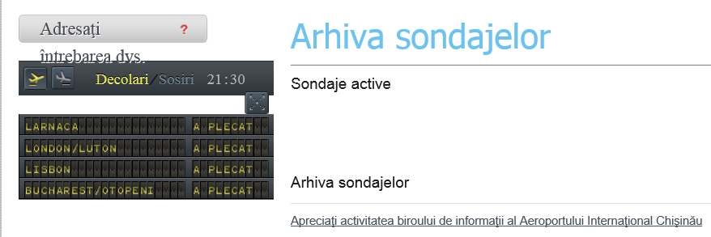
Date​ ​ Raised:​ ​ 15.02.2018
Reported​ ​ by:​ ​ Moscvin Denis
Severity:​ ​ Moderay
Priority:​ ​ High

