

Human–Computer Interaction

NOVA School of Sciences and Technology

(FCT NOVA)

2020/2021

MASTERBOOK

G12 Stage 5

Group Team:

* António Morais, 47774
* Nelson Santos, 48288
* Nuno Sequeira, 55903
* Rúben Barreiro, 42648

2 December 2020

# Heuristic Evaluation

We have been assigned the task of evaluating the interface of an interactive system. The group we are going to evaluate will be group 13 - TMASK. For the evaluation of the interface, we will use heuristics that will help us to identify problems, and possible solutions.

We received the work of the group 12 on December 1 at 11:41 am and we delivered ...

|  |  |  |  |  |  |  |
| --- | --- | --- | --- | --- | --- | --- |
| Nº | Problem | Heuristic | Description | Severity | Solution | Screenshot |
| 1 | Navbar overrides the form header | **4.** Consistency and standards | In this form, and in the following ones, the positioning of the form appears off-center, and with other components preventing the visualization. In this case, the navbar is overlapping the top of the form. | 3 | 2.1 | Figure 2.1 |
| 2 | Absence of a stepper | **1.** Visibility of system status | During the elaboration of the form for choosing the mask profile, we do not have the idea of the timeline for filling out the form. | 2 | 2.2 | Figure 2.2 |
| 3 | Standard measures | **2.** Match the real world | When choosing the mask size, the SI measurement used is the centimeter. However, I may belong to a country where the standard mediation measure may be different. | 1 | 2.3 | Figure 2.3 |
| 4 | Buttons do not work | **3.** User control and Freedom | The 3 buttons for the edition of the Profile’s information does not work. | 3 | 2.4 | Figure 2.4 |
| 5 | The need to leave the page | **4.** Consistency and standards | Make a mask should be on the same page than the others. It makes the user take unnecessary steps by changing pages. | 2 | 2.5 | Figure 2.5 |
| 6 | Buttons should not exist | **4.** Consistency and standards | The user should see every mask and then apply filters if necessary. | 2 | 2.6 | Figure 2.6 |
| 7 | System status not perceptible | **1.** Visibility of system status | After click on “CATALOG” in not perceptible to understand if we are on “MADE BY TMASK TEAM” or “MADE BY COSTUMERS” tabs. | 1 | 2.7 | Figure 2.7 |
| 8 | Unknown term | **2.** Match the real world | While on “CART” the term “ME” is not familiar to user. | 1 | 2.8 | Figure 2.8 |
| 9 | Error message on Cart | **9.** Help users recognize, diagnose, and recover from errors | While on “CART” and user clicks on remove item button the system crashes without a suggested solution. | 3 | 2.9 | Figure 2.9 |
| 10 | Search feature is not responsive | **1.** Visibility of system status | While performing a search for an item, if the item searched is composed by two words, the search is not responsive (and does not work at all). | 3 | 2.10 | Figure 2.10 |
| 11 | Search feature does not implement any Keyboard accelerator | **7.** Flexibility & Efficiency of Use | While performing a search for an item, when the user is typing the respective term, identifying it, it is not available, any Keyboard accelerator (like Keyboard’s ENTER shortcut) to facilitate its use. | 1 | 2.11 | Figure 2.11 |
| 12 | Shopping Cart’s Information about the Form’s Fields are not useful | **1.** Visibility of system status | The system does not provide any useful information about the fields of the form related to the Shopping Cart (e.g., Facial Profile or Quantity of Masks). | 1 | 2.12 | Figure 2.12 |
| 13 | Shopping Cart’s Form is not responsive | **1.** Visibility of system status | While trying to update the field of Quantity, the Final Price does not update automatically, and it is not offered any option to the user to do it, manually. | 2 | 2.13 | Figure 2.13 |

# Solutions and screenshots

# Graphical user interface, application, Teams Description automatically generatedSolutions: Reformulate the positioning of the canvas so that the form appears under the navbar

Figure 1 Screenshot for problem #1

# Solutions: Implementation of a stepper so that the user knows the actual step and how many to the final.

Figure 2 Screenshot for problem #2

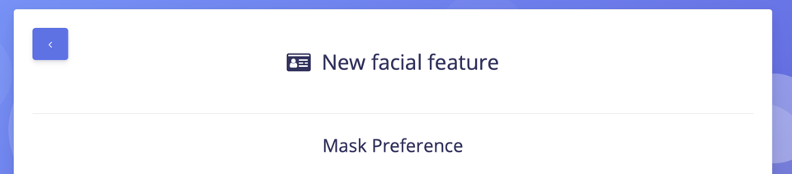

# Solutions: When visiting the website for the first time, there could be a choice of language and standard measures.

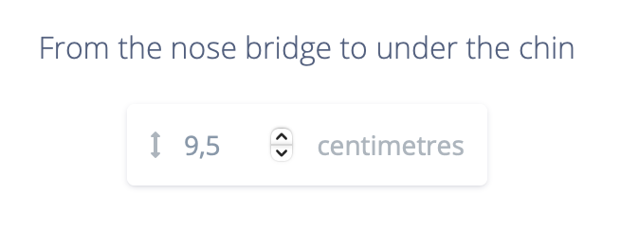

Figure 3 Screenshot for problem #3

# Solutions: Enable button functionality.



Figure 4 Screenshot for problem #4

* 1. 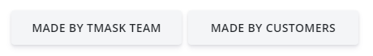**Solutions**: A button next to the existing ones.

Figure 5 Screenshot for problem #5

* 1. **Solutions**: Make this a filter on the search bar. Remove buttons.

Figure 6 Screenshot for problem #6

* 1. **Solutions:** Mark the tab where the user is, as already happens after clicking the tab.



Figure 7 Screenshot for problem #7

* 1. **Solutions:** Use familiar terms to sizes such M or Medium.

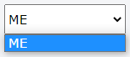

Figure 8 Screenshot for problem #8

* 1. **Solutions:** Offer users a solution, for example a shortcut that can solve the error immediately.

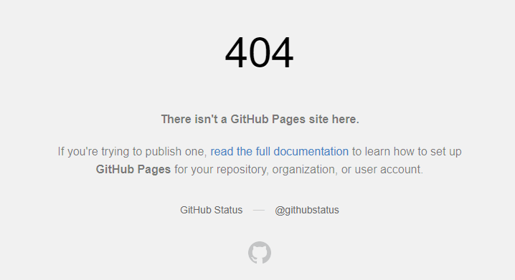

Figure 9 Screenshot for problem #9

* 1. **Solutions:** Offer users a responsive search, supporting search of items, identifiable by more than word.

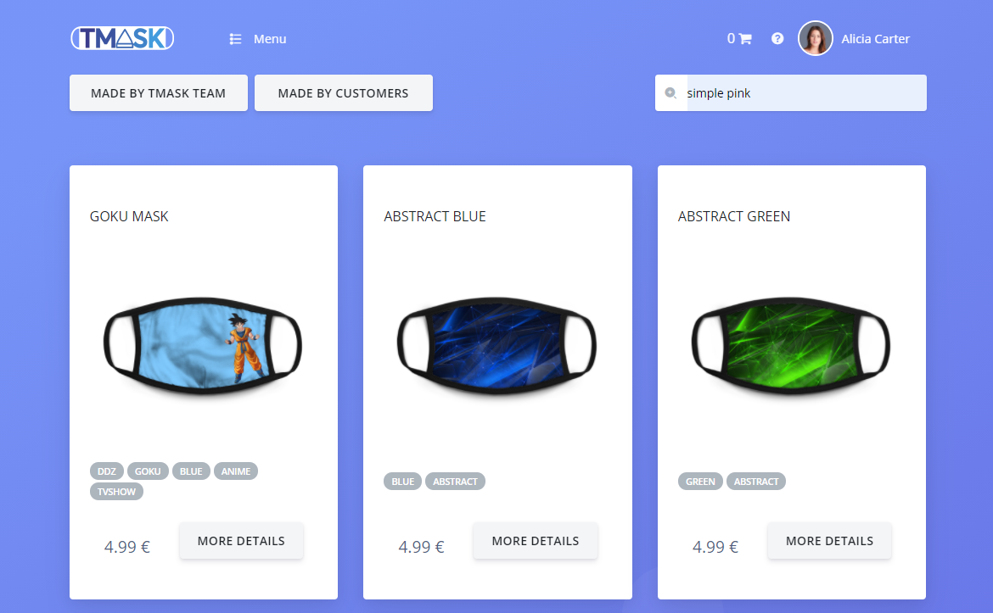

* 1. **Solutions:** Offer users some flexibility and efficiency of use on the search feature, providing a Keyboard accelerator, when the terms pretended to be searched (Keyboard’s ENTER as a shortcut, per example).

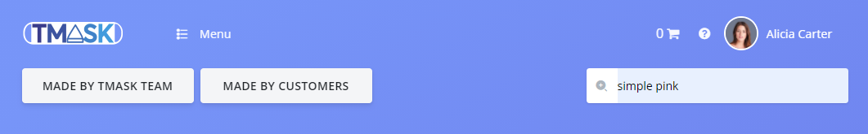

* 1. **Solutions:** Offer users some information feedback about the fields of the form of the Shopping Cart needed to be fulfilled (e.g., Price, Mask Profile and Quantity of Masks).

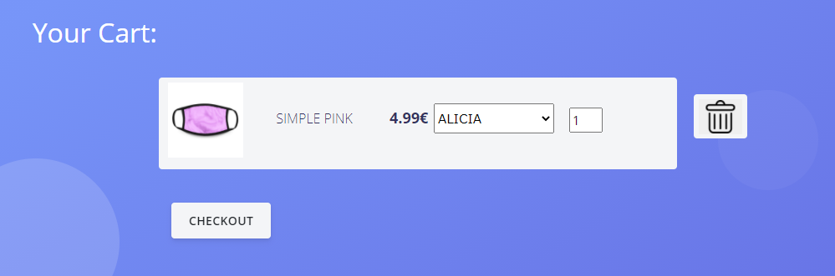

* 1. **Solutions:** Offer users some information feedback about the Final Price of an item, by updating that Final Price automatically.

