logoFCT_horiz.pdf

**Interacção Pessoa-Máquina**

**2020/2021**

**TMASK**

Stage 4: Functional prototype

**Realizado por: Lab class Nº** P2

41936, Samuel Robalo **Group Nº 13**

44592, Alexander Denisov

50654, Francisco Silva **Professor:**

51095, Daniel Dias Teresa Romão

Novembro 30, 2020

**URL for your prototype**

Visible online from url: <https://denisov93.github.io/Tmask/>

GitHub Repository at: <https://github.com/denisov93/Tmask>

(email: [a.deni@campus.fct.unl.pt](mailto:a.deni@campus.fct.unl.pt) for access if required)

Zip file located at:

**Startup instructions**

To run the project it is required to download Visual Studio Code, load provided .zip file or use git (<https://github.com/denisov93/Tmask>) to open project.

For git is clone repository like shown below:

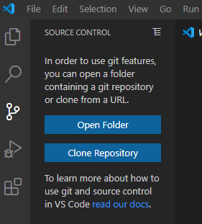

Project show load and appear similar as the image below:

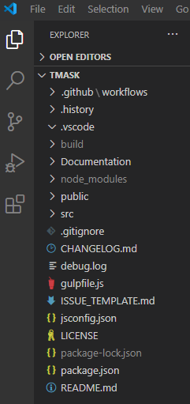

We now turn on the terminal, if terminal is not visible, the top menu bar View contains the Terminal for display.

This project will set a running server in localhost, for that the localhost port 3000 must not be in use, requires closing any server running or application binding this specific port.

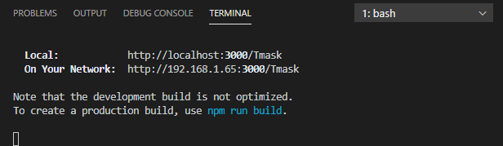

Firstly, we need to install all project dependencies with command ***npm install***, after this is complete we need to do ***npm update*** to ensure latest versions of dependencies are up to date, we then launch the server in localhost with ***npm start***. If any issues arrive doing ***npm install***and ***npm update*** again should fix them.

A browser window automatically appears after building successfully, (with npm start),

in the localhost address: <http://localhost:3000/Tmask>, if that doesn’t happen address must be accessed manually.

**Briefing**

The website is called TMask design being planned by TacticalDesign (IPM Group13 of P2 Shift).

At the core focus this web application allows the user to create personalized masks with an editor, has an account system, that allows multiple profiles per account, a mask catalog with default masks by TMask and shopping cart to view items before buying them.

The ideia is that these masks catch the eyes of people walking around or give a feel of a fashionable item.

**Scenarios**

Scenario #1 - Find a matching mask for a dress

Alicia had a beautiful pink dress with strass to wear to the ball.

But, due to COVID, she should always wear a mask whenshe goes outside.

She looked in her house and found only ugly "medical green" masks.

She decided to browse online on a useful website that she already had an account and searched for a matching mask. She chose the mask “Simple Pink”, selected the facial profile “Alice”, and bought it.

Scenario #2 – Share your Art

Pedro, a local artist, was looking for a way to share his art and express himself. But, due to COVID, there is no way to display it in the gallery or in the usual way.

So, to show his paintings, he went to the website that Alicia recommended him. He opened the mask builder, uploaded one of his pictures, adjusted it to its fit and shared them with his audience by the tags “art, painting”.

Scenario #3 – Jonny spend too much on masks

Jonny is very afraid catch COVID, so he always uses a mask!

Luckily for Jonny, he found a nice website with masks in different shapes and colours. He chose some masks (“Fire” and “The Whale”) and even designed one himself (a mask with a triangle in the center). He put all of them on the shopping list, but later found out he was about to buy too much. So, he checked what he was buying, removing all but the one he designed. (He did not finish the purchase.)

Scenario #4 – Create a facial profile

Nahla just logged in and is using the website for the first time. She decides to create a facial profile. Proceeds to take her measurements and introduces the data on the forms. Nahla has an oval face, 7cm from the bridge of her nose to just under her chin and 26cm between her ears, passing through the chin. Picks the "Cloth" type and format of the mask, selects 3 protection layers and saves the profile under the name of “Custom profile”.

**URL of Project**

URL: https://denisov93.github.io/tacticaldesign/

So evaluators have access to your project history, which will help them to understand your application.

• Also describe which parts of your prototype are incomplete, so evaluators know what is supposed to work and what is not.

• …don’t forget to describe your application and to identify the tools you used to develop it.

Incomplete parts:

Most of the project work as intended on all scenarios, there are some bugs…

Tools used:

Web Application was made with **React** and running on a **Node.js server**, we used a **React Template (Argon Design)** as a base to start developing the functionalities of the paper prototype we designed in an earlier phase, we added extra Libraries that provided icons such as **FontAwesome**, **Bootstrap 4** to speed up component development and website responsiveness, the react framework **MaterialUI** for more component functionality and **Konva Framework** where the Mask Editor was built upon (similar to HTML5 canvas). We used **GitHub** for version control and **Visual Studio Code** for the actual development.

**Observation**