logoFCT_horiz.pdf

**Interacção Pessoa-Máquina**

**2020/2021**

**Evaluation Report**

Stage 5: Heuristic Evaluation

**by**



**Elaborated by: Lab class Nº** P2

41936, Samuel Robalo **Group Nº 13**

44592, Alexander Denisov

50654, Francisco Silva **Professor:**

51095, Daniel Dias Teresa Romão

December 6, 2020

**Report**

Considerations

This evaluation was done by our team (IPM group 13) to the android application **Foodie** elaborated by the IPM group 14.

Although some features and buttons or functionalities where unavailable or disregarded during the app development as indicated in group 14 report, we still approached the app from usability standpoint, a button that provides no popup or error information would still be flagged on our heuristic report.

A mobile application should have a storyboard that begins by showing the user a loading screen, where the system preloads the application resources, followed up by a login system if any, or optionally, into the app main screen itself as an anonymous user (for some extra user liberty), older smartphones can take more time loading, which causes I brief hanging during the app opening.

**Conclusions**

The concept of the project is interesting the bottom menu is useful, simple, and clean for the end user, the application layout seems to be on point although we do consider some lack of presentation and styling.

The home where recipes are displayed, we recommend this to be ordered by rating, even if at this point rating system is not implemented, it also should be limited to a certain amount.

**Title**

SubTitle

Content text

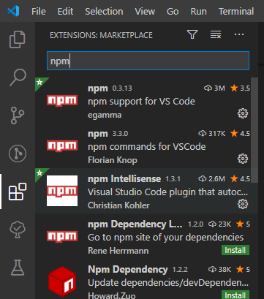

Figure : description