logoFCT_horiz.pdf

**Interacção Pessoa-Máquina**

**2020/2021**

**TMASK**

Stage 6: Evaluation results

and presentation of the final

**Realizado por: Lab class Nº** P2

41936, Samuel Robalo **Group Nº 13**

44592, Alexander Denisov

50654, Francisco Silva **Professor:**

51095, Daniel Dias Teresa Romão

December 10, 2020

**Heuristic Evaluation (pointed by group 12)**

|  |  |  |  |  |  |  |
| --- | --- | --- | --- | --- | --- | --- |
| Nº | Problem | Heuristic | Description | Severity | Solution | Screenshot |
| 1 | Navbar overrides the form header | **4.** Consistency and standards | In this form, and in the following ones, the positioning of the form appears off-center, and with other components preventing the visualization. In this case, the navbar is overlapping the top of the form. | 3 | 2.1 | Figure 1 |
| 2 | Absence of a stepper | **1.** Visibility of system status | During the elaboration of the form for choosing the mask profile, we do not have the idea of the timeline for filling out the form. | 2 | 2.2 | Figure 2 |
| 3 | Standard measures | **2.** Match the real world | When choosing the mask size, the SI measurement used is the centimeter. However, I may belong to a country where the standard mediation measure may be different. | 1 | 2.3 | Figure 3 |
| 4 | Buttons do not work | **3.** User control and Freedom | The 3 buttons for the edition of the Profile’s information does not work. | 3 | 2.4 | Figure 4 |
| 5 | The need to leave the page | **4.** Consistency and standards | Make a mask should be on the same page than the others. It makes the user take unnecessary steps by changing pages. | 2 | 2.5 | Figure 5 |
| 6 | Buttons should not exist | **4.** Consistency and standards | The user should see every mask and then apply filters if necessary. | 2 | 2.6 | Figure 6 |
| 7 | System status not perceptible | **1.** Visibility of system status | After click on “CATALOG” in not perceptible to understand if we are on “MADE BY TMASK TEAM” or “MADE BY COSTUMERS” tabs. | 1 | 2.7 | Figure 7 |
| 8 | Unknown term | **2.** Match the real world | While on “CART” the term “ME” is not familiar to user. | 1 | 2.8 | Figure 8 |
| 9 | Error message on Cart | **9.** Help users recognize, diagnose, and recover from errors | While on “CART” and user clicks on remove item button the system crashes without a suggested solution. | 3 | 2.9 | Figure 9 |
| 10 | Search feature is not responsive | **1.** Visibility of system status | While performing a search for an item, if the item searched is composed by two words, the search is not responsive (and does not work at all). | 3 | 2.10 | Figure 10 |
| 11 | Search feature does not implement any Keyboard accelerator | **7.** Flexibility & Efficiency of Use | While performing a search for an item, when the user is typing the respective term, identifying it, it is not available, any Keyboard accelerator (like Keyboard’s ENTER shortcut) to facilitate its use. | 1 | 2.11 | Figure 11 |
| 12 | Shopping Cart’s Information about the Form’s Fields are not useful | **1.** Visibility of system status | The system does not provide any useful information about the fields of the form related to the Shopping Cart (e.g., Facial Profile or Quantity of Masks). | 1 | 2.12 | Figure 12 |
| 13 | Shopping Cart’s Form is not responsive | **1.** Visibility of system status | While trying to update the field of Quantity, the Final Price does not update automatically, and it is not offered any option to the user to do it, manually. | 2 | 2.13 | Figure 13 |

**Solutions and screenshots**

For each problem and respective solution that we were given, we present our solution below.

# 2.1 Solution:

Reformulate the positioning of the canvas so that the form appears under the navbar.

****

Figure 1 Screenshot for problem #1

# Our solution:

We do not consider it a problem, on the contrary, it was implemented for this purpose.

The navbar is not always present, it appears or disappears depending on the user interaction.

When scrolling down, the bar disappears to maximize the view.

When scrolling up, you have the shortcuts available at the top of the page without having to go all the way up, increasing efficiency.

**2.2 Solutions:**

Implementation of a stepper so that the user knows the actual step and how many to the final.



Figure 2 Screenshot for problem #2

# Our solution:

We agree with the solution presented and implemented it, as it is represented in *Figure 2a*.



Figure 2a Screenshot of our solution for problem #2

# 2.3 Solutions:

When visiting the website for the first time, there could be a choice of language and standard measures.

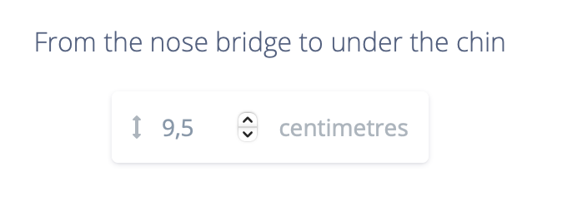

Figure 3 Screenshot for problem #3

# Our solution:

We agree with the solution presented but we did not implement it, as the effort vs benefit did not justify.

# 2.4 Solutions:

Enable button functionality.



Figure 4 Screenshot for problem #4

# Our solution:

We implemented the functionalities for the three buttons.

# 2.5 Solutions:

A button next to the existing ones.



Figure 5 Screenshot for problem #5

# Our solution:

We do not consider it a problem, as their functionality is not directly related. The user also has a fast access to this feature in the navigation bar.

# 2.6 Solutions:

Make this a filter on the search bar. Remove buttons.



Figure 6 Screenshot for problem #6

# Our solution:

We do not consider it a problem, as buttons are more intuitive to use for average user.

# 2.7 Solutions:

Mark the tab where the user is, as already happens after clicking the tab.



Figure 7 Screenshot for problem #7

# Our solution:

We agree with the solution presented and implemented it, as it is represented in *Figure 7a*.



Figure 7a Screenshot of our solution for problem #7

# 2.8 Solutions:

Use familiar terms to sizes such M or Medium.

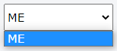

Figure 8 Screenshot for problem #8

# Our solution:

We do not consider it a problem, the term “ME” was given by the user when creating facial features for his account.

The usage of generic terms such as “Medium” goes against the objective of our project, which is to provide hygienic masks with customized dimensions so that they adapt well.

# 2.9 Solutions:

Offer users a solution, for example a shortcut that can solve the error immediately.



Figure 9 Screenshot for problem #9

# Our solution:

Fixed the issue that would cause the system to crash when attempting to remove an item from the cart.

# 2.10 Solutions:

Offer users a responsive search, supporting search of items, identifiable by more than word.

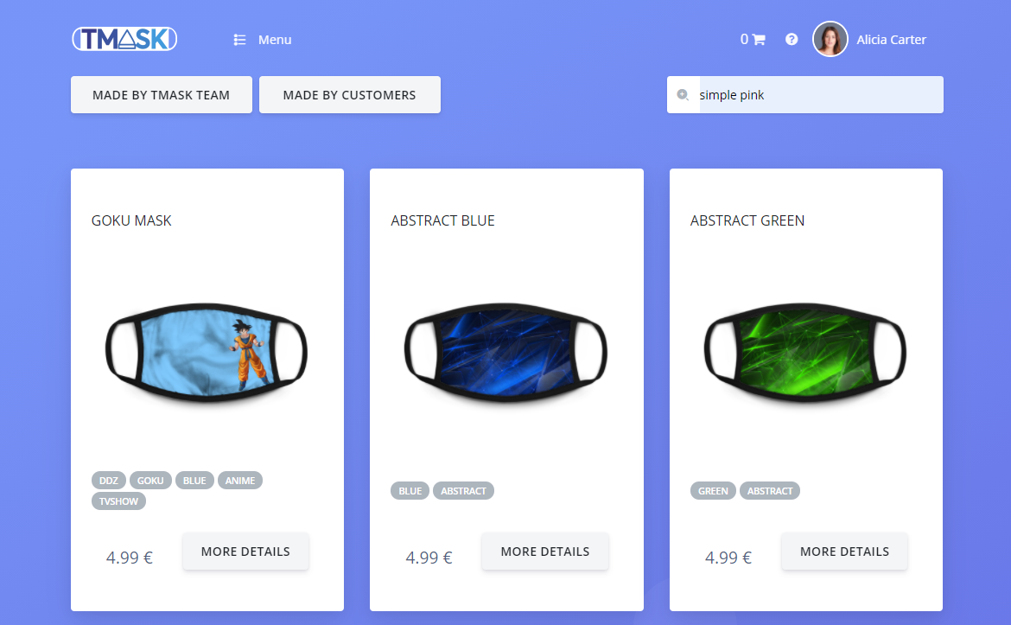

Figure 10 Screenshot for problem #10

# Our solution:

We agree with the solution presented and implemented it, as it is represented in *Figure 10a*.

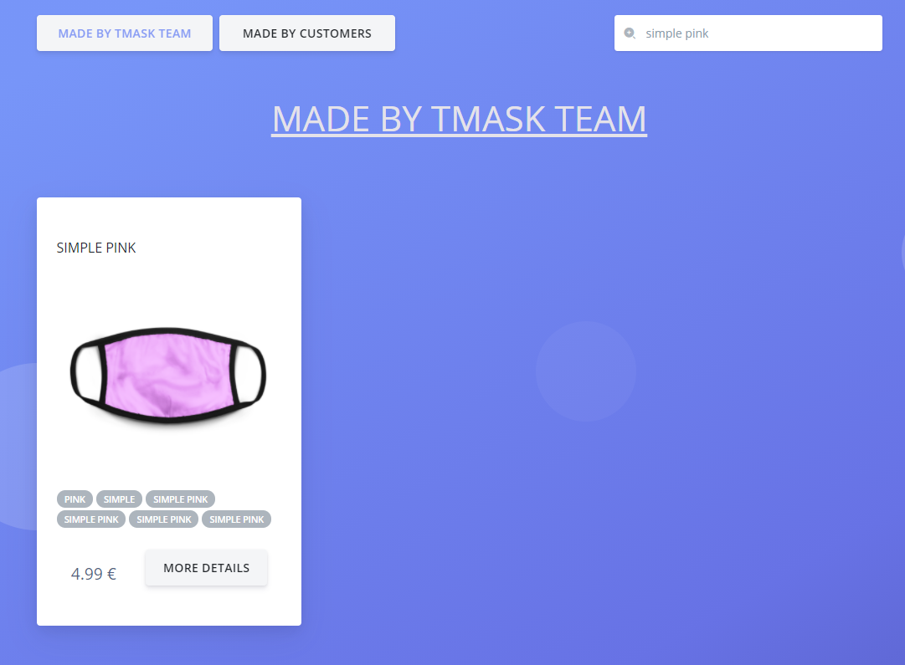

Figure 10a Screenshot of our solution for problem #10

# 2.11 Solutions:

Offer users some flexibility and efficiency of use on the search feature, providing a Keyboard accelerator, when the terms pretended to be searched (Keyboard’s ENTER as a shortcut, per example).



Figure 11 Screenshot for problem #11

# Our solution:

We agree with the solution presented but we did not implement it, as the effort vs benefit did not justify.

# 2.12 Solutions:

Offer users some information feedback about the fields of the form of the Shopping Cart needed to be fulfilled (e.g., Price, Mask Profile and Quantity of Masks).

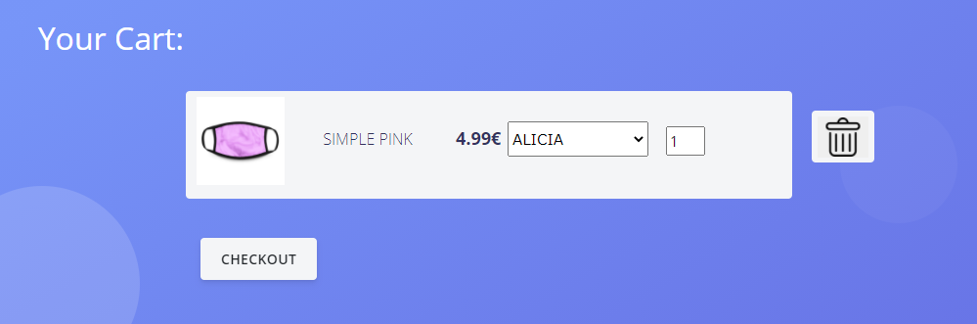

Figure 12 Screenshot for problem #12

# Our solution:

Added a question mark icon with popup, clarifying that the form is related to the Facial features. Also added a dynamic value, showing the total cost of a specific Item set.

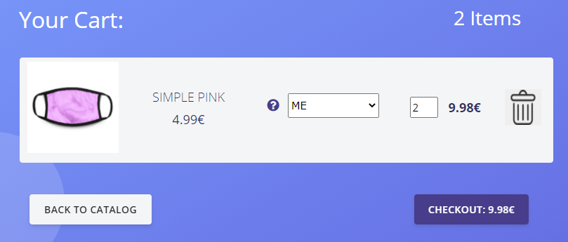

Figure 12a Screenshot for our solution to problem #12

# 2.13 Solutions:

Offer users some information feedback about the Final Price of an item, by updating that Final Price automatically.

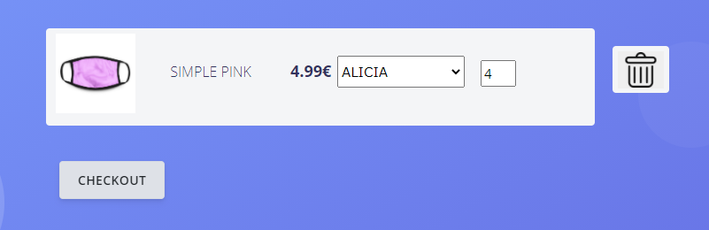

Figure 13 Screenshot for problem #13

# Our solution:

Added the final cost of the purchase to the checkout section. This value is responsive, and updates itself as the amount changes.

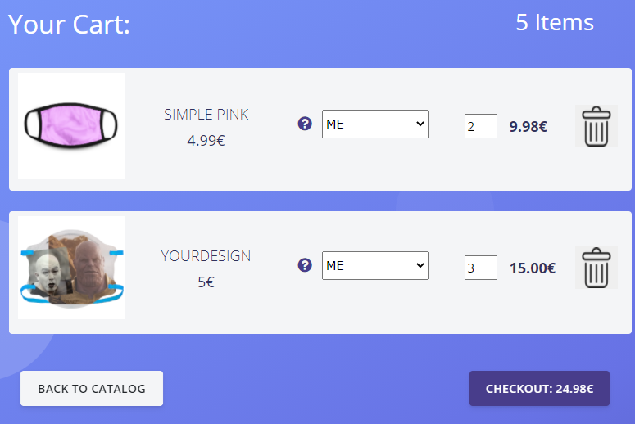

Figure 13a Screenshot for our solution to problem #13