PPspliT for MacOS

U

ntil a few years ago, the development of PowerPoint for Windows and PowerPoint for MacOS was carried out using a different set of libraries, causing a gap in the available features and making some add‑ins incompatible across the two branches. This lasted until Office 2011 for MacOS was followed by Office 2016: at that point Microsoft finalized a significant effort to port most of the libraries and functions across the two platforms, leaping forward on the development of Office for MacOS and making PowerPoint for Windows and PowerPoint for MacOS impressively close to each other in terms of functions and VBA programming interface.

As of today this gap can be considered filled up to the point that the same code of PPspliT has been reported to work in a comparable base of cases on PowerPoint for Windows and PowerPoint for MacOS.

# Installation instructions

PPspliT for MacOS is made conveniently available in the form of a .dmg image file. However, security restrictions introduced in recent releases of MacOS (mostly Catalina), may make the installation process a little less convenient: hence the reason for these instructions.

*Note*: despite the number of issued warnings, the installer performs only 2 non‑intrusive actions on your system: 1) copying a file to a path in the user’s home directory and 2) activating the add‑in inside PowerPoint.

To install PPspliT for PowerPoint for MacOS you can proceed as follows:

* Download PPspliT.dmg from my web site.
* Double click on the PPspliT.dmg file to open it in the Finder. A window should pop up containing the “Install PPspliT.app” application bundle.
* Double click on “Install PPspliT.app” to start the PPspliT installer. At this point a security prompt may warn you about the fact that the installer has not been signed, preventing it from continuing the setup process:   
  Immagine che contiene screenshot

  Descrizione generata automaticamenteClick on “Cancel”.
* Immagine che contiene screenshot

  Descrizione generata automaticamenteOpen MacOS “System Preferences” and access the “Security and Privacy” panel.
* Immagine che contiene screenshot

  Descrizione generata automaticamenteMake sure the “General” tab is selected and that the “Allow apps downloaded from” selector is set to “Anywhere” or, in case this is unavailable, to “App Store and identified developers”:  
  Right below this selector you may see a warning stating that application “Install PPspliT.app” has been blocked because it does not come from an identified developer. This is actually true, but there is nothing really dangerous in starting this application anyway.   
  Therefore, just click on “Open anyway”.
* Immagine che contiene screenshot

  Descrizione generata automaticamenteAt this point the installer should successfully start:
* As indicated in the first dialog box, further security restrictions on MacOS require that you accept a few security prompts that may come out during the installation process. For example:   
  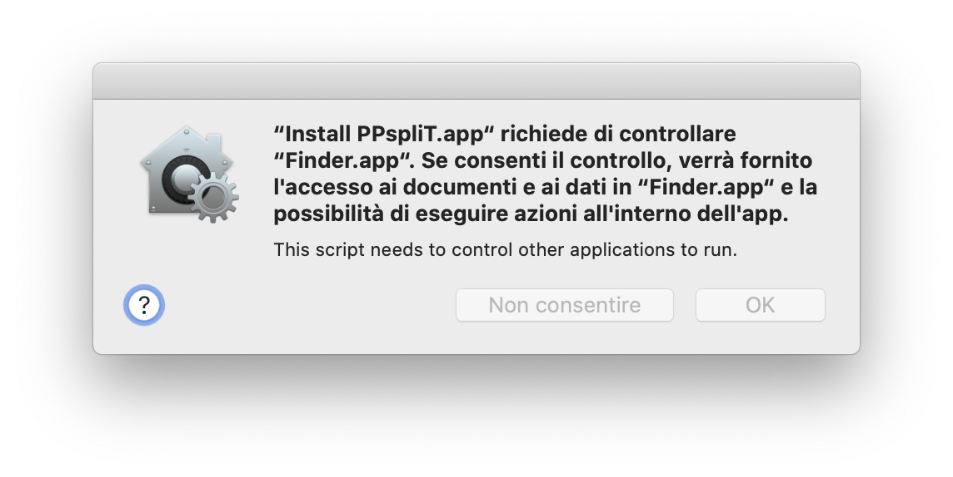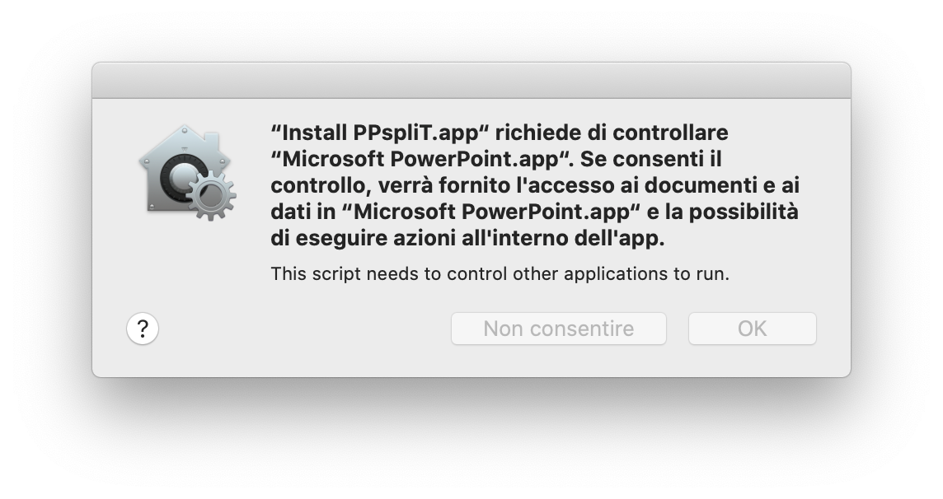  
    
  Please accept all these security prompts, as the installer would not be able to proceed otherwise.
* Immagine che contiene screenshot

  Descrizione generata automaticamenteImmagine che contiene screenshot

  Descrizione generata automaticamenteThe following window confirms that the installation has been successfully completed:   
  As a result, the PPspliT toolbar should be immediately available in PowerPoint (a restart should not be required):   
    
  Please notice that the add‑in does not provide any entries in the MacOS top menu bar: just a tab in the ribbon. Especially if you have many tabs displayed and the PowerPoint window is not large enough, you may need to click on the double arrow at the right of the ribbon tab bar to reveal the PPspliT entry (see the above picture).

# Uninstallation instructions

The PPspliT installer makes use of the AppleScript automation facility. Unfortunately, while an interface is exposed by PowerPoint to register new add‑ins through AppleScript, the same does not apply for de‑registration. Therefore, uninstallation of PPspliT on MacOS must be performed manually.

However, it is a fairly simple process:

* 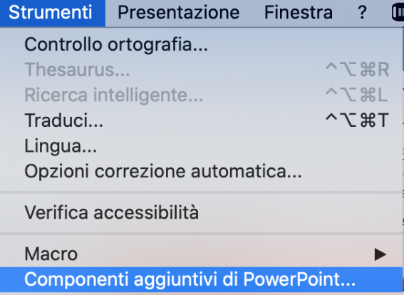Start PowerPoint and, from the top menu, select “Tools”à”Add‑Ins…”:
* 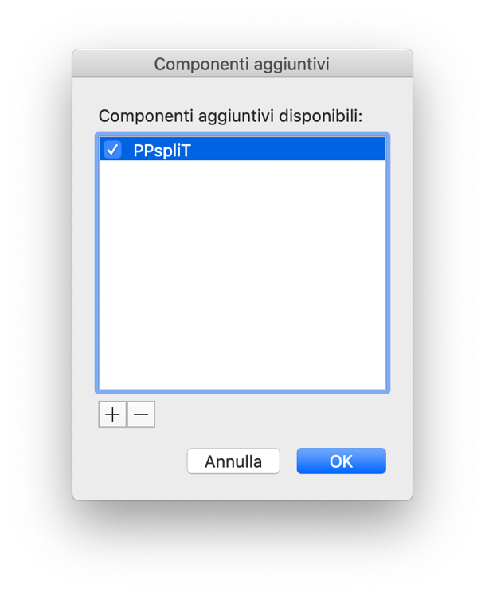Select “PPspliT” in the list and click on the minus “–“ button below:
* Open the “Terminal” application of MacOS and type the following command:   
    
  rm ~/Library/Group\ Containers/UBF8T346G9.Office/PPspliT.ppam