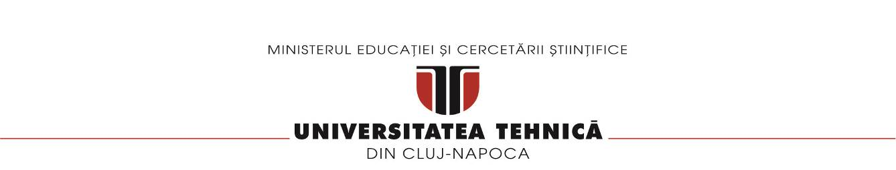

**Facultatea de Automatica si Calculatoare**

**Sectia Calculatoare**

**Polynomial curve fitting using Least Squares algorithm**

**Documentation**

Zilai Denis

Grupa 30244; Anul 4, sem 1

SRF

Contents

1. Introduction 3

2. Defining terms and the problem 3

3. Theoretical description of the method 3

4. Implementation description 3

5. Evaluation and results 4

6. Conclusions 6

# Introduction

The purpose of this project is to fit a 3rd grade polynomial curve on a list of 2D points.

# Defining terms and the problem

A polynomial curve is a curve that can be parametrized by polynomial functions of R[x], so it is a special case of rational curve. Therefore, any polynomial curve is an algebraic curve of degree equal to the higher degree of the above polynomials P and Q of a proper representation.

# Theoretical description of the method

The solution of this problem can be reached by following the steps:

* A list of 2D points is given
* The Least Squares Regression method is used to find the parameters of the curve. The least squares method is a statistical procedure to find the best fit for a set of data points by minimizing the sum of the offsets or residuals of points from the plotted curve. Least squares regression is **used to predict the behavior of dependent variables**.
* The error is computed

# Implementation description

The following functions have been used and implemented:

* get_system_of_equations(x, y, n): this function computes the sum of x based on the equation: 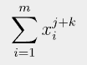

and the product of the values x and y based on the equation:

* find_error(y, fn): this function computes the error based on the function evaluation:

* fn(x, a): this function evaluates the P(x) equation
* main(): in the main class, the functions mentioned above are used to solve the system of equations:

,

to print the solutions of those equations, to compute the P(x) error, to print the points and to print the curve approximation

The most difficult part of the code was determining the solutions to the equation, as attention was required to correctly put into code, the given equations and sums.

# Evaluation and results

The solution has been tested on two datasets, presented through the following snippets.

In the following snippet, the system of equations is computed, those being the results that were later processed to extract the solutions.

The next snippet presents the solutions to the equations:

And finally, the computed error:





And of course, the final snippet, the curve approximation, using the plot() function offered by Python:

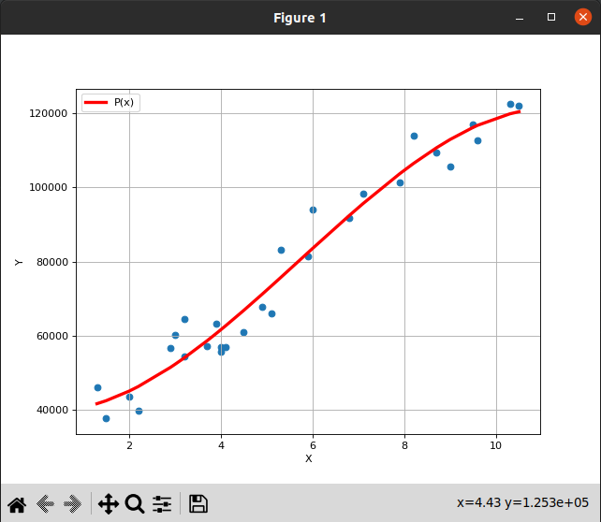

# Conclusions

This project was a little bit of a challenge, regarding the mathematical part, but the result is satisfactory, as the approximation of the curve is more or less accurate. Through this project, I also exercised the Python language, and an interesting algorithm which I will put to use in my next Image Processing projects.