GWAS Analysis Report

Table of Contents

# Introduction

This report presents the results of a genome-wide association study (GWAS) analysis.

run this in terminal in the resutys folder first:

for file in *.pdf; do convert "${file}" "${file%.pdf}.png"; done

# GWAS Results

The filtered GWAS results are provided in the following CSV file:

| SNP | Chr | Pos | P.value | MAF | traits |
| --- | --- | --- | --- | --- | --- |
| S10_1438611 | 10 | 1438611 | 8e-07 | 0.3356113 | FarmCPU.Area_inhibition |
| S2_3666681 | 2 | 3666681 | 6e-07 | 0.4423658 | FarmCPU.Ratio_inhibition |
| S10_1438611 | 10 | 1438611 | 9e-07 | 0.3356113 | FarmCPU.Percentage_inhibition |
| S2_395257 | 2 | 395257 | 0e+00 | 0.4081633 | BLINK.Area_inhibition |
| S2_3666681 | 2 | 3666681 | 0e+00 | 0.4423658 | BLINK.Area_inhibition |
| S4_110986 | 4 | 110986 | 0e+00 | 0.3404941 | BLINK.Area_inhibition |
| S10_1438611 | 10 | 1438611 | 0e+00 | 0.3356113 | BLINK.Area_inhibition |
| S2_3666681 | 2 | 3666681 | 0e+00 | 0.4423658 | BLINK.Ratio_inhibition |
| S2_395257 | 2 | 395257 | 0e+00 | 0.4081633 | BLINK.Percentage_inhibition |
| S2_3666681 | 2 | 3666681 | 0e+00 | 0.4423658 | BLINK.Percentage_inhibition |
| S4_110986 | 4 | 110986 | 0e+00 | 0.3404941 | BLINK.Percentage_inhibition |
| S10_1438611 | 10 | 1438611 | 0e+00 | 0.3356113 | BLINK.Percentage_inhibition |

# Manhattan Plots

## BLINK

### Area Inhibition

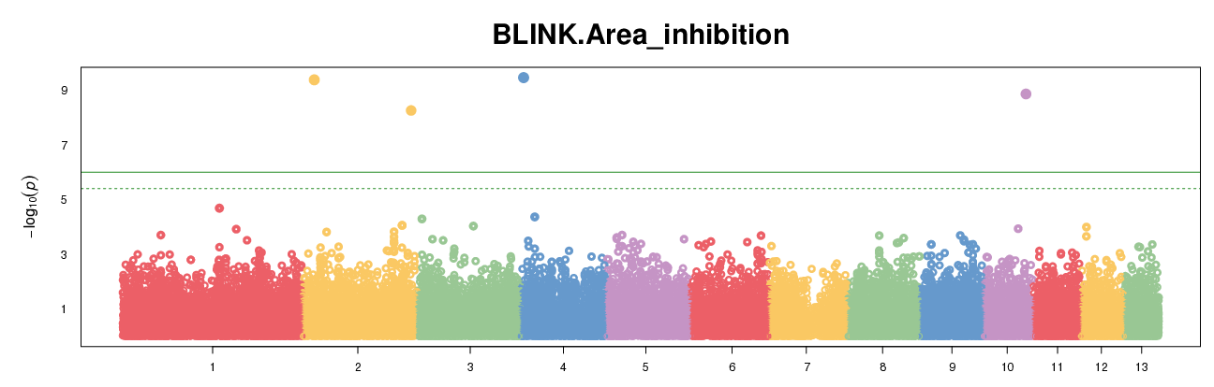

Manhattan Plot for BLINK Area Inhibition

### Growth Endophyte

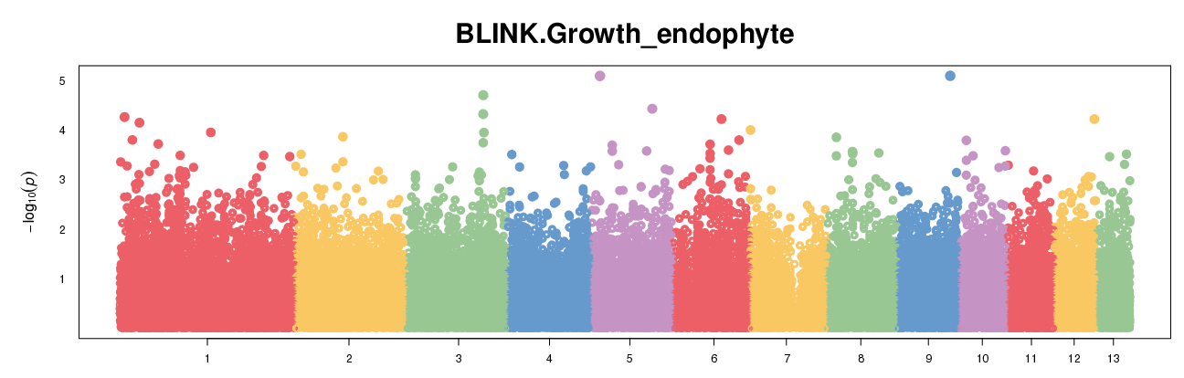

Manhattan Plot for BLINK Growth Endophyte

### Percentage Inhibition

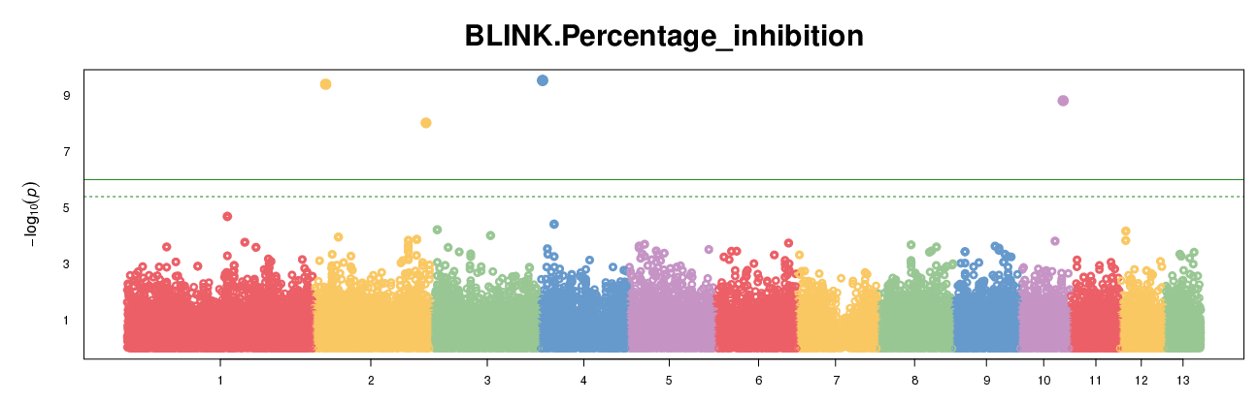

Manhattan Plot for BLINK Percentage Inhibition

### Radius Inhibition

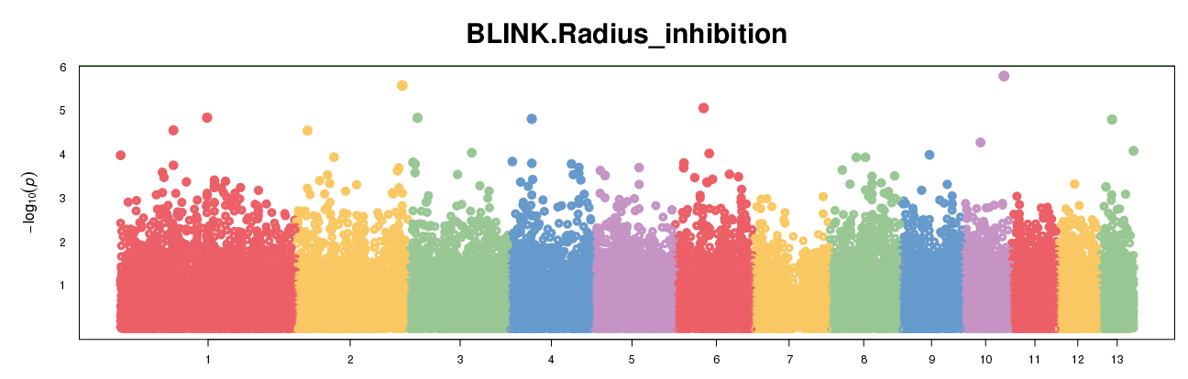

Manhattan Plot for BLINK Radius Inhibition

### Ratio Inhibition

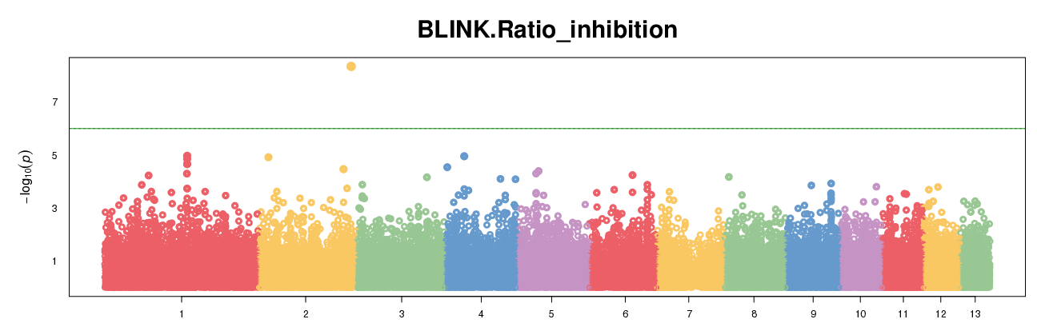

Manhattan Plot for BLINK Ratio Inhibition

## FarmCPU

### Area Inhibition

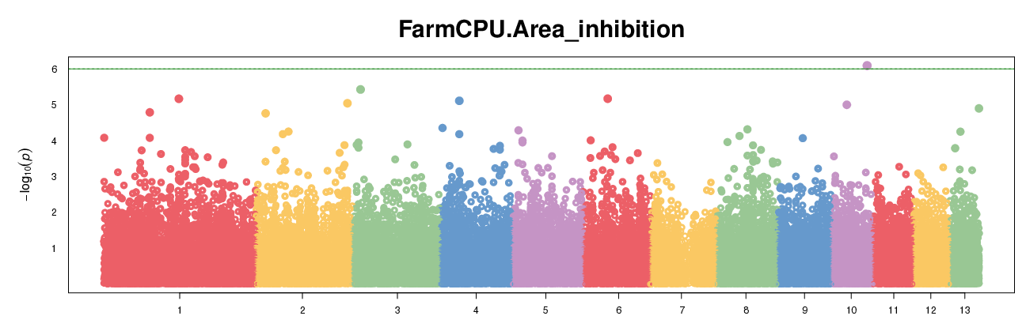

Manhattan Plot for FarmCPU Area Inhibition

### Growth Endophyte

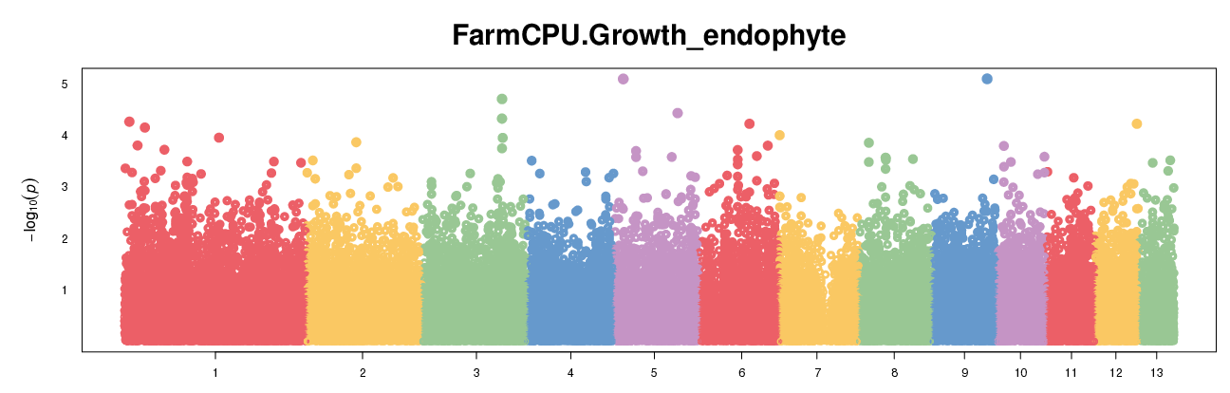

Manhattan Plot for FarmCPU Growth Endophyte

### Percentage Inhibition

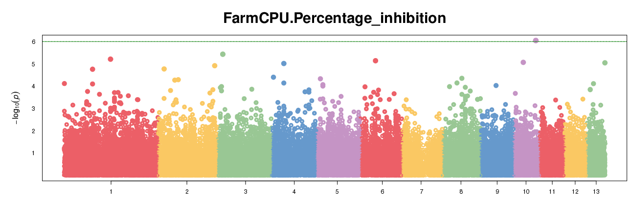

Manhattan Plot for FarmCPU Percentage Inhibition

### Radius Inhibition

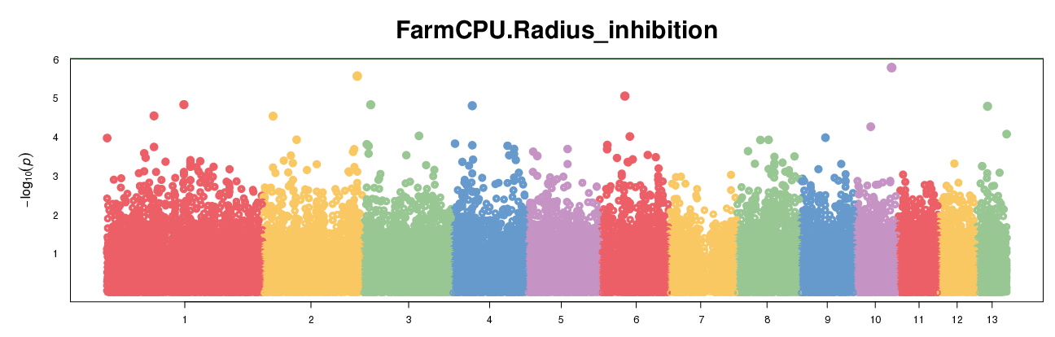

Manhattan Plot for FarmCPU Radius Inhibition

### Ratio Inhibition

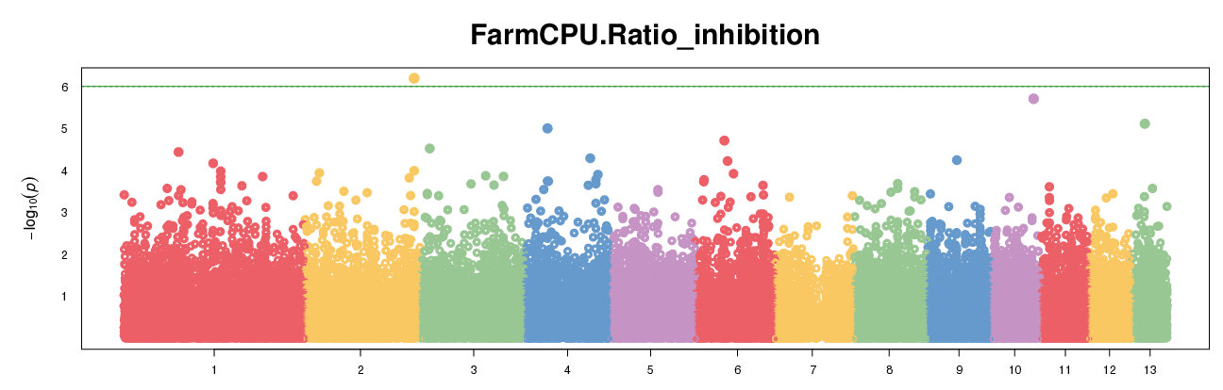

Manhattan Plot for FarmCPU Ratio Inhibition

# Symphysic

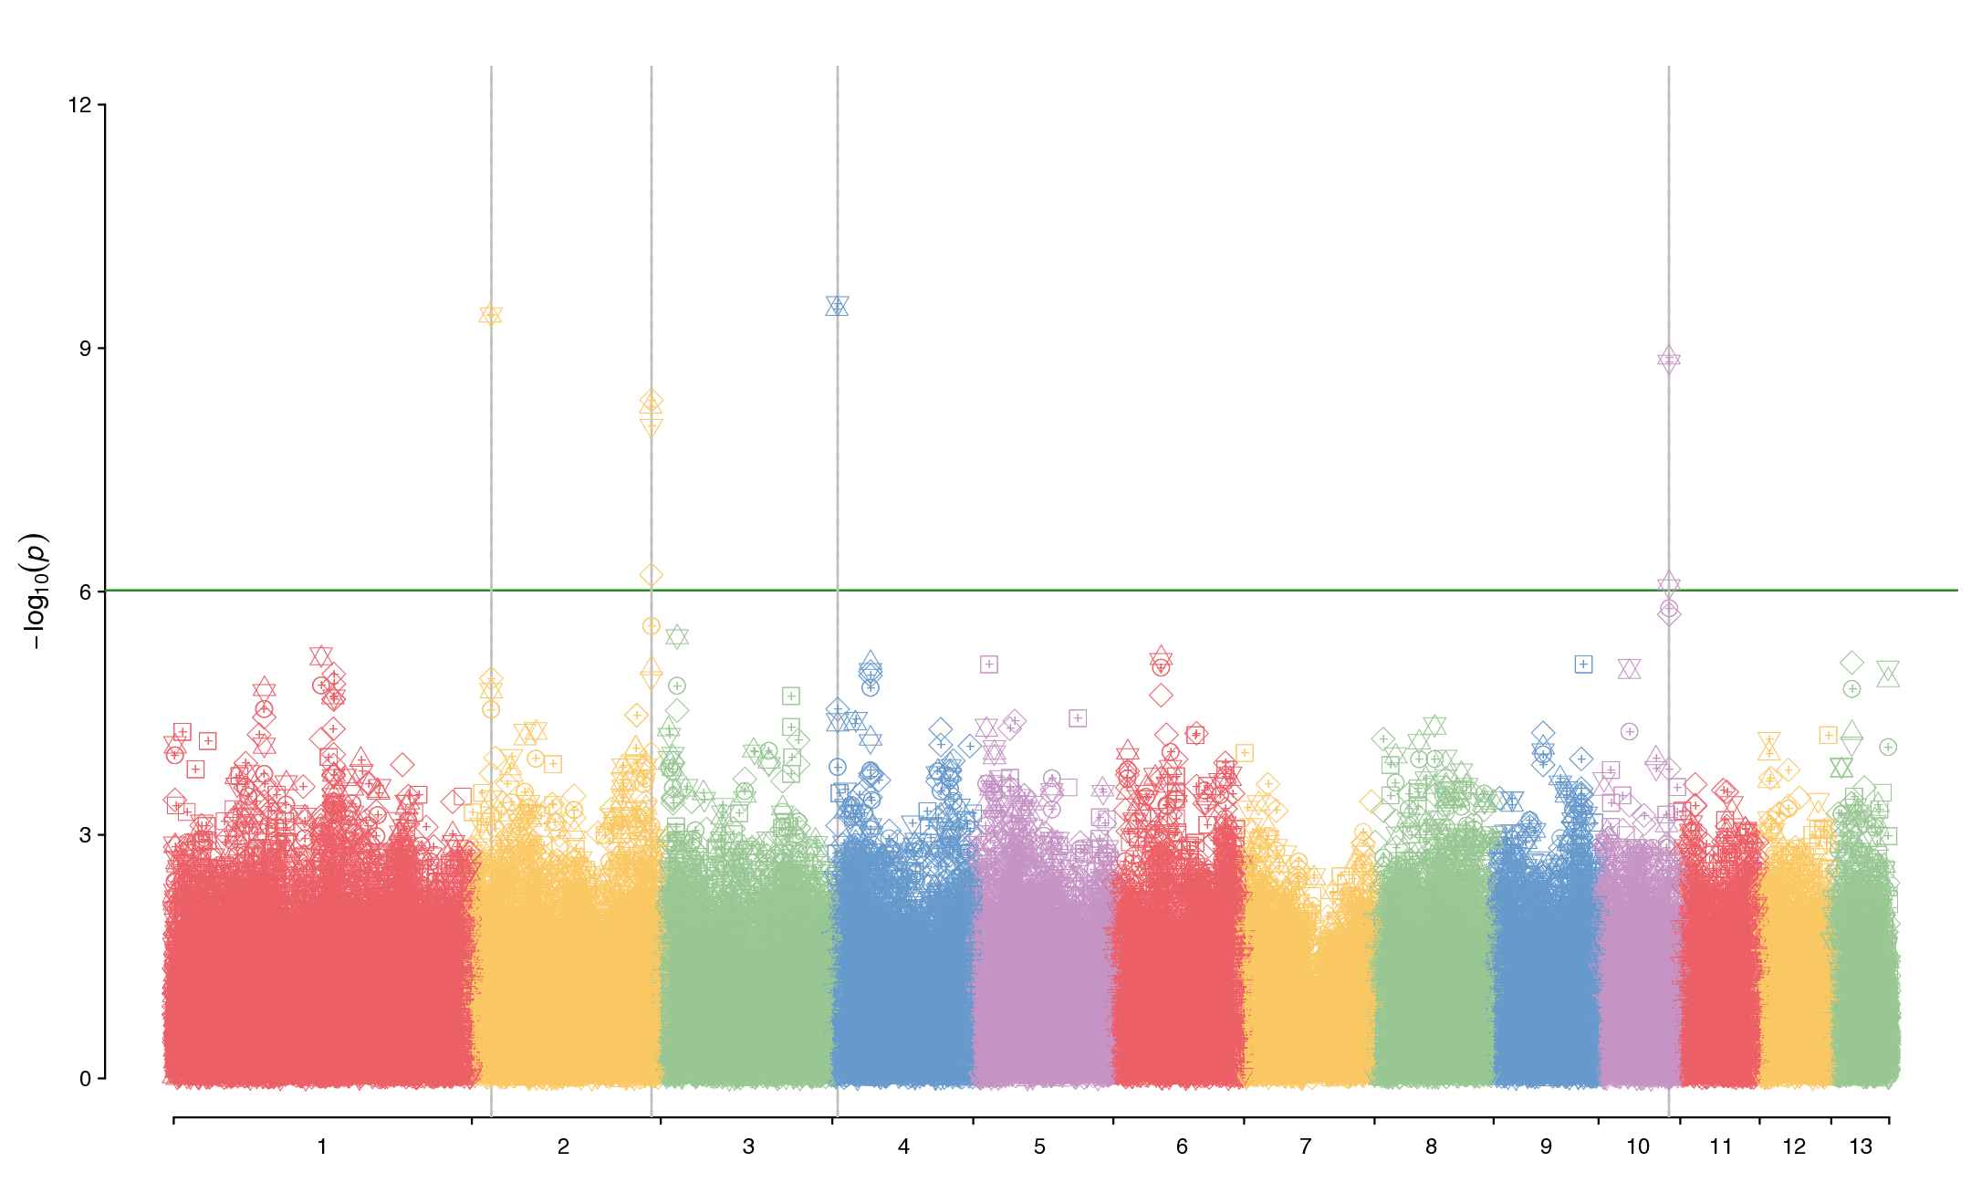

Manhattan Plot for Symphysic

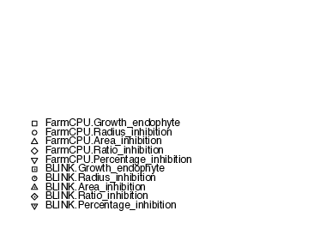

Legend for Symphysic Manhattan Plot

# QQ Plots

## BLINK

### Area Inhibition

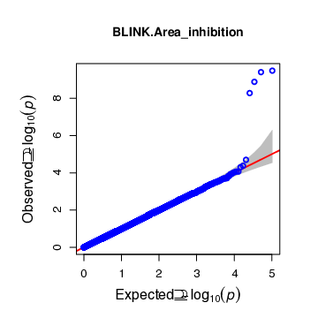

QQ Plot for BLINK Area Inhibition

### Growth Endophyte

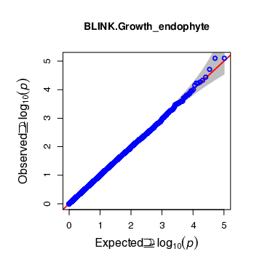

QQ Plot for BLINK Growth Endophyte

### Percentage Inhibition

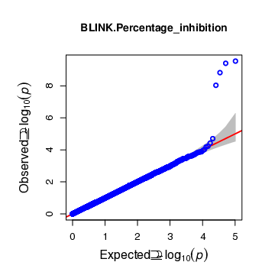

QQ Plot for BLINK Percentage Inhibition

### Radius Inhibition

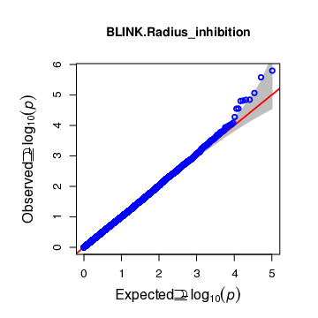

QQ Plot for BLINK Radius Inhibition

### Ratio Inhibition

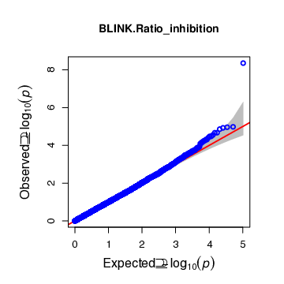

QQ Plot for BLINK Ratio Inhibition

## FarmCPU

### Area Inhibition

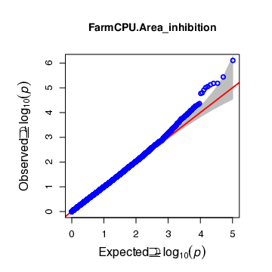

QQ Plot for FarmCPU Area Inhibition

### Growth Endophyte

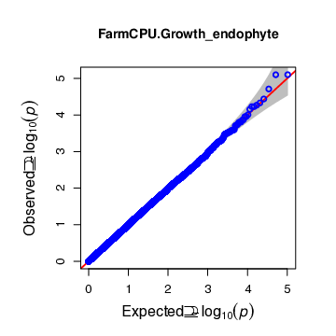

QQ Plot for FarmCPU Growth Endophyte

### Percentage Inhibition

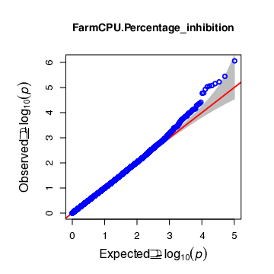

QQ Plot for FarmCPU Percentage Inhibition

### Radius Inhibition

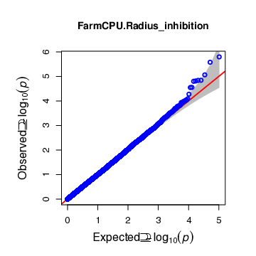

QQ Plot for FarmCPU Radius Inhibition

### Ratio Inhibition

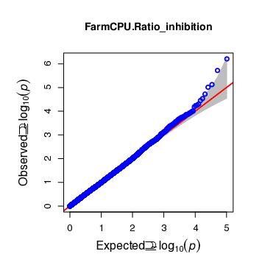

QQ Plot for FarmCPU Ratio Inhibition

# Genotype Plots

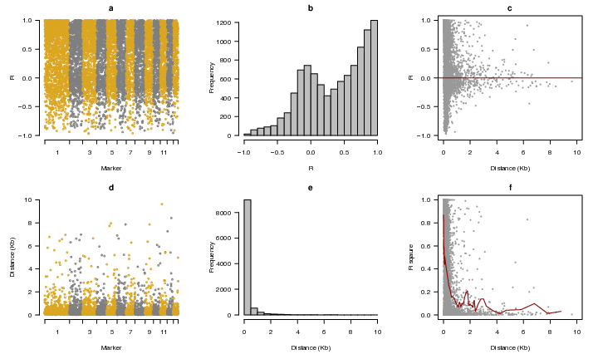

Distance R Chro

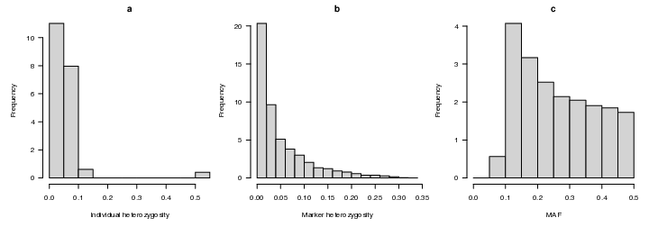

Frequency

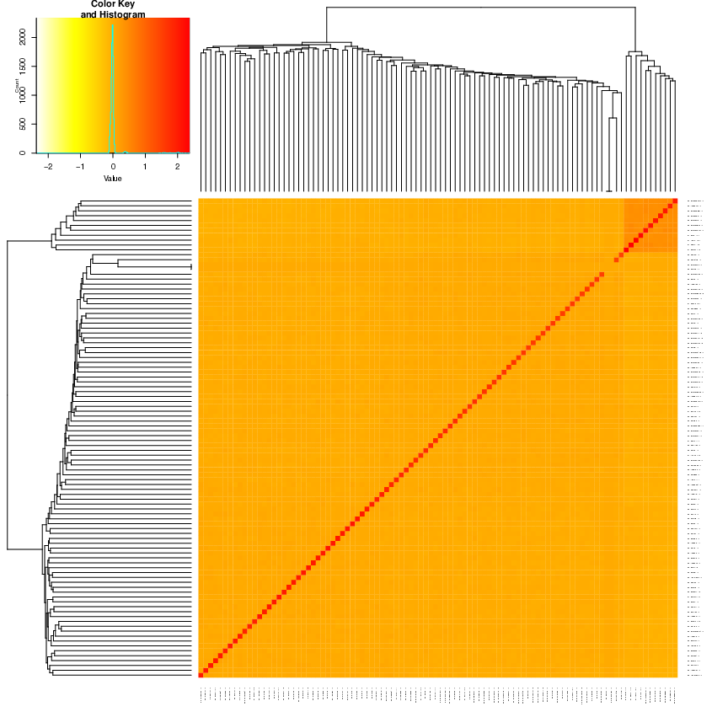

Kin thirdPart

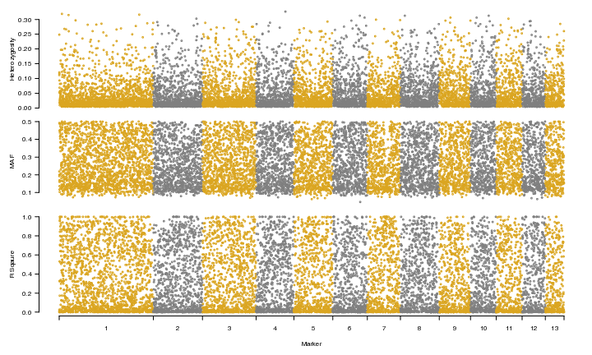

MAF Heterozosity

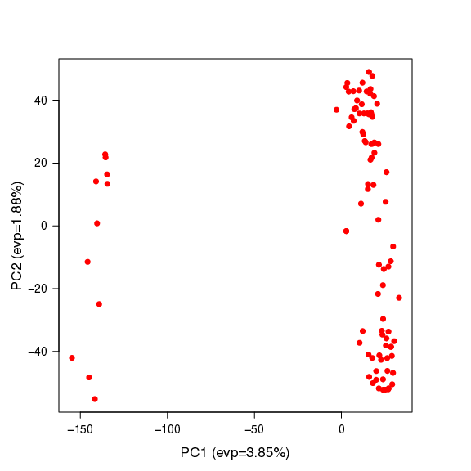

PCA 2D

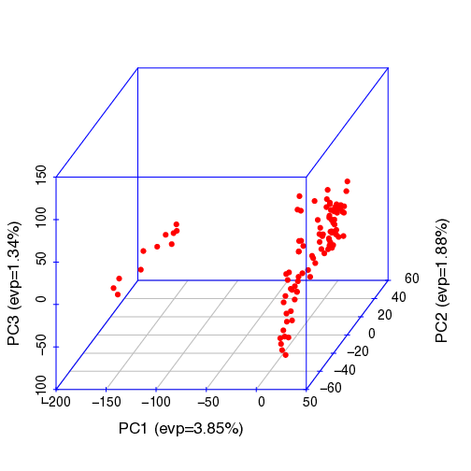

PCA 3D

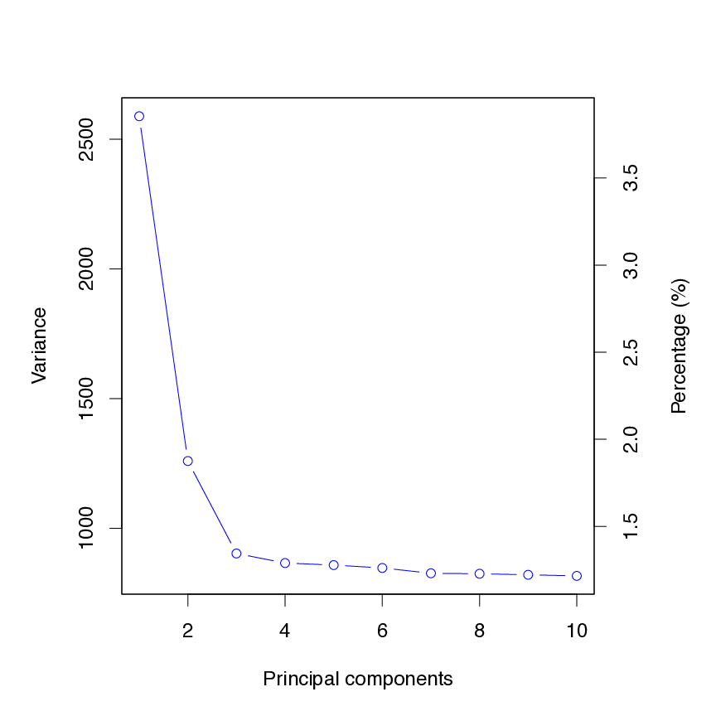

PCA eigenValue

# Phenotype Plots

## Distribution of Significant Markers

### BLINK

#### Ratio Inhibition

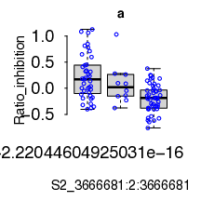

Distribution of Significant Markers for BLINK Ratio Inhibition

### FarmCPU

#### Ratio Inhibition

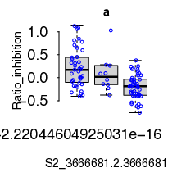

Distribution of Significant Markers for FarmCPU Ratio Inhibition

## View

### Area Inhibition

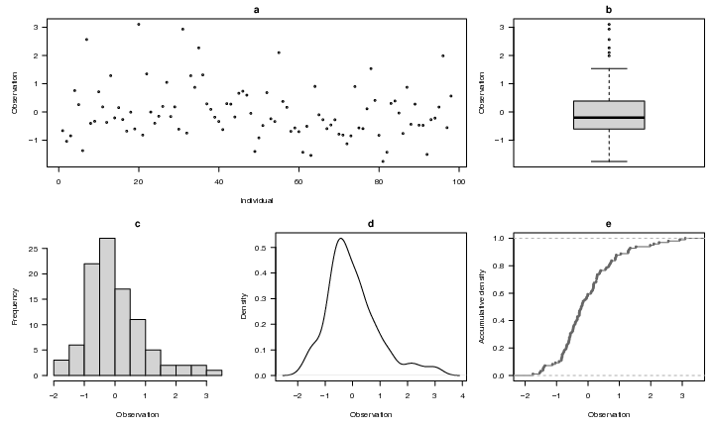

View of Area Inhibition

### Growth Endophyte

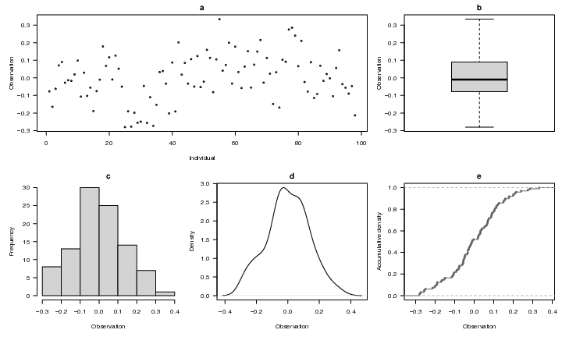

View of Growth Endophyte

### Percentage Inhibition

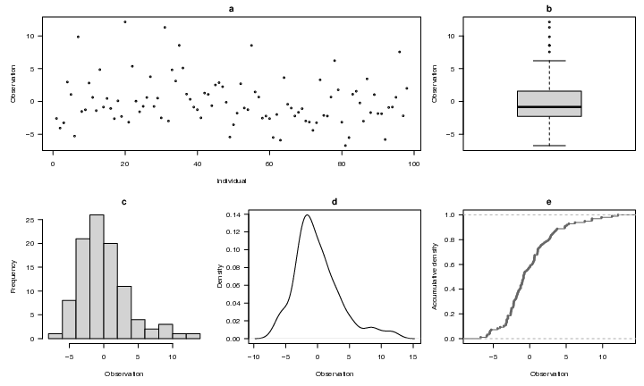

View of Percentage Inhibition

### Radius Inhibition

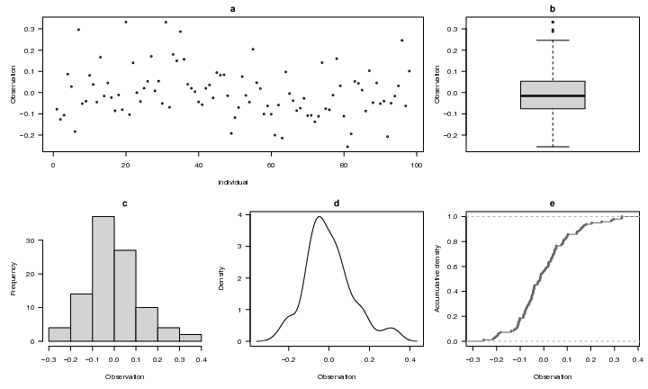

View of Radius Inhibition

### Ratio Inhibition

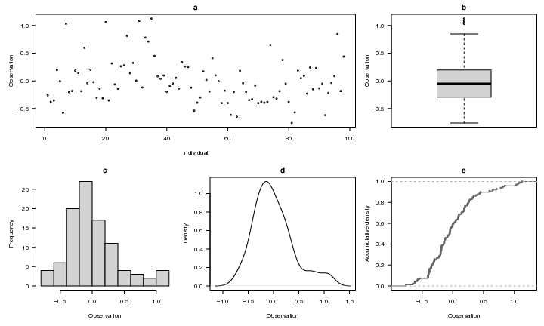

View of Ratio Inhibition