DOKUZ EYLUL UNIVERSITY
ENGINEERING FACULTY
DEPARTMENT OF COMPUTER ENGINEERING

CME 2201
REPORT
Assignment 1

INVERTED INDEX BY USING HASH TABLES

by
Deniz ALBAYRAK 2017510007

Lecturers
ZERRİN IŞIK
ALTUĞ YİĞİT

IZMIR
15.11.2019

PROGRESS DESCRIPTION

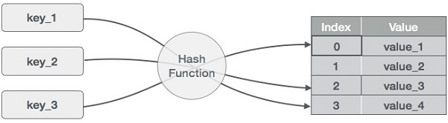

In this project we need to use Hash Table. Hash Table is a data structure which stores data in an associative manner. In a hash table, data is stored in an array format, where each data value has its own unique index value. Access of data becomes very fast if we know the index of the desired data.

Load Factor | Hash Function |  | Collision Handling |  | Collision Count |  | Indexing Time |  | Avg. Search Time |  | Min. Search Time | Max. Search Time
α=50% |  | SSF |  | LP |  | 378751 |  | 34.1640 |  | 1 | 3 | 16
 |  |  |  | DH |  | - |  | - |  | - | - | -
 |  | PAF |  | LP |  | 378751 |  | 45.143 |  | 0 | 0 | 16
 |  |  |  | DH |  | - |  | - |  | - | - | -
α=80% |  | SSF |  | LP |  | 378751 |  | 47.895 |  | 0 | 0 | 2
 |  |  |  | DH |  | - |  | - |  | - | - | -
 |  | PAF |  | LP |  | 378751 |  | 48.004 |  | 0 | 0 | 2
 |  |  |  | DH |  | - |  | - |  | - | - | -

The program can read all txt files and placed in the hash table perfectly but the other functions are not working very well. It was good in the beggining but the and of the project everything were mixed up.

