**DOKUZ EYLUL UNIVERSITY**

**ENGINEERING FACULTY**

**DEPARTMENT OF COMPUTER ENGINEERING**

**FINAL REPORT**

**PROJECT – 2**

**Project:**  **Journey Planner for Izmir Public Transportation  
  
  
by  
Deniz ALBAYRAK 2017510007  
  
  
  
  
IZMIR  
  
22.12.2019**

**Progress Description**

A journey planner (or trip planner) is a specialized electronic search engine that finds one or more journey (trip) suggestions between an origin and a destination. This system assists travelers for planning their journey.

I have 8 classes.

**Bus name** class has 4 values LineID, LineNo, Name,VehicleTypeID.

**Distance** class has 4 values key, OriginstopID,DestinationstopID,Distance.

**Edge** class has 4 values source, destination, weight, busname.

**Line** class has 5 values key, LineID, Direction, Order, StopID.

**Vertex** class has 4 values StationID, StationName, VehicleTypeID, Neighboors.

**Graph** class has 5 HashMap, print and addEdge commend.

**Dijkstra** class has all algorithm that calculating ways. In previous pages there is some codes from this class.

And there is **test** class that has main. In that class all txt files were reading. For reading txt files, I used BufferedReader.

I’ve should consider two optimization criteria: ***fewer stops*** and ***minimum distance***.

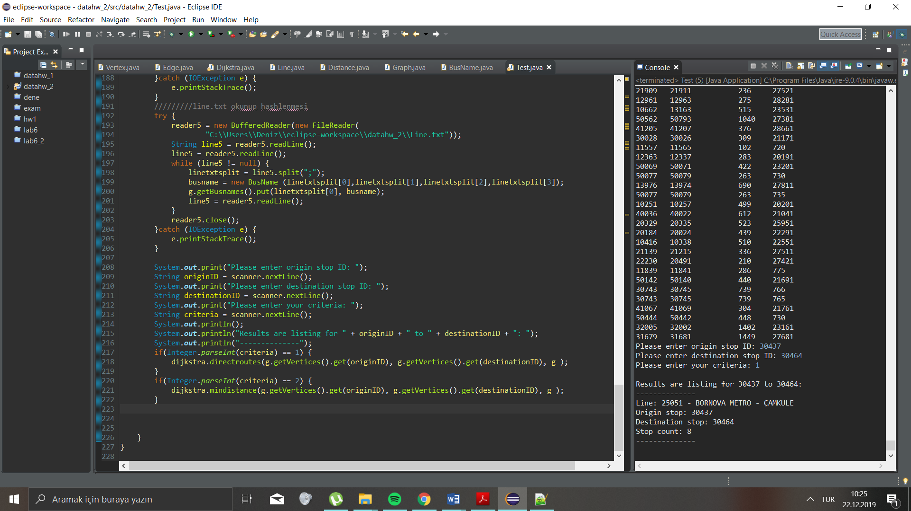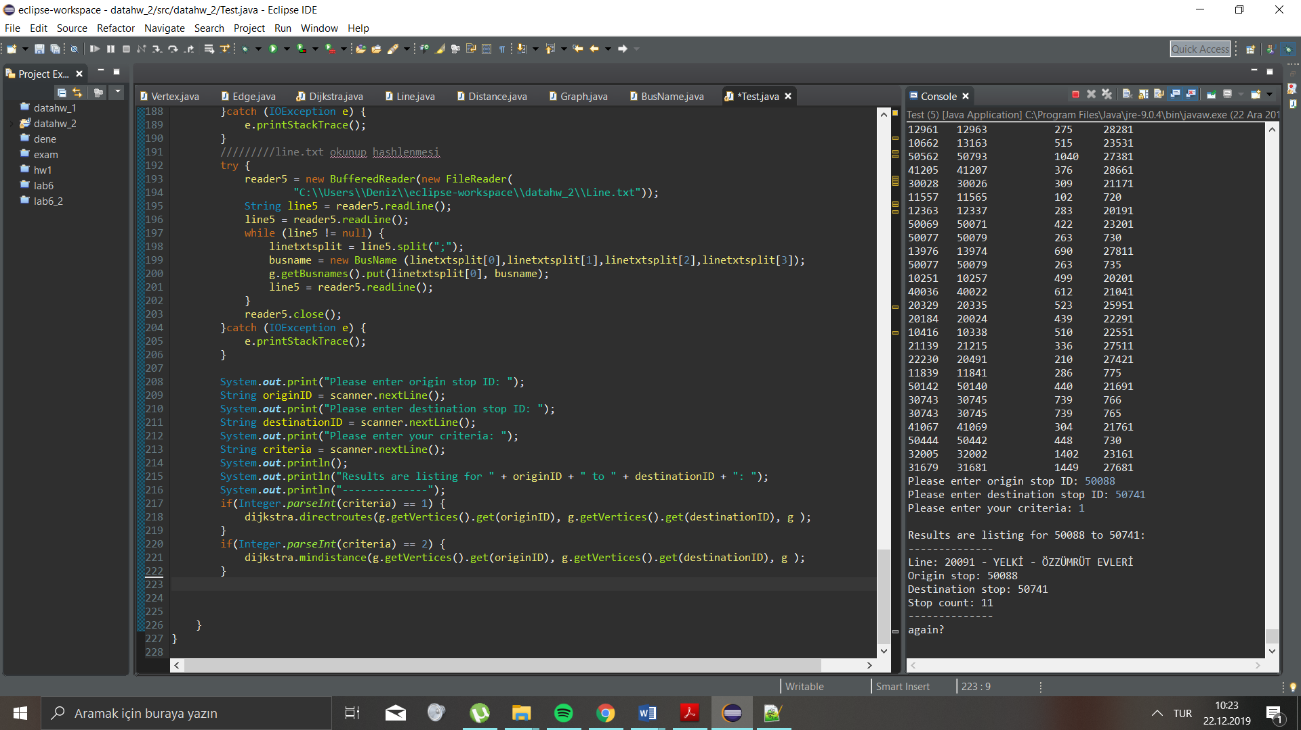Without transfer, my program is working for one way line for fewer stops. Examples;  
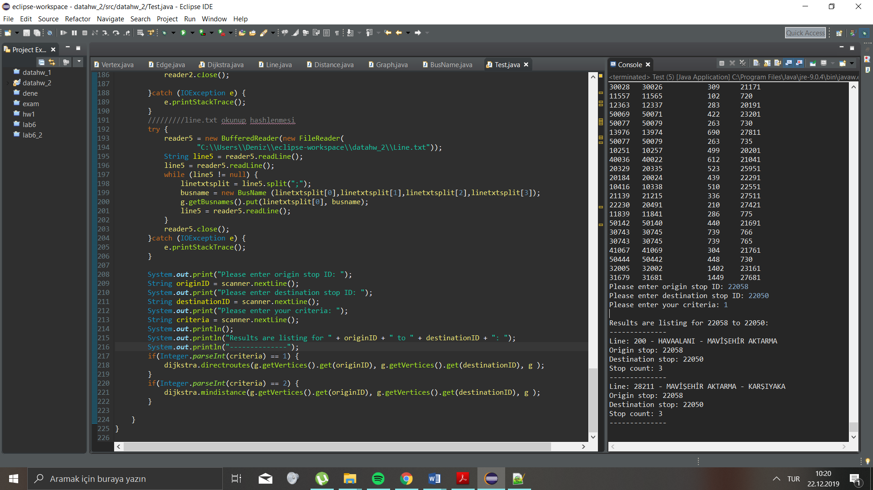

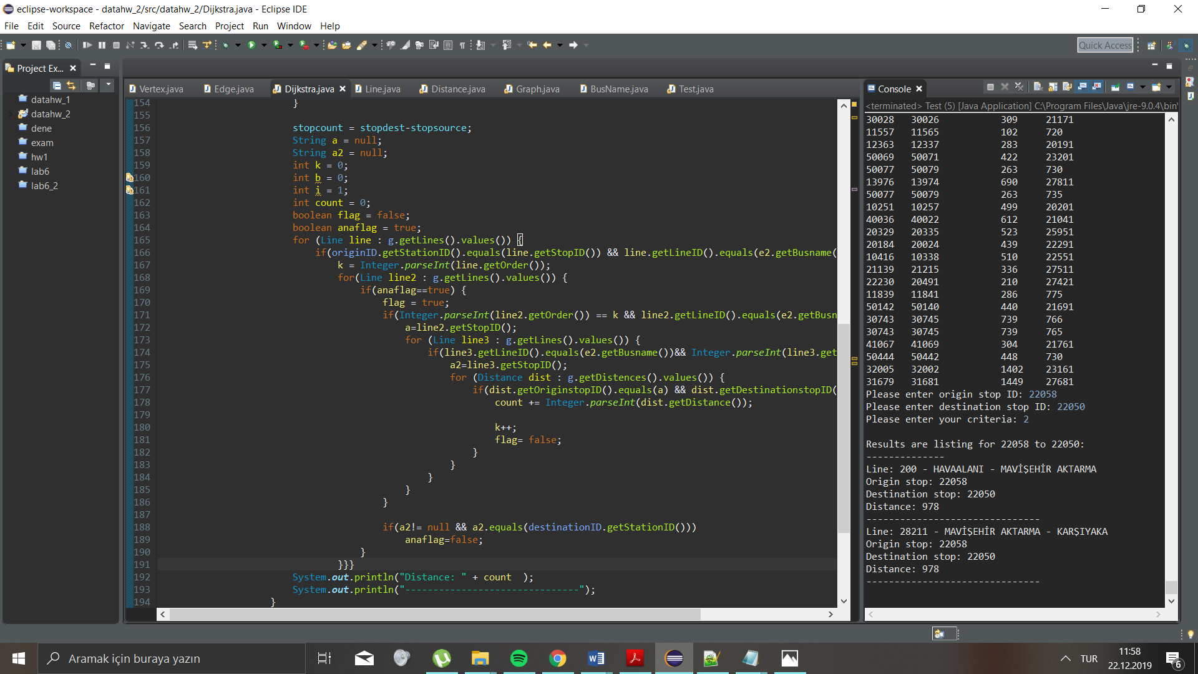Without transfer, my program is working for one way line for minimum distances. Example;

I have a small code for fewer stops. 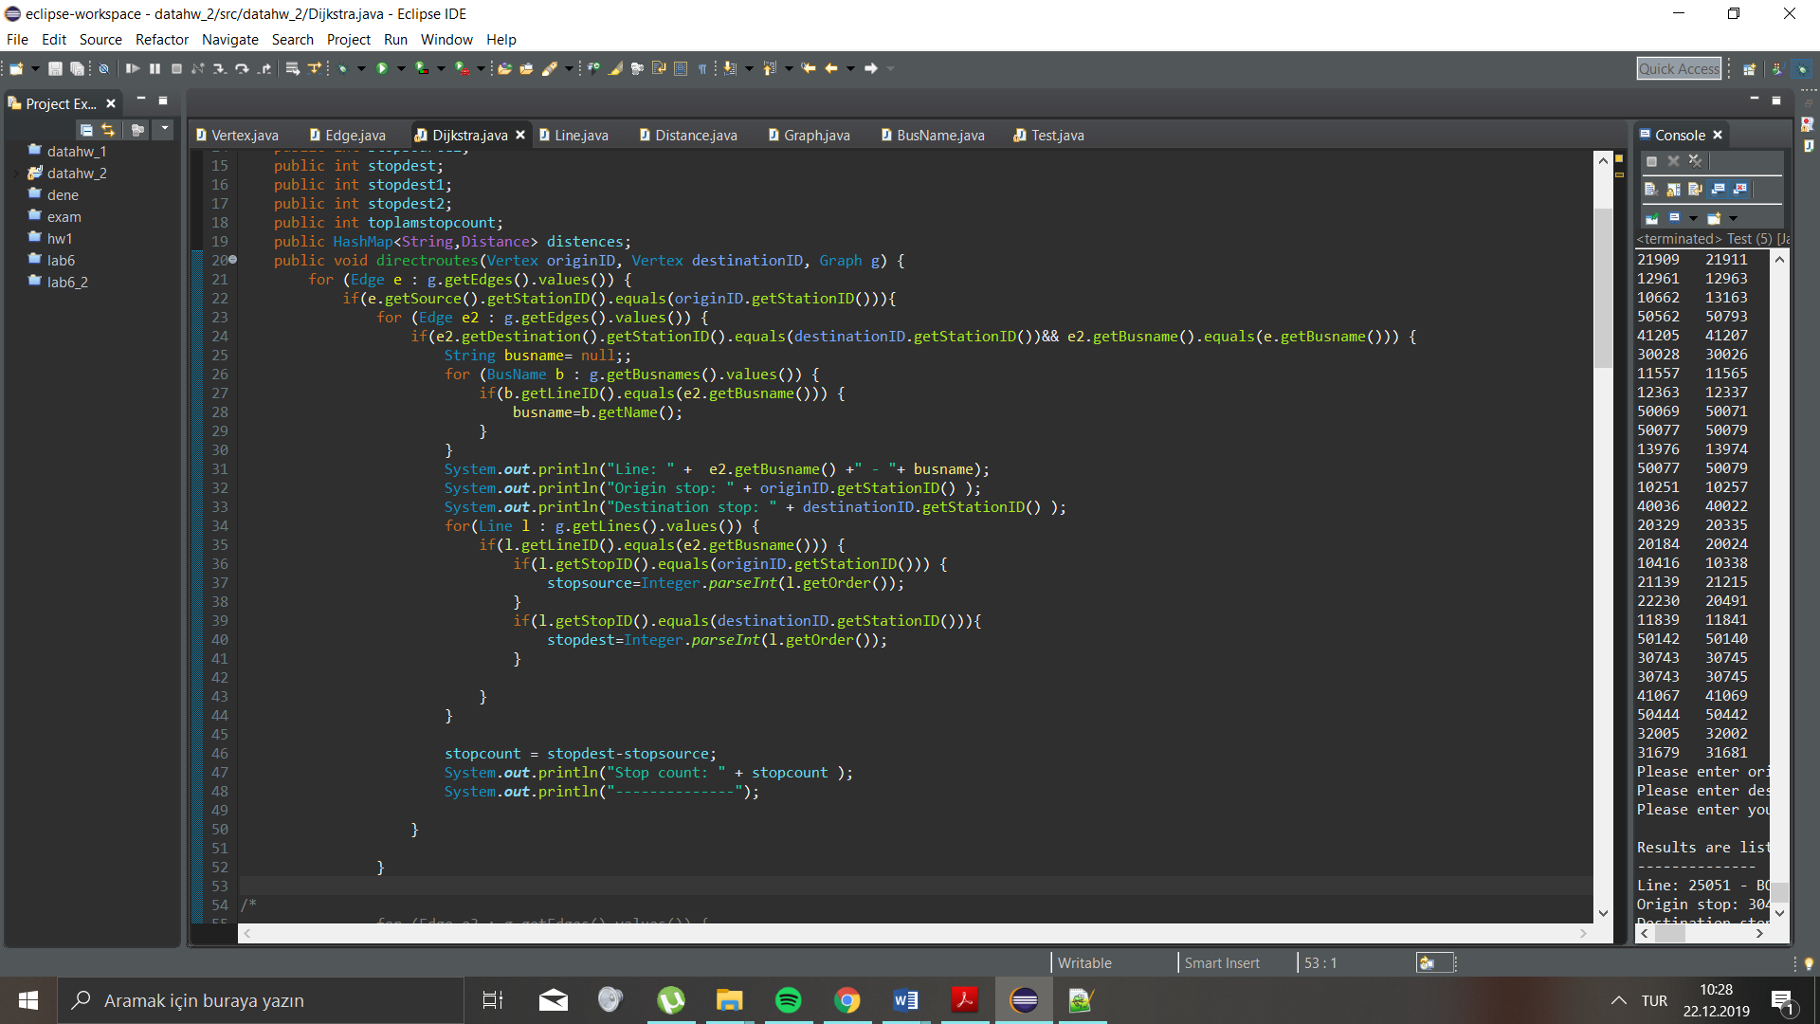

This code for minimum distance;

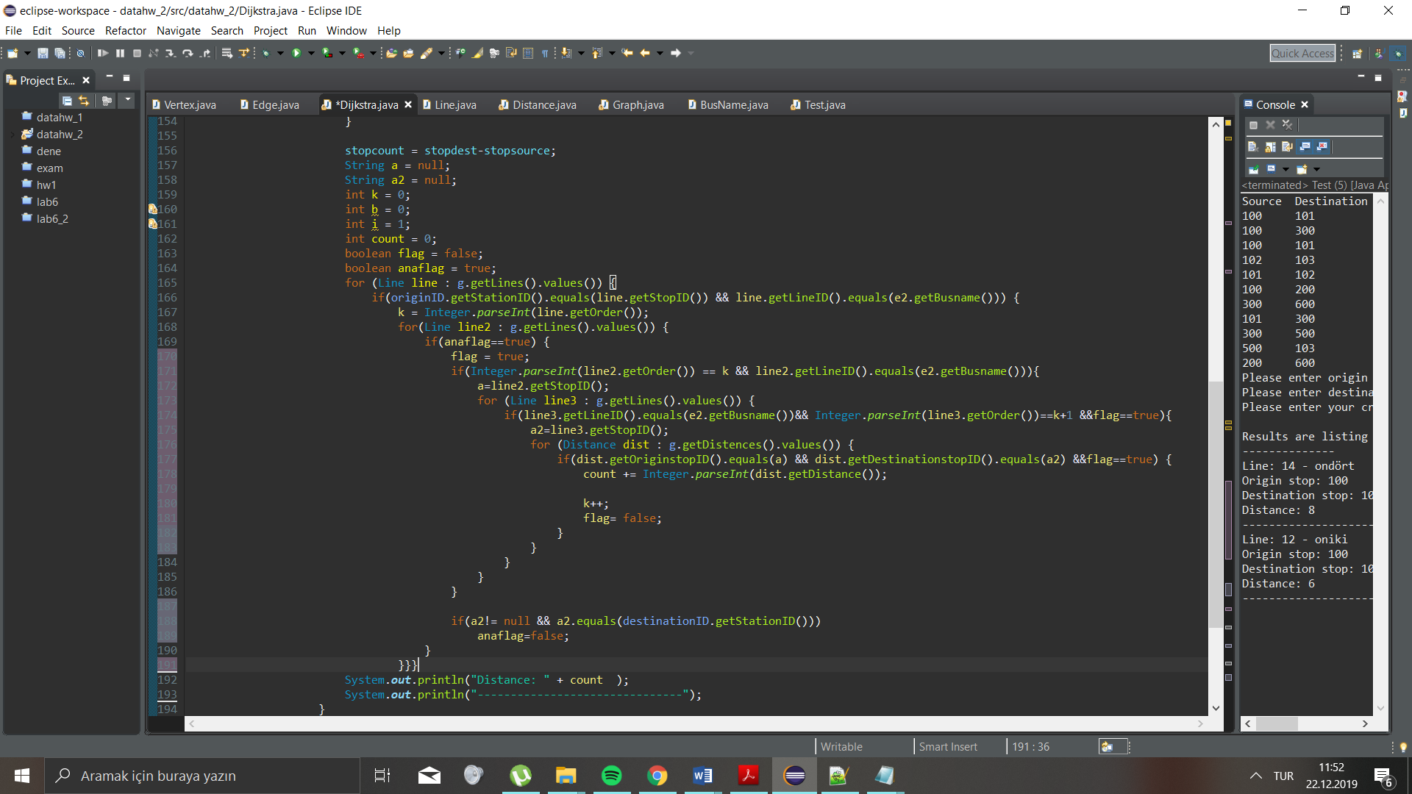

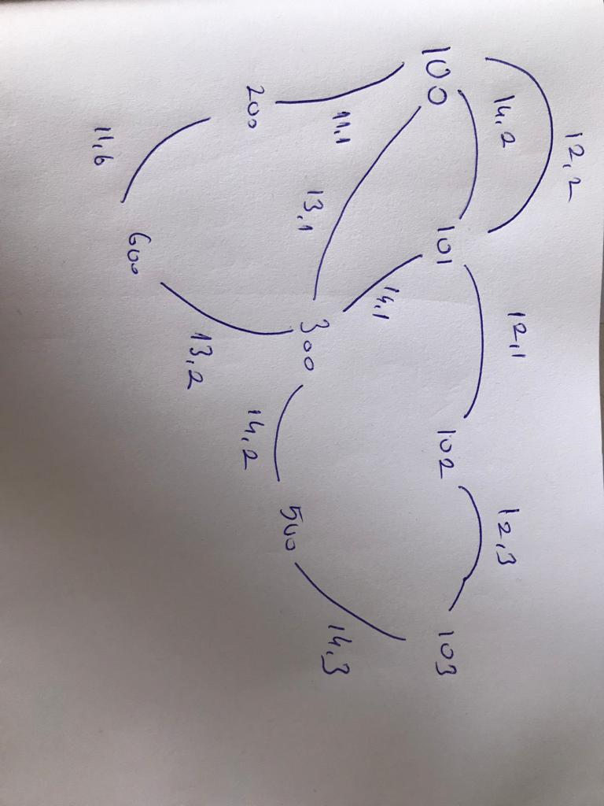With small path we have better answers.

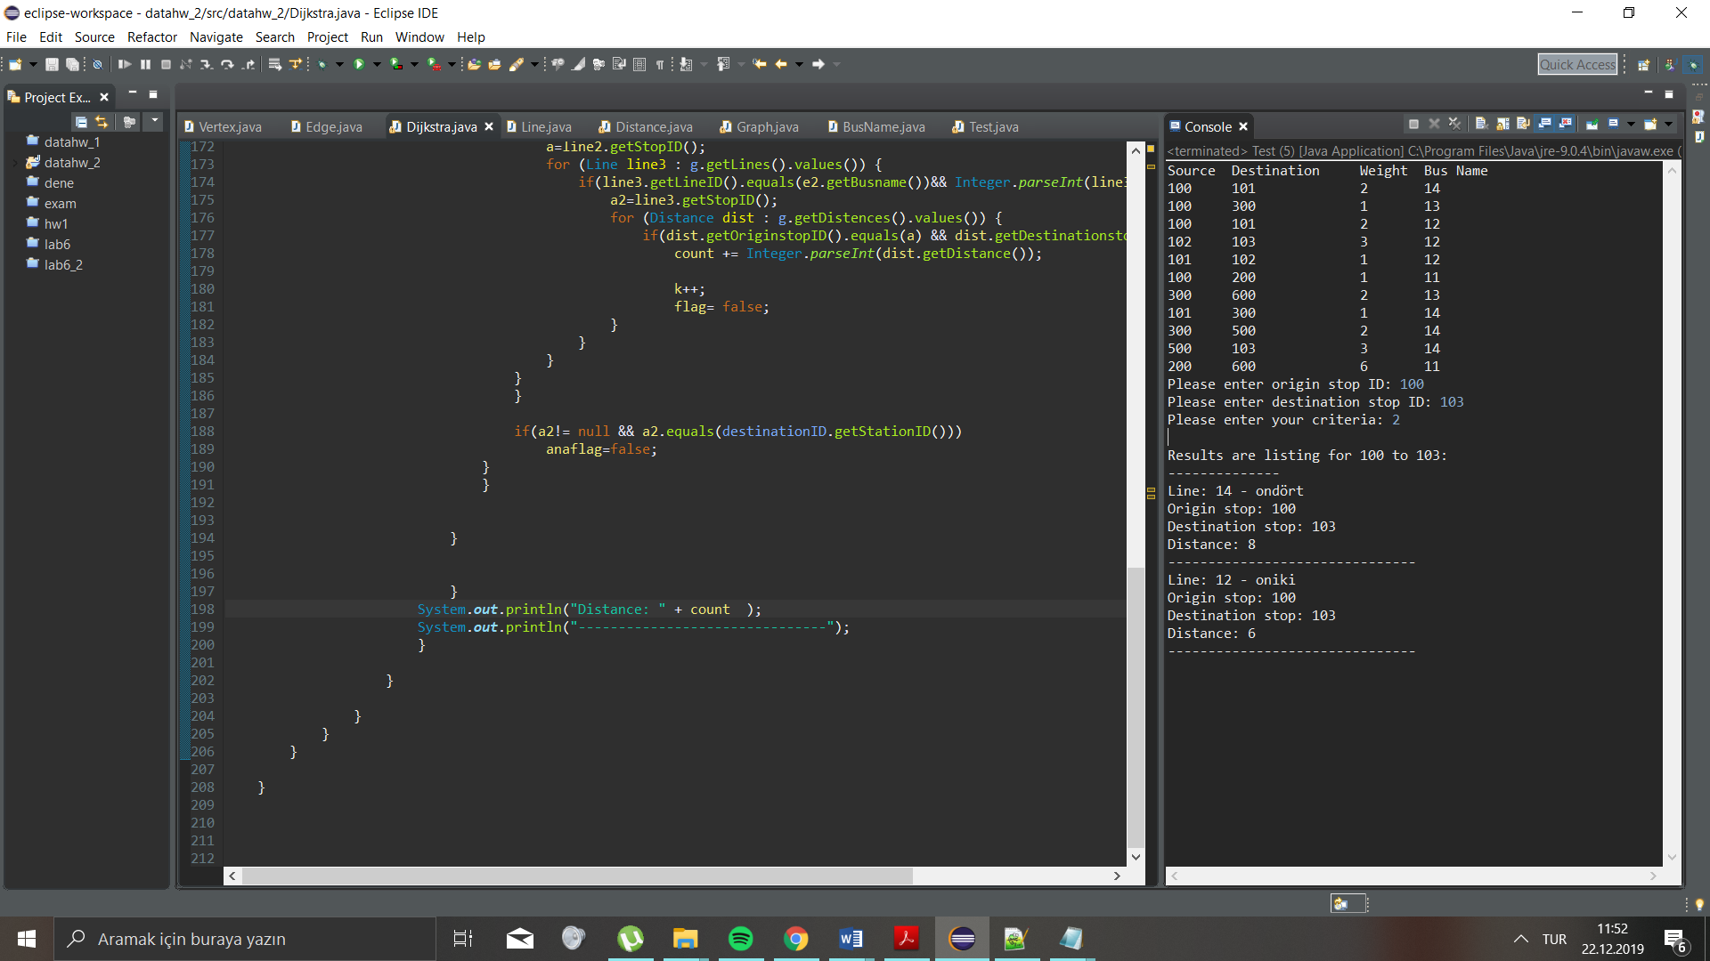

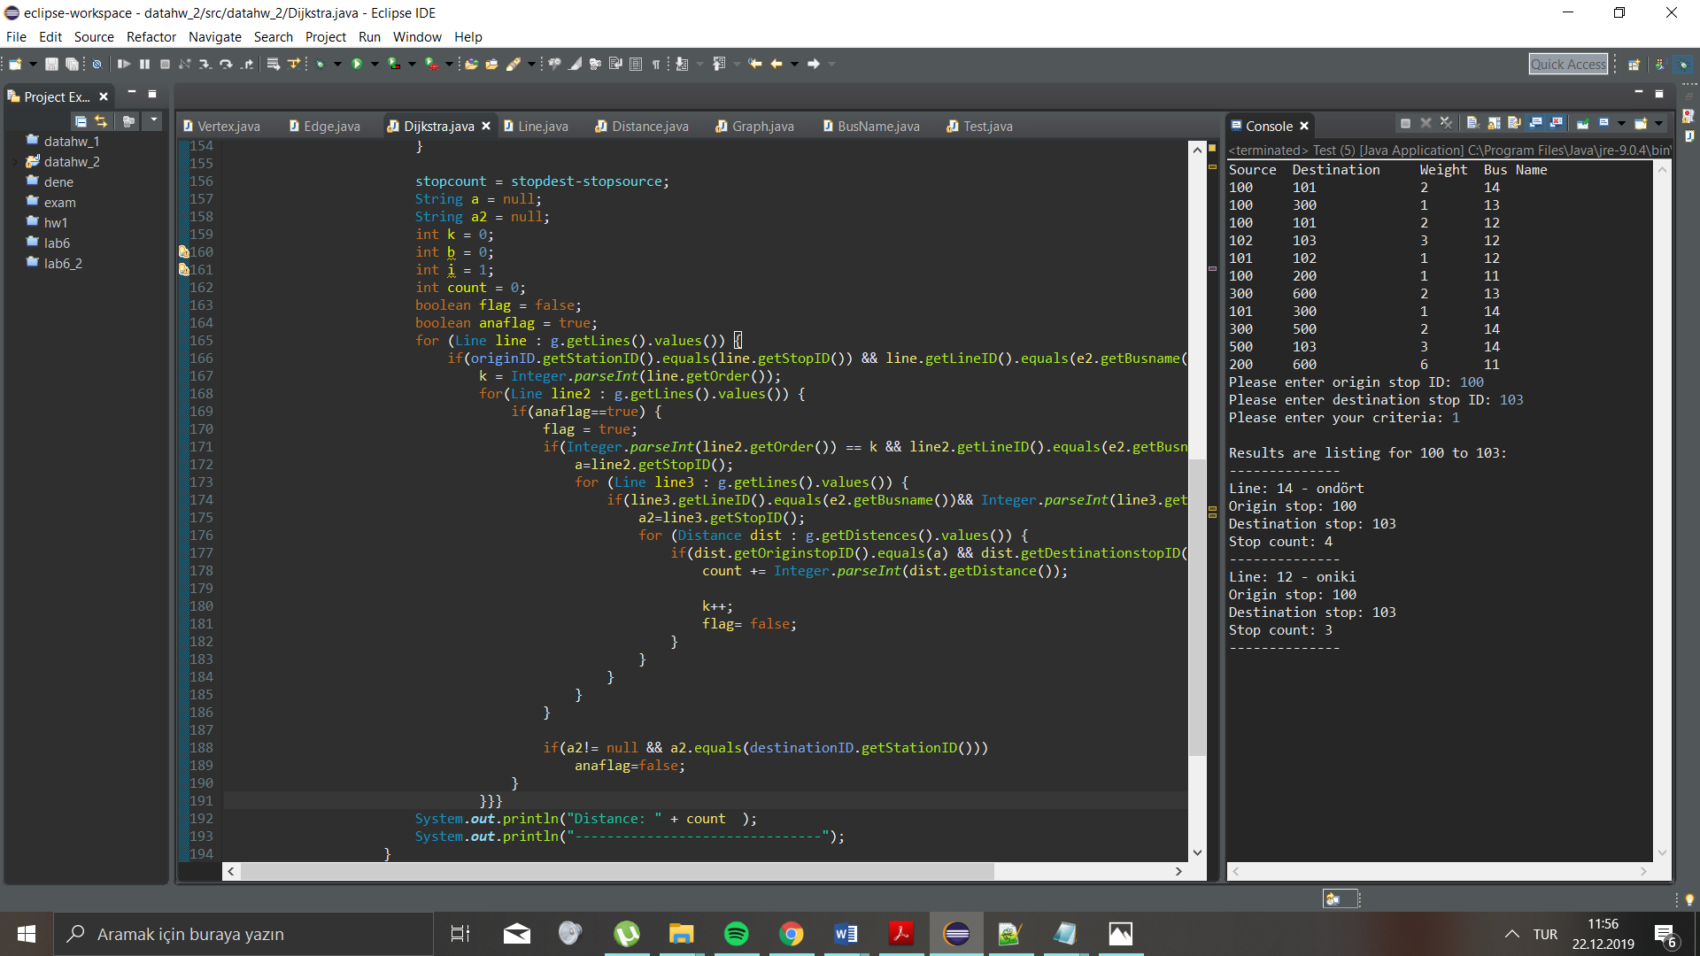

Finally, my code is half and half working. I couldn’t finish all tasks because of the time. And sadly, my code is not working for test stops.